# Handbook of Clinical Audiology 7th

Jack Katz

# Dedication

The Seventh Edition of the Handbook of Clinical Audiology is Dedicated to Raymond Carhart (192?–1975), who is recognized as the “Father of Audiology.” He talked about the shared responsibility of the clinician and the hearing scientists (both of whom he considered as audiologists) to learn about the hearing process and develop ways to help persons living with hearing loss.

题词

第七版临床听力学献给听力学之父雷蒙德·卡哈特（192?–1975），他提到临床医生和听力科学家（他都认为是听力学家）的共同责任是了解听觉的过程并帮助听力损失者。

# Foreword

前言

It is ﬁtting that this book is dedicated to Dr. Raymond Carhart. He stated in a 1976 interview that he conceived of an audiologist “as someone who has a prime commitment to learning about hearing and its processes as well as a commitment to understanding and coping with its problems.” He talked about the shared responsibility of the clinician and the hearing scientists (both of whom he considered as audiologists) to learn about the hearing process and ways to help the persons with hearing impairment. The seventh edition of Handbook of Clinical Audiology book strives to do that, as have the previous editions.

这本书献给雷蒙德·卡哈特博士是合适的。在1976年的一次采访中，他认为听力学家是“作为一个致力于学习听觉及其过程以及致力于理解和解决其问题的人。” 他谈到了临床医生和听力科学家（他认为他们都是听力学家）的共同责任，即了解听觉过程和如何帮助听障人士。第七版《临床听力学》力图做到这一点，前几版也是如此。

Carhart has been referred to as the “Father of Audiology”—or sometimes the “Grandfather of Audiology.” Perhaps it would be most appropriate to call him the “Grand Father of Audiology.”

卡哈特被称作“听力学之父”，有时也被称为“听力学祖师爷”。或许最合适的称呼为“伟大的听力学之父”。

Although he came to the ﬁeld somewhat indirectly, his contributions were enormous.

虽然他是间接来到这个领域的，但他的贡献是巨大的。

Dr. Carhart was born in Mexico City. He received his Bachelor’s degree from Dakota Wesleyan University in 1932 in speech pathology and psychology; his Master’s and Ph.D. degrees from Northwestern in 1934 and 1936, respectively, in Speech Pathology, Experimental Phonetics, and Psychology. He was an instructor in speech reeducation at Northwestern from 1936 to 1940 and then an assistant, and associate professor in 1943 in speech science.

卡哈特博士出生于墨西哥城。 他于1932年在达科他卫斯里昂大学获得言语病理学和心理学学士学位；1934年和1936年在西北大学分别获得言语病理学、实验语音学和心理学硕士和博士学位。1936年至1940年，他在西北大学担任言语再教育讲师，之后担任助理，1943年担任言语科学副教授。

Although Carhart initially worked in speech science, he was asked to replace C.C. Bunch following Bunch’s untimely death in June, 1942. Carhart then began to teach Bunch’s courses in hearing and became so interested in the problems that, as he said, “I’ve been working with them ever since.”

虽然卡哈特最初从事言语科学工作，但在1942年6月班奇早逝后，他被要求接替班奇。后来卡哈特开始教授班奇的听力课程，并对这些问题产生极大兴趣，正如他所说：“从那以后，我一直在研究这些问题。”

In 1943, Carhart joined the Medical Administrative Corps, US Army, as a captain, he was assigned to DeShon Hospital in Butler, Pennsylvania as Director of the Acoustic Clinic and as Acoustic Physicist where he was asked to develop a program for veterans who had lost their hearing during the war. In that capacity he contacted the scientists at the Psycho-Acoustic Laboratory (PAL) at Harvard, who, among other things, had come up with word lists that might be used in evaluating a person’s ability to understand speech. He also developed a fairly comprehensive rehabilitation program that involved selecting and ﬁtting hearing aids (which were not so complex or elaborate as they are today), and teaching the soldiers and veterans how to use them.

1943年，卡哈特加入了美国陆军医疗队，担任上尉，他被分配到宾夕法尼亚州巴特勒的德森医院，担任声学诊所主任和声学物理学家，在那里他被要求为战争中失去听力的退伍军人制定方案。在此期间，他联系了哈佛大学心理-声学实验室（PAL）的科学家们，这些科学家提出了可用于评价一个人言语理解能力的词汇表。他还制定了一个相当全面的康复方案，包括选择和佩戴助听器（这些助听器不像今天这么复杂和精致），并教导士兵和退伍军人如何使用它们。

When Carhart returned to Northwestern in 1946, he convinced the dean to establish an academic program in Audiology, which was the name that Dr. Norton Canﬁeld chose for the department at DeShon. He became the ﬁrst professor of Audiology at Northwestern.

当卡哈特1946年回到西北大学时，他说服院长建立了一个听力学学院课程，这是诺顿·坎尼尔德博士为德森大学的系选择的名字。卡哈特成为西北大学的首位听力学教授。

Carhart later said (in class if not in print) that sound— and especially speech—was comprised of many dimensions. Four of those dimensions were (1) sensitivity (how faintly can one hear); (2) clarity of sound (speech or otherwise) in quiet; (3) clarity in noise; and (4) tolerance (how loud can sound be without becoming a problem). Two of these dimensions (sensitivity and clarity), which were detailed by Carhart in a 1951 paper, became the basis of Plomp’s (1978) two-component model of hearing loss involving audibility and distortion. Carhart said there were many more dimensions to hearing, but those four should always be measured when ﬁtting hearing aids and working with patients with hearing loss.

卡哈特后来说（在课堂上，如果没有印刷的话）声音—尤其是言语—由许多维度组成。其中四个维度是（1）灵敏度（一个人能听到多微弱的声音）；（2）安静时声音（语音或其他）的清晰度; （3）噪音清晰度; （4）耐受性（能听到多大声而没有引起不适）。其中两个维度（灵敏度和清晰度）是卡哈特在1951年的一篇论文中详述了的，成为包含清晰度和失真的Plomp听力损失模型基础。卡哈特曾经说过，听力还有很多维度，但在配备助听器和治疗听力损失患者时，这四个维度应该一直被测量。

Although Carhart worked as a speech scientist, a clinician (in speech and in hearing), a researcher in speech and especially in hearing, his primary contribution is probably as a teacher and educator. An educator can be described as one who conveys learning in which the knowledge, skills, and habits of a group of people are transferred from one generation to the next through teaching, training, or research, and that certainly describes Dr. Carhart.

虽然卡哈特是一名语言科学家、临床医生（言语和听力方面）、言语特别是听力方面的研究人员，但他的主要贡献大概是作为一名教师和教育工作者。教育工作者可以被描述为通过教学、培训或研究将一群人的知识、技能和习惯从一代传到下一代，这就是卡哈特博士。

In his capacity as an educator, Carhart directed some 35 dissertations, beginning in 1946 with a study by John Keys entitled “Comparative Threshold Acuity of Monaural and Binaural Hearing for Pure Tone and Speech as Exhibited by Normal and Hard of Hearing.” Although his primary interest was in speech and speech understanding, the dissertations he directed covered a range of hearing problems from difference limens, to effects of surgery and speciﬁc diseases on hearing, to auditory fatigue, loudness and many more topic areas. In addition, as an educator he taught some of the leaders in the ﬁeld of audiology like James Jerger, Donald Dirks, Cornelius Goetzinger, Jack Willeford, and many more. Many of those went on to teach, and to educate other students in audiology programs at our most prestigious universities.

作为一名教育工作者，卡哈特指导了大约35篇论文，从1946年约翰·凯斯的一项研究开始，该研究的题目是“正常人和听力障碍患者单耳和双耳听力对纯音和言语的阈值敏感度的比较研究。”虽然他的主要兴趣在于言语和言语理解，但他所指导的论文涵盖了一系列听力问题，从差异阈值，到手术和特殊疾病对听力的影响，到听觉疲乏、响度等更多的领域。此外，作为一名教育家，他还教授出一些听力学领域的领军人物，如詹姆斯·杰格、唐纳德·德克斯、科尼利厄斯·戈特辛格、杰克·威尔福德等。他们中的许多人继续执教，并在我们最负盛名的大学的听力学课程中培育其他学生。

In 1949, he directed the dissertation of Miriam Pauls Hardy, who may have been the ﬁrst female to graduate with a Ph.D. in audiology. Unlike some of the professors of the time, Dr. Carhart did not discriminate on the basis of gender. He believed that it was the mind—not the gender—that was important. He did, however, believe that one should do the work, not just talk the talk. He set an example in that one often found him in his ofﬁce or laboratory in the evening and on weekends.

1949年，他指导了米里亚姆·保尔斯·哈代的论文，她可能是第一位获得听力学博士学位的女性。与当时的一些教授不同，卡哈特博士没有性别歧视。他认为重要的是思想，而不是性别。然而，他相信一个人应该做这项工作，而不是光说不练。他树立了一个榜样，人们经常晚上和周末在他的办公室或实验室里发现他。

His early research interests at Northwestern were in conductive hearing loss (the “Carhart notch,” which can be an indicator of possible otosclerosis was named for him), including a method of checking the accuracy of bone conduction measurements before there was an artiﬁcial mastoid, let alone an ANSI standard. He was interested in masking (forward, backward, and perceptual, which we now call informational masking), and did much to enhance our understanding of the way speech is processed by the damaged ear.

他在西北大学的早期研究兴趣是传导性听力损失（“卡哈切迹”，耳硬化症的一个指征，就是以他名字命名的），包括在人工乳突出现之前，检查骨传导测量准确性的方法，更不用说ANSI标准了。他对掩蔽感兴趣（向前、向后和知觉，我们现在称之为信息掩蔽），并做了很多工作来增加我们对受损耳处理语音方式的理解。

Before there were computers in our clinics and most academic research laboratories, he developed a key-sort system as a way of classifying audiograms so that one could better interpret the puretone audiogram.

在我们的诊所和大多数学术研究实验室有电脑之前，他开发了一种关键词分类系统，作为对听力图进行分类的一种方法，以便更好地解释纯音听力图。

Finally, Carhart believed that audiology was more than a clinical ﬁeld and that the clinicians who practiced it should continue to explore and research the ways in which we hear and how to improve the lives of those who do not hear normally.

最后，卡哈特认为听力学不仅仅是一门临床学科，从事听力学的临床医生应该继续探索和研究我们的听觉通路，以及如何改善那些听障人士的生活。

Raymond Carhart died at his desk in October 1975, leaving behind a legacy to the academic discipline of audiology, the numerous leaders in the ﬁeld of audiology whom he had educated, and the greater understanding of audiologic assessment and hearing aid rehabilitation for which he is known as the father—or Grand Father of Audiology.

雷蒙德·卡哈特于1975年10月在他的办公桌前去世，为听力学学科留下了宝贵的遗产，他培养了众多听力学领域的领军人物，并使人们对听力学评估和助听器康复有了更深入的了解，他因此被称为听力学之父。

We dedicate this seventh edition to Dr. Carhart, because like him the Handbook of Clinical Audiology has educated so many leaders of our ﬁeld and has inspired countless audiologists throughout the world. This edition of the Handbook will provide a broad perspective of the ﬁeld of audiology by nearly 100 contributing experts in the ﬁeld. They offer their knowledge, wisdom, and enthusiasm to help another generation of audiologists to fulﬁll their mission.

我们将第七版献给卡哈特博士，因为像他一样，《临床听力学》也培养了我们这个领域的许多领军人物，并激励了全世界无数的听力学家。该手册的这一版本提供了一个广阔的视角，由听力学领域内近100位专家所撰稿。他们奉献了自己的知识、智慧和热情，以帮助新一代听力学家完成他们的使命。

# Preface

序言

For more than 40 years, the Handbook of Clinical Audiology（HOCA）has maintained an important role in the education of graduate students in audiology, both in North America and throughout the world. It also serves as a useful reference for audiologists, otologists, and speech–language pathologists who wish to have a comprehensive and practical guide to the current practices in audiology.

40多年来，《临床听力学》（HOCA）一直在北美和世界各地的听力学研究生教育中发挥着重要作用。对于那些希望在当前听力学实践中有一个全面和实用指导的听力师、耳科医生和言语病理学家来说，它也是一个有用的参考。

Each edition of the HOCA has been an update of the previous one, but we have also striven to make the newest edition better than the one that came before. For this edition, there are four highly skilled and knowledgeable editors plus one senior editor. We have worked together to select highly qualiﬁed contributors on topics that are both core and current for students and professionals in audiology. Online case studies and references have been added to this edition to enable the reader to go beyond the basic scope of this book.

HOCA的每个版本都是上一个版本的更新，但是我们也努力使最新的版本比之前的版本更好。本版本有四位技术精湛、知识渊博的编辑和一名资深编辑。我们合作选择了高质量的撰稿人，他们的主题对于听力学的学生和专业人士来说既是核心又是通用的。本版本增加了在线案例研究和参考资料，使读者能够学到本书内容以外的知识。

## THE FOREWORDS

前言

In the previous edition of the Handbook the foreword was written by Moe Bergman, a distinguished gentleman with many years of audiology behind him. Moe Bergman, Ed.D., was in the very ﬁrst group of audiologists who began this discipline more than 70 years ago. Starting prior to World War II and for decades following, Dr. Bergman was a clinician, administrator, professor, researcher, and writer, and after he retired from Hunter College in New York City, he went to Israel to establish audiology as a profession there. He is considered as the Father of Audiology in Israel. For many years, Dr. Bergman has continued to be active as an advisor and an ofﬁcer in international professional organizations. His clarity about the events and developments so many years ago (see Bergman, 2002) makes him a treasured link to our roots.

在上一版的“手册”中，前言是由莫·伯格曼撰写的，他是一位有着多年听力学经验的杰出绅士。莫·伯格曼博士是70多年前最早从事这门学科的听力学家之一。从第二次世界大战开始，此后的几十年，伯格曼博士是一名临床医生，行政人员，教授，研究员和作家，从纽约亨特学院退休后，他来到以色列，在那里建立了一个听力学专业。他被认为是以色列的听力学之父。多年来，伯格曼博士一直积极担任国际专业组织的顾问和官员。他对多年前的事件及其发展的清晰理解（参见Bergman，2002），使他成为我们互相了解的基础。

This edition is dedicated to Raymond Carhart, “The Father of Audiology.” We are delighted to have the book’s dedication and foreword discussing Dr. Carhart; written by Laura Ann Wilber a former student of his and a distinguished audiologist in her own right. Dr. Carhart was her dissertation advisor and she worked with him and Tom Tillman to develop what later became the NU-6 word recognition test. When Laura Wilber earned her Ph.D. there were few women who were educated at that level in audiology and many people felt that it was a male profession. So Dr. Carhart’s acceptance of her and clearing a path for her was especially important.

这个版本是献给“听力学之父”雷蒙德·卡哈特的。 我们很高兴这本书的题词和前言讨论了卡哈特博士，由他以前的学生劳拉·安·威尔伯执笔，也是一位杰出的听力学家。卡哈特博士是她的论文导师，她与他和汤姆·蒂尔曼合作开发了后来成为NU-6单词识别测试的程序。当劳拉·威尔伯获得博士学位时，那时候还很少有女性接受这种程度的听力学教育，很多人认为这是一个男性从事的职业。所以卡哈特博士对她的接纳并为她扫清道路就显得尤为珍贵。

It is worth noting that Laura Wilber has contributed to each edition of the Handbook since the ﬁrst edition in 1972. She herself was honored by the editors of the HOCA in the previous edition by dedicating the book to her and to three other audiologists.

值得注意的是，自1972年第一版以来，劳拉·威尔伯对每一版都有贡献。在前一版中，HOCA的编辑们把这本书献给了她和其他三位听力学家，以此向她表示敬意。

## SECTIONS, CHAPTERS, AND CONTRIBUTORS

部分、章节和撰稿人

The strength of HOCA has always been the knowledge and expertise of the contributors in the many aspects of audiology. They have both clinical and research credentials in the topics they write about and most are also professors who are proﬁcient in communicating with students. Audiologists looking down the list of contributors will recognize familiar and highly respected colleagues. They have contributed much to the ﬁeld in the past and now contribute again by providing important and readable materials for both colleagues and students. We have made every effort to provide up-to-date, accurate, and clinically applicable information.

HOCA的优势是有一批在听力学的许多领域有一定知识和专业技能的撰稿人。他们在所参写的主题中都有临床和研究方面的经历，而且大多数人还是擅长与学生交流的教授。从听力学家撰稿者名单上往下看，会认出熟悉的、受人尊敬的同僚。他们过去为这个领域做出了很多贡献，现在通过为同僚和学生提供重要且可读性强的材料再次做出贡献。我们已尽一切努力提供最新，准确和临床适用的信息。

Each of the four main editors of this book has a distinguished record of teaching, research, writing, and clinical work. Each one took responsibility for signiﬁcant portions of the book. Linda Hood helped to edit the Sixth Edition and decided to go “another round.” Her chapters deal primarily with physiological methods for audiologic diagnosis. Marshall Chasin, our ﬁrst Canadian editor, edited the chapters dealing with ampliﬁcation and other technical aspects. Kim Tillery edited the chapters dealing with central auditory processing disorders and shared in the ﬁnal editing of all chapters. Kristina English edited the basic chapters and those dealing with rehabilitation. Jack Katz reviewed all of the chapters and saw to the overall manuscript issues.

本书的四位主编都有着突出的教学，研究，写作和临床工作经历。每个人都对本书的重要部分负责。琳达·胡德曾帮助编辑了第六版并决定“再来一轮”。她的章节主要讨论听力诊断的生理学方法。我们的第一位加拿大编辑马歇尔·查辛，负责编辑有关扩音器和其他技术方面的章节。金·蒂勒里编辑了有关中枢听觉处理障碍的章节，并参与了所有章节的最终编辑。克里斯汀娜·英格利斯编辑了基本章节和有关康复的章节。杰克·凯茨审阅了所有的章节，并查看了手稿的所有问题。

The Handbook is divided into four sections. There are eight chapters dealing with Introduction, Basic Tests, and Principles. A chapter that summarizes diagnostic audiology and brings together the various contributions has been added in this edition. Other top-notch audiologists wrote on Puretone Air Conduction, Bone Conduction, and Speech Audiometry, as well as Masking and Case History.

手册分为四个部分。涉及引言、基本测试和原则的内容有八章。本版增加了一章，总结了诊断听力学，并汇集了各种成果。其他顶尖的听力学家写了关于纯音空气传导，骨传导，言语测听法，以及掩蔽和病史。

The second section is made up of 14 chapters dealing with Physiologic Principles and Measures. This section of the book includes auditory measures starting with the conductive mechanism up to the brain and vestibular measures that assess from the inner ear to the brain. Some chapters include specialty areas such as intraoperative monitoring and therapy for vestibular disorders. Some of the most pronounced advances in recent years have been made in these areas.

第二部分由14章组成，涉及生理学原理和方法。本书的这一部分包括从传导机制开始到大脑和前庭测量来达到对内耳到大脑的评估。一些章节包括特殊领域，如术中监测和前庭疾病的治疗。近年来在这些领域取得了一些特别显著的进展。

The third section is devoted to a wide variety of Special Populations. It contains 14 chapters beginning with Newborn Hearing Screening, Assessment of Hearing Loss in Children and Educational Audiology and ends with Hearing Loss in the Elderly, Tinnitus/Hyperacusis, and Tele-Audiology. Four chapters deal with Central Auditory Processing Disorders and Central Auditory Functions.

第三部分专门讨论各种特殊人群的研究。包含14章，从新生儿听力筛查、儿童听力损失评估和教育听力学开始，以老年人听力损失、耳鸣/听觉过敏和远程听力学结束。有四个章节涉及中枢听觉处理障碍和中枢听觉功能。

The ﬁnal section, Management of Hearing Disorders, is made up of 10 chapters. Five of the chapters deal with hearing aids and cochlear implants, two focus on management, and two more are on Room Acoustics and Assistive Technologies as well as Building a Successful Audiologic Practice. In addition, for the ﬁrst time we will have a chapter dealing with infection control in audiology practice that was written by A.U. Bankaitis. This important topic relates to all aspects of audiology that deal with clinical patients and/or research subjects.

最后一部分，听力障碍管理，由10章组成。其中五章涉及助听器和人工耳蜗植入，两个专注于管理，另外两个专注于室内声学和辅助技术以及建立成功的听力实践。此外，我们首次将有一章涉及讨论听力学实践中的感染控制，该章由班凯提斯撰写。这个重要话题涉及与听力学有关的临床患者和/或研究对象的所有方面。

Sadly, during the writing of the chapter on electrocochleography with Rosamaria Santarelli, contributor Edoardo Arslan passed away. He was both her co-author and mentor.

遗憾的是，在与罗莎玛丽亚·桑塔雷利合著有关耳蜗电图的章节时，撰稿者埃多·阿尔斯兰去世了。他既是她的合著者，也是她的导师。

## NEW FEATURES

新特性

Six new chapters have been introduced in the seventh edition. They are Diagnostic Audiology, The Dizzy Patient and Vestibular Rehabilitation, Newborn Hearing Screening, Genetic Hearing Loss, Tele-Audiology, and Infection Control. At the close of every chapter is a new section called Food for Thought, which encourages readers to interact more deeply with the text.

第七版引入了六个新章节。它们是诊断听力学、眩晕患者和前庭康复、新生儿听力筛查、遗传性听力损失、远程听力学和感染控制。每一章的末尾都有一个新的章节叫做“引人深思的事情”，鼓励读者与内容进行更深入的互动。

**The Point**

Point公司

In this edition of this Handbook we have added supplemental materials (e.g., extended references and case studies) on thePoint companion website at http://thepoint.lww.com/ Katz7e.

在本手册的这个版本中，我们在Point伙伴网站http://thepoint.lww.com/Katz7e上添加了补充材料（例如，扩展参考资料和案例研究）。

## TERMINOLOGY

术语

The following is an explanation of some of the spelling conventions used in the HOCA and brieﬂy why we chose them. Further discussion may be found in Chapter 1.

以下是对HOCA中使用的一些拼写习惯的解释，并简要说明了我们选择它们的原因。进一步的讨论可以在第一章找到。

**Compound Words**

复合词

In clinical audiology, as well as in English generally, compound words (two words written as one) are common. Compound words are simpliﬁcations of words that are frequently used together. For example, brain and stem are combined in the term auditory brainstem response. When two words are frequently used together to express a certain meaning, in time, they may be connected by a hyphen and eventually joined together into a single word (base ball, base-ball, baseball).

在临床听力学，以及一般英语中，复合词（两个词合写为一个）是常见的。复合词是经常一起使用的词的简化。例如，大脑和脑干结合在一起称为听觉脑干反应。当两个词经常一起使用来表达某种意思时，经过一段时间后它们可能由连字符连接起来，到最后组合成一个单词（base ball, base-ball, baseball）。

**PURETONE**

纯音

The terms pure tone and pure-tone are constantly used in audiology with or without a hyphen. This has encouraged us to combine them into a compound word, puretone. By choosing a single word it eliminates the inconstancies that we see when they are used or misused with or without a hyphen.

有或者没有连字符的术语纯音（pure tone and pure-tone）在听力学中经常使用。这鼓励我们把它们组合成一个复合词，puretone。通过选择一个单词，它消除了当使用或误用带连字符或不带连字符时的多变情况。

**SENSORY/NEURAL**

感音/神经

On the one hand, while there is good reason to use puretone as a compound word, on the other hand, it would be beneﬁcial for the term sensorineural to be separated into sensory or neural using a slash as we often use for “or” (i.e., sensory/ neural). This makes it clear that the test or result it did not distinguish sensory from neural. From the term sensorineural it is often not clear what is intended as many professionals assume that sensorineural means sensory. This problem has led to important confusions and errors that can be easily remedied by the use of sensory/neural if it is unclear which is indicated (e.g., with no air-bone gap for puretone thresholds we do not know if it is sensory, neural, or both). If the speciﬁc region is identiﬁed (e.g., present Otoacoustic Emissions but absent Middle Latency Response) we indicate that it was speciﬁcally neural or retrocochlear. If it is both we state “both sensory and neural” or just “sensory and neural.”

一方面，虽然有充分的理由将puretone用作复合词，但另一方面，将sensorineural（感音神经的）一词用斜杠分隔成sensory（感音的）或neural（神经的）一词将是有益的，因为我们经常用斜杠表示“或”（比如感觉/神经）。这清楚地表明测试或结果并没有区分感音和神经。从术语“感音神经”来看，通常不清楚它的用意，正如许多专业人士认为感音神经是指感音的。这个问题已经导致了严重的混淆和错误，如果不清楚是哪一种表现，可以使用感觉/神经来轻松纠正（例如，没有气骨间隙的气导阈值，我们不知道它是感音、神经还是两者都有）。如果确定了特定情况（例如，存在耳声发射，但没有中间潜伏期响应），我们就认为它具体是神经或耳蜗后区。如果两者兼而有之，我们会说“既感音又神经”，或者只是“感音和神经”。

## EPILOGUE

后记

We are pleased that the Handbook of Clinical Audiology (HOCA) is used widely by audiologists around the world. Interestingly when the HOCA ﬁrst came out in 1972, we were living in the Turkish Republic. There the word hoca means a religious leader or a revered teacher. While HOCA is certainly not a religious leader, we do hope it will be a revered teacher for the many students and colleagues that read this book.

我们很高兴《临床听力学》（HOCA）被世界各地的听力学家所使用。有趣的是，HOCA在1972年首次问世时，我们住在土耳其共和国。在那里，hoca这个词的意思是宗教领袖或受人尊敬的老师。虽然HOCA肯定不是宗教领袖，但我们确实希望它能成为读过这本书的许多学生和同僚尊敬的老师。

## ACKNOWLEDGMENTS

致谢

We would like to thank the editors of Wolters Kluwer, especially Linda Francis and Meredith Brittain, not only for their ﬁne editing of this book but also for advising us and keeping us to our deadlines. We would like to mention the following colleagues and other individuals who also helped us in many ways to make the Handbook as high quality a text and reference book that we could. They are Mark Chertoff, Robin Gashler, Jay Hall, Amy Lane, Larry Medwetsky, Marcello Peppi, Lynden Ronsh, and Natalie Turek. In addition, I appreciate the tremendous support from my family and would like to highlight those who made special contributions to the completion of this edition. They are Eric Kaseff, Lainie Kaseff, Mark Katz, and Miriam Kaseff. Another member of my family deserves very special mention. My wife Irma Laufer Katz has been heavily involved as reader, advisor, and organizer of most of my projects over the past 58 years. For the Handbook she was also the secretary who kept track of the 46 chapters as they came and went from authors to editors and back again in the various stages of completion. We must certainly mention the many authors who contributed their knowledge and skills to make this Handbook an important contribution to the education and practice of those in the ﬁeld of Audiology. To all of them and, of course, to my fellow editors my thanks and gratitude.

我们要感谢威科的编辑们，特别是琳达·弗朗西斯和梅雷迪思·布里廷，不仅因为他们对本书进行了精心编辑，而且还为我们提供建议，使我们按时完成任务。我们想提及以下同事和其他个人，他们在很多方面帮助了我们，使“手册”成为高质量的文本和参考书。他们是马克·切尔托夫、罗宾·加什勒、杰伊·霍尔、艾米·莱恩、拉里·梅德韦茨基、马塞洛·佩皮、林登·隆什、娜塔莉·图雷克。此外，我衷心感谢家人给予我的大力支持，并想重点感谢那些为完成本版本做出特殊贡献的人。他们是埃里克·卡塞夫、莱尼·卡塞夫、马克·凯茨、米里亚姆·卡塞夫。我的另一位家庭成员值得特别提及。在过去的58年里，我的妻子埃尔玛·劳弗·凯茨作为读者、顾问和组织者积极参与了我的大部分项目。在本手册的编辑过程中，她也是秘书，记录了46章的来龙去脉，从作者到编辑，再到完成的各个阶段。我们必须要提到许多贡献了他们的知识和技能的作者，使这本手册在对听力学领域的教育和实践方面作出重要贡献。对他们所有人，当然还有我的编辑同事们，我表示感谢和感激。

# Contents

目录

Contributors

撰稿人

Dedication

题词

Foreword

前言

Preface

序言

SECTION I: BASIC TESTS AND PROCEDURES 1

第一部分：基础测试和程序

1 A Brief Introduction to Clinical Audiology and This Handbook.........................3

Jack Katz

临床听力学及本手册简要介绍——Jack Katz

2 Calibration.................................9

Laura Ann Wilber and Robert Burkard

校准

3 Puretone Evaluation .......................29

Robert S. Schlauch and Peggy Nelson

纯音评估

4 Bone Conduction Evaluation ...............49

James R. Steiger

骨导评估

5 Speech Audiometry ........................61

Rachel McArdle and Theresa Hnath-Chisolm

言语测听

6 Clinical Masking...........................77

William S. Yacullo

临床掩蔽

7 Case History .............................113

Douglas L. Beck

病史

8 Diagnostic Audiology .....................119

Brian M. Kreisman, Jennifer L. Smart, and Andrew B. John

诊断听力学

SECTION II: PHYSIOLOGICAL PRINCIPLES AND MEASURES 135

第二部分：生理学原理与方法

9 Tympanometry and Wideband Acoustic Immittance ..............................137

Lisa L. Hunter and Chris A. Sanford

鼓室压测量法与宽带声导抗

10 Acoustic Stapedius Reﬂex Measurements....165

M. Patrick Feeney and Kim S. Schairer

镫骨肌反射声学测量

11 Introduction to Auditory Evoked Potentials ................................187

Robert Burkard and Manuel Don

听觉诱发电位导论

12 Electrocochleography .....................207

Rosamaria Santarelli and Edoardo Arslan

耳蜗电图

13 Auditory Brainstem Response: Differential Diagnosis ................................231

Frank E. Musiek, Jennifer E. Gonzalez, and Jane A. Baran

听性脑干反应：鉴别诊断

14 Auditory Brainstem Response: Estimation of Hearing Sensitivity . . . . . . . . . . . . . . . . . . . . .249

Linda J. Hood

听性脑干反应：听觉敏感度的评估

15 Auditory Steady-State Response ...........267

Andrew Dimitrijevic and Barbara Cone

听觉稳态反应

16 Intraoperative Neurophysiological Monitoring ..............................295

Paul R. Kileny and Bruce M. Edwards

术中神经生理学监测

17 Middle-Latency Auditory-Evoked Potentials ................................315

Anthony T. Cacace and Dennis J. McFarland

中期潜伏听觉诱发电位

18 Cortical Auditory-Evoked Potentials........337

Kelly Tremblay and Christopher Clinard

皮层听觉诱发电位

19 Otoacoustic Emissions ....................357

Beth Prieve and Tracy Fitzgerald

耳声发射

20 Clinical Neurophysiology of the Vestibular System.........................381

Erin G. Piker and Douglas B. Garrison

前庭系统的临床神经生理学

21 Evaluation of the Patient with Dizziness and Balance Disorders ....................399

Troy Hale, Henry Trahan, and Tabitha Parent-Buck

眩晕及平衡障碍患者的评估

22 Vestibular Rehabilitative Therapy ..........425

Richard Gans

前庭康复疗法

SECTION III: SPECIAL POPULATIONS 435

第三部分：特殊人群

23 Newborn Hearing Screening...............437

Karl R. White

新生儿听力筛查

24 Assessment of Hearing Loss in Children ....459

Allan O. Diefendorf

儿童听力损失评估

25 Genetic Hearing Loss .....................477

Carmen Brewer and Kelly King

遗传性聋

26 Educational Audiology ....................501

Cheryl DeConde Johnson and Carrie Spangler

教育听力学

27 Central Auditory Processing: A Functional Perspective from Neuroscience.............513

Dennis P. Phillips and Rachel N. Dingle

中央听觉处理：神经科学的功能视角

28 Auditory Pathway Representations of Speech Sounds in Humans.................527

Daniel A. Abrams and Nina Kraus

人类言语声音的听觉通路表征

29 Central Auditory Processing Evaluation: A Test Battery Approach...................545

Kim L. Tillery

中央听觉处理评估：测试组方法

30 Central Auditory Processing Disorder: Therapy and Management ................561

Jack Katz, Jeanane Ferre, William Keith, and Angela Loucks Alexander

中央听觉处理障碍：治疗和管理

31 Individuals with Multiple Disabilities ......583

Anne Marie Tharpe and Samantha Gustafson

多重残疾人士

32 Noise Exposure...........................595

Brian Fligor, Marshall Chasin, and Rick Neitzel

噪声暴露

33 Nonorganic Hearing Loss..................617

Frederick N. Martin and John Greer Clark

非器质性聋

34 Hearing Loss in the Elderly: A New Look at an Old Problem ........................631

Barbara E. Weinstein

老年性聋：旧问题新视角

35 Tinnitus and Hyperacusis .................647

Richard S. Tyler, William Noble, Claudia Coelho, Eveling Rojas Roncancio, and Hyung Jin Jun

耳鸣和听觉过敏

36 Tele-audiology ...........................659

De Wet Swanepoel

远程听力学

SECTION IV: MANAGEMENT OF HEARING DISORDERS 673

第四部分：听力障碍的管理

37 Room Acoustics and Auditory Rehabilitation Technology...............................675

Joseph Smaldino, Brian Kreisman, Andrew John, and Lindsay Bondurant

室内声学与听觉康复技术

38 Hearing Aid Technology...................703

Jennifer Groth and Laurel A. Christensen

助听器技术

39 Troubleshooting and Testing Hearing Aids .............................727

William Cole and Marshall Chasin

助听器故障排除与测试

40 Hearing Aid Fitting for Children: Selection, Fitting, Veriﬁcation, and Validation.........759

Susan Scollie

儿童助听器：选择、安装、验证和确认

41 Hearing Aid Fitting for Adults: Selection, Fitting, Veriﬁcation, and Validation.........777

Michael Valente and Maureen Valente

成人助听器：选择、安装、验证和确认

42 Building and Growing an Audiologic Practice..................................805

Melanie Herzfeld

建立和发展听力学实践

43 Implantable Hearing Devices ..............817

Teresa A. Zwolan

植入式听力设备

44 Intervention, Education, and Therapy for Children with Hearing Loss ............835

Christine Yoshinaga-Itano and Kristin M. Uhler

听力损失儿童的干预，教育和治疗

45 Audiologic Rehabilitation .................849

Joseph Montano

听力康复

46 Infection Control.........................861

A.U. Bankaitis

感染控制

SECTION V: APPENDICES

第五部分：附录

869

Author Index 895

作者索引

Subject Index 907

主题索引

# Section 1 Basic Test and Procedures

## CHAPTER 1 A Brief Introduction to Clinical Audiology and This Handbook

第一章：临床听力学及本手册简介

Audiology is the study of hearing and hearing disorders, a ﬁeld devoted to helping those with auditory and vestibular dysfunctions. This work may involve evaluation, re/habilitation, counseling, education, research, and/or screening/ prevention.

听力学是一门研究听力和听力障碍的学科，致力于帮助那些有听力和前庭功能障碍的人。这项工作可能涉及评估、康复、咨询、教育、研究、和/或筛查/预防。

Audiology combines aspects of science and art with techniques that are based on both basic and clinical research. We use sophisticated equipment to provide precision in determining the type and extent of the problems. But audiology is also an art. It involves the ability to perform the various tasks precisely and to provide information and maximum support to the individuals affected and their families. Because of these intellectually and emotionally gratifying aspects, it makes audiology an exciting career.

听力学基于基础研究与临床研究将科学与艺术结合起来。我们使用精密的设备来确定问题的类型和程度。但听力学也是一门艺术。它包括准确执行各项任务的能力，以及向受影响的个人及其家庭提供信息和最大限度支持的能力。由于这些智力和情感上的满足，它使听力学成为一个令人兴奋的事业。

In my more than 50 years in this field, audiology has continued to be interesting and rewarding work. It is a comparatively new field that emerged in the aftermath of World War II (WWII) to aid service members who suffered hearing impairments. It brought together speech-language pathologists, deaf educators, psychologists, and ear, nose, and throat (ENT) physicians. This interdisciplinary cooperation was responsible for the excellent services that were provided to the injured military personnel. At the same time these multidisciplinary activities helped to lay the groundwork for the field of audiology. Indeed this interdisciplinary aspect of the field of audiology remains one of its great strengths even today. Initially, audiologic work was carried out in military hospitals and then spread to universities and university clinics, afterward to hospitals and community clinics.

在我50多年的职业生涯中，听力学一直是一项有趣而有意义的工作。这是一个相对较新的领域，出现在二战后，用于帮助听力受损的军人。它汇集了言语病理学家、聋人教育学家、心理学家以及耳鼻喉科医生。这种跨学科合作向受伤的军事人员提供了出色的服务。同时, 这些多学科活动为听力学领域奠定了基础。事实上，即使在今天，听力学领域的跨学科方面仍然是它的一大优势。最初，听力工作是在军事医院进行的，然后传播到大学和大学诊所，后来传播到医院和社区诊所。

Presently there are about 12,000 members of the American Academy of Audiology and approximately 2,000 members of the International Society of Audiology. Also memberships continue to grow in local, state, and national associations around the world. Audiology has several peerreviewed journals and other publications, both printed and digital, that report on research and clinical developments. The ﬁeld of audiology is constantly expanding its horizons and developing deeper understandings of both normal and abnormal processes.

目前，美国听力学学会约有12,000名会员，国际听力学学会约有2,000名会员。此外，世界各地的地方协会、州协会和国家协会的会员人数也在不断增长。听力学领域的相关杂志和其他出版物，包括印刷版和电子版，都对研究和临床发展进行了报道。听力学不断拓展它的范围，加深了人们对正常和异常听力过程的认识。

### AUDIOLOGY FROM 1940s TO TODAY

20世纪40年代至今的听力学

As mentioned above, the ﬁeld of audiology was founded during WWII. Prior to that time hearing testing was carried out using tuning forks and whispered speech by medical doctors, although some puretone audiometers that provided repeatable stimuli were also in use. The combined efforts of the different disciplines fostered the variety of procedures we have to address the problems caused by hearing impairment. Bone-conduction testing and speech audiometry were soon added to the clinical tools. Aspects such as lip reading/speech reading, auditory training, and counseling were borrowed from deaf education, psychology, and speech-language pathology. An important adjunct for the service members was the ﬁtting of hearing aids which were quite limited by today’s standards. Nevertheless for years after the war these veterans were still using and beneﬁting from the ampliﬁcation and training that they had received from those early audiologists when the profession was in its infancy.

如上所述，听力学是在二战期间创立的。在此之前，听力测试是由医生使用音叉和耳语来完成的，尽管一些提供可重复刺激的纯音听力计也在使用。在不同学科的共同努力下，我们有了各种各样的程序来解决听力障碍造成的问题。骨导测试和言语测听很快应用于临床。诸如唇读/言语阅读、听觉训练和心理咨询等借鉴于聋人教育、心理学和言语病理学。对从业人员来说，一个重要的辅助设备是助听器的装配，这在今天的标准下来看是相当有限的。尽管如此，战后多年来，这些退伍军人仍然在使用助听器，并从早期听力学家的训练中获益。

After leaving military service, the early audiologists began to train others at colleges and universities. Audiologists began to research the clinical problems that they faced and many of these approaches and solutions are still in use today. These procedures also led the way to important innovations. Because it was clear that we did not have enough diagnostic information to accurately measure and categorize hearing disorders, early on, there was a heavy emphasis on developing new diagnostic procedures. For a number of years the area of diagnosis was the primary focus in audiologic research and practice.

退伍后, 早期的听力师开始在高校培训其他人。听力学家开始研究他们面临的临床问题, 其中许多方法和解决方案至今仍在使用。这些程序也引领了重要创新。因为很明显，当时没有足够的诊断信息来准确测量和分类听力障碍，早期我们就大力重视开发新的诊断程序。多年来, 诊断领域一直是听力研究和实践的主要焦点。

When audiologists began dispensing hearing aids, this caused an expansion of attention, from just evaluation and identiﬁcation of hearing loss to include providing means of managing hearing difﬁculties and therapy to address the communication problems. Hearing aid ﬁtting was also a major impetus for audiologists to go into private practice. At the same time there were major breakthroughs in physiological measurements. This began with what we now refer to as cortical responses, but after a few years, earlier responses were identiﬁed from the auditory nerve and even the cochlea. The ﬁeld of audiology has expanded to include the assessment of more complex functions at all levels of the peripheral and central auditory nervous system. Immittance measurements enabled audiologists to assess mechanical properties of the auditory system of the outer and middle ears, as well as middle-ear muscle responses that rely on auditory nerve and brainstem activity. Specialties such as auditory processing disorders, educational audiology, vestibular function, and interoperative monitoring have added to the breadth and depth of the ﬁeld.

当听力师开始验配助听器时，这引起了广泛的关注，从仅仅评估和识别听力损失，到提供处理听力障碍的手段和治疗来解决沟通问题。助听器验配也是听力师进入私人诊所的一个主要动力。与此同时，生理性测量方面也取得了重大突破。这开始于我们现在所说的皮层反应，但几年之后，从听觉神经甚至耳蜗中发现了早期的反应。听觉学的领域已经扩大到包括评估周围和中央听觉神经系统各级更复杂功能。导抗测量使听力师能够评估外耳、中耳听觉系统的力学特性，以及依赖听觉神经和脑干活动的中耳肌肉反应。诸如听觉处理障碍、教育听力学、前庭功能和术间监测等专业增加了该领域的广度和深度。

The growing sophistication and understanding of auditory functions and development can be seen in the lowering of the target ages for various services. In the mid-1950s it was taught that we should wait until deaf children are perhaps 10 years of age before testing them and presumably provide ampliﬁcation after that. Given our current state of knowledge, in retrospect, this seems absurd and counterproductive. At that time we did not understand that developmental problems should be identiﬁed at the earliest possible time. Otherwise, the person could miss critical periods and lose plasticity, as well as fall further behind with reduced learning and more acquired misconceptions. Now, neonatal hearing screening is widespread and we strive to begin habilitation by 6 months of age. In fact, in the past, one audiologist was ridiculed when she advocated that audiologists ﬁt hearing aids for children as young as 1 year of age. Once we realized the critical importance of the early years for later development, early identiﬁcation and assessment procedures, as well as training procedures were targeted and developed.

听觉功能及发育认识和理解的提高可以从越来越低的就诊患者年龄中看出来。在20世纪50年代中期，人们教导我们应该等到失聪儿童10岁左右再进行测试，之后再进行助听器验配。考虑到我们目前的知识水平，回想起来，这似乎是荒谬和适得其反的。当时我们不理解应尽早查明发育问题。否则，该人可能错过关键时期并失去可塑性，并且随着学习减少和更多误解而进一步落后于人。如今，新生儿听力筛查非常普遍，我们努力在6个大的时候开始进行康复训练。事实上，在过去，有一位听力学家曾因主张听力学家应该为1岁儿童验配助听器而遭到嘲笑。一旦我们认识到早期阶段对今后发展的重要性，就有针对性地制订早期识别、评价以及培训。

As the ﬁeld of audiology expanded so did the academic demands on the practitioners. Initially, a bachelor’s degree was required to practice and then a master’s degree was the entry level along with basic clinical certiﬁcation. As in the past a Ph.D. was generally desired for university teaching and research. In more recent years (in the United States) the Doctorate of Audiology (Au.D.) degree was introduced to provide even broader clinical teaching and training experiences. Also, higher levels of competency and certiﬁcation are generally required today to practice audiology. Students interested in a career that includes independent research continue to pursue a Ph.D. in audiology, hearing science, or related areas. Now many of the top university programs in audiology have both Ph.D. and Au.D. trained professors to provide the student the best of both worlds. We also see combined Au.D./Ph.D. programs that offer students excellent ground for both clinical and research endeavors.

随着听力学领域的发展，对听力学工作者的学术要求也在不断提高。最初，学士学位需要实习，然后硕士学位是基础临床认证的初级水平。和过去一样，哲学博士学位通常是大学教学和研究所需要的。近年来（在美国）引进了听力学博士学位，以便提供更广泛的临床教学和培训经验。此外，今天听力实践通常需要更高水平的能力和认证。对独立研究的职业感兴趣的学生继续攻读听力学、听力科学或相关领域的听力学博士学位和哲学博士学位。现在许多顶尖大学的听力专业都有听力学博士学位和哲学博士学位。训练有素的教授在两个领域为学生提供优质的服务。我们也看到听力学博士/哲学博士课程结合在一起，为学生的临床和研究提供了良好基础。

We owe a debt of gratitude to those early audiologists who helped to form this vibrant and vital health profession. Although we cannot mention the many important contributors, it is perhaps appropriate to mention Raymond Carhart (1912 to 1975) who is generally recognized as “The Father of Audiology.” He was an important contributor to the developing ﬁeld of audiology and an excellent teacher. Many of his students from Northwestern University in Evanston, Illinois went on to contribute signiﬁcantly to the ﬁeld of audiology in their own right.

我们应该感谢那些早期的听力学家，他们帮助形成了这个生机盎然的健康行业。虽然我们不能提及全部重要的贡献者，但也许应该提及雷蒙德•卡哈特（1912 – 1975），他被公认为“听力学之父”。他对听力学的发展做出了重要贡献，也是一名优秀的教师。他的许多学生来自伊利诺斯州埃文斯顿的西北大学，他们后来凭借自己的能力在听力学领域做出了重大贡献。

### ABOUT THIS HANDBOOK

关于这本书

The ﬁrst edition of the Handbook of Clinical Audiology was published in 1972 and subsequent editions have served several generations of audiologists in the United States and increasingly throughout the world. It is used widely as both a text and reference book by students and professionals in various ﬁelds.

《临床听力学》第一版于1972年出版，随后的版本哺育了美国的几代听力学家，并逐渐遍及世界各地。它作为教科书和参考书被多个领域的学生和专业人士广泛使用。

Currently, for this edition, we have ﬁve editors who have diverse areas of specialization in clinical, research, and teaching aspects for which they are responsible. To broaden our horizons and to be as inclusive as possible, in this edition we have tried to include more international voices and procedures.

目前, 本版有五位编辑, 他们负责临床、科研和教学方面的不同领域。为了拓宽我们的视野, 尽可能具有包容性, 我们在本期试图纳入更多的国际观点和程序。

We have squeezed in as much information in 1,000 pages as we could. The more than 90 contributors are highly regarded audiologists who also have clinical, research, and teaching experience. This makes the chapters authoritative, well organized, and geared for sharing our knowledge in a ﬁeld that we love. We have always considered readability an important feature of this book and especially now that it is used by many people whose ﬁrst language is not English.

我们尽可能把更多信息压缩到1000页里。超过90位撰稿者都是非常受尊敬的听力学家，他们均有临床、科研和教学经验。这使得这些章节具有权威性，组织良好，适合于在热爱的领域分享我们的知识。我们一直认为可读性是这本书的一个重要特点，尤其是现在许多母语不是英语的人都在使用它。

The 46 chapters are divided into four sections. Section I deals with basic tests and procedures that are used by most audiologists for most of the people with whom they work. This involves puretone air and bone conduction, as well as standard speech audiometry. Calibration and case history chapters are also important components for any audiologic assessment. The Diagnostic Audiology chapter helps the reader to combine all of the previous information into a coherent diagnosis.

46章被分为四个部分。第一部分介绍大多数听力师所使用的基本测试方法和程序。这涉及纯音空气传导和骨传导，以及标准的言语测听。校准和病史章节也是任何听力评估的重要组成部分。诊断听力学章节帮助读者将所有先前的信息组合成一个连贯的诊断。

Section II introduces the various physiological and electrophysiological procedures used by audiologists at this time. These include immittance measures that primarily reveal the status of the middle ear. Electrocochleography and Otoacoustic Emissions provide detailed information about the responses from the cochlea, the end organ of hearing. Five chapters in this section discuss the electrophysiological responses from the auditory nerve, brainstem, and various areas of the brain. The chapter on intraoperative monitoring describes the analysis of the auditory system during surgery that informs the surgeons about the status and possible adverse effects of their manipulations of the auditory system. The ﬁnal three chapters in this section deal with the vestibular system. They begin with the study of vestibular neurophysiology and end with vestibular rehabilitation.

第二部分介绍了当前听力学家使用的多种生理和电生理程序。包括主要反映中耳状态的导抗测量。耳蜗电图和耳声发射提供了有关听觉的最终器官耳蜗反应的详细信息。本节有五章讨论来自听觉神经、脑干和大脑不同区域的电生理反应。关于术中监测的章节描述了对手术中听觉系统的分析，该分析将告知外科医生手术期间听觉系统的状态和可能的不良影响。本节的最后三章讨论前庭系统。从前庭神经生理学研究开始，至前庭康复结束。

Section III is called Special Populations. This recognizes that certain groups often require modiﬁcations in audiometric procedures or accommodations. Evaluation of young children offers a special challenge to the audiologist because they do not have the auditory or cognitive development needed for some of the tests, and it is sometimes difﬁcult to have them perform in the expected fashion. This chapter describes ways to obtain the desired results. Hearing, screening, and educational audiology generally involve the work carried out in schools with those who have normal hearing as well as those with auditory impairments. This section also includes chapters that deal with those who have multiple disabilities, hereditary hearing loss, and the elderly. Other special groups are those with noise-induced hearing loss, those who have tinnitus, and individuals who have “nonorganic” hearing loss. Four of the other chapters involve auditory processing disorders, which include the bases of central auditory problems, diagnostic procedures, and subsequent remediation. This section concludes with a chapter on tele-practice in which audiologists can work with people at far distances via communication systems.

第三部分称为特殊群体。要认识到是，特定群体往往需要在听力测量程序或调节方面作出修改。幼儿评估对听力学家来说是一个特殊的挑战，因为测试所需的听觉或认知还没有发育完全，有时很难让他们按照预期的方式进行测试。本章介绍了获得预期结果的方法。听力、筛查和教育听力学一般涉及在学校进行的工作，对象既有听力正常的人，也有听力障碍的人。这部分也包括处理那些有多重残疾，遗传性听力损失，和老年人群等章节。其他特殊人群包括噪音性听力损失、耳鸣和“非器质性”听力损失。其他四章涉及听觉处理障碍，包括中央听觉问题，诊断程序，和随后的矫正的一些基础知识。本节以一个关于远程实践的章节结束，在这个章节中，听力学家可以通过通信系统远程与人一起工作。

Section IV deals with the management of hearing disorders. It begins with acoustical environments and technologies that are used to aid the hard-of-hearing person in reducing the inﬂuence of noise and other factors that can compromise communication. This is followed by four chapters related to various aspects of hearing aids and hearing aid ﬁttings. Another chapter, which deals with implantable hearing devices, is a rapidly expanding area. The chapter discusses cochlear implants and other devices that are surgically imbedded into the person with a hearing loss. Two other chapters deal with management of those with hearing problems in the classroom and with rehabilitation of adults. There is also a chapter in this section that advises audiologists on how to start an effective audiologic practice.

第四部分讨论听力障碍的管理。它从声学环境和技术开始，这些技术被用来帮助听力困难的人以减少噪音和其他影响交流因素的影响。接下来是与助听器和助听器验配各方面有关的四章。另一章是关于植入式听觉装置，这是一个正在蓬勃发展的领域。这一章讨论了人工耳蜗和其他通过手术植入到失聪患者体内的设备。另外两章论述了有听力问题的学龄儿童的管理与成年人康复的管理。本节还有一章是关于指导听力师如何开始有效的听力学实践。

**New Chapters in This Edition**

本版本的新章节

a. Diagnostic Audiology serves an important purpose in bringing together the information from the basic evaluation procedures in this book to form an audiologic interpretation and an understanding of the patient’s needs. This chapter will also discuss some procedures that are not covered in the preceding chapters, as well as mentioning what our tests do not tell us.

诊断听力学的一个重要目的是汇集本书基本评估程序中的信息以形成听力学解释和对患者需求的理解。本章还将讨论一些在前面的章节中没有涉及的程序，并且提到测试没有告诉我们什么。

b. The Dizzy Patient and Vestibular Rehabilitation chapter is an extension of a former Handbook chapter, applying diagnostic information to enable appropriate treatment decisions for patients with vestibular problems. It will describe audiologic procedures designed to relieve patient’s symptoms, as well as the role of physical therapy and the necessity of collaboration among healthcare professionals.

“眩晕患者和前庭康复”章节是上版本章节的延伸，应用诊断信息来为前庭问题患者作出适当的治疗决策。它介绍了用于减轻患者症状的听觉程序，以及物理疗法的作用和卫生保健专业人员之间协作的必要性。

c. Hearing Screening discusses newborn hearing screenings, school screenings, and other screening procedures using universal approaches and targeted population approaches. The speciﬁc procedures, their value, and outcomes of screening programs will be discussed.

听力筛查讨论新生儿听力筛查、学校筛查和其他筛查程序，使用通用方法和目标人群方法。特定的程序及其评估，和筛选程序的结果将被讨论。

d. Hereditary Hearing Loss describes much-needed information for audiologists related to genetic aspects of hearing loss that may be nonsyndromic or part of a known syndrome. Since audiologists are often the ﬁrst professionals to suspect a genetic basis for a hearing loss, it is important to have current information available as well as the knowledge of resources.

遗传性听力损失描述了与听力损失的遗传方面相关的听力学家亟需的信息，这些可能是非综合征型或已知综合征的一部分。由于听力学家通常是第一个怀疑听力损失与遗传因素有关的专业人员，因此获得最新信息及对信息的了解都非常重要。

e. Audiology Tele-practice follows the global trend to provide appropriate services at a distance from the professional. Using a range of communication technologies and appropriate training of para-professionals, audiologists can treat individuals in remote places who might otherwise not receive care. Tele-practice also provides convenience to patients who live relatively close by, but nonetheless ﬁnd it challenging to visit the clinic for routine problems. By making oneself available using teletechnology, the audiologist helps patients conserve their physical energy, time, and travel expenses, while keeping abreast of the patient’s challenges as they develop.

听力远程实践遵循全球趋势, 在没有专业人员的地方提供适当的服务。利用一系列通信技术和对专业人员的助手进行适当培训, 听力专家可以治疗那些在偏远地区可能得不到治疗的个人。远程实践也为住在附近的患者提供了便利, 尽管如此，因为常规问题而访问诊所也是比较困难的。通过使用远程技术，听力专家帮助患者节省了体力、时间和差旅费, 同时了解患者在成长过程中面临的挑战。

f. The topic of Infection Control relates to every aspect of audiology, because it is important not to harm the people whom we are here to help. Infection control is part of every aspect of our work and for this reason it is the ﬁrst of many chapters, in the future, that will be available from the Point on internet.

感染控制的话题涉及听力学的各个方面，因为重要的是不要伤害我们在这里帮助的人。感染控制是我们工作的各个方面的一部分，正因如此，它是许多章节的第一章，在未来，这些章节将在Point网站上发布。

**Other New Features in This Handbook**

本书的其他新特点

In this edition of the Handbook we have reduced the number of references provided in each chapter, but there are extensive lists of references for the interested students, professors, and researchers on the Point. In this way the reader is not encumbered with reading through or skipping over many references when trying to understand the concepts and to remember the facts in this book. At the same time there are thousands of references organized by chapters online for those who are interested in research or for greater depth on the topics covered in this book.

在本手册的这个版本中，我们减少了每一章所附参考文献的数量，但对于感兴趣的学生、教授和研究人员, 我们在Point网站上列出了大量的参考资料。这样，当读者试图理解本书的概念并记住书中的内容时，就不会因为阅读或跳过许多参考文献所累。与此同时，在线章节组织了数千个参考资料，供那些对研究感兴趣或想更深入了解本书所涉主题的人。

Another new feature is the thought questions at the end of each chapter. They will ask how and what you would do in dealing with, or solving, problems associated with the information in the chapter. This is not another hoop to jump through but a valuable exercise. The student must take what they have learned from the chapter and combine it with their other knowledge to ﬁgure out a good solution to a problem/question. In this way they take what was on page and internalize it, while it is fresh in their minds, and put the information to a practical use. This will help you to internalize the information and make the material your own.

另一个新特性是每章末尾的思考问题。他们会问你在处理或解决与本章内容相关的问题时，你会怎么做，会做些什么。这不应跳过，而是一个有价值的练习。学生必须把从这一章中学到的知识与其他知识结合起来，找出好的解决问题的办法。通过这种方式，他们把纸上的内容所消化，将他们留在脑海里，并将信息用于实际用途。这将帮助你理解信息并为我所用。

**Terminology**

术语

Most of the terms used in this edition are standard in the ﬁeld at this time. However, when a change is made it should be for a worthwhile purpose and not one that creates important problems. For example, this writer was pleased to see a recent change back to a previous term. What was once called Central Auditory Processing was changed to Auditory Processing and recently was changed back to the clearer and more speciﬁc Central Auditory Processing again (American Academy of Audiology, 2010).

本版本中使用的大多数术语都是当时该领域的标准术语。然而，当进行更改时，应该是为了有价值的目的，而不要产生重大问题。例如，本文作者很高兴看到最近又变回上一个术语。曾经“中央听觉处理”被改为“听觉处理”，最近又被改回更清晰、更具体的“中央听觉处理”。（美国听力学会，2010）。

**SENSORY/NEURAL**

感音/神经

A conductive loss is a mechanical impairment of hearing, associated with the outer and/or middle ears. For many years a nonconductive loss had been called a “nerve loss.” After WWII it was changed to “sensory-neural loss” when ENT doctors and audiologists were then able to separate sensory (cochlear) from neural (acoustic nerve or brainstem) disorders. For example, cochlear problems (such as Meniere’s disease) were demonstrated by a rapid growth of loudness when a sound was presented above the person’s threshold of hearing. On the other hand with retrocochlear losses (e.g., auditory nerve or brainstem) there was no accelerated growth of loudness with sounds above the neural hearing level (as with a person who had an auditory nerve tumor). However, after a number of years the term sensory-neural was changed to “sensorineural.” There was little reaction to this minor change.

传导性损失是听力的机械性损伤，与外耳和/或中耳有关。多年来，非传导性的损失被称为“神经性损失”。二战后，耳鼻喉科医生和听力学家能够将感音（耳蜗）和神经（听觉神经或脑干）疾病分开时，它就变成了“感觉-神经性损失”。例如，耳蜗问题（如梅尼埃病）表现为当声音超过人的听觉阈值时，其响度迅速增加。另一方面，对于耳蜗后损伤（如听觉神经或脑干），当声音高于听觉阈值时（如患有听觉神经肿瘤的人），响度没有快速增加。然而，若干年后，“感音-神经性”一词改为“感音神经的”。这一小小的变化几乎没有引起什么反应。

I was shocked, however, to receive an angry phone call from a doctor who claimed that I made a mistake which caused him to delay surgery for his patient’s auditory nerve tumor. From a review of my report it was abundantly clear that the patient had retrocochlear characteristics that are consistent with an “eighth nerve or brainstem involvement” and not cochlear involvement. How could that have been misinterpreted? The physician only had read up to the ﬁrst test result, that puretone testing showed a “sensorineural loss in the right ear.” On seeing the term “sensorineural” he incorrectly concluded that it was a cochlear problem and not a very dangerous auditory nerve tumor. He did not know that the term sensorineural could represent two importantly different types of hearing loss. Puretone thresholds distinguish conductive from both sensory and neural disorders.

然而，当我接到一个愤怒的医生打来的电话时，我震惊了，医生说我犯了一个错误，导致他推迟了为病人的听神经瘤做手术。从我的报告中可以清楚地看到，患者的蜗后特征符合“第八对脑神经或脑干受累”，而不是耳蜗受累。这怎么可能被误解呢？医生只读了第一个测试结果，纯音测试显示“右耳感音神经性损失”。在看到“感觉神经性”这个词时，他错误地认为这是一个耳蜗问题，而不是一个非常危险的听觉神经肿瘤。他不知道“感音神经性”一词可以代表两种重要的不同类型的听力损失。纯音阈值可以区分传导性与感音性神经性障碍。

Later on similar mistakes, with the term sensorineural, were made by knowledgeable audiologists in two separate publications. This convinced me that the term sensorineural can create serious problems that should be less problematic with the original term sensory-neural.

后来，有经验的听力师在两份不同的出版物中犯了类似的错误，使用了“感音神经性”一词。这使我相信，“感音神经性”这个术语可以产生严重的问题，最初的术语“感音-神经”就不会产生这么严重的问题。

Since the second edition of the Handbook we have used the term sensory-neural to avoid the errors caused by sensorineural (Katz, 1978). If those who coined the term sensorineural originally did not try to combine two auditory components that we try hard to distinguish from one another, it is likely that fewer problems would have occurred. Other authors have recognized the problem with the term sensorineural. Jacobson and Northern (1991) suggest using just sensory or neural, when it is clearly one or the other. Martin and Clark (2012) avoid the confusion by using the term sensory/neural which is also a good way to clarify the term. For this edition we will combine both the Jacobson and Northern and the Martin and Clark approached as this seems to be better than sensory-neural and avoids the problems that ‘sensorineural’ has caused.

自手册第二版以来，我们使用了“感音-神经性”这个术语来避免由“感音神经性”引起的错误（Katz, 1978）。如果那些发明“感音神经性”这个词的人最初并没有试图将我们难以区分的两种听力损失类型结合起来，那么很可能发生的问题就可能会减少。其他作者已经认识到“感音神经性”这个词的问题。雅各布森和诺森（1991）建议当能明显分别的时候只使用感音性或神经性。马丁和克拉克（2012）通过使用“感音/神经性”这一术语避免了混淆，这也是一种澄清术语的好方法。在本版中，我们将综合雅各布森和诺森以及马丁和克拉克的方法，因为这似乎比“感音-神经性”更好，避免了“感音神经性”引起的问题。

**PURETONE**

纯音

The reader might infer that the writer does not like compound words (two words that are combined to form a composite of the two, e.g., ﬂashlight, textbook). We rarely combine opposites (e.g., dogcat, daynight, or even sensorineural). But when two words are frequently spoken together (e.g., base and ball) often the ﬁrst step is to hyphenate them (base-ball) and when people get used to this expression, they are often combined and made a compound word (baseball).

读者可能会推断作者不喜欢复合词（两个词组合在一起构成一个复合词，如手电筒（ﬂashlight），教科书（textbook））。我们很少把对立的事物结合在一起（例如，狗猫（dogcat），白天黑夜（daynight），甚至是感音神经性（sensorineural））。但是，当两个词经常要一起说时（如base和ball），通常第一步是使用连字符（base-ball），当人们习惯这个表达时，它们经常被组合成一个复合词（baseball）。

The term “pure tone” is shown one or more times on every audiogram and appears in almost every report and is a very common type of audiometer (but in that case it might be hyphenated because it is followed by a noun, e.g., pure-tone audiometer). Because (1) we have to explain this to students and often have to decide if it needs a hyphen when we are writing, and (2) it is surely time to graduate from pure-tone to puretone, this change seems appropriate. In this case there is no compelling reason for doing so (as it would be in the case of sensorineural) but it seems that it is time for “pure” and “tone” to be ofﬁcially married and to be a compound word forever more.

“pure tone纯音”一词在每个听力图上出现一次或多次，并在几乎每一份报告中出现，这是一种非常常见的听力计类型（但在这种情况下，它可能是连字符，因为它后面跟着一个名词，例如，pure-tone audiometer纯音听力计）。因为（1）我们必须向学生解释这一点，并且在我们写作时常常必须决定它是否需要连字符；（2）是时候从pure-tone转向puretone了，这一改变似乎是可行的。在这种情况下，没有不可抗拒的理由这样做（就像“感觉神经性”的例子），但似乎是时候让“pure”和“tone”正式结合并永远成为复合词了。

### ESPECIALLY FOR STUDENTS— SOME SUGGESTIONS

致学生——一些建议

As a student, it is most helpful to educate yourself broadly in your profession and related subjects. You may beneﬁt from speech, psychology, and many other courses as much as from some of your audiology courses. The ability to take a broader view is certainly an advantage no matter how you plan to practice audiology.

作为一名学生，在你的专业和相关学科上进行广泛的自我学习是最有帮助的。你可能会从语言、心理学和许多其他课程中受益，就像从听力课程中受益一样。无论你打算如何练习听力学，能从更广泛的角度看待问题当然是一个优势。

When you have a choice in taking your ﬁrst job, it is well to take one that covers a wider area of professional activity over one that is narrow. You may ﬁnd that an area that previously did not seem too interesting is one that you realize is very interesting or gratifying. Also, if you have a broad experience you can qualify for more opportunities later on.

当你有选择第一份工作的机会时，最好选择一个涵盖广泛专业活动的领域，而不是一个狭窄的领域。以前看起来不太有趣的领域，你会意识到其实是非常有趣或令人兴奋的。此外，如果你有广泛的经验，可以在以后获得更多机会。

As you get deeper into your areas of major interest you will necessarily reduce how broadly you can practice. But having a prior background or learning can help you in what you are doing and perhaps provide variety in your professional activities. Later on, if you have specialized in one area then an exciting and enriching aspect is to carry out research to improve your success or simply to obtain a better understanding. One way to repay your profession for training you is to supervise students in your external practicum site. Mentoring students and sharing what you have learned can be most rewarding, but in addition you may learn some new concepts from the students that you may have missed or learn from having to answer their questions.

当深入到感兴趣的领域时，你会减少学习的广度。但是，拥有先前的背景或学习能够帮助你正在做的事情，也可能在你的专业活动中提供多种可能。此后，如果你专门从事一个领域，那么一个令人兴奋和充实的方面是进行科研以提高你的成功，或者只是为了获得更好的理解。回报你专业培训的一个方法是在你的外部实习场所监督学生。指导学生并分享你学到的知识可能是最有意义的，除此之外，你可以从学生那里学到一些你可能错过的新概念，或者从必须回答他们的提问中学到东西。

It is our pleasure to provide you with this book full of knowledge that was written by dozens of audiologists who have enjoyed sharing with you their hundreds of years of experience in this wonderful ﬁeld. Finally, as professionals we should be committed to helping those we serve. We also need to follow the rules. Of course, in addition your work needs to provide you with the necessities of life. Despite these constraints, to a great extent, your profession is pretty much what you make of it.

我们很高兴为您提供这本满载知识的书，这本书是由几十位听力专家撰写，他们很高兴与您分享他们在这一奇妙领域的数百年经验。最后，作为专业人士，我们应该致力于帮助我们所服务的人。我们也需要遵守规则。当然，另外你的工作需要为你提供生活必需。尽管有这些限制，但在很大程度上，你的职业很大程度上取决于你对它的理解。

### FOOD FOR THOUGHT

引人深思的事

1. What personal characteristics and experiences do you have that you think will be helpful to you as an audiologist?

作为一名听力师，你认为你有哪些个人特征和经验对你有帮助？

2. You are the Director of an Audiology Department at a medical center. There is a need to establish guidelines for the audiologists to provide a degree of consistency (e.g., in reports). You have seen “sensorineural” spelled like that and also as sensory/neural. Consider the main reason for choosing each of them for your department.

你是一家医疗中心的听力科主任。有必要为听力师建立指导方针，以提供一定程度的一致性（例如，报告中）。你见过这样拼写的“sensorineural”（感音神经的），也有sensory/neural感音/神经的。请考虑你的部门选择它们的主要原因。

3. If you were the editor of Handbook of Clinical Audiology and could only add one chapter to this edition, based on what you know or imagine, which of the six new chapters (see above) would you choose and why?

如果你是《临床听力学》的编辑，根据你所知道或所想象，你只能在这个版本上增加一章，你会选择六篇新章节中的哪一章（见上面），为什么？

## Chapter3 Puretone Evaluation

纯音评估

### INTRODUCTION

简介

Most people who attend primary school in the United States and in other industrialized nations experience puretone* testing ﬁrsthand as a method to screen for hearing loss. Puretone threshold testing is seen in ﬁlms, such as Woody Allen’s award-winning movie Hannah and Her Sisters or the ﬁlm Wind Talkers. These casual experiences with audiology may give lay people the false impression that audiology is a narrow profession.

在美国和其他工业化国家，大多数上小学的人都经历过纯音测试，而纯音测试是一种筛选听力损失的方法。纯音阈值测试可以在电影看到，比如伍迪·艾伦的获奖电影《汉娜和她的姐妹们》或者电影《风语者》。这些与听力学有关的偶然经历可能会给外行人一个错误的印象，即听力学是一个狭窄的职业。

*The use of the compound noun “puretone” is the editor’s choice for consistency purposes.

复合名词“puretone”的使用是编辑出于一致性目的而选择的。

Most audiologists would likely agree that puretone (PT) thresholds represent a key component of the assessment battery. Proper administration and interpretation of PT threshold tests require considerable knowledge, as it is not always simple and straightforward. The goal of this chapter is to introduce readers to the complexity of PT threshold testing, as well as to provide clinicians with a reference for clinical applications.

大多数听力学家可能会同意纯音（PT）阈值是评估组块的一个关键组成部分。纯音阈值测试的正确使用和解释需要大量的知识，因为它并不总是简单和直接的。本章的目的是向读者介绍纯音阈值测试的复杂性，并为临床医师提供临床应用参考。

### WHAT ARE PURETONES AND HOW ARE THEY SPECIFIED?

什么是纯音，它们是如何定义的？

PT thresholds represent the lowest level of response to a tonal stimulus. Puretones are the simplest of sounds described by their frequency, amplitude, phase, and duration. The most important of these characteristics for puretone audiometry are frequency and amplitude (or intensity level).

纯音阈值是对音调刺激最低响应级别的表示。纯音是根据频率、振幅、相位和持续时间来描述的最简单的声音。这些特征中对于纯音测听来说最重要的是频率和振幅（或强度级别）。

Puretone frequency is perceived as pitch, the characteristic of sound that determines its position on a musical scale. Young people with normal hearing are able to perceive frequencies between 20 and 20,000 Hz. Human hearing is more sensitive (better) in the range of frequencies between 500 and 8,000 Hz than it is at either extreme of the audible range of frequencies. Conventional puretone audiometry typically assesses thresholds for frequencies between 250 (or 125) and 8,000 Hz. The frequency range for conventional audiometry is very similar to the range of frequencies (100 to 6,000 Hz) that is important for speech understanding (French and Steinberg, 1947).

纯音频率被视为音高（音调），声音的特性决定了它在音阶中的位置。听力正常的年轻人能够感知20到20000赫兹之间的频率。人类的听觉在500到8000赫兹的频率范围内比在可听频率范围的任一极端都更灵敏（更好）。传统的纯音测听通常评估频率在250（或125）到8000赫兹之间的阈值。传统测听的频率范围非常相似对语音理解很重要的频率范围（100到6000 Hz）（French and Steinberg, 1947）。

Puretone amplitude or level is usually quantiﬁed in decibels. Decibels (dB) represent the logarithm of a ratio of two values; the term is meaningless without a reference. Two commonly used decibel scales are sound pressure level (SPL) and hearing level (HL). The reference level for dB SPL is 20 μPa, a pressure value. This reference value for SPL was selected to correspond to the faintest pressure that is audible in the frequency region where hearing is most sensitive. The frequency is not speciﬁed in the reference level for dB SPL; all sounds expressed in units of dB SPL share the same reference of 20 μPa. The SPL scale is frequently used in audiology to compare the level of speech or other sounds at different frequencies. Such comparisons are critical for prescribing and evaluating hearing aids. HL, a second decibel scale, is used to plot an audiogram, the accepted clinical representation of puretone thresholds as a function of frequency. The reference for dB HL is the median threshold for a particular frequency for young adults with no history of ear problems. Unlike dB SPL, the zero reference level for dB HL varies with frequency, because humans have more sensitive hearing at some frequencies than others. Because the reference is normal human hearing, thresholds that deviate from 0 dB HL at any frequency show how much one’s hearing deviates from this normal value.

纯音的振幅或音量通常用分贝表示。分贝（dB）表示两个值之比的对数；没有参考，这个术语就没有意义。两种常用的分贝标度是声压级（SPL）和听力级（HL）。dB SPL的参考音量是20μPa，一个压力值。SPL的这个参考值是根据听觉最敏感的频率区域所能听到的最微弱的压力来选择的。dB SPL参考音量未指定频率；所有以dB SPL为单位表示的声音共享相同的参考20μPa。SPL测量在听力学中经常用来比较不同频率下的语音或其他声音的水平。这种比较对于开处方和评估助听器至关重要。HL是第二种分贝标度，用于绘制听力图，纯音阈值作为频率函数的公认临床表现。dB HL的参考值是一个特定频率的中值阈值，适用于没有耳部病史的年轻人。与dB SPL不同，dB HL的零参考水平随频率变化，因为人类在某些频率下的听力比其他频率更灵敏。因为参考的是正常人的听力，在任何频率上偏离0 dB HL的阈值显示了一个人的听力偏离这个正常值的程度。

Figure 3.1 illustrates thresholds displayed in dB SPL and dB HL. The left panel shows hearing thresholds plotted in dB SPL as a function of frequency. Thresholds plotted in this way constitute a minimum audibility curve. The right panel shows a conventional audiogram plotted in dB HL. Note that on the dB SPL scale, larger decibel values are plotted higher on the graph. By contrast, larger values in dB HL are plotted lower on the audiogram. To illustrate the relationship between dB SPL and dB HL, the reference values for 0 dB HL (average normal hearing) for a speciﬁc earphone are plotted in dB SPL as a solid line. Illustrated with a dashed line on these same two ﬁgures are the thresholds for a person with a high-frequency hearing loss. Note in the ﬁgure on the left that the separation between the solid line and the dashed line represents values for dB HL on the audiogram.

图3.1显示了以dB SPL和dB HL显示的阈值。左图显示以dB SPL绘制的听力阈值作为频率的函数。以这种方式绘制的阈值构成最小可听曲线。右图显示了以dB HL绘制的传统听力图。请注意，在dB SPL标度上，较大的分贝值在图表上绘制得更高。相比之下，在听力图上较大的dB HL值被绘制得较低。 为了说明dB SPL和dB HL之间的关系，将特定耳机的0 dB HL（平均正常听力）的dB SPL参考值绘制为实线。在这两个图中用虚线表示的是高频听力损失的人的阈值。请注意，左侧图中实线和虚线之间的间隔表示听力图上dB HL的值。

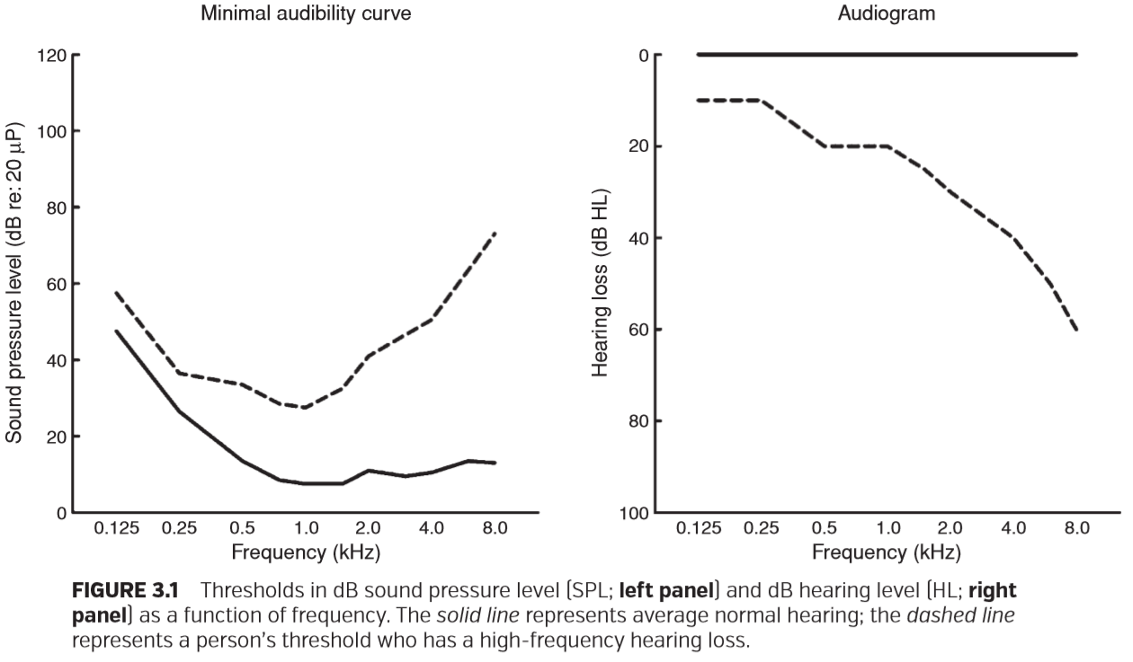

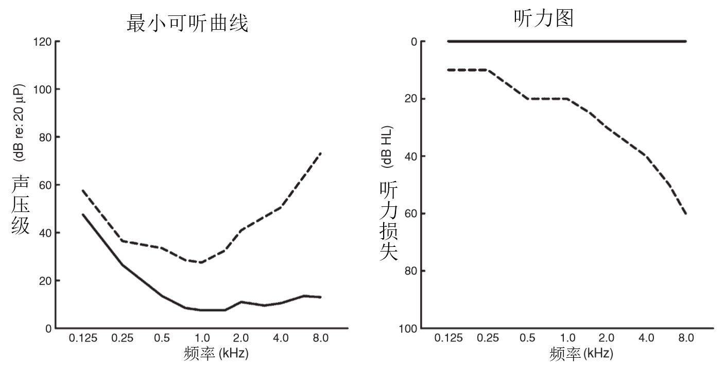

图3.1：以dB声压级（SPL；左图）和dB听力级别（HL；右图）的阈值与频率的函数关系图。实线代表平均正常听力；虚线表示具有高频听力损失的人的阈值。

### WHY PURETONE THRESHOLDS?

为什么是纯音阈值？

The reader might be wondering why audiologists use puretones at speciﬁc frequencies when the most meaningful stimulus is speech. Two important reasons are that PT thresholds provide information about the type of hearing loss, as well as quantify frequency-speciﬁc threshold elevations that result from damage to the auditory system.

读者可能想知道，为什么听力学专家在特定频率使用纯音，而最有意义的刺激是语音。 两个重要原因是纯音阈值提供了有关听力损失类型的信息，并且量化了由听觉系统受损导致的特定频率阈值升高多少。

PT thresholds provide quantiﬁcation of amount of loss due to problems with the outer and middle ear (the conductive system) separately from the cochlea and the auditory nerve (the sensory/neural system). This distinction helps in the diagnosis and guides audiologists and physicians with important details for providing treatment strategies.

纯音阈值提供了外耳和中耳（传导系统）不同于耳蜗和听神经（感音/神经系统）所导致的损失量的量化。这种区别在诊断和指导方面有助于为听力师和医生提供有关治疗策略的重要细节。

Damage to the auditory system often results in a loss of sensitivity that is frequency speciﬁc. For instance, changes in the stiffness and mass properties of the middle ear affect the relative amount of loss in the low and high frequencies (Johanson, 1948). For air-conduction thresholds, an increase in stiffness results in a greater low-frequency loss, whereas an increase in mass results in a greater loss in the high frequencies. Thresholds for puretones (or other narrowband sounds) also provide us with diagnostic information about the integrity of different channels in the sensory/neural pathway. The auditory system is organized tonotopically (i.e., a frequency-to-place mapping) from the cochlea to the cortex. The tonotopic organization of the cochlea is a result of the frequency tuning of the basilar membrane, with high frequencies represented at the basal end and low frequencies at the apical end. Damage to sensory cells of the cochlea at a speciﬁc place along the basilar membrane can result in a loss of hearing that corresponds to the frequencies coded by that place. For this reason, PT threshold tests provide details that would otherwise remain unknown if a broadband stimulus such as speech were used.

听觉系统的损伤通常会导致特定频率的灵敏度下降。例如，中耳硬度和质量特性的变化会影响低频和高频的相对损失量（Johanson, 1948）。对于空气传导阈值，硬度的增加导致更大的低频损耗，而质量的增加导致更大的高频损耗。纯音（或其他窄带声音）的阈值也为我们提供了关于感音/神经通路中不同通道完整性的诊断信息。听觉系统是从耳蜗到皮质的以拓扑方式组织的（即，频率到位置的映射）。耳蜗的拓扑组织是基底膜频率调谐的结果，在基底端表现为高频，在顶端表现为低频。耳蜗基底膜上某一特定位置的感觉细胞受损，会导致与该位置编码频率相对应的听力的丧失。由于这个原因，纯音阈值测试提供了一些细节，如果使用语音等宽带刺激，这些细节将不得而知。

In addition to providing audiologists with critical diagnostic information about the amount and type of loss, PT thresholds ﬁnd applications (1) for estimating the degree of handicap, (2) as a baseline measure for hearing conservation programs, (3) for monitoring changes in hearing following treatment or progression of a disease process, (4) for screening for hearing loss, (5) for determining candidacy for a hearing aid or a cochlear implant, and (6) for selecting the frequency-gain characteristics of a hearing aid. PT thresholds also provide a reference level for presentation of suprathreshold speech testing and for the meaningful interpretation of other audiologic tests, such as evoked otoacoustic emissions and acoustic reﬂex thresholds. PT thresholds are also used to assess the functional attenuation of hearing protection devices.

除了向听力师提供关于损失数量和类型的关键诊断信息之外，纯音阈值还应用于：（1）评估残障的程度，（2）作为听力保护计划基线测量，（3）用于监测治疗或疾病进展后的听力变化，（4）听力损失的筛查，（5）确定助听器或人工耳蜗的候选资格，（6）选择助听器的频率增益特性。纯音阈值还为阈上语音测试的呈现提供了参考，并为其他听力测试（如诱发耳声发射和声反射阈值）的有意义解释提供了参考。纯音阈值也被用来评估听力保护装置功能的衰减。

### TUNING FORK TESTS

音叉试验

A struck tuning fork produces a sustained puretone that decays in level over time. Unlike an audiometer, tuning forks cannot present a calibrated signal level to a listener’s ear. Despite this shortcoming, tuning fork tests provide qualitative information that can help determine whether a hearing loss is conductive or sensory/neural. Tuning fork tests are promoted by some as an important supplement to puretone audiometry. In a recently published book, otologists are advised to include tuning fork tests as an integral part of the physical examination for conductive hearing loss(Torres and Backous, 2010).

被敲击的音叉产生持续的纯音，其音量会随着时间的推移而衰减。与听力计不同，音叉不能向听者耳朵提供经过校准的信号。尽管有这个缺点，音叉测试提供的定性的信息可以帮助确定听力损失是传导性的还是感音/神经性的。一些人提倡使用音叉测试作为纯音测听的重要补充。在最近出版的一本书中，耳科医生被建议将音叉测试纳入传导性听力损失的体检中（Torres and Backous, 2010）。

The two best known tuning fork tests are the Weber and Rinne. Judgments about the type of hearing loss are made by comparing the pattern of results on both tests. Air conduction (AC) is tested by holding the tuning fork at the opening of the ear canal, and bone conduction (BC) is tested by placing the tuning fork on the mastoid process (the bony area behind the pinna) or on the forehead or incisors (British Society of Audiology, 1987). For the Weber test, a client judges whether sound is perceived in one or both ears when the tuning fork is placed on the forehead. For the Rinne test, the client judges whether sound is louder when presented by AC or by BC. Ideally, conductive hearing losses produce a pattern of responses that is uniquely different from the one for sensory/neural hearing losses. In the Weber, the sound is lateralized to the poorer ear with a conductive loss and to the better ear for a sensory/neural loss. In the Rinne, the sound is louder by BC in a conductive loss and by AC with a sensory/neural loss.

最著名的两个音叉试验是韦伯试验和林纳试验。通过比较两种测试结果来判断听力损失的类型。空气传导（AC）通过将音叉放在耳道口进行测试，骨传导（BC）通过将音叉放在乳突（耳廓后的骨质区域）或前额或门牙上进行测试（英国听力学学会，1987）。在韦伯测试中，当音叉放在前额上时，受试者判断是单耳还是双耳感知到声音。在林纳试验中，受试者判断是AC还是BC感知的声音更大。理想情况下，传导性听力损失会产生一种不同于感官/神经性听力损失的反应模式。在韦伯试验中，在传导性聋中声音偏向差耳，在感音/神经性聋中偏向好耳。林纳试验中，在传导性损失下，骨导感知的声音更大，在感觉/神经性损失下，气导感知的声音更大。

Some recommend tuning fork tests to check the validity of audiograms (Gabbard and Uhler, 2005) or to conﬁrm the audiogram before conducting ear surgery (Sheehy et al., 1971). However, it is important to recognize that tuning fork tests administered to people with known conductive losses have shown that these procedures are often inaccurate (Browning, 1987; Snyder, 1989). Although only about 5% of people with normal hearing or sensory/neural losses are falsely identiﬁed as having conductive losses with the Rinne test, this test misses many people with signiﬁcant conductive losses (Browning, 1987), including 50% of losses that have 20-dB air–bone gaps. The Weber test fares equally poorly. Browning (1987) reports that a majority of children with conductive losses give inappropriate responses on the Weber test. From these and other studies, one must conclude that tuning fork tests are not a replacement or even a supplement to audiometry. Audiometry is capable of identifying nearly 100% of air–bone gaps, as small as 15 dB.

有人建议使用音叉试验来检查听力图的有效性（Gabbard and Uhler, 2005），或者在进行耳外科手术前确认听力图的有效性（Sheehy et al.， 1971）。然而，重要的是要认识到，对已知传导性损伤的人进行的音叉试验表明，这些往往是不准确的（Browning, 1987;斯奈德,1989）。虽然只有大约5%的听力正常或感觉/神经损失的人通过林纳试验被错误地识别为传导性损失，但是这个测试遗漏了许多有显著传导性损失的人（Browning, 1987），包括其中50%的有20分贝气骨间隙的损失。韦伯试验的表现同样糟糕。Browning（1987）报告说，在韦伯试验中，大多数有传导性损失的儿童给出了不恰当的反应。从这些研究和其他研究中，我们必须得出这样的结论：音叉试验不是听力测试的替代品，甚至不是它的补充。听力测定能够识别几乎100%的气骨间隙，最小可达15分贝。

### PURETONE AUDIOMETRY

纯音测听

Audiometers are used to make quantitative measures of AC and BC PT thresholds. AC thresholds assess the entire auditory pathway and are usually measured using earphones. When sound is delivered by an earphone, the hearing sensitivity can be assessed in each ear separately. BC thresholds are measured by placing a vibrator on the skull, with each ear assessed separately, usually by applying masking noise to the nontest ear. The goal of BC testing is to stimulate the cochlea directly, thus bypassing the outer and middle ears. A comparison of AC and BC thresholds provides separate estimates of the status of the conductive and sensory/neural systems. If thresholds are elevated equally for sounds presented by AC and BC, then the outer and middle ear are not contributing to a hearing loss. By contrast, if thresholds are poorer by AC than by BC, then the source of at least some of the loss is the outer or middle ear. Figure 3.2 illustrates the AC and BC pathways and how hearing thresholds are typically affected by damage to these structures. See Chapter 4 for a complete review of BC assessment.

听力计用于定量测量空气传导和骨传导纯音阈值。空气传导阈值评估整个听觉通路，通常使用耳机测量。当通过耳机发出声音时，可以分别在每只耳朵中评估听觉灵敏度。骨传导阈值通过在颅骨上放置振动器来测量，每个耳朵单独评估，通常是通过对非测试耳施加掩蔽噪声来测量。骨传导测试的目标是直接刺激耳蜗，从而绕过外耳和中耳。空气传导和骨传导阈值的比较提供了对传导和感音/神经系统状态的分别评估。如果空气传导和骨传导所呈现的声音阈值同等升高，则外耳和中耳不会导致听力损失。相反，如果空气传导的阈值比骨传导的阈值更差，那么至少一些损失来自外耳或中耳。图3.2显示了空气传导和骨传导通路以及听力阈值如何受到这些结构损伤的影响。有关骨传导评估的完整回顾，请参见第4章。

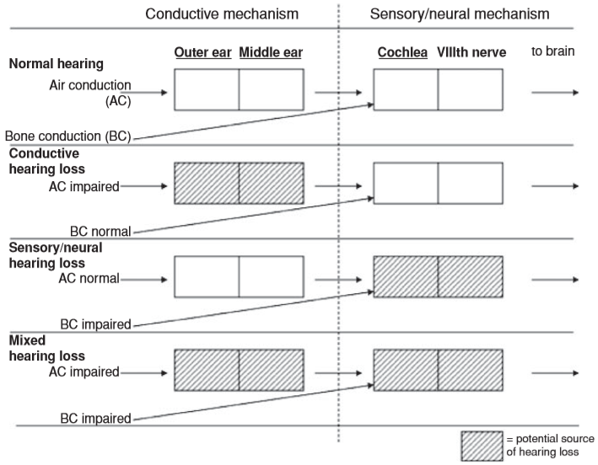

FIGURE 3.2 Conductive and sensory/ neural pathways. (Adapted from Martin (1994))

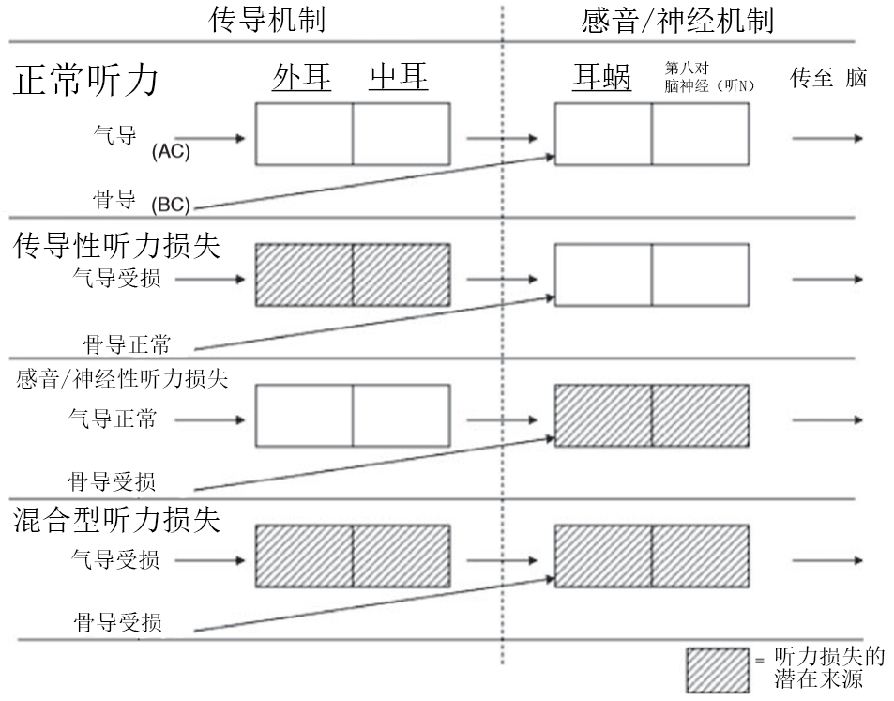

图3.2传导通路和感觉/神经通路。（改编自Martin (1994)）

**Equipment**

设备

**AUDIOMETERS**

听力计

Puretones are generated within an audiometer. Audiometers have the ability to select tonal frequency and intensity level and to route tones to the left or right earphone. All audiometers also have an interrupter switch that presents the stimulus to the examinee. The American National Standards Institute (ANSI) Speciﬁcation for Audiometers (ANSI, 2010) describes four types of audiometers, with Type 1 having the most features and Type 4 having the fewest features. A Type 1 audiometer is a full-featured diagnostic audiometer. A Type 1 audiometer has earphones, bone vibrator, loud speakers, masking noise, and other features. A Type 4 audiometer is simply a screening device with earphones, but none of the other special features.

纯音是在听力计中产生的。听力计能够选择音调频率和强度级别，并将音调传送到左耳机或右耳机。所有听力计也有一个断续开关，向受检者提供刺激。美国国家标准协会（ANSI）中听力计的规范（ANSI，2010年）描述了四种类型的听力计，类型1功能最多，类型4功能最少。1型听力计是一种功能齐全的诊断听力计。1型听力计具有耳机、骨振动器、扬声器、掩蔽噪音和其他功能。4型听力计只是一种带有耳机的筛选设备，不具有其他特殊功能。

Type 1 (full-featured, diagnostic audiometer) has the ability to assess puretone AC thresholds for frequencies ranging from 125 to 8,000 Hz and BC thresholds for frequencies ranging from 250 to 6,000 Hz. If an audiometer has extended high-frequency capability, air-conduction thresholds can be extended to 16,000 Hz. Maximum output levels for AC testing are as high as 120 dB HL for frequencies where hearing thresholds are most sensitive. By contrast, distortion produced by bone oscillators at high intensities limits maximum output levels for BC thresholds to values nearly 50 dB lower than those for AC thresholds for the same frequency.

类型1（功能齐全的诊断听力计）能够评估125至8000 Hz频率的纯音气导阈值和250至6000 Hz频率的骨导阈值。如果听力计具有扩展的高频能力，则气导阈值可以扩展到16,000 Hz。 在听力阈值最敏感的频率范围内，气导测试的最大输出水平高达120 dB HL。相比之下，骨振动器在高强度下产生的失真将骨导阈值的最大输出限制在比相同频率下气导阈值的输出低近50 dB。

**TRANSDUCERS**

换能器

**Earphones**

耳机

Earphones are generally used to test puretone AC thresholds. A pair of supra-aural earphones is illustrated in Figure 3.3. For decades, supra-aural earphones, ones in which the cushion rests on the pinna, were the only choice for clinical audiology. The popularity of supra-aural phones was mainly due to their ease of calibration and the lack of other types of commercially available earphones. In the past few years, insert earphones and circumaural earphones have become available and provide some useful applications for puretone assessment.

耳机通常用于测试纯音气导阈值。图3.3显示了一对压耳式耳机。几十年来，压耳式耳机（耳垫放在耳廓上）是临床听力学的唯一选择。压耳式耳机之所以受欢迎，主要是因为它们易于校准，而且缺乏可商用的其他类型耳机。在过去的几年中，插入式耳机和耳罩式耳机已经面世，并应用于纯音评估。

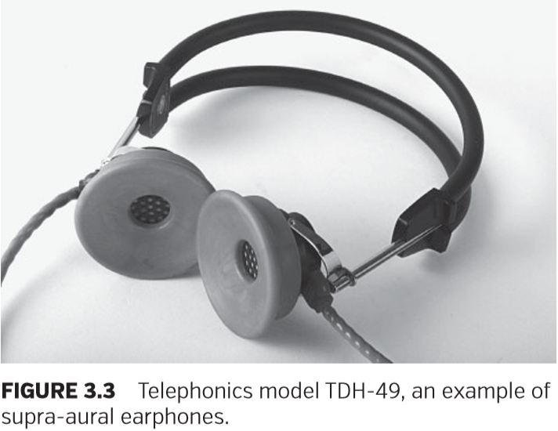

图3.3 TDH-49型，一种压耳式耳机

Insert earphones are coupled to the ear by placing a probe tip, typically a foam plug, into the ear canal. The commercially available model that has a standardized calibration method for audiology is the Etymotic model ER-3A, which is illustrated in Figure 3.4. These earphones have gained popularity in the past few years because they offer distinct advantages over supra-aural earphones. One major advantage is that insert earphones yield higher levels of interaural attenuation than supra-aural earphones (Killion and Villchur, 1989). Interaural attenuation represents the decibel reduction of a sound as it crosses the head from the test ear to the nontest ear. The average increase in interaural attenuation is roughly 20 dB. This reduces the need for masking the nontest ear and decreases the number of masking dilemmas, situations for which thresholds cannot be assessed, because the presentation level of the masking noise is possibly too high. (See Chapter 6 for a comprehensive review of masking.) Another important advantage of insert earphones over supra-aural earphones is lower test–retest variability for thresholds obtained at 6 and 8 kHz; variability for other frequencies is comparable. Given that thresholds for 6 and 8 kHz are important for documenting changes in hearing due to noise exposure and for identifying acoustic tumors, lower variability should increase the diagnostic precision. A third advantage that insert earphones offer is elimination of collapsed ear canals (Killion and Villchur, 1989). In about 4% of clients, supra-aural earphones cause the ear canal to narrow or be closed off entirely when the cushion presses against the pinna, collapsing the ear canal (Lynne, 1969), resulting in false hearing thresholds, usually in the high frequencies (Figure 3.5) (Ventry et al., 1961). Because insert earphones keep the ear canal open, collapsed canals are eliminated. A fourth advantage of insert earphones is that they can be easily used with infants and toddlers who cannot or will not tolerate supra-aural earphones. A ﬁfth advantage of insert earphones is the option of conducting middle-ear testing and otoacoustic emission testing without changing the earphones; some recently introduced diagnostic instruments use this approach. Although insert earphones offer a hygienic advantage over supra-aural earphones, because the foam tips that are placed into a client’s ear canal are disposable, the replacement cost of those tips is prohibitive for many applications. In addition to higher costs, insert earphones also yield errant thresholds in persons with eardrum perforations, including pressure-equalization tubes (Voss et al., 2000). (See Figure 3.12 for additional information about perforations.) Insert earphones also have maximum output levels that are lower than those produced by supra-aural earphones for some frequencies. Because of these differences, many diagnostic clinics keep both earphone types on hand and switch between them depending on the application.

插入式耳机通过将探头尖端（通常是泡沫塞）插入耳道与耳朵相连。通过听力学标准化校准方法的市售模型是etymotic模型ER-3a，如图3.4所示。这种耳机在过去几年里很受欢迎，因为它们比压耳式耳机有明显的优势。一个主要优点是插入式耳机比压耳式耳机具有更高的耳间衰减（Killion和Villchur，1989年）。耳间衰减代表声音从测试耳穿过头部到非测试耳时的分贝衰减。耳间衰减平均增加约20dB。这减少了掩蔽非测试耳朵的需求，并减少了掩蔽困境的数量，这种困境是无法评估阈值的情况，因为掩蔽噪声程度可能太高。（有关掩蔽的全面回顾，请参阅第6章。）。与压耳式耳机相比，插入式耳机的另一个重要优点是，在6k和8 kHz处测得的阈值的复测变异性较低；其他频率的变异性的可比较的。鉴于6和8 kHz的阈值对于记录噪声暴露引起的听力变化和识别听神经瘤非常重要，较低的变异性可提高诊断精度。插入耳机提供的第三个优点是消除耳道塌陷（Killion和Villchur，1989年）。在约4%的试验者中，当耳垫压在耳廓上时，压耳式耳机会导致耳道狭窄或完全关闭，使耳道塌陷（Lynne，1969），从而导致错误的听力阈值，通常为高频（图3.5）（Ventryet al.，1961）。由于插入耳机使耳道保持开放，从而消除了耳道塌陷。插入式耳机的第四个优点是，它可以很容易用于不能或不愿忍受压耳式耳机的婴幼儿。插入式耳机的第五个优点是可以在不更换耳机的情况下进行中耳测试和耳声发射测试；最近推出的一些诊断仪器使用这种方法。尽管插入式耳机与压耳式耳机相比更卫生，但由于放置在受试者耳道中的泡沫耳塞是一次性的，更换这些耳塞的成本对于许多机构来说是难以承受的。除了较高的费用外，插入式耳机还会对鼓膜穿孔的人产生错误的阈值，包括压力平衡管（Voss等人，2000年）。（有关穿孔的更多息，请参见图3.12。）在插入式耳机的最大输出也低于压耳式耳机在某些频率下的最大输出。由于这些差异，许多诊所保留了这两种耳机类型，并根据不同的应用情况在它们之间切换。

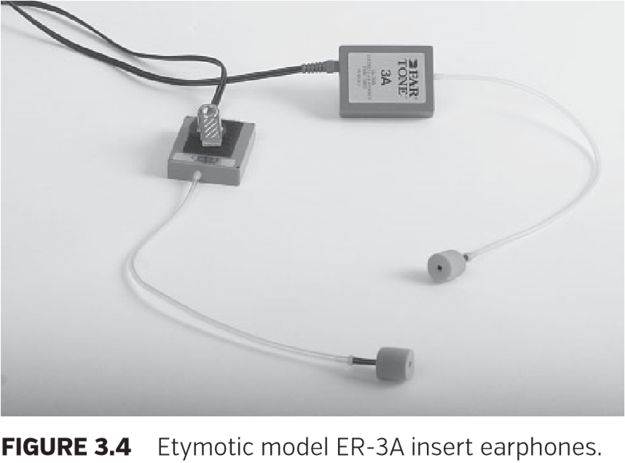

图3.4 Etymotic型号ER-3A插入式耳机

Circumaural earphones, a third type, have cushions that encircle the pinna. ANSI (2010) describes reference equivalent threshold SPL values (SPL values corresponding to 0 dB HL) for Sennheiser model HDA200 and Koss model HV/1A earphones. These earphones and the Etymotic ER-2 insert earphones are the only ones in the current standard that have reference values covering the extended high frequencies (8 to 20 kHz).

耳罩式耳机是第三种类型，具有环绕耳廓的垫子。 ANSI（2010）描述了Sennheiser型号HDA200和Koss型号HV / 1A耳机的参考等效阈值SPL值（对应于0dB HL的SPL值）。 这些耳机和Etymotic ER-2插入式耳机是目前标准中唯一具有覆盖扩展高频（8k至20 kHz）参考值的耳机。

Current standards for earphone calibration specify the level based on measures obtained with the earphone attached to an acoustic coupler or artiﬁcial ear. These couplers are designed to approximate the ear canal volume of an average person. Given that some clients (e.g., infants) have very small or very large ear canals (e.g., some postsurgical clients and persons with perforated eardrums), coupler measures may produce erroneous results, regardless of the earphone type (Voss et al., 2000; Voss and Herman, 2005). For these cases, measuring the SPL at the eardrum to specify the level presented to an individual patient would improve the accuracy of hearing thresholds. The probetube microphones necessary for these types of measures already exist, and hopefully, this technology will become routinely available for use in diagnostic audiometers (see Scheperle et al., 2011 for a discussion of calibration in the ear canal).

当前的耳机校准标准是根据耳机连接到声音耦合器或仿真耳上所获得的测量值来规定的。这些耦合器被设计成近似于一个普通人的耳道容积。考虑到一些受试者的耳道非常小（例如婴儿）或非常大（例如一些术后病人和耳膜穿孔的人），无论何种类型的耳机，耦合器测量都可能产生错误的结果（Voss等，2000; Voss和Herman，2005）。对于这些情况，测量鼓膜处给予个体患者的SPL将提高听力阈值的准确性。这类措施所需的探头麦克风已经存在，希望这项技术可以常规地用于诊断听力计（关于耳道校准的讨论，参见Scheperle等，2011）

**Speakers**

扬声器

AC thresholds can be measured using speakers as the transducer. Thresholds so obtained are known as sound-ﬁeld thresholds. Sound-ﬁeld thresholds are unable to provide ear-speciﬁc sensitivity estimates. In cases of unilateral hearing losses, the listener’s better ear determines threshold. This limitation and others dealing with control over stimulus level greatly limit clinical applications involving sound-ﬁeld thresholds. Applications for sound-ﬁeld thresholds are screening infant hearing or demonstrating to the parents their child’s hearing ability. Sound-ﬁeld thresholds may also be desirable for a person wearing a hearing aid or cochlear implant.

气导阈值可以用扬声器作为换能器来测量。这样获得的阈值称为声场阈值。声场阈值无法提供特定耳的灵敏度评估。在单侧听力丧失的情况下，听者较好的耳朵决定了阈值。这种局限性和有关其他刺激程度的控制极大地限制了涉及声场阈值的临床应用。声场阈值应用于筛查婴儿听力，或向父母展示其孩子的听力能力。对于配戴助听器或人工耳蜗的人来说，声场阈值也是可取的。

In sound-ﬁeld threshold measures, the orientation of the listener to the speaker has a large effect on stimulus level presented at the eardrum. A person’s head and torso as well as the external ear (e.g., pinna, ear canal, concha) affect sound levels (Shaw, 1974). Differences in SPL at the eardrum are substantial for speaker locations at different distances and different angles relative to the listener. For this reason, sound-ﬁeld calibration takes into consideration these factors. A mark is usually made on the ceiling (or ﬂoor) of the room to indicate the location of the listener during testing. Even at the desired location, stimulus level at the eardrum for some frequencies can vary as much as 20 dB or more by simply having the listener move his or her head (Shaw, 1974). Calibration assumes the listener will always be facing the same direction relative to the sound source (ANSI, 2010). Furniture and other persons in the sound ﬁeld also affect the stimulus level at a listener’s eardrum (Morgan et al., 1979). All of these factors add to the challenge of obtaining accurate sound-ﬁeld thresholds.

在声场阈值测试中，听者相对说话者的方位对呈现在鼓膜上的刺激程度有很大影响。一个人的头部和躯干以及外耳（如耳廓、耳道、耳蜗）都会影响声音程度（Shaw, 1974）。相对于听者不同距离和不同角度的扬声器位置，鼓膜声压级的差异是显著的。因此，声场校准要考虑这些因素。通常在房间的天花板（或地板）上做一个标记，以指示测试期间听者的位置。即使在理想的位置，只要听者移动他（她）的头，一些频率在鼓膜上的刺激程度可以变化多达20分贝或更多（Shaw, 1974）。校准假定的是听者始终面对与声源相同的方向（ANSI, 2010）。声场中的设备和其他人也会影响听者鼓膜的刺激程度（Morgan et al.， 1979）。所有这些因素都增加了获得准确声场阈值的难度。

Another important consideration in sound-ﬁeld threshold measures is the stimulus type. Thresholds corresponding to different frequencies are desired for plotting an audiogram, but puretones can exhibit large differences in level at different positions in a testing suite as a result of standing waves. Standing waves occur when direct sound from the speaker interacts with reﬂections, resulting in regions of cancellation and summation. Differences in stimulus level due to standing waves are minimized by using narrowband noise or frequency-modulated (FM) tones as the stimulus (Morgan et al., 1979). FM tones, also known as warbled tones, are tones that vary in frequency over a range that is within a few percent of the nominal frequency. This variation occurs several times per second. Under earphones, thresholds obtained with these narrowband stimuli are nearly identical to thresholds obtained with puretones, with some exceptions in persons with steeply sloping hearing loss conﬁgurations. FM tones and narrowband noise are the preferred stimuli for sound-ﬁeld threshold measures.

声场阈值测量中的另一个需要考虑的重要因素是刺激类型。不同频率对应的阈值最终绘制成听力图，但是纯音由于驻波的作用，在测试套件的不同位置可以表现出较大程度的差异。当扬声器直接发出的声音与反射相互作用时，就会产生驻波，从而导致抵消和叠加。通过使用窄带噪声或调频（FM）音调作为刺激最大限度地减少了驻波引起的刺激差异（Morgan等，1979）。FM音调，又称颤音，是指频率变化范围在额定频率的百分之几以内变化的音调。这种变化每秒发生数次。在耳机下，使用这些窄带刺激获得的阈值与使用纯音获得的阈值几乎相同，但对于听力损失严重的人来说有些例外。FM音调和窄带噪声是声场阈值测量的首选刺激。

**Bone Vibrators**

骨振动器

A bone vibrator is a transducer that is designed to apply force to the skull when placed in contact with the head. Puretone BC thresholds are measured with a bone vibrator like the one illustrated in Figure 3.6. A separation of 15 dB or more between masked AC and BC thresholds, with BC thresholds being lower than AC thresholds, is often evidence of a conductive hearing loss. Other possible explanations for air–bone gaps and bone–air gaps are equipment miscalibration, test–retest variability, and individual differences in anatomy that cause thresholds to deviate from the groupmean data used to derive normative values for relating AC and BC thresholds.

骨振动器是一种换成器，设计用于放置在头部向颅骨施加力。纯音骨导阈值是用骨振动器测量的，如图3.6所示。掩蔽的气骨导阈值之间存在15dB或更高的分离，且骨导阈值低于气导阈值，这通常是传导性听力损失的证据。气-骨间隙和骨-气间隙的其他可能解释是设备校准错误、复测变异性和个体解剖差异，这些因素导致阈值偏离气骨导阈值标准值。

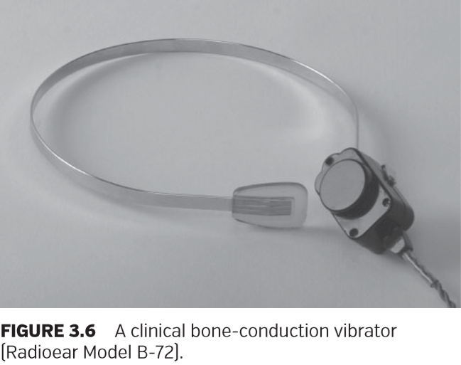

临床骨传导振动器（无线电耳型号B-72）。

For threshold measurements bone vibrators are typically placed behind the pinna on the mastoid process or on the forehead. Although forehead placement produces slightly lower intrasubject and intersubject threshold differences (Dirks, 1994), placement on the mastoid process is preferred by 92% of audiologists (Martin et al., 1998). Mastoid placement is preferred mainly because it produces between 8 and 14dB lower thresholds than forehead placement for the same power applied to the vibrator, depending on the frequency (ANSI, 2010). The median difference is 11.5 dB. Given that the maximum output limits for bone vibrators with mastoid placement are as much as 50 dB lower than that for AC thresholds, forehead placement yields an even larger difference. The inability to measure BC thresholds for higher levels means that a comparison of AC and BC thresholds is ambiguous in some cases. That is, when BC thresholds indicate no response at the limits of the equipment (e.g., 70 dB HL) and AC thresholds are poorer than the levels where no response was obtained (e.g., 100 dB HL), the audiologist cannot establish from these thresholds whether the loss is purely sensory/neural or whether it has a conductive component.

阈值测量时，骨振动器通常放置在耳廓后的乳突上或前额上。虽然前额放置会产生更小的主体内和主体间阈值差异（Dirks，1994），但92％的听力学家首选乳突位置（Martin等人，1998）。首选乳突放置是因为给振动器施加相同的力量，根据频率的不同，其测量出的阈值比前额放置低8到14 dB（ANSI，2010）。中间值为11.5 dB。考虑到乳突放置的骨振动器的最大输出限制比气导阈值低50 dB，前额放置会产生更大的差异。无法测量更高的BC阈值意味着在某些情况下气导和骨导阈值的比较是不明确的。也就是说，当骨导阈值显示在设备极限处无反应（如70dB HL），而气导阈值低于无反应处的骨导阈值（如100dB HL）时，听力学专家不能从这些阈值中确定损失仅仅是感音/神经性损失或是传导性损失。

**Test Environment**

测试环境

Hearing tests ideally are performed in specially constructed sound-treated chambers with very low background noise. A sound-treated room is not a sound-proof room. High-level external sounds can penetrate the walls of a sound-treated room and may interfere with test results. Because test tones near threshold can be easily masked by extraneous, external noise, test chambers have strict guidelines for maximum permissible ambient noise levels. Low background noise levels are particularly important for BC testing, when the ears remain uncovered. When testing is done in a room that meets the ANSI guidelines, the audiogram reﬂects that by citing ANSI S3.1 (1999), the standard governing permissible ambient noise levels. Table 3.1 shows the minimum levels of ambient noise measured in octave bands encompassing the test frequency that enable valid hearing threshold measurements at 0 dB HL.

理想的听力测试是在背景噪音非常低的特殊构造的声音处理室中进行的。声音处理室不是隔音室。高强度的外部声音可以穿透声音处理室的墙壁，并可能干扰测试结果。由于接近阈值的测试音调很容易被无关的外部噪声掩盖，因此测试室对最大允许周围环境噪声水平有严格的准则。当耳朵未遮盖时，低背景噪音水平对骨导测试尤其重要。当在符合ANSI准则的房间内进行测试时，听力图反映了标准管理所允许的周围环境噪声程度，准则引用的是ANSI S3.1（1999）。表3.1给出了在0 dB HL下有效听力阈值测量的测试频率范围内，以倍频音程测量的环境噪声的最低水平。

At times, audiologists must estimate hearing thresholds in rooms that do not meet the guidelines for minimal ambient noise. Some patients in hospital rooms or nursing homes must be tested at bedside. In those cases, test results should be clearly marked so that others know the conditions under which the test was done. When possible, these bedside tests should be performed using insert earphones, which provide a greater amount of attenuation in low frequencies where ambient noise is typically more of a problem. In these environments, BC testing, particularly in the low frequencies, may not be valid.

有时，听力师必须在不符合最低环境噪声准则的房间中评估听力阈值。一些住在病房或疗养院的病人必须在床旁接受检查。在这些情况下，应该清楚地标记测试结果，以便其他人知道测试是在什么条件下进行的。如果可能的话，这些床旁测试应该使用插入式耳机，这样在周围环境噪声是比较大的问题时，插入式耳机在低频处可以提供更大的衰减。在这些环境中，骨传导测试，尤其是在低频中，可能是无效的。

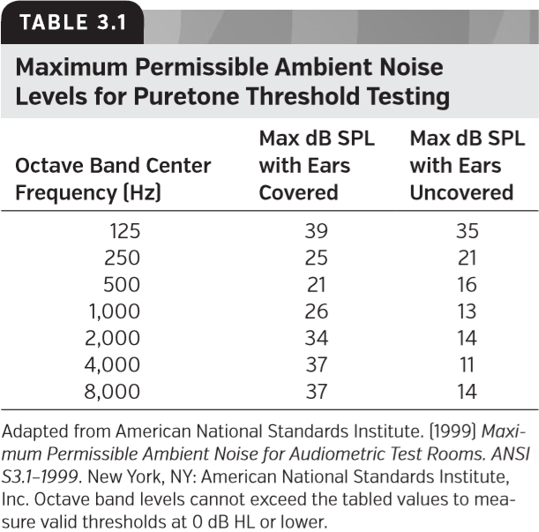

改编自美国国家标准学会。（1999年）听力测试室允许的最大周围环境噪声。ANSI S3.1-1999。纽约州纽约市：美国国家标准协会。在测量0 dB HL或更低的有效阈值时倍频音程级别不能超过列表值。

**Measuring Puretone Thresholds**

测量纯音阈值

Psychophysics is the ﬁeld of study that relates the physical world with perception. PT thresholds are an example of a psychophysical measure relating the physical characteristics of a tone to a behavioral threshold.

心理物理学是将物理世界与感知联系起来的研究领域。纯音阈值是一种将音调的物理特征与行为阈值联系起来的心理物理测量的例子。

A psychophysical procedure describes the speciﬁc method used to obtain behavioral thresholds. The most common one used in puretone audiometry is a modiﬁed method of limits. In the method of limits, the tester has control over the stimulus. A threshold search begins with the presentation of a tone at a particular frequency and intensity that is often speciﬁed by the procedure. After each presentation of the tone (or a short sequence of pulsed tones), the tester judges whether or not the listener heard it based upon the listener’s response or lack of response. Each response determines the subsequent dB-level presentation. If a tone on a given presentation is not heard, the tone level is raised. If a tone is heard, the level is lowered. The rules of the psychophysical procedure govern the amount of the level change following each response, when to stop the threshold search, and the deﬁnition of threshold. The procedure, which is described in detail in subsequent sections, may be modiﬁed slightly based on the clinical population (e.g., the age of the listener).

心理物理程序描述了获得行为阈值的具体方法。纯音测听最常用的方法是一种改进的限制法。在限制法中，测试者可以控制刺激。阈值搜索从特定频率和强度的音调开始，该频率和强度通常由程序指定的。在每一次音调的发出之后（或者是一小段脉冲音调序列），测试人员根据听者的反应与否来判断听众是否听到了它。每个反应决定了后续的db程度。如果没有听到给定的演示音调，则提高音调强度。如果听到音调，则降低强度。心理物理程序的规则控制了每个响应之后的程度变化量、何时停止阈值搜索以及阈值的确定。该过程可能会根据临床人群（例如，听者的年龄）稍作修改，将在后续章节中详细描述。

**COOPERATIVE LISTENERS AGE 5 YEARS TO ADULT (EARPHONES)**

5岁至成人受试者（耳机）

*Guidelines for Manual Pure Tone Audiometry* is a publication that describes a uniform method for measuring thresholds (American Speech-Language-Hearing Association [ASHA], 2005). The goal of the guideline is to minimize differences across clinics by standardizing procedures. The committee that drafted this consensus document understood that its recommendations represent general guidelines and that clinical populations may require variations of the procedure.

“人工纯音测听指南”是一份介绍测量听阈的统一方法的出版物（美国语言听力协会[ASHA]，2005年）。该指导方针的目标是通过标准化程序最大限度减少不同诊所间的差异。起草这份共识文件的委员会理解，其建议代表一般准则，临床人群可能工作时需要改变程序。

**Instructions**

说明

Puretone audiometry begins with instructing the individual being tested. The instructions are a critical part of the puretone test, because thresholds measured using this clinical procedure are biased by the willingness of a person to respond. Some listeners wait for a tone to be distinct before they respond, which leads to higher thresholds than for someone who responds whenever they hear any sound that could be the tone. This bias is controlled in the instructions by informing listeners to respond any time they hear the tone no matter how faint it may be. A study by Marshall and Jesteadt (1986) shows that response bias controlled for in this manner plays only a small role (a few dB at most) in PT thresholds obtained using the ASHA guideline. Marshall and Jesteadt (1986) also reported that the response bias of elderly listeners was not different than that of a group of younger persons. Before the study by these authors, it was believed that elderly persons might adopt an extremely conservative response criterion, resulting in artiﬁcially elevated thresholds compared to those of younger persons.

纯音测听是从指导被测试者开始。“指导”是纯音测试的一个关键部分，因为使用这一临床程序测量的阈值会因一个人的反应意愿而产生偏差。有些听者会等待清晰的音调才会做出反应，这会导致其反应阈值都要高于那些在听到任何可能是音调的声音都作出反应的人的阈值。这种偏差可以在指导中控制，只要听到音调，无论多么微弱，都要作出反应。Marshall和Jestet（1986）的一项研究表明，以这种方式控制的反应偏差在使用ASHA准则做出的纯音阈值中只起到很小的作用（最多几dB）。Marshall和Jestet（1986）报告还提到，老年人的反应偏差与一组年轻人的反应偏差没什么不同。在这些作者的研究之前，人们认为老年人可能会采用一个非常保守的反应标准，与年轻人相比，这会导致阈值明显升高。

According to the ASHA (2005) guideline, the instructions should also include the response task (e.g., raise your hand or ﬁnger, or press a button), the need to respond when the tone begins and to stop responding when it ends, and that the two ears are tested separately. Although not in the ASHA guideline, instructions asking the examinee to indicate which ear the sound is heard in may be useful. This is especially important in cases of unilateral or asymmetrical hearing losses where cross-hearing is possible.

根据ASHA（2005）的指南，指导还应该包括响应任务（例如，举起你的手或手指，或按下一个按钮），当音调开始时作出响应和结束时停止响应，以及两个耳朵分别测试。虽然ASHA指南中没有记录，但是“指导”要求被试者指出在哪个耳朵里听到声音可能是有帮助的。这在可能发生交叉听力的单侧或非对称听力损失的情况下尤为重要。

The examiner should present the instructions prior to placement of earphones. Earphones attenuate external sounds making speech understanding more difﬁcult, particularly for persons with hearing loss. Listeners should also be queried after the instructions are presented to determine if they understood what was said. Sample instructions are given below:

检查者应在放置耳机前说明。带上耳机会使外界声音变弱，使语音理解更加困难，尤其对于有听力损失的人。在给出“指导”之后，还应该询问听者，以确定他们是否理解所讲的内容。示例说明如下：

You are going to hear a series of beeps, ﬁrst, in one ear and then in the other ear. Respond to the beeps by pressing the button [switch] when one comes on and release it as soon as it goes off. Some of the beeps will be very faint, so listen carefully and respond each time you hear one. Do you have any questions?

你会听到一系列的哔哔声，先是一只耳朵，然后另一只耳朵。当听到哔哔声时，按下【开关】按钮，声音消失时立即松开。有些哔哔声会非常微弱，所以要仔细听，每次听到哔哔声都要做出反应。你有什么问题吗？

**Earphone Placement**

耳机放置

The earphones should be placed by the examiner. For convenience, earphones are color coded; red and blue correspond to the right and left ears, respectively. Prior to placement of earphones, clients are asked to remove jewelry such as earrings and glasses if they will interfere with the placement of the earphone. This is particularly relevant for supra-aural earphones.

耳机应由检查者放置。为方便起见，耳机采用彩色编码；红色和蓝色依次对应右耳和左耳。在放置耳机之前，如果诸如耳环和眼镜之类首饰干扰耳机的放置，则要求受试者摘除。 这对于压耳式耳机尤为重要。

For circumaural and supra-aural earphones, the diaphragm of the earphone should be centered over the ear canal. The examiner should view each ear while the phone is being placed. Immediately after placement, the headband is tightened enough to make the earphone perpendicular to the ﬂoor when the examinee is sitting upright.

对于耳罩式耳机和压耳式耳机，耳机的振膜应位于耳道的中心位置。在放置耳机时，检查者应查看每只耳朵。放置完毕后，立即收紧头带，以便当考生直坐时，耳机垂直于地面。

The ﬁrst step in placement of insert earphones is to attach a spring-loaded clip that holds the transducer in place to the examinee’s clothing. The clip can be attached to clothing near the shoulder (or behind a child’s neck) to keep the plug from being pulled out of the ear. In some newer implementations that combine middle-ear and otoacoustic emission measurements, the earphone is attached to a headband. For both types of support, the audiologist compresses the foam plug and inserts it into the ear canal so that its outer edge lines up with the tragus.

插入式耳机放置的第一步是将附有弹簧夹的换能器固定在检查者的衣服上。这种夹子可以固定在靠近肩膀（或孩子脖子后面）的衣服上，防止耳塞从耳朵里拉出来。在一些结合中耳测量和耳声发射测量的较新型装置中，耳机附在头带上。对于这两种类型的设备，听力师压缩泡沫塞并将其插入耳道，使其外缘与耳屏对齐。

**Placement of the Bone-conduction Vibrator**

骨传导振动器的放置

Although some recommend forehead placement (Dirks, 1994), typically audiologists place the BC oscillator on the most prominent part of the mastoid process. While holding the oscillator against the mastoid process with one hand, the headband is ﬁt over the head to hold the oscillator in place using the other hand. The oscillator surface should be set directly against the skin, not touching the pinna, and with no hair or as little hair as possible between the oscillator and the skin. Some audiologists play a continuous lowfrequency tone while moving the oscillator slightly side to side, asking the listener to report the location at which the tone is the strongest.

尽管有人建议前额放置（Dirks，1994），但通常听力师将骨传导振动器置于乳突最突出的部位。用一只手将振荡器固定在乳突上，头带戴在头上，另一只手将振动器固定在适当的位置。振动器表面应直接贴在皮肤上，不要接触耳廓，并且在振荡器和皮肤之间不要有毛发或尽可能少的毛发。一些听力专家在轻轻左右移动振荡器的同时播放连续的低频音调，要求听者报告音调最强的位置。

**Audiometric Procedure for Threshold Measurement**

听阈测量程序

The ASHA Guideline (2005) recommends starting a threshold search from either well below threshold or using a suprathreshold tone that familiarizes the participant with the stimulus. Most clinicians prefer the familiarization method. For the familiarization approach, testing usually begins at 1,000 Hz at 30 dB HL unless prior knowledge of the examinee’s hearing suggests otherwise (ASHA, 2005). At 1,000 Hz, an examinee is more likely to have residual hearing than at a higher frequency, and test–retest reliability is excellent. Testing begins with an examinee’s self-reported better ear. If the examinee believes both ears are identical, testing begins by convention with the right ear. The better ear is tested ﬁrst to provide a reference to know whether masking needs to be delivered to obtain a valid estimate of threshold for the poorer ear.

ASHA指南（2005）建议从低的阈值或使用听者熟悉刺激的阈上音调开始阈值搜索。大多数临床医生更喜欢“熟悉性”的方法。对于“熟悉性”方法，除非事先了解受试者的听力，否则测试通常从1000 Hz，30 dB HL开始（ASHA，2005）。受试者在1,000 Hz比更高频率更容易出现残余听力，并且复测可靠性好。测试从受试者自我感觉听力更好的耳朵开始。如果受检者认为双耳听力是相同的，则按照惯例从右耳开始测试。首先对较好的耳朵进行测试，以提供一个参考，了解是否需要提供掩蔽以获得对差耳阈值的有效评估。

Tonal duration is an important factor in a puretone test. On most audiometers, the option exists to select either pulsed or manual presentation. A 1- to 2-second duration tone is recommended for manual presentation (ASHA, 2005). The duration is determined by the amount of time the interrupter switch is held down. Pulsed tones are achieved by selecting this option on the audiometer’s front panel. If pulsed tones are selected, then the audiometer alternately presents the tone followed by a short silent interval (typically 225 ms on followed by 225 ms off) for as long as the interrupter switch is depressed. The minimum duration for a single pulse of the tone is critical. Numerous psychoacoustic studies have shown that tonal durations between roughly 200 ms and 1 second or more yield nearly identical thresholds (Watson and Gengel, 1969). By contrast, the same studies show that durations less than 200 ms result in higher thresholds. For this reason, audiometers are designed to have a nominal pulse duration of 225 ms (ANSI, 2010). Pulsed and manually presented tones presented from audiometers that maintain tonal durations between 200 ms and 2 seconds yield nearly identical thresholds, as the psychoacoustic studies suggest. However, pulsed tones are preferred for two reasons. Most patients prefer pulsed tones (Burk and Wiley, 2004), and pulsed tones also reduce the number of presentations required to ﬁnd threshold in persons with cochlear hearing loss who have tinnitus (Mineau and Schlauch, 1997). Apparently, pulsed tones help patients to distinguish the puretone signal from the continuous or slowly ﬂuctuating noises generated from within their auditory system (tinnitus), thereby reducing false-positive responses. False-positive responses can lengthen test time (Mineau and Schlauch, 1997), which is costly to an audiology practice.

音调持续时间是纯音测试中的一个重要因素。在大多数听力计上，可以选择脉冲或手动演示。1到2秒的持续音调被建议于手动演示时使用（ASHA，2005）。持续时间由中断开关按下的时间长短确定。脉冲音调是通过在听力计的前面板上选择此选项来实现的。如果选择脉冲音调，则只要按下中断开关，听力计就会交替呈现音调和一个短的无声间隔。（通常为225毫秒打开，然后225毫秒关闭）。音调的单一脉冲的最短持续时间至关重要。大量的心理声学研究表明，大约200毫秒到1秒或更长时间的音调持续时间产生几乎相同的阈值(Watson和Gengel，1969)。相反，同样的研究表明，小于200ms的持续时间会导致更高的阈值。因此，听力计的额定脉冲持续时间为225毫秒（ANSI，2010年）。心理声学研究表明，由听力计呈现的脉冲和手动呈现的音调在200毫秒到2秒之间产生几乎相同的阈值。然而，首选脉冲音有两个原因。大多数患者更喜欢脉冲音调（Burk和Wiley，2004年），脉冲音调也减少了患有耳鸣的耳蜗性听力损失患者找到阈值所需的呈现次数（Mineau和Schlauch，1997年）。显然，脉冲音调可以帮助患者区分纯音信号和听觉系统（耳鸣）中产生的持续或缓慢的噪声，从而减少假阳性反应。假阳性反应会延长测试时间(Mineau和Schlauch，1997)，这对听力学实践来说代价很高。

Thresholds typically are obtained using a modiﬁed Hughson–Westlake down-up procedure, which is a speciﬁc implementation of a method-of-limits procedure (Carhart and Jerger, 1959; Hughson and Westlake, 1944). The examiner begins the threshold-ﬁnding procedure by presenting a tone at 30 dB HL (ASHA, 2005). If the listener responds, the level of the tone is decreased in 10-dB steps until the listener no longer responds. If the listener does not respond to this initial 30-dB tone, the examiner raises the tone in 20-dB steps until a response is obtained. After every response to a tone, the level of the tone is decreased in 10-dB steps until there is no response. For subsequent presentations when there is no response, the examiner raises the level of the tone in 5-dB steps until a response is obtained. Following this “down-10/up-5” rule, the tester continues until the threshold is bracketed a few times, and a threshold estimate is obtained. ASHA (2005) recommends that threshold should correspond to the level at which responses were obtained for two ascending runs, which is what most clinicians based their thresholds on even when the ASHA (1978) Guideline recommended that thresholds be based on three ascending runs. Research based on computer simulations of clinical procedures (Marshall and Hanna, 1989) supports the clinician’s position and that of the ASHA (2005) guideline. The computer simulations of thresholds based on three ascending runs showed only a minimal reduction of the variability when compared to thresholds based on two ascending runs. Listeners who produce inconsistent responses are an exception, and for these listeners, additional measurements can be made to conﬁrm the threshold estimate.

阈值通常是使用修改后的HW升降法获得的，该过程是限制法的具体实现（Carhart and Jerger，1959；Hughson and Westlake，1944）。测试者通过30dBHL的音调开始阈值测试过程（Asha，2005年）。如果受试者响应，则音调以每次10dB降低，直到受试者不再响应。如果听者对最初的30分贝音调没有反应，则检查者以每次20dB提升音调，直到出现响应。在对音调的每次响应之后，音调以每次10dB降低，直到没有响应。对于没有响应的情况下，检查者以每次5dB提升音调，直到获得响应。在该“降10 /升5”规则之后，测试继续，直到阈值被大致测到几次，并获得阈值评估值。ASHA（2005）建议阈值应该对应于两次上升时的响应的水平，这是大多数临床医生基于的阈值，即使ASHA（1978）指南建议阈值基于三次上升时的响应的水平。基于计算机模拟临床程序的研究（Marshall和Hanna，1989）支持临床医生的立场和ASHA（2005）指南的立场。基于三次上升运行的阈值的计算机模拟显示，与基于两次上升运行的阈值相比，只有很小的降低。产生不一致响应的受试者是一个例外，对于这些受试者，可以进行额外的测量以确定阈值评估值。

After a threshold is measured at 1,000 Hz, the next frequencies that are examined depend on the goal, but the higher frequencies are typically tested prior to the lower frequencies. For diagnostic audiometry, thresholds are measured at octave intervals between 250 and 8,000 Hz, along with 3,000 and 6,000 Hz. Intra-octave thresholds between 500 and 2,000 Hz should be measured when thresholds differ by 20 dB or more between two adjacent octaves. ASHA (2005) also recommends that 1,000 Hz be tested twice as a reliability check. Refer to the ASHA (2005) guidelines for speciﬁcs about the recommended protocol and Chapter 6 for details about the use of masking noise to eliminate the participation of the nontest ear. Masking noise is needed whenever the threshold difference between ears is equal to or exceeds the lowest possible values for interaural attenuation. For BC testing, masking is needed to verify results anytime an air–bone gap in the test ear of greater than 10 dB is observed. For AC testing, masking is needed when the difference between the AC threshold in the test ear and the BC threshold of the nontest ear is greater than or equal to 40 dB for supra-aural earphones, and considerably more for insert earphones, especially in the low frequencies (Killion and Villchur, 1989). Speciﬁc recommendations for insert earphones cannot be made until a study with a larger sample size is completed.

在以1,000Hz测量阈值之后，下一个被检查的频率取决于所需目标，但是通常较高频率在较低频率之前测试。对于诊断听力测量，阈值测量的倍频音程在250至8，000赫兹之间，以及3，000和6，000赫兹。当两个相邻倍频音程之间的阈值相差20 dB或更多时，应测量500到2,000 Hz之间的半倍频程阈值。ASHA（2005）还建议将1000hz测试两次作为可靠性检查。有关使用掩蔽噪声消除非测试耳朵参与的详细信息，请参阅ASHA（2005）指南中的具体推荐方案和第6章的内容。只要两耳之间的阈值差等于或超过耳间衰减的最低可能值时，就需要施加掩蔽噪声。对于骨导测试，只要观察到测试耳中的气骨间隙大于10 dB，就需要进行掩蔽以验证结果。在气导测试中，使用压耳式耳机时，当测试耳的气导阈值与非测试耳的骨导阈值之间的差异大于或等于40dB时，需要掩蔽，对于插入式耳机，尤其是在低频时，掩蔽值要大的多（Killion和Villchur，1989）。在完成较大样本量研究之前，不能对插入式耳机做出具体建议。

**TESTING CHILDREN YOUNGER THAN AGE 5 YEARS AND PERSONS WITH SPECIAL NEEDS**

测试对5岁以下儿童及有特殊需要的人员

For most children younger than age 5 years, audiologists have special procedures that they employ to measure PT thresholds. Some of these same procedures are also appropriate for persons older than 5 years who have cognitive deficits. Chapter 24 on pediatric hearing assessment describes these procedures and their interpretation.

对于大多数5岁以下的儿童，听力学家采用特殊方法来测量纯音阈值。其中一些同样的方法也适用于5岁以上有认知缺陷的人。第24章描述了关于儿科听力评估程序及其解读。

**Audiometric Interpretation**

听力测定解读

PT thresholds are displayed in tabular or graphical formats. The tabular format is useful for recording the results of serial monitoring of thresholds, as in a hearing conservation program, but in many applications, thresholds are plotted on an audiogram. ASHA (1990), in a publication entitled Guidelines for Audiometric Symbols, suggests a standardized form for the audiogram. Although other formats for plotting audiograms are acceptable, it is helpful to use a standardized format for ease of interpretation across clinics. The audiogram consistent with that recommended in the ASHA guidelines (1990) is shown in Figure 3.7 along with recommended symbols. This audiogram only covers the conventional frequencies. Thresholds for extended high frequencies are plotted often in units of dB SPL, because average extended high-frequency thresholds vary over a wide range with the age of the listener, making dB SPL a better reference than dB HL for comparing thresholds to norms for listeners of different ages. Conversion between units of dB SPL and dB HL can be accomplished for three different earphone models by consulting reference levels published in ANSI (2010).

纯音阈值以表格或图形格式显示。表格格式对于记录连续监测阈值的结果很有用，就像在听力保护程序中一样，但在许多应用中，阈值被绘制在听力图上。ASHA（1990）在题为“听力符号指南”的出版物中提出了听力图的标准化格式。尽管使用其他格式绘制听力图也是可以接受的，但使用标准化格式以助于临床之间的解释。如图3.7展示了符合ASHA指南（1990）建议的听力图，并附有推荐符号。该听力图只包含常规频率。扩展高频的阈值通常以dB SPL为单位绘制，因为扩展高频的平均阈值随着受试者的年龄在变化范围很大，使得dB SPL比dB HL更适合于比较不同年龄的听者的常规阈值。通过参考ANSI（2010）中公布的参考数据，可以针对三种不同的耳机型号实现dB SPL和dB HL之间的转换。

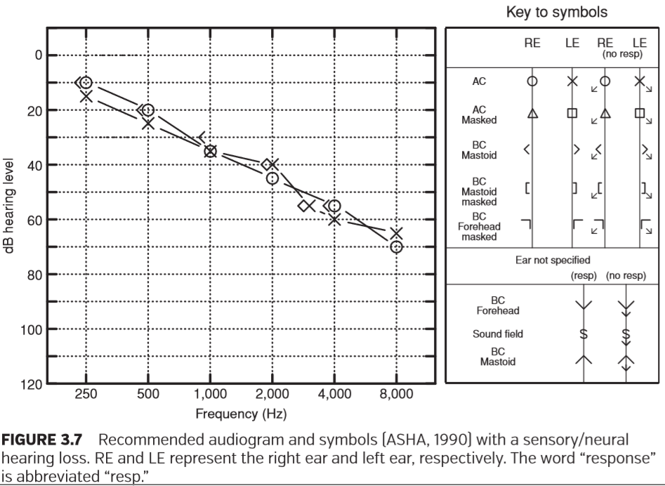

推荐的听力图和符号（Asha，1990），伴有感觉/神经听力损失。re和le分别代表右耳和左耳。“Response”一词缩写为“resp”。

Audiograms are often classiﬁed by categories based on the degree of hearing loss. A number of authors have published systems for classifying hearing loss based on the average AC thresholds for three frequencies. The frequencies used for this purpose are usually 500, 1,000, and 2,000 Hz, often referred to as the three-frequency puretone average (PTA). Table 3.2 shows the categories for the degree of loss based on this PTA for three different authors (Goodman, 1965; Jerger and Jerger, 1980; Northern and Downs, 2002). The ﬁrst category is normal hearing. Note that none of the three authors agree on the upper limit for normal, which ranges from 15 to 25 dB HL. Northern and Downs (2002) suggest using 15 dB HL as the upper limit for normal hearing for the three-frequency PTA for children between 2 and 18 years of age and a higher limit for adults. A 15 dB HL upper limit for normal hearing may produce a signiﬁcant number of false positives when applied to thresholds for individual audiometric frequencies, even in children (Schlauch and Carney, 2012). Regardless of the value used as an upper limit for normal hearing, keep in mind that an ear-related medical problem can still exist even though all thresholds fall within the deﬁned normal range. For example, the presence of a signiﬁcant air–bone gap might indicate the presence of middle-ear pathology even though all AC thresholds fall within normal limits.

听力图通常根据听力损失程度按类别分类。许多作者已经公布了基于三个频率的平均气导阈值对听力损失进行分类的系统。用到的频率通常为500,1,000和2,000Hz，通常称为三频纯音平均值（PTA）。表3.2给出了三个不同作者基于PTA的损失程度分类（Goodman，1965; Jerger和Jerger，1980; Northern和Downs，2002）。第一类是正常听力。请注意，三位作者均未就正常上限达成一致，范围为15至25 dB HL。 Northern和Downs（2002）建议使用15 dB HL作为2至18岁儿童的三频纯音平均值（PTA）的正常听力上限，成人使用较高上限。当应用于个别测听频率的阈值时，正常听力的上限15dbHL可能会产生大量的假阳性，即使在儿童中也是如此（Schlauch和Carney，2012）。不管用什么值作为正常听力的上限，请记住，即使所有阈值都在规定的正常范围内，与耳朵有关的医学问题仍然可能存在。例如，即使所有气导阈值都在正常范围内，但显著的气骨间隙可能表明存在中耳病变。

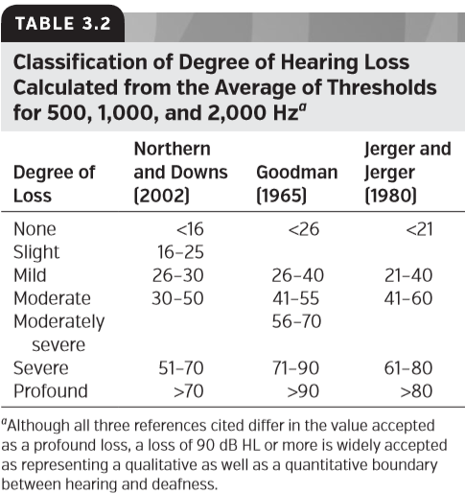

虽然所引用的三个参考文献在作为严重损失的接受值上有所不同，但90dB HL或更大的损失被广泛认为是听力和耳聋之间的定性和定量界限。

The original intent of classiﬁcation system for severity of loss based on a three-frequency PTA was to express, in a general way, the degree of handicap associated with the magnitude of the loss. These categories are only somewhat successful at achieving this goal, because (1) handicap is dependent on many factors related to an individual’s needs and abilities, (2) only some of the speech frequencies are assessed using this three-frequency average (speech frequencies range from 125 to 6,000 Hz), and (3) identical amounts of hearing loss sometimes result in large differences in the ability to understand speech and, as a consequence, the degree of disability associated with the loss. Despite these limitations, many audiologists use these categories routinely to summarize the amount of loss in different frequency regions of an audiogram when describing results to other professionals or to a client during counseling.

基于三频PTA的损失严重程度分级系统的最初目的是以一般方式表示与损失程度相关的障碍程度。这些类别只在一定程度上成功地实现了这一目标，因为（1）障碍取决于与个人需求和能力相关的许多因素，（2）只有部分语音频率是用这三个频率的平均值进行评估（语音频率在125至6，000 Hz之间），（3）相同数量的听力损失有时会导致理解语言能力的巨大差异，从而导致与听力损失相关的残疾程度。尽管有这些限制，但许多听力学家在向其他专业人员或咨询期间的客户描述结果时，经常使用这些类别来总结听力图不同频率区域的损失量。

Another factor in audiometric classiﬁcation is the type of hearing loss. The type of hearing loss is determined by comparing the amount of hearing loss for AC and BC thresholds at the same frequency. A sensory/neural hearing loss has an equal amount of loss for AC and BC thresholds (as shown in Figure 3.7). By contrast, a conductive loss has lower BC thresholds than AC thresholds (as shown in Figure 3.8). Conductive-loss magnitude is described by the decibel difference between AC and BC thresholds. This difference is known as the air–bone gap, a value that has a maximum of about 65 dB† (Rosowski and Relkin, 2001). Due to test–retest differences, an air–bone gap needs to exceed 10 dB before it is considered signiﬁcant. A mixed hearing loss shows a conductive component and a sensory/neural component. In other words, a mixed loss has an air–bone Classification gap, and the thresholds for BC fall outside the range of normal hearing (Figure 3.9).

听力损失分级的另一个因素是听力损失的类型。通过比较相同频率下气导和骨导阈值的听力损失量来确定听力损失的类型。感音/神经性听力损失中气导和骨导阈值具有相等的损失量（如图3.7所示）。相比之下，传导性听力损失中骨导阈值损失低于气导阈值（如图3.8所示）。传导损耗幅度是通过气导和骨导阈值之间的分贝差来描述。这种差异被称为气骨间隙，最大值约为65 dB（Rosowski和Relkin，2001）。由于复测的差异，气骨间隙需要超过10 dB才被认为是显著的。混合性听力损失包含传导性成分和感觉/神经性成分。换句话说，混合损失具有气骨间隙，并且骨导的阈值在正常听力范围之外（图3.9）。

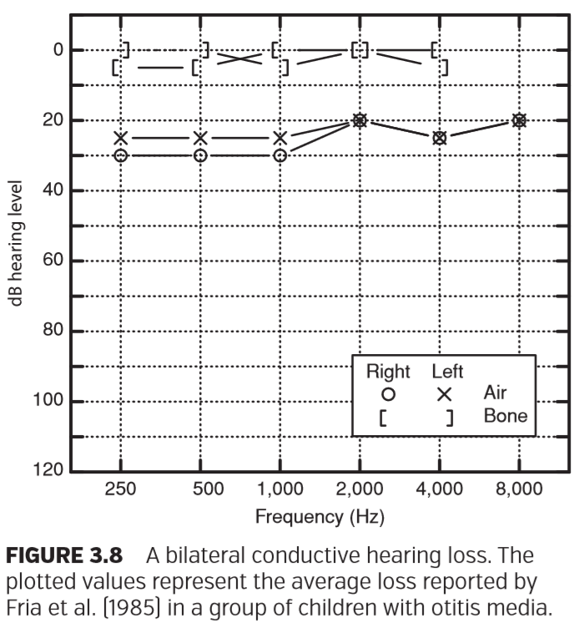

图3.8 双侧传导性听力损失。这些标绘值代表Fria等人（1985）在一组中耳炎儿童报告中的平均损失。

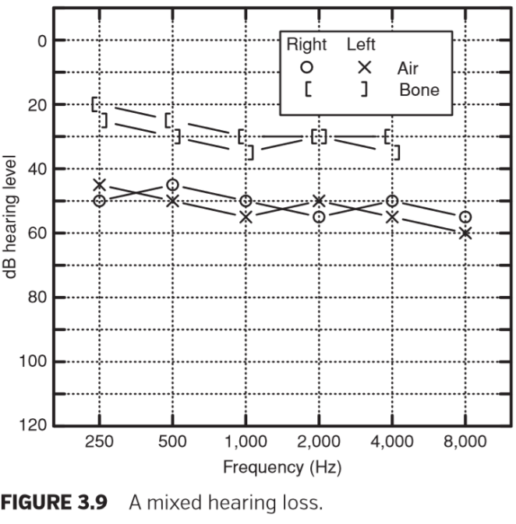

图3.9 混合型听力损失

Yet another way that audiograms are described is by the hearing-loss conﬁguration. The conﬁguration takes into account the shape of the hearing loss. A description of the conﬁguration of the loss helps in summarizing the loss to patients and to other professionals and often provides insight into the etiology or cause of the loss. Some typical shapes and the criteria used to describe them are shown in Table 3.3.

描述听力图的另一种方式是听力损失结构。该结构考虑了听力损失的形状。对损失结构的描述有助于对患者和其他专业人员的不足进行总结，并常常有助于了解损失的病因或原因。表3.3显示了一些典型的形状和用于描述它们的标准。

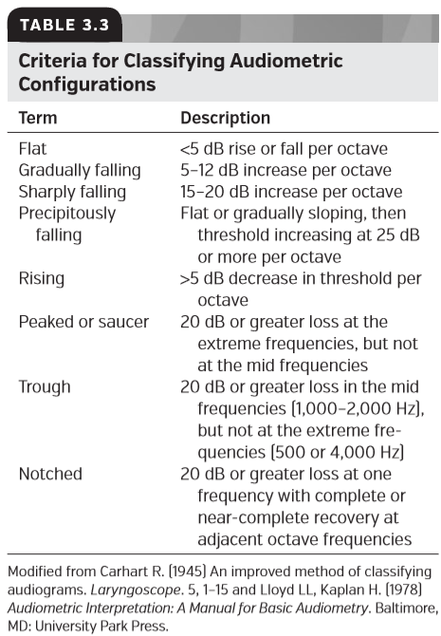

据Carhart R.(1945) 改编，一种改进的听力图分类方法。《喉镜》5,1 - 15和Lloyd LL, Kaplan H.(1978)《听力判读:基础听力手册》。马里兰州巴尔的摩市:大学公园出版社。

An audiogram is summarized verbally by the degree, type, and conﬁguration of the hearing loss for both ears. If a person has normal thresholds in one ear and a hearing loss in the other ear, this is known as a unilateral hearing loss. A loss in both ears is described as a bilateral hearing loss. Bilateral losses are described as symmetric (nearly equal thresholds in both ears) or asymmetric.

听力图是根据双耳听力损失的程度、类型和结构口头总结出来的。如果一个人的一只耳朵有正常的阈值，另一只耳朵有听力损失，这就是所谓的单侧听力损失。双耳的损失称为双侧听力损失。双侧损失分为对称（双耳阈值几乎相等）或不对称。

**Some Limitations of Puretone Testing**

纯音测试的一些局限性

**TEST–RETEST RELIABILITY**

复测可靠性

PT thresholds are not entirely precise. Consider a cooperative adult whose AC thresholds are measured twice at octave intervals between 250 and 8,000 Hz. For these two measures, assume too that the earphones are removed and replaced between tests. For this situation, the probability of obtaining identical thresholds at each frequency is small. This is due to test–retest variability. Test–retest variability is also responsible for BC thresholds not always lining up with AC thresholds in persons with pure sensory/neural losses. As reported by Studebaker (1967), test–retest variability causes false air–bone gaps and false bone–air gaps (BC thresholds poorer than AC thresholds). The source of this variability is a combination of variations in the person’s decision process, physiologic or bodily noise, a shift in the response criterion, and differences in transducer placement. It is assumed that the equipment is calibrated correctly for successive tests and that the standard is not in error (Margolis et al., 2013).

纯音阈值并不完全准确。考虑一个成人合作者，其气导阈值在250到8,000 Hz之间的倍频音程将测量两次。对于这两次措施，假设耳机在测试之间被移除和更换。对于这种情况，在每个频率上获得相同阈值的概率很小。这是由于复测的变异性。复测变异性也是导致单纯感音/神经性损伤患者的骨导阈值与气导阈值不总是一致的原因。正如Studebaker（1967）报道的那样，复测的变异性导致假的气骨间隙和假的骨气间隙（骨导阈值比气导阈值差）。这种变异性的来源是人的决策过程中的变化、生理或身体噪声、反应标准的变化和换能器位置的差异的组合。假设设备已针对连续试验进行了正确校准，并且标准无误(Margolis et al., 2013)。

The inherent variability of PT thresholds poses a problem for audiologists who are faced with making clinical decisions based on these responses. Audiologists frequently need to assess whether hearing has changed signiﬁcantly since the last test, whether hearing is signiﬁcantly better in one ear than the other, and whether an air–bone gap is signiﬁcant.

纯音阈值的固有变异性给听力学家提出了一个问题，他们要根据这些反应做出临床决策。听力学家经常需要评估自上次测试以来，听力是否发生了显著的变化，一只耳朵的听力是否明显好于另一只耳朵，以及气骨间隙是否显著。

A good place to begin with understanding test–retest variability is to consider the standard deviation (SD) of test–retest differences at a single frequency. When a 5-dB SD is assumed, threshold differences on retest of 15 dB or more are rarely expected if only a single threshold measurement is retested. By contrast, when complete audiograms are assessed, the likelihood of obtaining a large threshold difference at one frequency on retest increases. For example, 15 dB or greater differences on retest are expected only 1.24% of the time when the threshold for a single frequency is assessed. When thresholds for six frequencies are assessed in each ear (octave intervals between 0.25 and 8 kHz), 14% of the persons tested would be expected to have at least one threshold differing by 15 dB or more (Schlauch and Carney, 2007). Thus, differences of 15 dB or more in these applications would be much more commonplace than those predicted by the SD of inter-test differences for a single frequency.

理解复测变异性的一个好的起点是考虑在单个频率下测试重测差异的标准偏差（SD）。当假设5dB SD时，如果只对单个阈值测量进行了重新测试，则重新测试时的阈值差异很少达到15 db或更大。相比之下，当对整个听力图进行评估时，重新测试时在一个频率上获得较大阈值差的可能性增加。例如，当评估单个频率的阈值时，预计出现5dB或更大重测差异仅为1.24%。当在每个耳朵中评估6个频率的阈值（0.25到8千赫之间的倍频音程）时，14%的被测试者预计至少有一个阈值相差15分贝或更多（Schlauch和Carney，2007年）。因此，在这些情景中15dB或更大的差异将比单个频率测试间的标准差预测的差异更为常见。

Several methods have been proposed to assess the signiﬁcance of threshold differences on retest for complete audiograms (Schlauch and Carney, 2007). These methods usually require that thresholds for more than one frequency contribute to the decision process, although some accept a large change for a single frequency, such as 20 dB or more, as a signiﬁcant difference. One of these methods deﬁnes a signiﬁcant threshold shift by a minimal change in a PTA. For instance, the Occupational Safety and Health Administration (1983) deﬁnes a notable threshold shift (in their terminology, a standard threshold shift) as a 10-dB or greater change in the PTA based on thresholds for 2, 3, and 4 kHz in either ear. These frequencies were selected because they include those that are susceptible to damage by occupational noise and have stable test–retest reliability. A second commonly used approach requires threshold differences to occur at adjacent frequencies. One rule that is applicable to many situations deﬁnes a signiﬁcant threshold shift as one for which two adjacent thresholds differ by 10 dB or more on retest. This criterion has been applied widely in audiometric studies and is sometimes combined with other criteria to arrive at a decision (ASHA, 1994). A third approach recommends repeating threshold measurements during a single session to improve audiometric reliability (National Institute for Occupational Safety and Health, 1998). This method is paired with a rule or rules deﬁning the criterion for a signiﬁcant threshold shift. The notable difference between this method and the others described earlier is that the criterion deﬁning a threshold shift must be repeatable to be accepted as signiﬁcant.

有几种方法被提出用来评估整个听力图重测中阈值差异的显著性（Schlauch和Carney，2007）。这些方法通常要求多个频率的阈值参与决策过程，尽管有些方法接受单个频率（如20 dB或更多）的较大变化作为显著差异。其中一种方法通过PTA中的最小变化来确定显著的阈值偏移。例如，职业安全和健康管理局（1983年）根据任一耳中2、3和4 kHz的阈值改变10 dB或更大的PTA变化，确定了一个显著的阈值偏移（在其术语中，标准阈值偏移）。选择这些频率是因为它们包括那些易受职业噪声损害并具有稳定的复测信度的频率。第二种常用的方法要求在相邻频率处出现阈值差异。一个适用于许多情况的规则是将标记阈值偏移定义为两个相邻阈值在重测时相差10dB或更多。这一标准在听力学研究中得到了广泛的应用，有时还与其他标准相结合以做出决定（ASHA，1994）。第三种方法建议在单个会话期间重复阈值测量以提高听力测量的可靠性（National Institute for Occupational Safety and Health，1998）。该方法与一个或多个规则结合，这些规则定义了显著阈值偏移的标准。此方法与前面描述的其他方法之间的显着差异在于，定义阈值偏移的标准必须是可重复的，才能被认为显著的。

The examples in this section on the variability of PT thresholds have assumed a ﬁxed SD of test–retest differences of ±5 dB for all audiometric frequencies. Although 5 dB is a reasonable average value for many situations, studies show that the SD varies with type of earphone, the time between tests, and even with audiometric frequency (Schlauch and Carney, 2007)

本节中有关纯音阈值变异性的示例假设了一个固定的标准差，即所有测听频率的重测差异为±5dB。虽然在许多情况下，5dB是一个合理的平均值，但研究表明，标准偏差（sd）会随耳机类型、测试间隔时间、甚至听力测量频率而变化。

**VIBROTACTILE THRESHOLDS**

振动触觉阈值

In persons with signiﬁcant hearing losses, sound vibrations produced by earphones and bone vibrators may be perceived through the sense of touch. Such thresholds are known as vibrotactile thresholds.

对于严重听力受损的人来说，耳机和骨振动器产生的声音振动可通过触觉感知。这种阈值称为振动触觉阈值。

Figure 3.10 illustrates the range of levels found to yield vibrotactile thresholds for a supra-aural earphone and a bone vibrator. A threshold occurring within the range of possible vibrotactile thresholds is ambiguous; it could be a hearing threshold or a vibrotactile threshold. Because relatively low vibrotactile thresholds are observed for BC at 250 and 500 Hz, a false air–bone gap is likely to occur in persons with signiﬁcant sensory/neural losses at these frequencies.

图3.10说明了为压耳式耳机和骨振动器产生振动触觉阈值的水平范围。在可能的振动阈值范围内出现的阈值是不明确的；可以是听力阈值或振动触觉阈值。由于在250和500 Hz下观察到的骨导振动触觉阈值相对较低，因此在这些频率下，感音/神经性损失较大的人很可能出现假的气-骨间隙。

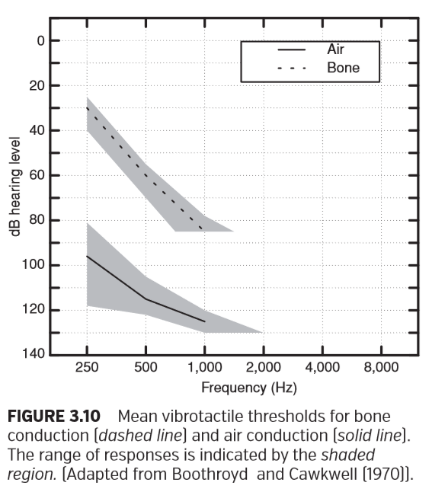

骨传导（虚线）和气导（实线）的平均振动触觉阈值。响应范围由阴影区域指示。改编自Boothroyd和Coulwell（1970年）

Boothroyd and Cawkwell (1970) recommend asking the client if they “feel” the stimulus or “hear” the stimulus as a means to differentiate between these two outcomes. Persons with experience with auditory sensations can usually make this distinction.

Boothroyd和Cawkwell（1970）建议询问患者是“感觉到”刺激还是“听到”刺激，以此作为区分这两种结果的一种方法。有听觉感受经验的人通常可以做出这种区分。

The values for vibrotactile thresholds illustrated in Figure 3.10 are based on only nine listeners. A more detailed study needs to be conducted to specify these ranges more precisely for the transducers in current use.

图3.10所示的振动触觉阈值仅基于9个受试者。需要进行更详细的研究，以便更准确地为当前使用的换能器指定这些范围。

**BONE-CONDUCTION THRESHOLDS: NOT A PURE ESTIMATE OF SENSORY/NEURAL RESERVE**

骨传导阈值：感觉/神经的性损伤的非纯粹评估

The goal of BC testing is to obtain an estimate of sensory/ neural reserve, but BC thresholds sometimes are inﬂuenced by the physiologic properties of the external, middle, and inner ears. The BC vibrator sets the skull into vibration, which stimulates the cochlea, but this does not happen in isolation. When the skull is vibrated, the middle-ear ossicles are also set into motion, and this inertial response of the ossicular chain contributes to BC thresholds. Changes in the external and middle ear can modify the contribution of the inertial response, which may result in signiﬁcant changes in BC thresholds (Dirks, 1994).

骨导测试的目的是获得感音/神经性听力损失的估值，但是骨导阈值有时会受到外、中、内耳生理特性的影响。骨导振动器使颅骨振动，从而刺激耳蜗，但这不是孤立发生的。当颅骨振动时，中耳听小骨也开始运动，听骨链的惯性响应有助于骨导阈值。外耳和中耳的变化可以改变惯性响应，这可能导致骨导阈值的显著变化（Dirks, 1994）。

A classic example of a middle-ear problem that inﬂuences BC thresholds is otosclerosis. Otosclerosis frequently causes the footplate of the stapes to become ankylosed or ﬁxed in the oval window. This disease process and some other types of conductive losses (e.g., glue ear) (Kumar et al., 2003) reduce the normal inertial response of the ossicles to BC hearing. The result is poorer thresholds that form a depressed region of BC hearing known as Carhart’s notch (Carhart, 1950). This notch, which typically shows poorer BC thresholds between 500 and 4,000 Hz with a maximum usually at 2,000 Hz of 15 dB, disappears following successful middle-ear surgery. The ﬁnding that BC thresholds improve following middle-ear surgery is strong evidence that these poorer BC thresholds observed in stapes immobilization are due to a middle-ear phenomenon rather than a change in the integrity of the cochlea.

中耳问题影响骨导阈值的一个典型例子是耳硬化症。耳硬化症通常导致镫骨的足板变得僵硬或固定在卵形窗。该疾病和一些其他类型的传导性损失（例如，胶耳）（Kumar等人，2003）降低了听小骨对骨导听力的正常惯性响应。结果是较差的阈值形成了一个骨导听力的下降区域，被称为“卡哈切记”（Carhart，1950）。此切迹通常在500-4000 Hz之间出现较差的骨导阈值，最大值通常在2000 Hz，15dB，在成功施行中耳手术后消失。中耳手术后发现骨导阈值改善表明，在镫骨固定中观察到的这些较差的骨导阈值是由于中耳现象而不是耳蜗完整性的改变。

A frequently observed example of middle-ear problems affecting BC thresholds occurs in persons with otitis media with effusion. In this group, falsely enhanced BC thresholds in the low frequencies (1,000 Hz and below) are seen often. The magnitude of the enhancement can be as much as 25 dB (Snyder, 1989). Upon resolution of the middle-ear problem, these previously enhanced BC thresholds become poorer and return to their premorbid values.

中耳问题影响骨导阈值的一个常见例子发生在分泌性中耳炎患者身上。这一组中，在低频（1，000 Hz及以下）中经常看到虚假增强的骨导阈值。增强的幅度可达25dB（Snyder，1989）。在中耳问题解决后，这些先前增强的骨导阈值变得更差，并恢复到其发病前的值。

Similarly, enhancement in BC thresholds occurs for low frequencies with occlusion of the external ear canal by a supra-aural ear phone. This low-frequency BC enhancement, known as the occlusion effect, must be considered when occluding the nontest ear to present masking noise during BC testing. However, when the masking noise is presented using an insert earphone with the foam plug inserted deeply into the ear canal, the amount of the lowfrequency enhancement is smaller than it is when supraaural earphones are used to deliver the masking noise (Dean and Martin, 2000). Further, apparent enhancement of BC thresholds can occur in cases of superior canal dehiscence (see Chapter 4).

类似地，当外耳道被压耳式耳机堵塞时，低频率的骨导阈值也会增强。这种低频骨导增强，即堵耳效应，在遮挡非测试耳时必须加以考虑，以决定是否在骨导测试期间施加掩蔽噪声。但是，当在施加掩蔽噪声时，使用将泡沫塞深插入耳道的插入耳机，其低频增强量比使用压耳式耳机的要小（Dean和Martin，2000）。此外，在上半规管裂的病例下，骨导阈值也会出现明显的增强。（见第四章）

**Special Populations**

特殊人群

**TINNITUS**

耳鸣

Many people who come for hearing testing experience tinnitus, the sensation of hearing internal sounds when no sound is present (see Chapter 35). Tinnitus can interfere with the perception of test tones, which can lead to a large number of false-positive responses, and false-positive responses can produce an inaccurate (too sensitive) threshold estimation. Some listeners simply require additional instruction and encouragement to wait until they are more certain they have heard a test tone. In some cases, the audiologist can present a clearly audible tone at the test frequency to remind the listener of the test tone. For more intractable cases, the examiner can present a series of pulsed tones and ask the listener to count the number of tones. It is important with listeners who are giving false-positive responses to avoid a ﬁxed presentation rhythm and to provide irregular intervals of “no trial” silence to conﬁrm that their responses are, in fact, responses to test tones.

许多来进行听力测试的人都会有耳鸣的经历，即在没有声音时听到内部声音的感觉（见第35章）。耳鸣会干扰对测试音调的感知，这可以导致大量的假阳性反应，而假阳性反应可以产生不准确（过于敏感）的阈值评估。一些听众只需要额外的指导和鼓励，直到他们更确定听到测试音。在某些情况下，听力师可以在测试频率上给出清晰可听的音调，以提醒听者注意测试音调。对于更难处理的情况，检查者可以呈现一系列脉冲音，并要求听者计算音调的数量。对于那些给出假阳性反应的听众来说，重要的是要避免测试音调呈现固定的节奏，并提供不规则的“无测试”沉默间隔，以确认他们的反应实际上是对测试音调的反应。

In rare cases, patients have tinnitus resulting from blood ﬂowing nearby auditory structures. Blood ﬂowing through a vein or artery sometimes produces masking noise or “bruit” that can elevate thresholds for low-frequency tones (Champlin et al., 1990). On the audiogram, this form of tinnitus may produce an apparent sensory/neural loss. The loss occurs because the tinnitus masks AC and BC thresholds. Bruit, a recordable form of tinnitus resulting from vibrations in the head or neck, is documented by audiologists by measuring sound levels in the ear canal (Champlin et al., 1990). This problem is treatable when the problem is caused by a vein. In a case study reported by Champlin et al. (1990), the patient received some reduction in tinnitus loudness before surgery by applying pressure to her neck. Surgical ligation of the vein responsible for the tinnitus was shown to be an effective treatment. Surgery reduced tinnitus loudness, SPLs of the bruit measured in the ear canal were lower, and the audiogram showed signiﬁcantly improved thresholds.

在极少数情况下，病人耳鸣是由于听觉结构附近的血流引起的。流经静脉或动脉的血液有时产生掩蔽噪声或“杂音”，这种情况会提高低频音的阈值（Champlin等人，1990）。在听力图中，这种形式的耳鸣可能产生明显的感音/神经性损失。因为耳鸣会掩盖气导和骨导阈值，所以会发生损失。杂音是一种可记录的由头或颈部振动引起的耳鸣，听力学家通过测量耳道内的声级记录了这种情况（Champlin等人，1990）。当这个问题由静脉引起时是可以治疗的。在Champlin等人（1990年）报告的一个病例研究中，病人在手术前通过对颈部施加压力来减轻耳鸣的响度。手术结扎引起耳鸣的静脉被证明是一种有效的治疗方法。手术可降低耳鸣响度，耳道杂音声压级变低，听力图上的阈值明显改善。

**PSEUDOHYPACUSIS**

伪聋

Pseudohypacusis, also known as functional hearing loss and nonorganic hearing loss, is the name applied to intra-test and inter-test inconsistencies that cannot be explained by medical examinations or a known physiologic condition (Ventry and Chaiklin, 1965). Most persons who present with this condition are feigning a hearing loss for monetary or psychological gain, but a very small percentage of persons have subconscious motivations related to psychological problems (see Chapter 33).

伪聋，也被称为功能性听力损失和非器质性听力损失，是不能用医学检查或已知的生理状况来解释的测试内和测试间不一致的名称（Venter和Chaiklin，1965）。大多数患有这种情况的人为了金钱或心理上的利益而假装听力丧失，但极少数人有与心理问题有关的潜意识因素（见第33章）。

Persons presenting with pseudohypacusis are often identiﬁed from inconsistencies in their responses to the puretones. In addition to general poor reliability during threshold searches, there is a tendency for the threshold to become poorer as more presentations are made (Green, 1978). Methods of identifying the pseudohypacusis by comparing PT thresholds with other measures and the use of special tests are covered in Chapter 33.

表现伪聋的人通常从他们对纯音不一致的反应中辨别出来。除了在阈值搜索期间的一般较差的可靠性之外，随着更多的呈现，阈值有变差的趋势（Green，1978）。通过比较纯音阈值与其他测量值以及使用特殊测试来识别伪聋的方法将在第33章介绍。

**AUDITORY NEUROPATHY**

听神经病

Auditory neuropathy (or auditory dys-synchrony) is a condition that may account for 11% of hearing losses found in children at risk for hearing loss (Rance et al., 1999). Information about this disorder may be found in Chapters 13 and 19. Many of these children appear to be severely hard of hearing because of very poor speech recognition; however, PT thresholds do not follow any speciﬁc pattern. Puretone hearing thresholds for these children range from minimal to profound losses. Individuals with auditory neuropathy classically show very inconsistent audiometric responses during a test and between tests.

听神经病变（或听觉不同步）可能占儿童听力损失的11% (Rance et al.，1999)。有关这种疾病的信息可以在第13章和第19章找到。由于言语识别非常差，这些孩子中的许多人看起来都有严重的听力障碍。但是，纯音阈值不遵循任何特定模式。这些儿童的纯音听力阈值范围可以从最小值到严重损失。患有听觉神经病变的人通常在同一测试期间与多项测试之间表现出非常不一致的听觉反应。

**AGING**

老龄化

Presbycusis is a term that describes the gradual loss of hearing sensitivity that occurs in most individuals as they grow older. Studies suggest (Schuknecht, 1974; Dubno et al., 2013) that several different types of damage can occur to the auditory system because of aging. Hearing loss due to aging typically causes a gently sloping, high-frequency sensory/ neural hearing loss that tends to be slightly greater in men than in women. Figure 3.11 shows the average amount of threshold elevation expected based on aging in men who have had limited exposure to intense sounds. Even among this select group of participants, large individual differences are often observed.

老年性聋是一个术语，是用来描述大多数人随着年龄的增长听力敏感度逐渐丧失的术语。研究表明（Schuknecht，1974年；Dubno等人，2013年），由于衰老，听觉系统可能发生几种不同类型的损害。由于年龄增长导致的听力损失通常导致平缓倾斜的高频感觉/神经性听力损失，男性听力损失往往比女性略高。图3.11显示了有限地接触到强烈声音的男性，随着年龄增长，阈值的平均上升幅度。即使在这组被选中的参与者中，也经常观察到巨大的个体差异。

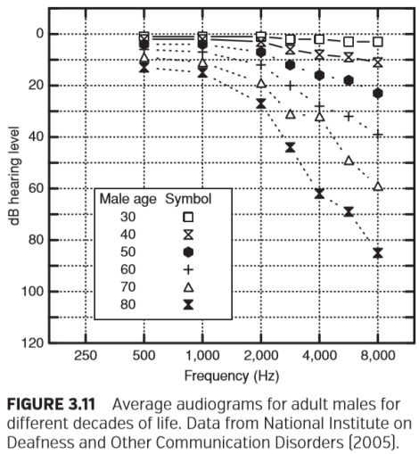

图3.11不同年龄的成年男性的平均听力图。 数据来自国家耳聋研究所和其他交流障碍研究所（2005年）。

**ACOUSTIC TUMORS**

听神经瘤

An acoustic tumor (acoustic neuroma/neurinoma or vestibular schwannoma) is a rare disorder. Once identiﬁed, these tumors are usually removed surgically, because they can compress the brainstem and threaten life. Early diagnosis and removal lessen the risk of complications during surgery and increase the opportunity to preserve hearing if that approach is pursued.

听神经瘤（听神经瘤/神经鞘瘤或前庭神经鞘瘤）是一种罕见的疾病。一旦确诊，这些肿瘤通常可通过手术切除，因为它们会压迫脑干，威胁生命。早期诊断和切除可以降低手术中并发症的风险，并且可以增加保持听力的机会。

Magnetic resonance imaging (MRI) is the deﬁnitive test for acoustic tumors. Unfortunately, it is expensive and only becomes cost effective when a screening test is used to assess which patients should receive an MRI. Puretone audiometry should be considered as part of that screening procedure. When the auditory nerve is compressed by the tumor, it often, but not always (Magdziarz et al., 2000), results in a unilateral or asymmetrical hearing loss. Because the ﬁbers on the outside of the auditory nerve code high frequencies, the hearing loss is associated with the high frequencies (Schlauch et al., 1995). Studies have shown that a screening test that compares the average threshold difference between ears for 1, 2, 4, and 8 kHz is most effective (Schlauch et al., 1995). Threshold differences between ears for this PTA that exceed 15 dB or 20 dB maximize identiﬁcation of persons with these tumors while minimizing false-positive diagnoses of persons with cochlear losses. The pass–fail criterion (e.g., requiring a 20-dB difference between ears) may differ depending on the money available for follow-up tests. A pass–fail criterion requiring 15-dB or greater differences between ears identiﬁes more tumors than one requiring 20-dB or larger differences, but the smaller difference also yields more false-positive responses. False-positive responses (in this case, persons with cochlear losses identiﬁed incorrectly as having tumors) place a burden on the healthcare system, because follow-up tests such as MRI or auditory-evoked potentials are expensive.

磁共振成像（MRI）是听神经瘤的确诊手段。遗憾的是，它很昂贵，并且只有在使用筛选检查评估哪些患者应该接受MRI时才具有成本效益。纯音测听应该被认为是筛选程序的一部分。当听神经被肿瘤压迫时，通常但不总是（Magdziarz et al.， 2000）导致单侧或不对称的听力损失。由于听觉神经外部的神经纤维对高频进行编码，因此听力损失与高频有关（Schlauch et al.，1995）。研究表明，比较1、2、4和8Hz之间的平均阈值差异的筛选检查是最有效的（Schlauch et al.， 1995）。超过15db或20db的PTA的耳间阈值差异可以最大限度地识别这些肿瘤患者，同时最大限度地减少耳蜗损失患者的假阳性诊断。通过-未过标准（例如，要求两耳之间相差20分贝）可能会因后续检查的可用资金而有所不同。两耳间15dB或更大差异的通过-未过标准比两耳间20dB或更大差异的标准能识别更多的肿瘤，但是较小差异也产生更多的假阳性反应。假阳性反应（在这种情况下，耳蜗受损的人被错误地认定为患有肿瘤）给医疗系统带来了负担，因为后续的检查，如核磁共振成像（MRI）或听觉诱发电位（auditor- evpotential），成本高昂。

The effectiveness of a screening test based on the threshold asymmetries between ears is dependent on the clinical population. This test was found to be ineffective in a Veterans Administration hospital where many patients are males who have presbycusis and noise-induced hearing loss (NIHL) (Schlauch et al., 1995). By contrast, preliminary data from young women with normal hearing in their better ear suggest that true-positive rates and false-positive rates for this test are comparable to those for auditory brainstem response (Schlauch et al., 1995). It should also be noted that a small percentage of persons (<3%) with acoustic tumors have no hearing loss or hearing threshold asymmetry (Magdziarz et al., 2000).

基于耳间阈值不对称的筛选试验的有效性取决于临床人群。这项测试在退伍军人管理局医院被发现是无效的，在那里许多患者是男性，他们有老年性耳聋和噪声性听力损失（NIHL）（Schlauch et al.， 1995）。相比之下，来自听力正常的年轻女性的初步数据表明，该测试的真阳性率和假阳性率与听觉脑干反应的真阳性率和假阳性率相当（Schlauch et al.，1995）。还应注意的是，有一小部分（<3%）听神经瘤患者没有听力损失或没有听力阈值不对称（Magdziarz et al.，2000）。

**MÉNIÈRE’S DISEASE**

梅尼埃病

Ménière’s disease is diagnosed based on the symptoms of sensory/neural hearing loss, vertigo, tinnitus, and aural fullness (Committee on Hearing and Equilibrium, 1995) as well as the exclusion of other known diseases. Adding to the diagnostic challenge, the four symptoms do not occur all at once, and some of them may occur only during the intermittent attacks that characterize this disease. It takes, on average, 1 year after the ﬁrst symptom occurs before all of the symptoms are experienced by a person stricken with this disease. Ménière’s disease rarely occurs before age 20 and is most likely to begin between the fourth and sixth decades (Pfaltz and Mateﬁ, 1981).

梅尼埃病的诊断依据是感音/神经性听力损失、眩晕、耳鸣和耳闷症状（听力和平衡委员会，1995年），以及排除其他已知疾病。诊断困难的是，这四种症状并不是同时出现的，其中一些症状可能只在这种疾病的间歇性发作期间出现。平均来说，在第一个症状出现后的1年内，患者才能经历到这种疾病的所有症状。梅尼埃病很少发生在20岁之前，最可能发生在40岁至60岁之间。（Pfaltz and Mateﬁ, 1981）

Ménière’s disease usually begins as a unilateral sensory/ neural hearing loss, but the frequency of bilateral involvement increases with disease duration (Stahle and Klockhoff, 1986). Although audiometric conﬁguration is not too helpful in diagnosing Ménière’s disease, a peaked audiogram (described in Table 3.3) is most common (roughly 60% of involved ears), and a rising audiogram is also seen quite frequently, especially in the earliest stages of the disease. However, the peaked audiogram is also seen in 13% of ears with acoustic tumors (Ries et al., 1998).

梅尼埃病通常以单侧感觉/神经性听力损失开始，但随着病程的延长，双侧受累的频率增加（Stahle和Klockhoff，1986）。虽然听力曲线对梅尼埃氏病的诊断没有太大帮助，但峰值听力图（表3.3中描述）是最常见的，而且上升的听力图也很常见（大约占受累耳朵的60%），特别是在疾病的早期阶段。然而，13%的听神经瘤患者的听力图也出现峰值听力图。

**NOISE-INDUCED HEARING LOSS AND ACOUSTIC TRAUMA**

噪声性聋与声损伤

Exposure to intense sound levels can cause permanent or temporary hearing loss due to hair cell damage. When a narrowband sound is presented at a level high enough to result in damage, a loss occurs at a frequency roughly one-half octave above the frequency of exposure (Henderson and Hamernik, 1995). Most people who are exposed to damaging noise levels in their work or recreational endeavors are exposed to broadband sounds, but their losses, especially during early stages of NIHL, are characterized by a “notch” (a drop in hearing) on the audiogram. The greatest hearing loss typically occurs in the region of 3,000 to 6,000 Hz. The susceptibility of these frequencies is a result of sound ampliﬁcation by the external ear (Gerhardt et al., 1987). The ampliﬁcation is mainly a result of the ear canal resonance, which increases the level of sound by 20 dB or more. Temporary hearing loss is referred to as temporary threshold shift (TTS), and permanent changes are referred to as permanent threshold shifts (PTS).

暴露于强烈的声级下可能会由于毛细胞损伤而导致永久性或暂时性听力损失。当窄带声音的音量高到足以造成损坏时，损失的频率大约在曝光频率后面的半倍频程上。大多数在工作或娱乐活动中暴露于破坏性噪音水平的人都会接触到宽带声音，但是他们的损失，特别是在噪声性聋的早期阶段，其特点是听力图上有一个“凹槽”（听力下降）。最严重的听力损失通常发生在3，000至6，000赫兹之间。这些频率的敏感性是外耳放大声音的结果。放大主要是耳道共振的结果，可使声级提高20dB或更多。暂时性听力损失称为暂时性阈移（TTS），永久性改变称为永久性阈移（PTS）。

The greater variability of thresholds at 6 and 8 kHz than at other frequencies makes small noise notches associated with early NIHL difﬁcult to identify. Some frequently used rules for quantifying noise notches can produce high falsepositive rates when decisions are based on a single audiogram (Schlauch and Carney, 2011). Averaging multiple audiograms improves diagnostic accuracy as does clearing the ear canals of all earwax, which can result in the appearance of a high-frequency loss (Jin et al., 2013; Schlauch and Carney, 2012). NIHL can be slowly progressive, as listeners are exposed to high sound levels over months and years (Ward et al., 2000), or it can rapidly change, such as noise trauma after a sudden explosion or impulsive sound (Kerr and Byrne, 1975; Orchik et al., 1987). The shooting of a riﬂe can result in a greater loss in the ear closest to the muzzle of the gun. In right-handed persons, the left ear is exposed directly to the muzzle, and the right ear is protected from the direct blast by the head. New evidence (Kujawa and Liberman, 2009) suggests that PT thresholds may return to near normal following noise exposure, whereas functional auditory abilities may remain compromised due to the noise exposure. (See Chapter 32 for NIHL.)

在6 kHz和8 kHz的阈值比在其他频率有更大的变异性，使得与早期噪声性聋相关联的小噪声切迹难以识别。当决策基于单个听力图时，一些常用的量化噪声切迹的规则可以产生高的假阳性率（Schlauch和Carney，2011年）。多次听力图的平均值可以提高诊断的准确性，如同清除所有耳道内的耳垢会提高诊断准确性，这些耳垢会导致高频损耗。噪声性聋可以缓慢进展，因为听者在数月或数年的时间里都暴露在高强度的声级中（Ward et al.， 2000），也可以快速变化，例如突然爆炸后或脉冲声的噪音创伤。步枪的射击会使靠近枪口的耳朵损失更大。在惯用右手的人中，左耳直接暴露于枪口，右耳受到头部保护免于直接受到冲击。新的证据显示，在噪声暴露后纯音阈值可能会恢复到接近正常水平，而功能性听觉能力可能会因噪声暴露而仍然受损。（NIHL见第32章。）

**OTOTOXICITY**

耳毒性

Regular monitoring of PT thresholds is particularly important for patients who take drugs known to be ototoxic. For example, certain powerful antibiotics and cancer-ﬁghting drugs are known to cause cochlear and vestibular damage in many patients. Monitoring hearing sensitivity during treatment could allow a physician to consider alternative treatments that might preserve hearing. Ototoxic drugs typically cause reduction in high-frequency hearing before having any adverse effect on hearing for the speech range. For this reason, extended high-frequency hearing testing is recommended for ototoxic monitoring test protocols. Several studies have demonstrated the effectiveness of early identiﬁcation of ototoxic hearing loss by monitoring thresholds for frequencies higher than 8,000 Hz (Fausti et al., 1992). However, for ototoxic drugs that selectively damage inner hair cells in the cochlea (e.g., carboplatin), PT thresholds may be unaffected even though extensive damage has occurred (Lobaranis et al., 2013).

定期监测纯音阈值对于服用已知具有耳毒性药物的患者尤为重要。例如，已知某些强效抗生素和抗癌药物会在许多患者造成耳蜗和前庭损伤。在治疗期间监测听力敏感性可让医生考虑可能保留听力的替代治疗。在对言语范围的听力产生任何不利影响之前，耳毒性药物通常会导致高频听力降低。因此，耳毒性监测测试方案中建议对扩展的高频进行听力测试。一些研究已经证明通过监测8,000 Hz以上频率的阈值来早期识别耳毒性听力损失的有效性。然而，对于选择性损害耳蜗内毛细胞的耳毒性药物，即使发生了广泛的损伤，纯音阈值也可能不受影响。

**OTITIS MEDIA**

中耳炎

Young children are susceptible to temporary, recurring middle-ear inﬂammations (otitis media) that are often accompanied by ﬂuid in the middle ear (effusion). Otitis media, often referred to as a middle-ear “infection,” may be viral or bacterial but is most often serous (noninfected ﬂuid). Otitis media is the most common medical diagnosis for children, accounting for 6 million ofﬁce visits in 1990 for children between the ages of 5 and 15 years (Stoll and Fink, 1996). Adults, too, may have otitis media with effusion, although the prevalence decreases signiﬁcantly with age (Fria et al., 1985). During the active infection, often lasting a month or more, a patient’s hearing loss may ﬂuctuate, usually varying between 0 and 40 dB. The average degree of hearing loss is approximately 25 dB. Figure 3.8, which was used earlier in this chapter to illustrate an audiogram for a conductive loss, shows an audiogram derived from the average thresholds from a group of children diagnosed with otitis media.

幼儿易患暂时性的、反复发作的中耳炎症（中耳炎），中耳炎常伴有中耳积液（积液）。中耳炎，通常被称为中耳“感染”，可能是病毒性或细菌性，但最常见的是浆液性（非感染液体）。中耳炎是儿童最常见的医学诊断，1990年，5 - 15岁儿童共有600万人次就诊（Stoll and Fink, 1996）。成年人也可能患有分泌性中耳炎，尽管其发病率随着年龄的增长而显著下降（Fria et al.，1985）。在感染发作期，通常持续一个月或更长时间，患者的听力损失可能出现波动，通常在0至40分贝之间变化。平均听力损失约为25分贝。图3.8是本章前面用来说明传导性损失的听力图，它显示了一组诊断为中耳炎的儿童的平均阈值。

**TYMPANIC MEMBRANE PERFORATIONS**

鼓膜穿孔

Tympanic membrane perforations are caused by trauma, disease, or surgery. The diameter and location of perforation and the involvement of other middle-ear structures determine the amount of conductive hearing loss, if any. For instance, a myringotomy and the placement of pressureequalization tubes represent a physician-induced perforation that results in a minimal air–bone gap in successful surgeries.

鼓膜穿孔是由外伤、疾病或手术引起的。如果有的话，穿孔的直径和位置以及其他中耳结构的参与决定了传导性听力损失量的程度。例如，鼓膜切开术和鼓膜置管代表了一种医生诱导的穿孔，在手术成功后会导致最小的气骨间隙。

The measurement of AC thresholds in the presence of tympanic membrane perforations requires special consideration. Figure 3.12 shows an audiogram obtained in a single session from a school-age child who has a tympanic membrane perforation in the left ear and a pressure-equalization tube in the right ear. Thresholds were measured twice in each ear, once with supra-aural earphones and again with insert earphones. Note that the low-frequency thresholds obtained from insert earphones were as much as 15 to 25 dB poorer than the ones obtained with supra-aural earphones. This outcome is typical and is predicted because insert earphones are more susceptible to calibration problems in the presence of perforations than are supra-aural earphones when calibration is based on coupler rather than real ear measurements (Voss et al., 2000). The thresholds obtained using the supra-aural earphones are more accurate in this instance and in any situations in which the effective volume of the ear canal is signiﬁcantly larger than is typical.

在鼓膜穿孔的情况下，测量纯音阈值需要特殊考虑。图3.12显示了一个学龄儿童在一次治疗中测到的听力图，该儿童左耳有鼓膜穿孔，右耳有鼓膜置管。每只耳朵中测量两次阈值，一次使用压耳式耳机，另一次使用插入式耳机。请注意，从插入式耳机获得的低频阈值比用压耳式耳机获得的低15至25dB。这种结果是典型的并且是可以预测的，因为当校准基于耦合器而不是真耳测量时，插入式耳机比压耳式耳机更容易在穿孔的情况下出现校准问题（Voss等，2000）。在这种情况下以及在任何耳道有效容积明显大于典型的情况下，使用压耳式耳机获得的阈值更准确。

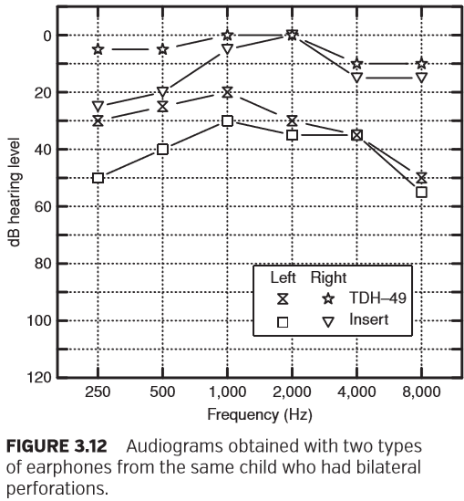

图3.12同一儿童双侧穿孔两种耳机的听力图。

**Relation between Puretone Thresholds and Speech Measures**

纯音阈值与言语测试的关系

PT thresholds are often compared with speech audiometric test results. The two most common comparisons are with speech reception thresholds (SRT) and suprathreshold word-recognition scores (WRSs). (See Chapter 5 for a comprehensive review of speech audiometry.)

纯音阈值通常与言语听力测试结果进行比较。两个最常见的比较是言语接受阈（SRT）和阈上单词识别率（WRSs）。（有关言语测听的全面回顾，请参见第5章。）

SRTs obtained using spondaic words (or spondees) agree well with PT thresholds for low frequencies. Spondees are easily recognized; listeners only need to recognize the vowels to identify these words correctly. Because of the importance of the vowels at low intensities, spondee thresholds are found to agree closely with the average of PT thresholds for 500 and 1,000 Hz (Carhart and Porter, 1971). In the event of a rising audiogram, better agreement between the spondee and PT thresholds is the average for 1,000 and 2,000 Hz. Spondee thresholds and a two-frequency PTA, as noted earlier, nearly always agree within ±10 dB in cooperative examinees. This agreement makes the threshold for spondaic words an excellent check on the validity and reliability of the audiogram. This comparison is important for most children. It is also a valuable tool for assessing the reliability of PT thresholds in adults who demonstrate inconsistent puretone responses or who may present with pseudohypacusis (Schlauch et al., 1996).

使用扬扬格单词（扬扬格词/双音节词）获得的SRTs与低频纯音阈值一致。扬扬格词很容易识别；听者只需要识别元音就可以正确识别这些单词。由于低强度时元音的重要性，扬扬格词阈值与500和1000 Hz的纯音阈值的平均值非常接近（Carhart and Porter, 1971）。在上升的听力图中，扬扬格词和纯音阈值之间更好的一致性是1000和2000 Hz的平均值。扬扬格词阈值和如前所述的双频PTA在合作参与者中几乎总是在±10dB内一致。这一协议使扬扬格词的阈值对听力图的有效性和可靠性进行了极好的检验。这种比较对大多数孩子都很重要。它也是评估成人纯音阈值可靠性的有价值的工具，这些成人表现出不一致的纯音反应或可能存在伪聋。

Suprathreshold word-recognition performance is assessed in most clinical settings by scoring a client’s ability to repeat back a list of monosyllabic words. WRSs provide a valid estimate of speech understanding ability (Wilson and Margolis, 1983) and quantiﬁcation of the distortion, if any, caused by sensory/neural hearing loss. WRSs are correlated with puretone audiometric thresholds in persons with cochlear losses (Pavlovic et al., 1986), but individuals’ scores vary considerably depending on the type of damage to the auditory system. If the words are presented at a level high enough to make the speech sounds audible (overcoming the attenuation caused by the loss), persons with mild cochlear hearing loss are expected to have high WRSs, and those with severe to profound losses are likely to have fairly low scores. Dubno et al. (1995) and Yellin et al. (1989) have published tables relating WRSs and the average of PT thresholds for 500, 1,000, and 2,000 Hz for groups of persons with typical cochlear losses. WRSs that are abnormally low for a given PTA are associated with a variety of conditions including an acoustic tumor, multiple sclerosis, Ménière’s disease, auditory neuropathy, and cochlear dead regions (Moore, 2004), to name a few. When there are dead regions (areas of missing inner hair cells in the cochlea), PT thresholds may appear artiﬁcially better than expected because of the spread of energy along the cochlea. Healthier cochlear cells adjacent to the missing cells will elicit a response to puretones presented at the dead region frequency.

在大多数临床环境中，阈上单词识别性能是通过对患者重复单音节单词的能力来评估的。WRSs提供了对言语理解能力的有效评估（Wilson and Margolis, 1983），并量化了由感音神经听力损失引起的失真 （如果有的话）。WRS与耳蜗损伤者的纯音听阈相关（Pavlovic et al., 1986），但个体的分数因听觉系统损伤类型的不同而有很大差异。如果这些单词音量足够高，使语音可以听到（克服了损耗引起的衰减），那么轻度耳蜗听力损失的人预计会有较高的WRSS，而重度至极重度损失的人可能会有相当低的分数。Dubno et al.，（1995）和Yellin et al.（1989）发表了关于典型耳蜗损伤人群WRSs与500、1000、2000 Hz纯音阈值平均值关系的表。对于给定PTA而言，异常低的WRSs与多种疾病有关，包括听神经肿瘤、多发性硬化症、梅尼埃病、听神经病变和耳蜗死区等等（Moore，2004）。当存在死区（耳蜗内毛细胞缺失的区域）时，由于能量沿着耳蜗的扩散，纯音阈值可能比预期的要高。与缺失细胞相邻的健康耳蜗细胞会对死区频率的纯音作出响应。

**Automated Audiometry**

自动听力测定

Clinical researchers automated the measurement of routine hearing thresholds to increase clinical efﬁciency (Rudmose, 1963). Devices were developed for this purpose, and several machines were manufactured and sold commercially. Some of these automated audiometers had the ability to vary intensity and frequency during a hearing test.

临床研究人员自动化了常规听力阈值的测量以提高临床效率（Rudmose, 1963）。为此研制了一些设备，制造了几台机器并进行了商业销售。其中一些自动测听仪能够在听力测试中改变强度和频率。

The Bekesy audiometer is an automated audiometer that was a common piece of equipment in major clinical and research settings in the 1960s. In its routine application, AC thresholds were assessed for interrupted tones and sustained tones for frequencies ranging from 100 to 10 kHz. Frequencies were swept through the range over time, typically at a rate of one octave per minute. The examinee controlled the level of the sound by depressing a handheld switch for as long as he or she heard a tone and released it when none was heard. The resulting brackets around threshold were recorded on an audiogram. Patterns of responses for sustained tones and interrupted tones were found to distinguish between different etiologies of hearing loss (see Chapter 33 on pseudohypacusis). In recent years, the use of Bekesy audiometry has decreased in medical settings, but it still has important applications in research, the military, and in hearing conservation programs.

贝克西（Bekesy）听力计是一种自动化听力计，20世纪60年代主要临床和研究环境中的常用设备。在它的常规应用中，100-10khz的中断音调和持续音调作为气导阈值评估。频率在一段时间内扫过整个范围，通常以每分钟一个倍频程的速度扫过。受检者只要听到一种声音，就按下手持开关来控制音量，当听不到时，就释放控制开关。由此产生的阈值被记录在听力图上。持续音调和间断音调的反应模式被发现可以区分听力损失的不同病因（见第33章关于伪聋）。近年来，贝克西听力计在医学环境中的使用有所减少，但在研究，军队和听力保护项目中仍有重要应用。

Within the past few years, a new generation of automated audiometers has been developed (Margolis et al., 2010). The new automated audiometers are capable of measuring masked AC and BC thresholds, as well as WRSs, with only a single placement of the earphones and BC oscillator. Bekesy audiometry is still used along with some other automated methods (Laroche and Hetu, 1997), including ones that implement the threshold-ﬁnding procedure used in manual puretone audiometry (Margolis et al., 2010). Computer- based rules control the presentation of stimuli, examinee responses, and the plotting of thresholds. The goal is to automate threshold collection for routine cases, which will free audiologists to perform more complex measures or to work with difﬁcult-to-test populations.

在过去的几年里，新一代的自动测听仪已经开发出来（Margolis et al.，2010）。新的自动测听仪能够测量掩蔽的气导和骨导阈值，以及WRSs，只需要放置一个耳机和骨导振荡器。贝克西听力计仍然与其他一些自动化方法一起使用（Laroche and Hetu, 1997），包括实现手工纯音测听中使用的阈值查找程序的方法（Margolis et al.， 2010）。基于计算机的规则控制刺激的呈现、受试者的反应和阈值的绘制。目标是自动收集常规病例的阈值，这将使听力学家得以执行更复杂的测量，或与测试困难的人工作。

**Calibration**

校准

Clinical data require accurate stimulus speciﬁcation, or the results are meaningless. When most persons think of calibration of audiometers, the obvious examples include the accuracy of puretone frequency and level. However, puretone calibration involves much more, including an assessment of attenuator linearity, harmonic distortion, rise and fall times, and more. Consult ANSI (2010) and Chapter 2 on calibration in this book to learn more about this topic.

临床数据需要精确的刺激指标，否则结果毫无意义。当大多数人想到听力计的校准时，最明显的例子包括纯音频率和音量的准确性。然而，纯音校准涉及更多，包括衰减器线性度，谐波失真，上升和下降时间等的评估。有关此主题的更多信息，请参阅ANSI（2010）和本书中有关校准的第2章。

**Puretone Thresholds and the Audiologic Test Battery**

纯音阈值与听力测试组合

PT thresholds are measured on nearly everyone entering a diagnostic audiology clinic, but the test sequence and the extent of the measurements often differ across clinics. Most of these differences in protocol are implemented to save testing time, which contributes to the cost of running a clinic. ASHA’s guide to manual PT threshold audiometry (2005) makes no recommendation concerning the puretone test sequence. In 2000, the Joint Audiology Committee on Practice Algorithms and Standards recommended an algorithm that listed puretone AC testing (with appropriate masking applied) followed by puretone BC testing with appropriate masking. They acknowledged that the assessment process may vary “based on patient need and the assessment setting.” Furthermore, they stated that “decision-making . . . occurs(s) throughout this process.”

纯音阈值是几乎所有进入听力学诊所就诊的患者都要测量的，但是测试顺序和测量的范围往往因诊所而异。这些协议上的差异大部分是为了节省测试时间而实现的，这有助于节省诊所的运营成本。ASHA的人工纯音阈值测试指南（2005）对纯音测试顺序没有给出任何建议。2000年，实践算法和标准联合听力委员会建议采用一种算法，列出纯音气导测试 （应用适当的掩蔽），然后使用适当的掩蔽方法进行纯音骨导测试。他们承认，评估过程可能会根据“病人的需要和评估环境”而有所不同。此外，他们还说“决策……在整个过程中发生。”

Based on informal surveys of clinicians in a variety of settings, it seems that there is considerable variability in test protocols among clinics. In many clinics, BC thresholds are not usually obtained from persons with normal AC thresholds (near 0 dB HL) unless the case history or risk of middle-ear problems suggests otherwise. BC threshold testing is also omitted in some clinics for returning patients with pure sensory/neural losses if their AC thresholds match those of the prior visit. A common alternative test sequence is to begin with puretone AC thresholds followed by suprathreshold word-recognition testing. After word-recognition testing, BC thresholds are measured. Although it would be useful to have puretone BC thresholds prior to AC thresholds to know how much masking noise can be presented safely, this advantage is outweighed by the inconvenience of having to enter the booth multiple times to reposition the BC vibrator and earphones. Valid, masked AC thresholds can be obtained successfully from most clients before obtaining BC thresholds.

根据在不同环境下对临床医生的非正式调查，各诊所之间的测试方案似乎存在相当大的差异。在许多诊所中，骨导阈值通常不是从具有正常气导阈值（接近0 dB HL）的人获得的，除非有中耳问题相关病史或风险。在一些诊所，单纯感音/神经性损失的患者如果其气导阈值与之前的检查值相匹配，那么骨导阈值测试会被省略。一种常见的替代测试顺序是从纯音气导阈值开始，然后进行阈上单词识别测试。经过单词识别测试，测得骨导阈值。虽然在气导阈值之前设置纯音骨导阈值会很有用，以了解多少掩蔽噪声是安全的，但这一优势被不得不多次进入测听室重新定位骨导振动器和耳机的不便所抵消。有效的、掩蔽的气导阈值可以在得到骨导阈值之前从大多数测试者那里成功获取。

A few clinics begin with immittance testing, which usually includes a tympanogram and acoustic reﬂex thresholds. If the case history does not indicate a middle-ear problem and these tests of middle-ear function are normal, then BC thresholds may not be performed, and the loss, if present, is assumed to be a sensory/neural loss. A possible risk of this strategy is that, in rare instances, persons with middle-ear problems have normal immittance measures. In this situation, a conductive loss would be missed. This approach also adds the expense of immittance testing for each client. Studies should be done using an evidence-based practice model to determine whether the assessment of middle-ear status of each client using immittance or wideband reﬂectance (see Chapter 9) is justiﬁed. Another time-saving strategy might be to measure BC thresholds at two frequencies, a low and a high frequency, and if an air–bone gap is not observed, BC thresholds are not measured for other frequencies. A low frequency, such as 500 Hz, would assess stiffness-related middle-ear pathologies. A high frequency, such as 4,000 Hz, would identify mass-related middle-ear pathologies and collapsed canals. Since this method requires placement of the BC vibrator, the amount of time actually saved would be limited.

一些诊所从导抗测试开始，通常包括鼓室图和声反射阈值。如果病史没有提示中耳问题，并且中耳功能测试正常，则可能不再进行骨导阈值测试，如果出现听力下降，则假定为感音/神经性损失。这种方法的一个可能风险是，在极少数情况下，有中耳问题的人具有正常的导抗测试值。在这种情况下，传导性损失会被忽略。这种方法还增加了每个受试者的导抗测试费用。应使用基于证据的实践模型进行研究，以确定是否使用导抗或宽带反射评估每个患者的中耳状态（见第9章）。另一种节省时间的策略可能是在两个频率测量骨导阈值，一个低频率和一个高频率，如果没有观察到气骨间隙，则不会测量其他频率的骨导阈值。低频（如500hz）可评估与硬化有关的中耳病变。高频，例如4000赫兹，可以识别与肿块有关的中耳病变和耳道塌陷。由于此方法需要放置骨导振子，所以实际节省的时间是有限的。

Despite the observed variability, it seems that it is possible for audiologists to obtain important diagnostic information about the degree, type, and conﬁguration of hearing losses using a variety of valid, evidence-based puretone audiometric methods. Although at ﬁrst glance, the puretone test procedure may appear elementary, it is clear that well-informed test procedures using appropriate and calibrated test equipment provide a necessary part of the complete audiologic test battery and form the basis for clinical decision making.

尽管存在观察变异性，但听力学家似乎可以使用各种有效的、基于证据的纯音听力测定方法获得关于听力损失的程度、类型和配置的重要诊断信息。虽然乍一看，纯音测试程序可能很基础，但很明显，采用适当和校准的测试设备进行的测试提供了完整的听力测试组合的必要部分，并形成临床决策的基础。

**FOOD FOR THOUGHT**

引人深思的事

1. Given the known test–retest variability of PT thresholds, what is the threat to the quality of a hearing conservation program if the tester chooses not to make multiple estimates of baseline audiograms?

1． 鉴于纯音阈值的已知测试重测变异性，如果测试人员选择不对基线听力图进行多次评估，对听力保护程序的质量有何威胁？

2. Think about examples of auditory pathology where the PT threshold might be misleading, when it might not reﬂect the full nature of the underlying cochlear injury.

3. 思考下听觉病理学的例子，其中纯音阈值可能具有误导性，而纯音阈值可能不会反映潜在耳蜗损伤的全部性质。

3. Consider several cases where the ear canal volume (the volume under the earphone) might signiﬁcantly affect the resulting PT threshold. Consider the client’s total volume of the outer ear, perforations of the eardrum, and possible occlusions in the ear canal. What effect will these have on the resulting thresholds?

3. 考虑几种情况，耳道容积（耳机下的音量）可能会显着影响最终的纯音阈值。考虑患者的外耳总容积、鼓膜穿孔以及可能的耳道阻塞情况。这些对最终的阈值产生什么影响？

## Chapter 4 Bone Conduction Evaluation

骨导评估

### INTRODUCTION

介绍

Puretone threshold measurements are routinely carried out in audiologic evaluations. By comparing air-conducted and bone-conducted thresholds, site-of-lesion information can be obtained. Disorders of the outer or middle ears disrupt the ﬂow of energy from the earphone to the inner ear. However, much of the energy that is conducted by a bone vibrator on the skull bypasses the outer and middle ears and stimulates the inner ear essentially unimpeded. Therefore, this discrepancy favoring the bone-conducted threshold (called the air–bone gap) indicates a mechanical or conductive hearing loss (CHL). On the other hand when the inner ear is impaired, both pathways from the earphone and the bone vibrator are impacted. This bioelectrical disturbance is referred to as a sensory/neural hearing loss (SNHL). A hearing loss that has both sensory/neural and conductive elements is called a mixed hearing loss (MHL).

纯音阈值测量通常是在听力评估中完成的。通过比较气导阈值和骨导阈值，可以获得病变部位信息。外耳或中耳的疾病会扰乱从耳机到内耳的能量传递。然而，颅骨上的骨振动器传导的大部分能量会绕过外耳和中耳，基本上可以不受阻碍地刺激内耳。因此，这种骨传导占优的阈值差异（称为气骨间隙）表明机械性或传导性听力损失（CHL）。另一方面，当内耳受损时，耳机和骨振动器的两条通路都会受到影响。这种生物电干扰的情况被称为感音/神经性听力损失（SNHL）。一种兼有感音/神经性和传导性的听力损失被称为混合性听力损失（MHL）。

However, bone-conducted energy does not entirely bypass the outer ear and middle ear. Site-of-lesion diagnoses will be more accurate with an understanding that occlusion or disorder of the outer ear, middle ear, and/or inner ear components may affect bone conduction thresholds too. An understanding of bone conduction hearing is essential for audiologists to accurately apportion hearing loss among the possible sites of lesion and to identify the etiologies of hearing losses.

然而，骨传导过程的能量并不能完全绕过外耳和中耳。 通过了解外耳，中耳和/或内耳的闭塞或紊乱也可能影响骨传导阈值，这将使病变部位诊断更准确。了解骨传导听力对于听力师准确评估听力损失可能的病变部位以及识别听力损失的病因至关重要。

### CHAPTER OVERVIEW

章节概述

In this chapter, a historical context and a few basic principles in bone conduction as tested with tuning fork techniques are ﬁrst introduced. Then highlights of the apparatus and evaluation procedures used in routine bone conduction evaluation today are considered. An overview is provided of the outer ear, middle ear, and inner ear components of bone conduction hearing, which lead to the main purpose of this chapter: a review of site-oflesion diagnoses based on an understanding of air and bone conduction hearing. Of course, not all possible diagnoses can be covered in one chapter; rather, examples were selected of outer ear, middle ear, and inner ear disorders to highlight their role in the bone conduction components. The diagnoses reviewed include, in order of presentation:

• normal-hearing sensitivity,

• CHL from outer ear disorder (cerumen and osteoma examples),

• CHL from middle ear disorder (ossicular ﬁxation and otitis media examples),

• MHL,

• SNHL from hair cell and/or neuron damage (presbycusis example),

• SNHL and pseudoSNHL from third-window disorders (superior semicircular canal dehiscence [SSCD] and large vestibular aqueduct examples), and

• pseudoSNHL from intracranial hypertension (syringohydromyelia example).

本章首先介绍了用音叉测试骨传导的历史背景和一些基本原理。然后重点介绍了目前常用的骨传导评估仪器和评估程序。本文概述了骨传导过程中的外耳、中耳和内耳要素，从而引出本章的主要目的：基于对气导和骨导听力的理解，对病位诊断进行回顾。当然，并非所有可能的诊断都包含在这一章中；相反，选择了外耳、中耳和内耳疾病的一些例子来突出它们在骨传导要素中的作用。挑选的诊断按先后顺序包括：

• 正常听力敏感性

• 外耳疾病引起的传导性听力损失（如耵聍、骨瘤）。

• 中耳疾病引起的混合型听力损失（如听骨链固定和中耳炎）。

• 混合型听力损失

• 内耳毛细胞和/或神经元损伤引起的感音神经性听力损失（如老年性聋）

• 第三窗口紊乱引起的感音神经性聋或伪聋（如上半规管裂综合征和大前庭导水管综合征），和

•颅内高压引起的伪聋（如脊髓空洞积水症）

This chapter concludes with a review of a few important technical issues including vibrotactile responses, interaural attenuation, mastoid and forehead bone vibrator placement, and air and bone conduction threshold variability. Throughout, readers should be aware that the chapter’s main focus is on persons with fully matured anatomy. Infants’ bone conduction hearing may differ from adults because of immature temporal bones, outer ears, middle ears, and/or neurons (Hulecki and Small, 2011).

本章回顾了一些重要的技术问题，包括振动触觉反应，耳间衰减，乳突和前额骨振动器的放置，以及气导和骨导阈值变异性。纵览全文，读者应该意识到，这一章的主要焦点是解剖上完全成熟的人。婴儿的骨传导听觉可能因颞骨、外耳、中耳、和/或神经元不成熟，不同于成人。

### EARLY WRITINGS ON BONE CONDUCTION HEARING

骨传导的早期著述

In the 1500s Italian physicians Giovanni Filippo Ingrassia, Girolamo Cardano, and Hieronymus Capivacci were among the earliest known writers to describe bone conduction hearing (Feldmann, 1970). For instance, Capivacci recognized the diagnostic signiﬁcance of bone conduction hearing to, as he described it, differentially diagnose disorders of the tympanic membrane (what we know today as CHL) from disorders of the cochlear nerve (what we know today as SNHL). For a test signal, Capivacci used the vibrations from a stringed musical instrument called a zither. He attached a metal rod to the zither strings, and his hearing-impaired listeners held the other end of the metal rod with their teeth. If the tone was heard by bone conduction, he concluded that the cochlear nerve was intact and the hearing loss was caused by a tympanic membrane disorder blocking the pathway of air-conducted sound. In contrast, if the tone was not heard by bone conduction, he concluded that the listener’s hearing loss was caused by a cochlear nerve disorder.在1500年代，意大利医生吉奥瓦尼·菲利普·英格拉西亚、吉洛拉莫·卡达诺和海罗尼莫斯·卡皮瓦奇是最早描述骨传导听力的作家之一（费尔德曼，1970）。例如，卡皮瓦奇认识到骨传导听力的诊断意义，正如他所描述的那样，可以区别诊断鼓膜疾病（今天我们称为CHL）和耳蜗神经疾病（今天我们称为SNHL）。作为测试信号，卡皮瓦奇使用了一种叫做齐特琴的弦乐器所发出的振动。他把一根金属棒系在齐特琴弦上，听力受损的患者用牙齿固定住金属棒的另一端。如果声音是通过骨传导听到的，他的结论是，耳蜗神经完整，听力损失是由于鼓膜紊乱阻塞了空气传导声音的通路。相反，如果声音不是通过骨传导听到的，他的结论是听力损失是由耳蜗神经紊乱引起的。

**The Rinne Tuning Fork Test**

林纳音叉试验

In 1855, Heinrich Adolf Rinne (1819 to 1868) described the tuning fork test that bears his name (Feldmann, 1970). Rinne noted that the intensity of air-conducted tones was greater than that of bone-conducted tones, owing to the relatively lesser density of air in contrast to the greater density of bone. Most people, including normally hearing listeners and listeners with SNHL, therefore hear airconducted tones louder than bone-conducted tones. In contrast, listeners with CHL hear bone-conducted tones louder than air-conducted tones for two reasons. First, listeners with CHL have outer ear occlusions or middle ear disorders that attenuate air-conducted tones. And second, outer or middle ear disorder can effectively trap bone-conducted tones that would otherwise radiate out of the ear canal; thus occlusions effectively intensify bone-conducted tones. This is the so-called occlusion effect.

1855年，海因里希·阿道夫·林纳（1819-1868）描述了以他的名字命名的音叉试验（费尔德曼，1970）。林纳指出，空气传导音调的强度大于骨传导音调，这是因为空气密度相对来说小于骨骼密度。大多数人，包括正常听力的听众和患有SNHL的听者，听到的气导音比骨导音大。相比之下，患有CHL的听者听到骨传导音比空气传导音强度响有两个原因。首先，患有CHL的听者有外耳阻塞或中耳疾病，这会减弱空气传导的音调。第二，外耳或中耳疾病可以有效地收集骨传导音调，否则这些音调会从耳道向外辐射；因此，阻塞有效地增强了骨传导音调。这就是所谓的堵耳效应。

Rinne’s procedure was straightforward; listeners held the tuning fork with their teeth (dense bone conduction transmission) allowing vibrations to attenuate until no longer audible. Then the still vibrating tuning fork was moved in front of the ear canal (less dense air conduction transmission). If the tuning fork was audible by air conduction, the listener had normal hearing or an SNHL. If not audible by air conduction, the listener had a CHL. Today the bone conduction tuning fork placement is more likely to be on the mastoid rather than the teeth.

林纳的程序很简单；听者用牙齿咬住音叉（密度较大的骨传导传输），让振动减弱，直到听不见为止。然后将仍然振动的音叉移动到耳道前方（密度较小的空气传导传输）。如果音叉是通过空气传导听到的，则听者的听力正常或患有感音神经性损失。如果听不到空气传导的声音，则听者有传导性损失。现在，骨传导音叉的位置更可能是在乳突而不是牙齿。

Audiologists to this day diagnose site of lesion by comparing the air and bone conduction thresholds of their patients. Audiometers, however, are calibrated so that 0 dB HL is a normal threshold referent for both air and bone conduction; air and bone conduction thresholds are therefore similar for normally hearing listeners as well as listeners with SNHL. For listeners with CHL, bone conduction thresholds are better than air conduction thresholds for the reasons stated above.

听力师目前通过比较患者的气传导和骨传导阈值来诊断病变部位。然而，对听力计进行校准以使0dB HL是气传导和骨传导的正常参考阈值；因此，气传导和骨传导阈值对于正常听力者以及患有感音神经性损失的患者是相似的。对于患有传导性损失的患者，由于上述原因，骨传导阈值优于空气传导阈值。

**Weber Tuning Fork Test**

韦伯音叉试验

In 1827, both the German physician C.T. Tourtual and the English physicist Charles Wheatstone described lateralization of bone-conducted stimuli to an occluded ear due to the occlusion effect (Feldmann, 1970). Wheatstone experienced the occlusion effect when manually occluding an ear while listening to a vibrating tuning fork in contact with his skull. Tourtual used as his stimulus a pocket watch held in his mouth. In the 1800s Heinrich Weber observed the phenomenon in hearing-impaired listeners, and his work was carried on by both Bonafant and Schmalz in the 1840s. It was Schmalz who ﬁrst wrote extensively on the diagnostic implications of what would become known as the Weber tuning fork test. Listeners with unilateral CHL hear bone-conducted tones louder in the impaired ear because of the occlusion effect, whereas listeners with unilateral SNHL hear bone-conducted tones softer in the impaired ear because of sensory/neural disorder. The Weber test is used to this day, with bone-conducted tones typically applied to the forehead by either tuning forks or bone vibrators.

1827年，德国内科医生图文（C.T. Tourtual）和英国物理学家查理斯·惠斯顿（Charles Wheatstone）都描述了由于堵耳效应，骨传导的刺激会对有堵塞的耳朵有偏侧优势（Feldmann, 1970）。惠斯顿将振动的音叉与颅骨接触，用手捂住一只耳朵，体验到了这种堵耳效应。图文用嘴里叼着的怀表作为刺激物体验到了堵耳效应。19世纪，海因里希•韦伯在听力受损的患者中观察到了这一现象，他的工作在19世纪40年代由博纳芬特和舒尔茨共同完成。舒尔茨是第一个广泛论述韦伯音叉试验诊断意义的人。单侧传导性损失的患者在受损的耳朵中听到的骨传导音调由于堵塞效应而变大，而单侧感音神经性损失的患者在受损的耳朵中听到的骨传导音由于感音/神经障碍而变小。韦伯试验一直沿用到今天，通常通过放置于前额的音叉或骨振动器发出骨传导音调。

### APPARATUS

设备

Bone vibrators are transducers composed of diaphragms encased in plastic. During bone conduction evaluation the circular vibrating plastic surface of the bone vibrator is held in contact with the patient’s skull by the tension of a metal band. The American National Standards Institute (ANSI, 2004) specifies bone vibrator surface diameter, metal band tension, and the output characteristics of audiometers and transducers including bone vibrators. As stated above, the clinical apparatus is calibrated so that patients’ air and bone conduction thresholds may be compared to the same 0 dB HL normal-hearing threshold referent. Figure 4.1 shows a common B-71 bone vibrator and also that same bone vibrator properly placed on the mastoid of a KEMAR manikin. Audiometric evaluations are conducted in test rooms compliant with ANSI S3.1-1999 (ANSI, 2003). The standard specifies maximum permissible ambient noise levels allowable for audiometric threshold testing as low as 0 dB HL, including when the ears are uncovered as during bone conduction threshold evaluations. A full discussion of calibration can be found in Chapter 2 of this book.

骨振动器是由塑料包裹的膜片组成的换能器。在骨传导评估中，骨振动器的圆形振动塑料表面通过金属带的张力与患者的颅骨接触。美国国家标准协会（ANSI，2004）规定了骨振动器的表面直径、金属带张力以及包括骨振动器在内的听力计和换能器的输出特性。如上所述，对临床设备进行校准，以使患者的气传导和骨传导阈值与相同的0dB HL正常听力阈值进行比较。图4.1显示了一个常见的B-71骨振子，同样的骨振子也正确地放置在一个KEMAR人体模型的乳突上。听力学评估是在符合ANSI S3.1-1999标准（ANSI，2003年）的测听室进行的。该标准规定了听阈测试允许的最大周围环境噪声水平，最低为0dB HL，包括在骨传导阈值评估过程中暴露耳朵的情况。关于校准的全面讨论可以在本书的第2章中找到。

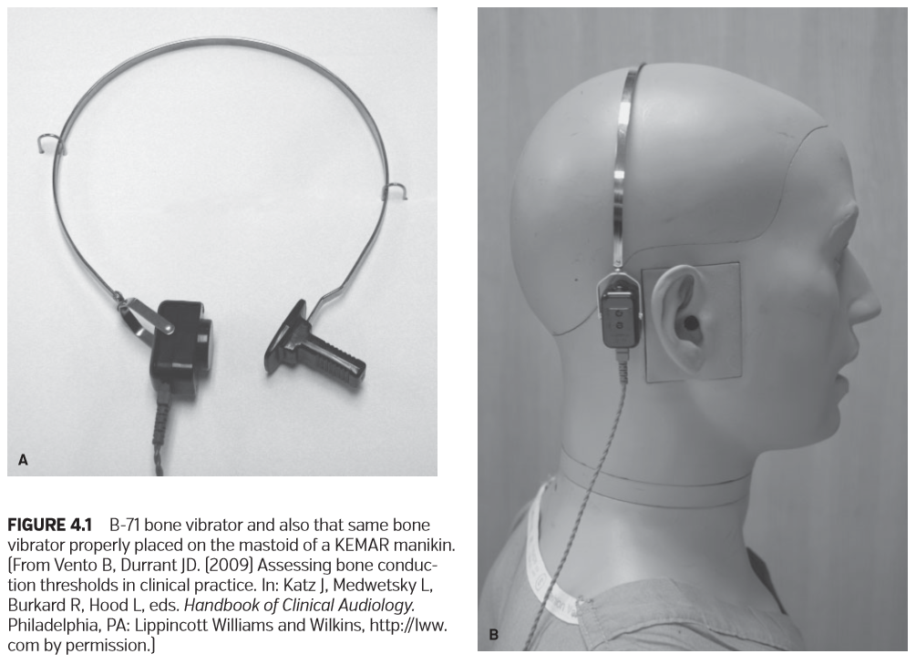

图4.1 B-71骨振子，以及正确放置在KEMAR人体模型乳突上的骨振子。

(从Vento B, Durrant JD。)（2009）临床评估骨传导阈值。In: Katz J, Medwetsky L, Burkard R, Hood L, eds。临床听力学手册。宾夕法尼亚州费城:利平科特·威廉姆斯和威尔金斯，http://lww。com许可。)

### EVALUATION PROCEDURES

评估程序

Common practice is to begin with the bone vibrator on the better hearing ear mastoid or the right mastoid if a better hearing ear is not known or suspected. Evaluation guidelines were published by the American Speech-LanguageHearing Association (ASHA) (2005), including a protocol for tone presentation, patient response modes, and the deﬁnition of threshold. Bone conduction thresholds should be tested at several frequencies and traditionally in this order: 1,000, 2,000, 3,000, and 4,000 Hz, a retest of 1,000, 500, and 250 Hz (ASHA, 1990). Because bone-conducted signals may reach either mastoid at similar intensities, contralateral ear masking may be necessary to obtain ear-speciﬁc bone conduction thresholds. A full discussion of threshold evaluation, masking procedures, and the symbols used for recording thresholds on an audiogram can be found in Chapters 3 and 6 of this book.

通常的做法是，在好耳的乳突上放置骨振动器开始的，如果不知道或没有怀疑有更好听力的耳朵，则从右侧乳突开始。评估指南由美国语言听力协会（ASHA）（2005）发布，包括用于音调呈现，患者反应模式和阈值定义。骨传导阈值应在多个频率下进行测试，传统上按此顺序进行测试：1,000,2,000,3,000和4,000 Hz，重新测试1,000,500和250 Hz（ASHA，1990）。由于骨传导信号可能以相似的强度到达任一乳突，因此可能需要在对侧耳施加掩蔽来获得特定耳朵的骨传导阈值。有关阈值评估、掩蔽步骤和用于在听力图上记录阈值的符号的完整讨论可以在本书的第3章和第6章中找到。

**Outer, Middle, and Inner Ear Components of Bone Conduction**

骨传导过程的外、中、内耳传导因素

Bone-conducted stimuli cause complex skull vibrations in several directions and with several resonances and antiresonances (Stenfelt and Goode, 2005), the details of which are beyond the scope of this chapter. Boneconducted energy ultimately arrives at the cochlea by various transmission routes, which in turn cause basilar membrane-traveling waves to propagate from the stiffer basilar membrane base toward the more compliant basilar membrane apex as occurs for air conduction (Bekesy, 1960). Bone conduction transmission routes can be discussed in terms of outer ear, middle ear, and inner ear components.

骨传导的刺激在多个方向上引起复杂的颅骨振动，并具有多种共振和反共振（StenfeldandGoode，2005），其细节超出了本章的范围。骨传导能量最终通过不同传输途径到达耳蜗，进而导致基底膜行波，从较硬的基底膜基底向较软的基底膜顶点传播，如空气传导所发生的那样（Bekesy，1960）。骨传导的传导路径可以从外耳、中耳、内耳三个要素来讨论。

OUTER EAR COMPONENT OF BONE CONDUCTION

骨传导过程的外耳要素

The outer ear bone conduction component arises from vibration of the bony and especially the cartilaginous walls of the outer ear canal that, in turn, causes sound waves to radiate into the outer ear canal (Stenfelt and Goode, 2005; Tonndorf, 1968). Vibration of the mandible may also add to the sound wave radiation into the ear canal (Stenfelt and Goode, 2005). These sound waves propagate through the middle ear and ﬁnally to the inner ear; thus, the complex phenomenon of bone conduction hearing includes exploitation of the air conduction pathway.

外耳骨传导源于骨骼的振动，特别是外耳道的软骨壁的振动，进而导致声波辐射到外耳道（StenfeldandGoode，2005年；Tonndorf，1968年）。下颌骨的振动也可能增加进入耳道的声波辐射（StenfeltandGoode，2005年）。这些声波通过中耳最终传到内耳，因此，骨传导听觉的复杂现象包含对空气传导通路的利用。

The outer ear component may play little role in the normal unoccluded ear canal, but its role is magniﬁed by the occlusion effect (Stenfelt and Goode, 2005). Normally the outer ear canal acts as a high-pass ﬁlter (Tonndorf, 1968), that is, high-frequency energy is passed into the middle ear whereas low-frequency energy escapes through the ear canal opening. Outer ear canal occlusion traps this low-frequency energy and thereby enhances bone conduction hearing up to 20 dB in the lower audiometric test frequencies (Stenfelt and Goode, 2005).

外耳成分在正常的未闭塞耳道中可能作用不大, 但其作用因堵耳效应而放大（stenfelt 和 goode, 2005年）。通常外耳道起着高通滤波器的作用（唐多夫, 1968），即高频能量进入中耳，而低频能量通过耳道开口逃逸。外耳道阻塞会吸收低频能量，从而在较低频率的听力测试下，将骨传导听力提高多达 20 db（Stenfeelt和Goode，2005年）。

**MIDDLE EAR COMPONENT OF BONE CONDUCTION**

骨传导过程的中耳要素

The middle ear component of bone conduction is the inertial lag of the ossicles (Barany, 1938). Middle ear ossicles are not directly attached to the skull, but are instead suspended by ligaments and tendons and attached at either end to the elastic tympanic and oval window membranes. The ossicles are free to move out of phase with skull vibrations and will do so because of inertia, much as coffee would lag and spill from a cup moved precipitously. Middle ear ossicles vibrate relative to the skull in a like manner as during air conduction hearing, and thus energy is propagated into the inner ear. The middle ear component occurs mainly at and above 1,500 Hz and is especially signiﬁcant near 2,000 Hz, the approximate resonant frequency of the middle ear (Stenfelt et al., 2003). Finally, some have proposed that bone conduction energy radiates from the walls of the middle ear into the middle ear space and sets the tympanic membrane into vibration, but that hypothesis has been challenged (Stenfelt and Goode, 2005).

骨传导过程的中耳部分是听小骨的惯性滞后（Barany，1938）。中耳小骨不是直接附着在颅骨上，而是由韧带和肌腱悬吊着，并在两端附着在弹性鼓膜和卵圆窗膜上。这些听小骨可以自由地与颅骨的振动脱离相位，这是因为惯性的缘故，就像急速移动的杯子中的咖啡会滞后并从中溢出一样。中耳听小骨相对于颅骨振动的方式与空气传导听力时的振动方式相似，因此能量会传播到内耳。中耳有关要素主要发生在1500 Hz以上，尤其在2000 Hz附近显著，这是中耳近似共振频率（Stenfelt等人，2003年）。最后，有人提出，骨传导能从中耳壁辐射到中耳空间，并使鼓膜振动，但这一假说受到了质疑（Stenfeelt和Goode，2005年）。

**INNER EAR COMPONENT OF BONE CONDUCTION**

骨传导过程的内耳要素

The inner ear component of bone conduction involves several contributing factors, including cochlear compression or distortion, cochlear ﬂuid inertia, osseous spiral lamina inertia, and sound pressure transmission through skull contents (brain, membranes, and ﬂuid). Inner ear bone conduction has been described as resulting from alternate compressions and expansions (Herzog and Krainz, 1926) or distortions (Tonndorf, 1968) of the bony cochlear capsule. In turn, cochlear ﬂuids are displaced and basilar membrane-traveling waves are initiated. One factor making cochlear ﬂuid displacement possible is the out-of-phase and disproportionate yielding of the round and oval cochlear windows, which creates alternating spaces for ﬂuid displacement. Cochlear ﬂuid movement, in turn, displaces the basilar membrane and initiates traveling waves. Also, the cochlear and vestibular aqueducts may serve as outlets for ﬂuid displacement allowing for bone conduction hearing when the oval window is ﬁxed as in otosclerosis (Stenfelt and Goode, 2005; Tonndorf, 1968). Fluid displacement is further enabled by a ﬂuid volume differential between the scala tympani on one side of the scala media and the greater ﬂuid volume of the scala vestibuli, vestibule, and semicircular canals on the other side of the scala media (Stenfelt and Goode, 2005; Tonndorf, 1968).

骨传导过程的的内耳要素涉及几个因素，包括耳蜗压缩或变形、耳蜗流体惯性、骨螺旋层惯性、颅骨内容物（脑、膜、液）的声压传递。内耳骨传导被描述为由骨性耳蜗囊的交替压缩和扩张（Herzog和Krainz, 1926）或扭曲（Tonndorf, 1968）引起的。接着，耳蜗液被移位，基底膜行波启动。使耳蜗流体移位成为可能的因素之一是圆窗和卵圆窗的异相和不成比例的屈曲，这为流体置换创造了交替空间。耳蜗的液体运动转而取代基底膜并引发了行波。在骨传导中，耳蜗和前庭导水管也可以作为淋巴液移位的出口，当卵圆窗固定时如耳硬化症（Stenfelt and Goode, 2005;Tonndorf,1968）。中阶（蜗管）一侧的鼓阶与高容量的前庭阶、前庭、半规管之间的流体容积差进一步导致淋巴液移位。

Inertia of the inner ear ﬂuids contributes to inner ear bone conduction hearing, especially below 1,000 Hz (Stenfelt and Goode, 2005). Cochlear ﬂuids and windows are free to vibrate out of phase with skull vibrations and will do so because of inertia, compared earlier to coffee that will lag and spill from a moving cup. Cochlear ﬂuid movement, in turn, displaces the basilar membrane and initiates traveling waves. The spiral lamina may also be ﬂexible and lag skull vibrations, thereby contributing to bone conduction hearing, especially at higher frequencies (Stenfelt et al., 2003).

内耳液体的惯性有助于内耳骨传导听力，尤其是在1000hz以下。耳蜗内的液体和窗口可以随着颅骨振动而自由地不同步振动，并且由于惯性会与之前提到的咖啡一样，滞后并从移动的杯子中溢出。耳蜗液体的流动反过来又取代了基底膜，并引发了行波。有弹性的螺旋层和滞后的颅骨振动，有助于骨传导听力，尤其在较高频率下。

Finally, bone conduction energy can travel in nonosseous skull contents, such as the brain, membranes, and ﬂuids, and reach the cochlea through the cochlear and/or vestibular aqueducts (de Jong et al., 2011; Stenfelt and Goode, 2005). The nonosseous skull contents route may contribute little to normal bone conduction hearing, but it plays a role in some inner ear disorders as discussed below.

最后，骨传导能量可以在非骨性颅骨内容物中传播，如大脑、膜和液体中，并通过耳蜗和/或前庭导水管到达耳蜗（de Jong et al.，2011;Stenfelt和Goode, 2005）。非骨性颅骨内容物路径对正常骨传导听力的贡献不大，但在如下所述的一些内耳疾病中起着重要作用。

### TRANSMISSION ROUTE MODEL

传输路径模式

Figure 4.2 illustrates the air and bone conduction transmission routes. Note the orderly air conduction route through the outer, middle, and inner ear in contrast with more complex bone conduction hearing involving concomitant outer, middle, and inner ear components bilaterally.

图4.2显示了气导和骨传导的传输路径。注意，通过外耳、中耳和内耳有序的空气传导通路，与双侧外耳、中耳和内耳杂乱的骨传导通路形成对比。

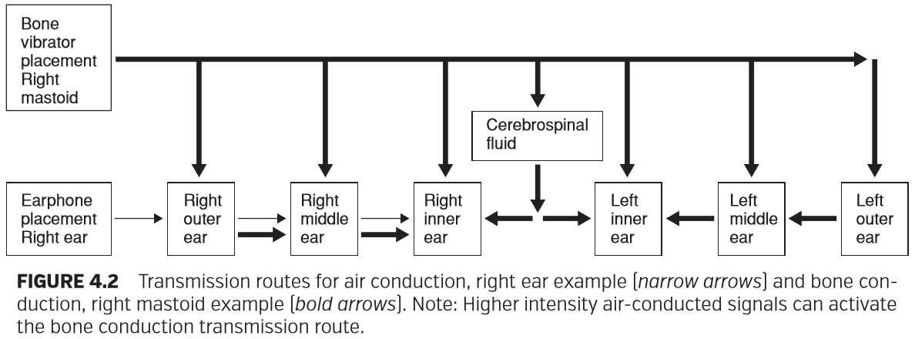

图4.2空气传导的传导路径，右耳示例（窄箭头）和骨传导，右乳突示例（粗箭头）。注:高强度空气传导信号可激活骨传导传导路径。

**EXAMPLES OF DIAGNOSES Normal-hearing Sensitivity**

听力正常灵敏度诊断实例

Normally hearing patients are without disorder that would hinder energy from reaching the inner ear by the air conduction route. Owing to calibration, air conduction thresholds will be near 0 dB HL. Similarly, normally hearing patients are without disorder that would hinder any of the bone conduction components. Again owing to calibration, bone conduction thresholds will be near 0 dB HL and be similar to air conduction thresholds (±10 dB). Figure 4.3 shows an example audiogram of a patient with normal-hearing sensitivity.

正常情况下，没有患病的听力正常患者会阻碍能量通过气导途径到达内耳。经过校准，空气传导阈值将接近0 dB HL。类似地，没有患病的听力正常的患者不会阻碍能量通过任何骨传导部分。再次经过校准，骨传导阈值将在0dBHL接近于空气传导阈值（±10 dB）。图4.3显示了一个听力正常患者的听力图。

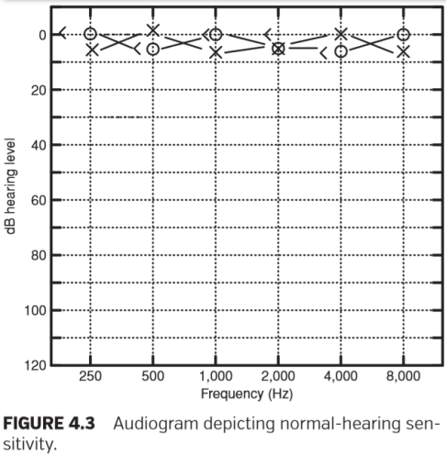

图4.3正常听力患者的听力图。

CHL with Air–Bone Gaps of Outer Ear Origin

外耳源性具有气骨间隙的传导性聋

Outer ear occlusive disorder may hinder air conduction energy from reaching the inner ear. In such cases, air conduction thresholds would be poorer than 0 dB HL, at least at some frequencies, to a degree dictated by the occlusive disorder. Bone conduction thresholds, in contrast, may be unaffected if the outer ear bone conduction component is not hindered. Bone conduction thresholds would be near 0 dB HL and accurately reﬂect sensory/neural hearing (sensory/ neural reserve or true sensory/neural capability). The result is a hallmark of CHL: air conduction thresholds >10 dB HL lower (poorer) than normal bone conduction thresholds. The maximum air–bone gap is approximately 60 dB; higher intensity air-conducted sound waves set the skull into vibration and induce bone conduction hearing thus limiting the maximum difference between air and bone conduction thresholds (Bekesy, 1960).

外耳闭塞性疾病可能阻碍能量通过气导到达内耳。在这种情况下，至少在某些频率下，空气传导阈值将比0dB HL差，达到闭塞性疾病所规定的程度。相反，如果外耳骨传导成分不受阻碍，则骨传导阈值可以不受影响。骨传导阈值将接近0 dB HL并准确地反映感音/神经听觉过程中骨导的情况（感音/神经储备或真正的感音/神经能力）。结果是传导性聋的一个标志：空气传导阈值> 10 dB HL（低于正常骨传导阈值）。最大气骨间隙约为60 dB；较高强度的空气传导声波使颅骨振动并产生骨传导听力，从而限制了气导和骨导阈值之间的最大差异

However, bone conduction thresholds are often improved by occlusive disorders due to the occlusion effect. In such cases, bone conduction thresholds overestimate sensory/neural reserve. In rarer cases, outer ear occlusive disorder may interfere with the outer or middle ear bone conduction components and thus lower bone conduction thresholds, a so-called pseudoSNHL because neither hair cell nor neuron damage is the cause (Hall and Croutch, 2008). In such cases, bone conduction thresholds underestimate sensory/neural reserve. Figure 4.4 shows an audiogram example involving occlusive osteomas; the presurgery audiogram shows CHL, but with bone conduction thresholds that underestimated the true sensory/ neural reserve revealed by postsurgery bone conduction thresholds. Cerumen impaction that loads (adds mass to) the tympanic membrane can cause pseudoSNHL (Hall and Croutch, 2008; Tonndorf, 1968). Anderson and Barr (1971) reported pseudoSNHL with partial cerumen occlusion of the outer ear canal, though they attributed it to earphone artifact.

然而，因为存在堵耳效应，骨传导阈值常常由于闭塞障碍而得到改善。在这种情况下，骨传导阈值评估高于感音/神经性聋评估。在较罕见的情况下，外耳阻塞性疾病可能会干扰外耳或中耳骨传导部分，从而降低骨传导阈值，即伪感音神经性聋，因为毛细胞或神经元损伤都不是其原因（Hall and Croutch，2008）。在这种情况下，骨传导阈值评估低于感音/神经性聋评估。图4.4显示了一个有关闭塞性骨瘤的听力图例子；术前听力图显示传导性聋，但骨传导阈值差于术后骨传导阈值的真正感音/神经性情况。堵塞鼓膜的（大量的）耵聍栓塞可导致伪感音神经性聋（Hall and Croutch，2008；Tonndorf，1968）。Anderson和Barr（1971）报道了耵聍阻塞外耳道的伪感音神经性聋，尽管他们将其归因于耳机伪影。

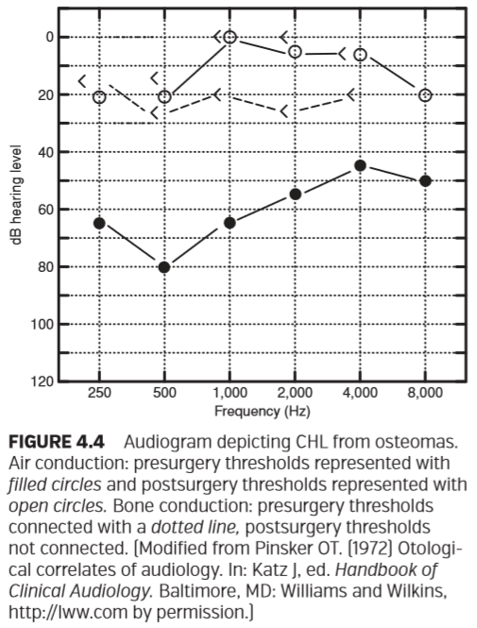

**CHL with Air–Bone Gaps of Middle Ear Origin**

中耳源性气骨间隙的传导性聋

Middle ear disorder may hinder air conduction energy from reaching the inner ear. In such cases, air conduction thresholds would be poorer than 0 dB HL, at least at some frequencies, to a degree dictated by the middle ear disorder. Bone conduction thresholds, in contrast, may be unaffected if the middle ear bone conduction component is not signiﬁcantly hindered. Bone conduction thresholds would therefore be near 0 dB HL and accurately reﬂect sensory/ neural reserve or be improved due to the occlusion effect. The resulting air–bone gaps can be as great as approximately 60 dB. Air–bone gaps can be seen with many middle ear disorders; an example of a CHL audiogram is shown in Figure 4.5.

中耳疾病可能阻碍能量经空气传导至内耳。在这种情况下，至少在某些频率，空气传导阈值将比0dB HL差，在一定程度上由中耳疾病决定。相反，如果中耳骨传导部分没有明显受阻，骨传导阈值可能不受影响。因此，骨传导阈值将接近0dB HL并且准确地反映感音/神经性情况或由于阻塞效应而得到改善。由此产生的气骨间隙可以高达约60dB。许多中耳疾病可见气骨间隙；如图4.5显示了一个CHL听力图的例子。

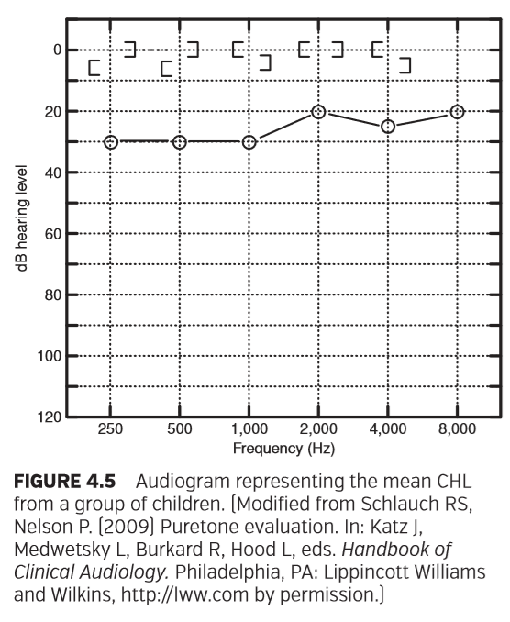

However, middle ear disorder often hinders the middle ear contribution to bone conduction and thus lowers (makes poorer) bone conduction thresholds. The result is a pseudoSNHL in addition to the CHL, with bone conduction thresholds underestimating sensory/neural reserve. For example, ossicular ﬁxation caused by otosclerosis predictably manifests as lower (poorer) than normal bone conduction thresholds at the approximate middle ear resonant frequency of 2,000 Hz (Carhart, 1950). The air–bone gaps one expects with CHL may therefore be reduced or obliterated at and near 2,000 Hz. For stapedial ﬁxation caused by otosclerosis, this pseudoSNHL is known as the Carhart notch. An audiogram example is shown in Figure 4.6; note the Carhart notch and CHL presurgery and the restoration of normal air and bone conduction thresholds postsurgery consistent with restoration to more normal middle ear resonance.

然而，中耳疾病经常阻碍中耳的骨传导从而降低（使较差）骨传导阈值。结果是除了传导性聋之外，还有假性SNHL，骨传导阈值低于感音/神经性。例如，由耳硬化症引起的听骨链固定可预见为在2000赫兹的近似中耳共振频率下比正常骨传导阈值更低（更差）（Carhart，1950）。 因此，CHL所预期的气骨间隙可以在2,000Hz和接近2,000Hz处减小或消失。 对于由耳硬化引起的镫骨固定，这种假性NHHL被称为卡哈切迹。 听力图示例如图4.6所示；注意卡哈切迹、CHL术前、术后正常气导和骨导阈值的恢复与恢复至正常的中耳共振相一致。

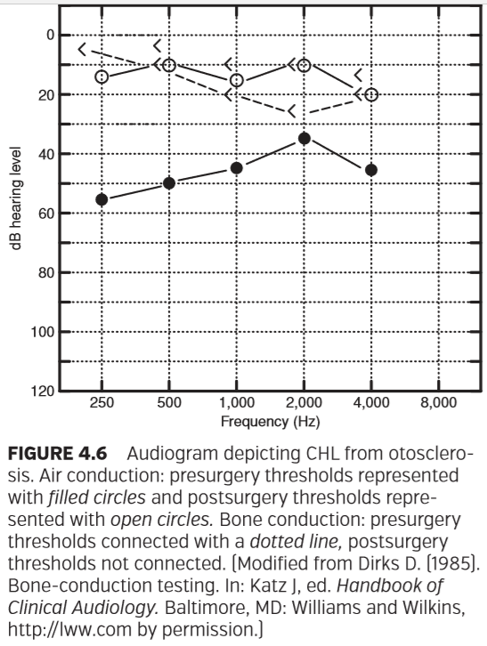

图4.6显示耳硬化症CHL的听力图。空气传导：术前阈值用实心圆表示，术后阈值用空心圆圈表示。骨传导：术前阈值与虚线连接，术后阈值未连接。

The middle ear bone conduction component can be affected by other disorders as well. For example, Dirks and Malmquist (1969) reported pseudoSNHL in addition to CHL in a case of mallear ﬁxation. Similarly, pseudoSNHL in addition to CHL has been reported for subjects with otitis media (Carhart, 1950; Hall and Croutch, 2008). Yasan (2007) reported 1,000 Hz and in some cases 2,000 Hz bone conduction notches in patients with otitis media, and Kumar et al. (2003) reported 2,000 Hz bone conduction notches in patients with glue ear. Apparently, effusion may produce stiffening or loading effects, thus hindering the middle ear bone conduction component (Tonndorf, 1968). An example of CHL caused by otitis media is shown in Figure 4.7; note the pretreatment pseudoSNHL and CHL, and the resolution of the same posttreatment.

中耳骨传导部分也可能受到其他疾病的影响。例如，德克斯和曼奎斯特（1969）报道了一例锤骨固定病例中假性snhl合并CHL。类似的，对于中耳炎患者，除了CHL外，也有关于假性SNHL的报道（Carhart, 1950;霍尔和Croutch, 2008）。Yasan（2007）报道了1000Hz和某些情况下2000Hz的中耳炎患者的骨传导切迹， Kumar等（2003）报道咽鼓管堵塞（胶耳）患者骨传导缺口在2000 Hz。显然，积液可能会产生硬化或负载效应，从而阻碍中耳骨传导部分（Tonndorf, 1968）。图4.7显示了由中耳炎引起的CHL一例，注意治疗前后伪snhl和CHL的情况，以及相同处理后的情况。

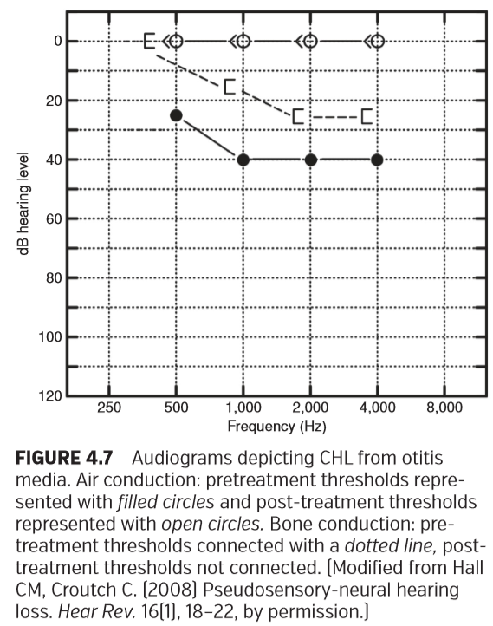

图4.7显示中耳炎CHL的听力图。 空气传导：用实心圆表示的预处理阈值和用空心圆表示的治疗后阈值。 骨传导：治疗前阈值与虚线连接，治疗后阈值未连接。

It should be noted here that true SNHL with otitis media has also been proposed. Pathogens in middle ear effusion may pass through the round window and cause damage to cochlear hair cells, and because of the round window proximity to the basal turn of the cochlea, high-frequency SNHL might result (Paparella et al., 1984).

需要注意的是，也有人提出了患有中耳炎的真SNHL。中耳积液中的病原体可能通过圆窗进入耳蜗，对耳蜗毛细胞造成损伤，由于圆窗靠近耳蜗基底部，可能导致高频SNHL。

### SNHL

感音神经性聋

Neither sensory nor neural disorders hinder energy from reaching the inner ear by the air conduction route or by any of the bone conduction routes. Changes in air and bone conduction thresholds are affected only by the damage to sensory/neural structures which will lower (make poorer) air and bone conduction thresholds similarly. Air and bone conduction thresholds will therefore be similar (±10 dB). Figure 4.8 shows an example audiogram of a patient with SNHL from presbycusis.

无论是感音性障碍和神经性障碍都不会阻碍能量通过气传导途径或任何骨传导途径到达内耳。空气和骨传导阈值的变化只受感音/神经结构损伤的影响，这将同样降低气导和骨导阈值。因此空气和骨传导阈值将是类似的（±10 dB）。图4.8显示了一例老年性感音神经性聋患者的听力图。

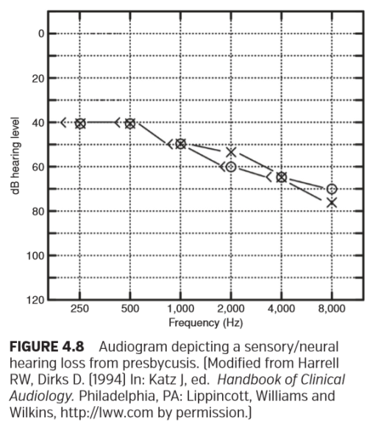

图4.8描绘老年性聋的感觉/神经性听力损失的听力图。

**MHL with Air–Bone Gaps of Outer or Middle Ear Origin**

外耳源或中耳源性气骨间隙的混合性聋

Patients may have an MHL. An MHL audiogram will therefore show evidence of both the SNHL (affected air and bone conduction thresholds) and the CHL (air–bone gaps >10 dB). Bone conduction thresholds may accurately reﬂect sensory/neural reserve or a pseudoSNHL may underestimate sensory/neural reserve. An MHL audiogram example is shown in Figure 4.9.

患者可能患有MHL。因此，MHL听力图将显示SNHL（受影响的空气和骨传导阈值）和CHL（气-骨间隙> 10 dB）的证据。骨传导阈值可以准确地反映感音/神经性情况，或者假性NHL可能低估感音/神经性情况。MHL听力图示例如图4.9所示。

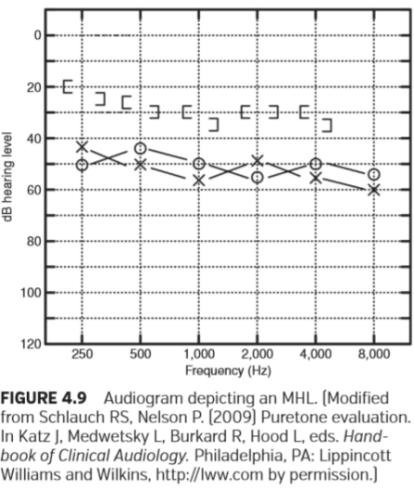

图4.9显示混合性聋的听力图

**Superior Semicircular Canal Dehiscence with PseudoSNHL and Air–Bone Gaps of Inner Ear Origin**

伪SNHL和内耳源性气骨间隙的上半规管裂

SSCD is a thinning or absence of the temporal bone over the membranous labyrinth of the superior semicircular canal. This condition opens a third elastic membranous inner ear window at the dehiscence, the other two windows of course being the oval and round windows of the cochlea (Merchant et al., 2007). The audiogram manifestation of SSCD may mimic CHL or MHL, with air–bone gaps that could approach 60 dB (Chien et al., 2012). Air conduction thresholds may be adversely affected because energy reaching the inner ear by the air conduction route is shunted away from the cochlea through the dehiscence, typically manifesting in the lower test frequencies consistent with a mathematical model analysis based on the anatomical dimensions of the inner ear (Merchant et al., 2007). Bone conduction thresholds, in contrast, may be improved by skull content sound pressure transmissions through the dehiscence, that is, augmentation of the inner ear bone conduction component. The term air–bone gap of inner ear origin has been used to describe these ﬁndings (Attias et al., 2012). This is a useful term as it emphasizes that the air–bone gaps do not reﬂect either a CHL or MHL. Figure 4.10 shows an example audiogram from a patient with SSCD.

SSCD是上半规管膜迷路上的颞骨变薄或缺失。这种情况在开裂处打开第三个弹性膜状内耳窗，另外两个窗当然是耳蜗的卵圆形和圆窗（Merchant et al.， 2007）。SSCD的听力图表现可能类似于CHL或MHL，气骨间隙可接近60db （Chien et al.， 2012）。气导阈值可能受到不利影响，因为通过气导路径到达内耳的能量通过开裂从耳蜗分流，通常表现在较低的测试频率，其与基于内耳解剖尺寸的数学模型分析一致。相反，颅骨内容物的声压通过裂开传递，即增加内耳骨传导元件，可以提高骨传导阈值。内耳源性气骨间隙这个术语被用来描述这些情况。这是一个有用的术语，因为它强调了气骨间隙既不反映CHL也不反映MHL。图4.10显示了一例SSCD患者的听力图。

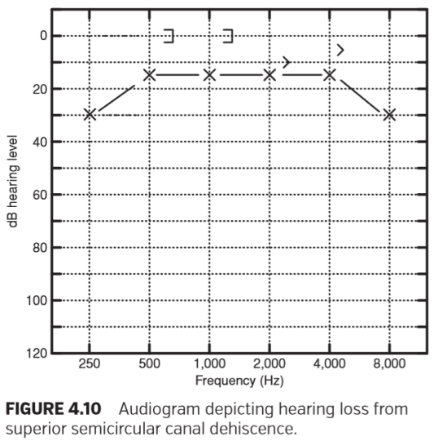

图4.10上半规管裂开所致听力损失的听力图。

**Large Vestibular Aqueducts with SNHL and Air–Bone Gaps of Inner Ear Origin**

SNHL和内耳源性气骨间隙的大前庭水管综合征

Large vestibular aqueducts (LVA) cause SNHL with air– bone gaps of inner ear origin (Attias et al., 2012; Jackler and De La Cruz, 1989). The cause of SNHL with LVA is unclear; it may result from traumatic endolymph pressure from the endolymphatic duct and sac that damages hair cells, or by endolymph electrolyte content that is harmful to the hair cells or stria vascularis (Campbell et al., 2011; Jackler and De La Cruz, 1989; Levinson et al., 1989). The audiometric ﬁndings for LVA may also be inﬂuenced by the third- window effect similar to SSCD. Air–bone gaps of inner ear origin are possible: Air conduction thresholds may be lowered (made poorer) because some energy is shunted away from the cochlea through the LVA, whereas bone conduction thresholds may be unaffected or improved by sound pressure transmissions through the skull contents to the LVA, (Attias et al., 2012; Merchant et al., 2007). Therefore, as with SSCD, the air–bone gaps seen with LVA do not reﬂect outer ear occlusion or middle ear disorder as in CHL or MHL. Figure 4.11 shows an example audiogram from a patient with LVA.

大前庭导水管（LVA）引起SNHL和内耳源性气骨间隙。LVA引起SNHL的原因尚不清楚；它可能是由于内淋巴管和内淋巴囊的创伤性内淋巴压力损伤了毛细胞，或者是内淋巴电解质含量对毛细胞或血管纹有害。LVA的听力测定结果也可能受到类似于SSCD的第三窗效应的影响。内耳来源的气-骨间隙是可能存在的：由于一些能量通过LVA从耳蜗分流，气导阈值可能降低（变得更差），而骨导阈值可能不受影响或通过颅骨内容物到LVA的声压传输而改善。因此，与SSCD一样，LVA所见的气骨间隙不会像CHL或MHL那样反映外耳阻塞或中耳疾病。图4.11显示了一例来自LVA患者的听力图。

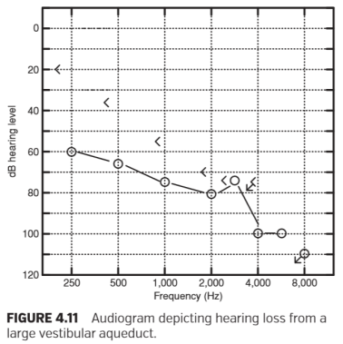

图4.11 描述大型前庭导水管听力损失的听力图。

**Intracranial Hypertension with PseudoSNHL**

伪SNHL的颅内高压

Intracranial hypertension with abnormal cerebrospinal ﬂuid ﬂow has been associated with a number of neurologic conditions including syringohydromyelia, Chiari malformations, trauma, tumors, arachnoiditis, subarachnoid hemorrhages, meningitis, and multiple sclerosis (Steiger et al., 2007). Resulting audiologic symptoms may include whooshing pulsatile tinnitus and low-frequency pseudoSNHL. The pulsatile tinnitus may arise from circle of Willis blood ﬂow or pulsations of the walls of the dural sinuses (Rudnick and Sismanis, 2005), which travel through the cochlear or vestibular aqueducts to the cochlea (Marchbanks et al., 2005). The pseudoSNHL might be attributable to masking from the pulsatile tinnitus (Rudnick and Sismanis, 2005; Steiger et al., 2007) or from elevated cochlear ﬂuid pressure stiffening the basilar, oval, and round window membranes (Sismanis, 1987). Stiffened cochlear membranes, in turn, may interfere with cochlear ﬂuid motion and thus hinder the inner ear bone conduction component. Figure 4.12 shows an audiogram of a patient with intracranial hypertension.

脑脊液流动异常引起的颅内高压与许多神经系统疾病有关，包括脊髓空洞积水症，chiari畸形（小脑扁桃体下疝畸形），创伤，肿瘤，蛛网膜炎，蛛网膜下腔出血，脑膜炎和多发性硬化症（Steiger等，2007）。由此产生的听力相关症状可能包括嗖的搏动性耳鸣和低频伪NHNL。搏动性耳鸣可能是威利斯循环血流或硬脑膜窦壁搏动引起的，这些搏动通过耳蜗或前庭导水管进入耳蜗。伪NHNL可能是由于搏动性耳鸣的掩蔽作用（Rudnick and Sismanis, 2005）；或来自升高的耳蜗流体压力，使基底膜、椭圆形膜和圆形窗膜变硬（Sismanis, 1987）。硬化的耳蜗膜反过来又会干扰耳蜗流体运动，从而阻碍内耳骨传导成分。图4.12显示了一例颅内高压患者的听力图。

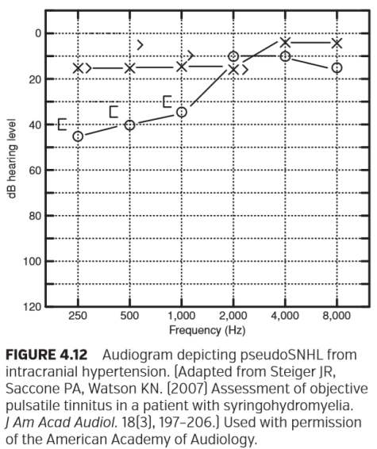

图4.12颅内高压性假性SNHL的听力图。脊髓空洞症患者客观脉动性耳鸣的评估。 经美国听力学会许可使用

### TECHNICAL CLINICAL CAVEATS

临床技术注意事项

**Vibrotactile Responses**

振动触觉反应

It is possible for a patient to feel bone conductor diaphragm vibrations during bone conduction evaluation, especially at high intensities and at lower test frequencies (Nober, 1964). When a patient responds to stimuli felt but not heard, the responses are called vibrotactile. Vibrotactile responses must not be recorded as auditory thresholds as two possible errors might result. First, bone conduction vibrotactile responses could be better than the air conduction thresholds and therefore might result in erroneous air–bone gaps and misdiagnoses. Second, recording vibrotactile responses as bone conduction thresholds might erroneously suggest hearing in patients who are deaf (Nober, 1964). Individual sensitivity to vibrotactile sounds is variable (Boothroyd and Cawkwell, 1970). Perhaps the only way to know if responses are vibrotactile is to ask patients; this is recommended, especially when bone conduction thresholds appear inconsistent with other audiometric ﬁndings or history.

在骨传导评估中，特别是在高强度和低测试频率下，患者有可能感觉到骨振动器的振动（Nober，1964）。当病人对感觉到但听不到的刺激做出反应时，这种反应被称为振动触觉反应。振动触觉反应不能被记录为听觉阈值，因为可能会产生两种错误。首先，骨传导的振动触觉反应可能比气导阈值更好，从而可能导致错误的气骨间隙和误诊。其次，将振动触觉反应记录为骨传导阈值可能会错误地提示耳聋患者的听力（Nober，1964）。个体对振动触觉声音的敏感性是可变的（Boothroyd和Coulwell，1970）。也许知道反应是否是振动触觉的唯一方法就是询问病人；建议这样做，尤其是当骨传导阈值与其他听力检查结果或病史不一致时。

**Interaural Attenuation, Masking, and the Occlusion Effect**

耳间衰减、掩蔽和堵耳效应

Audiologists typically target a test ear for evaluation while being vigilant for the possibility of the patient hearing in the nontest ear. This vigilance is warranted during boneconduction threshold evaluation; transducer placement on the test ear side mastoid bone results in activation of bone conduction bilaterally. The so-called cross-over from the test ear side to the nontest ear can occur with minimal interaural attenuation, ranging from 0 dB at 250 Hz to 15 dB at 4,000 Hz (Studebaker, 1967). Caution compels most audiologists to assume the worst-case scenario of 0 dB interaural attenuation, that is, equal tone intensity at the test and nontest ears. Bone conduction thresholds are therefore not typically considered to be ear-speciﬁc unless sufﬁcient masking noise is delivered to the nontest ear. There are many variables to consider while masking, such as when to mask, masking noise type, masker intensity, and accounting for the occlusion effect caused by the earphone on the nontest ear (see Chapter 6 for details).

听力学家通常以测试耳为目标进行评估，同时对非测试耳朵听力的可能情况保持警惕。这种警惕性在骨传导阈值评估期间是有必要的；换能器放置在测试耳侧乳突骨上可导致双侧骨传导发生。从测试耳到非测试耳的所谓交叉可能以最小的耳间衰减发生，范围从250Hz处的0dB到4,000Hz处的15dB（Studebaker，1967）。这个警惕迫使大多数听力学专家假设最坏的情况是0 dB耳间衰减，即测试和非测试耳朵的音调强度相等。因此，骨传导阈值通常不被认为是特定耳的，除非有足够的掩蔽噪声传递到未测试的耳朵。掩蔽时有许多变量需要考虑，例如何时掩蔽，掩蔽噪声类型，掩蔽强度，以及如何考虑耳机对未测试耳朵造成的堵耳效应（详见第6章）。

**Mastoid versus Forehead Placement**

乳突与前额位置的比较

During bone conduction hearing evaluation, audiologists may place the bone vibrator on either the mastoids or the foreheads of their patients. Mastoid placement is preferred by most audiologists (Martin et al., 1998). Perhaps the main advantage of mastoid placement is that the resulting bone conduction thresholds are up to 14.7 dB less than bone conduction thresholds measured with forehead transducer placement (Table 4.1). This allows for a greater testing range from threshold to equipment intensity limits or vibrotactile sensation. Moreover, vibrations from mastoid bone vibrator placement are in the same plane as middle ear ossicular motion, therefore engaging the middle ear bone conduction mechanism. This allows the audiologist to record evidence of changes in the middle ear bone conduction component, for example, the middle ear resonance changes that are likely to occur with otosclerosis. Not surprisingly, audiometers in most clinics are calibrated for mastoid placement.

在骨传导听力评估期间，听力学家可将骨振动器放置在患者的乳突或前额上。大多数听力学家都喜欢放置在乳突上（Martin等，1998）。也许乳突放置的主要优点是，导致的骨传导阈值比用前额放置的换能器测量出的骨传导阈值低14.7 dB（表4.1）。这是允许的更大测试范围，从阈值到设备强度限制或振动触觉。此外，乳突骨振动器放置的振动与中耳听骨运动处于同一平面，因此参与了中耳骨传导机制。这允许听力学家可以记录中耳骨传导成分变化的证据，例如，耳硬化可能发生的中耳共振变化。毫不奇怪，大多数诊所的听力计都是针对乳突放置进行校准的。

Forehead placement can be used if correction factors from Table 4.1 are applied or if the audiometer is calibrated for forehead transducer placement. Audiologists who prefer forehead transducer placement should consider purchasing a speciﬁcally designed bone vibrator and headband. Forehead placement has advantages, including low intrasubject and intersubject variability because of the less variable forehead placement surface and more uniform nonpneumatized forehead bone (Dirks, 1964). Also, vibrations from forehead placement are perpendicular to middle ear ossicular motion and may not engage the middle ear bone conduction mechanism as with mastoid placement. The resulting forehead bone conduction thresholds should be relatively unaffected by the changes in middle ear resonance and, in cases of ossicular ﬁxation, reﬂect a truer measure of cochlear reserve than bone conduction thresholds obtained during mastoid transducer placement. Figure 4.13 shows an example audiogram with forehead and mastoid bone vibrator placement for a patient with ossicular ﬁxation.

如果应用表4.1中的校正系数或者如果针对前额放置换能器校准了听力计，则可以使用前额放置。喜欢前额放置换能器的听力师应考虑购买专门设计的骨振动器和头带。前额放置具有优势，受试者测试内和受试者测试间的变异性较低，因为前额放置表面变化较小，前额骨非气化更均匀（Dirks，1964）。此外，前额放置的振动垂直于中耳听骨运动，并且可能不像乳突放置那样参与中耳骨传导机制。由此产生的前额骨传导阈值应该相对不受中耳共振变化的影响，并且在听骨固定的情况下，应比在乳突放置换能器获得的骨传导阈值更准确的反应耳蜗情况。图4.13显示了一个例听阈图，其中包括前额和乳突骨振动器放置，用于听骨固定的患者。

**Threshold Accuracy and the Air–Bone Gap**

阈值精度与气骨间隙

Throughout this chapter signiﬁcant air–bone gaps were deﬁned as >10 dB. However, patient response variability can result in underestimated or exaggerated air–bone gaps and even bone–air threshold gaps. Studebaker (1967), for example, calculated the standard deviation of air–bone gaps at 5 dB and noted that air–bone threshold gaps of ≥15 dB can sometimes be seen in the absence of CHL. Similarly, Margolis (2008) calculated a hypothetical air–bone threshold gap distribution based on the independent variability of air and bone conduction thresholds. Signiﬁcant air–bone and even bone–air threshold gaps were predicted, of course, with greater threshold gaps occurring less frequently. Moreover, Margolis reported apparent tester bias; when testing patients with SNHL an expert audiologist measured more air–bone threshold gaps ≤5 dB than the distribution predicted. Audiologists should not rigidly adhere to untenable expectations regarding air–bone threshold gaps.

在本章中，显著的气骨间隙定义为> 10 dB。然而，患者的反应变异性可导致低估或夸大的气骨间隙甚至骨-气阈值间隙。例如，Studebaker（1967）计算出气-骨间隙的标准偏差为5 dB，并指出在没有CHL的情况下，有时可以看到≥15dB的气-骨阈值间隙。同样，Margolis（2008）根据空气和骨传导阈值的独立变化计算出假设的气-骨阈值间隙分布。当然，预测显著的气-骨甚至骨-空气阈值间隙，阈值间隙越大，发生的频率越低。此外，Margolis报告了明显的测试偏差；当测试患有SNHL的患者时，专家听力学家测量的气-骨阈值间隙比预测的分布≤5dB。听力师不应拘泥于对气-骨阈值间隙的不合理期望。

### CONCLUSION

结论

Bone conduction threshold evaluation is an integral component of the basic audiologic examination. When bone conduction thresholds are interpreted with an understanding of air and bone conduction hearing, more accurate siteof-lesion and etiology diagnoses can be made. It is hoped that with this chapter the author has informed and motivated readers to that end.

骨传导阈值评估是基础听力学检查不可或缺的组成部分。通过理解气导和骨导听力来解释骨传导阈值时，可以更准确的做出病位诊断和病因诊断。希望通过这一章，作者已使读者了解并激励他们达到这一目的。

### FOOD FOR THOUGHT

引人深思的事

1. How might the air–bone gaps of patients with outer ear occlusion differ from the air–bone gaps of patients with middle ear disorder?

1. 外耳闭塞患者的气骨间隙与中耳疾病患者的气骨间隙有何不同？

2. Why are air–bone gaps usually but not always indicative of CHL?

2. 为什么气骨间隙通常是CHL的标志，但并不总表明是CHL？

3. Why is worsening bone conduction hearing not always indicative of hair cell and/or neural disorder?

3. 为什么骨导听力恶化并不总是表明毛细胞和/或神经紊乱？

## Chapter 6 Clinical Masking

临床掩蔽

In the ﬁrst edition of this text, Sanders (1972) wrote the following introduction to his chapter on clinical masking:

在本章的第一版中，Sanders（1972）在其关于临床掩蔽的章节中写了以下简介：

Of all the clinical procedures used in auditory assessment, masking is probably the most often misused and the least understood. For many clinicians the approach to masking is a haphazard hit-or-miss bit of guesswork with no basis in any set of principles. (p 111)

在用于听觉评估的所有临床程序中，掩蔽可能是最常被误用和最难理解的。对于许多临床医生来说，掩蔽的方法是一种没有任何依据随意的猜测。

Unfortunately, this statement may still hold true today.

不幸的是，这种说法在今天仍然适用。

The principles of clinical masking are difﬁcult for many beginning clinicians to understand. Although the clinician can apply masking formulas and procedures appropriately in most clinical situations, a lack of understanding of the underlying theoretical constructs becomes evident during cases where modiﬁcation of a standard procedure is required. A lack of understanding of the underlying concepts of masking often leads to misuse of clinical procedures.

临床掩蔽的原理对许多刚入门的临床医生来说是很难理解的。虽然临床医生可以在大多数临床情况下适当地应用掩蔽公式和程序，但在需要修改标准程序时，对基础理论结构的理解不足会变得很明显。对掩蔽的基本概念理解不足常常导致临床程序的滥用。

Theoretical and empirical bases of masking provide a strong foundation for the understanding of applied clinical masking procedures. It will become evident throughout this chapter that there is not a single “correct” approach to clinical masking. Any approach to clinical masking that is based on sound theoretical constructs and veriﬁed through clinical experience is correct. One approach will not meet all clinical needs. A strong foundation in the underlying concepts of clinical masking serves three purposes. First, it allows the clinician to make correct decisions about the need for masking. Second, it allows the clinician to make a well-informed decision when selecting a speciﬁc approach to clinical masking. Finally, it allows the clinician to apply and modify a clinical masking procedure appropriately.

掩蔽的理论和经验为临床应用掩蔽程序的理解提供了坚实的基础。对于临床掩蔽在本章中很明显没有一种单一的“正确”的方法。任何基于健全的理论构建并通过临床经验验证的临床掩蔽方法都是正确的。一种方法不能满足所有临床需求。临床掩蔽基本概念的坚实基础有三个目的。首先，它允许临床医生对掩蔽需求做出正确的决定。其次，它允许临床医生在选择特定的临床掩蔽方法时做出明智的决定。最后，它允许临床医生适当地应用和修改临床掩蔽程序。

### THE NEED FOR MASKING

掩蔽的需求

A major objective of the basic audiologic evaluation is assessment of auditory function of each ear. There are situations during both air-conduction and bone-conduction testing when this may not occur. Although a puretone or speech stimulus is being presented through a transducer to the test ear, the nontest ear can contribute partially or totally to the observed response. Whenever it is suspected that the nontest ear is responsive during evaluation of the test ear, a masking stimulus must be applied to the nontest ear to eliminate its participation.

基础听力学评估的一个主要目的是评估每个耳朵的听觉功能。在气导和骨导测试期间有可能不会发生这种情况。尽管通过换能器向测试耳朵呈现纯音或语音刺激，但是非测试耳朵可以部分或完全地做出响应。在测试耳的评估过程中，当怀疑非测试耳有反应时，必须对非测试耳施加掩蔽刺激，以消除非测试耳的参与。

**Air-Conduction Testing**

气导测试

Cross hearing occurs when a stimulus presented to the test ear “crosses over” and is perceived in the nontest ear. There are two parallel pathways by which sound presented through an earphone (i.e., an air-conduction transducer) can reach the nontest ear. Speciﬁcally, there are both bone-conduction and air-conduction pathways between an air-conduction signal presented at the test ear and the sound reaching the nontest ear cochlea (Studebaker, 1979). First, the earphone can vibrate with sufﬁcient force to cause deformations of the bones of the skull. An earphone essentially can function as a bone vibrator at higher sound pressures. Because both cochleas are housed within the same skull, the outcome is stimulation of the nontest ear cochlea through bone conduction. Second, sound from the test earphone can travel around the head to the nontest ear, enter the opposite ear canal, and ﬁnally reach the nontest ear cochlea through an air-conduction pathway. Because the opposite ear typically is covered during air-conduction testing, sound attenuation provided by the earphone will greatly minimize or eliminate the contribution of the air-conduction pathway to the process of cross hearing. Consequently, cross hearing during air-conduction testing is considered primarily a boneconduction mechanism.

呈现给测试耳的刺激“穿过”测试耳并且被非测试耳感知到，就会发生交叉听力。通过耳机（即，空气传导换能器）发出声音有两条平行的途径可以到达非测试耳。具体来说，在测试耳中呈现的气导信号与声音到达未测试耳的耳蜗之间，存在骨传导和气传导通路（Studebaker, 1979）。首先，耳机可以以足够的力量振动，使颅骨变形。耳机在较高的声压下基本上可以充当骨振动器。由于两个耳蜗位于同一个颅骨内，其结果是通过骨传导也刺激了非测试耳的耳蜗。其次，测试耳机发出的声音可以绕过头部进入对侧耳道到达非测试耳，最后通过气导通路到达非测试耳的耳蜗。由于在气导测试过程中，对侧耳朵通常会被遮盖，因此耳机提供的声音衰减将极大地减少或消除气导通路对交叉听力影响。因此，交叉听力在空气传导测试中主要被考虑是一种骨传导机制。

Cross hearing is the result of limited interaural attenuation (IA). IA refers to the “reduction of energy between ears.” Generally, it represents the amount of separation or the degree of isolation between ears during testing. Speciﬁcally, it is the decibel difference between the hearing level (HL) of the signal at the test ear and the HL reaching the nontest ear:

交叉听力是有限的耳间衰减（IA）的结果。IA指的是“耳朵之间的能量减少。”通常，它表示在测试时耳朵之间的隔离量或隔离程度。具体而言，它是测试耳朵信号的听力级（HL）与达到非测试耳朵的听力级之间的分贝差异：

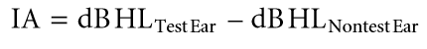

Consider the following hypothetical examples presented in Figure 6.1. You are measuring puretone airconduction threshold using traditional supra-aural earphones. A puretone signal of 90 dB HL is presented to the test ear. Because of limited IA, a portion of the test signal can reach the nontest ear cochlea. If IA is 40 dB, then 50 dB HL theoretically is reaching the nontest ear:

请考虑图6.1中给出的以下假设示例。您正在使用传统的压耳式耳机测量纯音气导阈值。向测试耳朵呈现90dB HL的纯音信号。由于有限的耳间衰减，部分测试信号可以到达非测试耳的耳蜗。如果IA为40 dB，那么理论上50 dB HL会达到非测试耳朵：

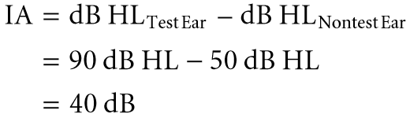

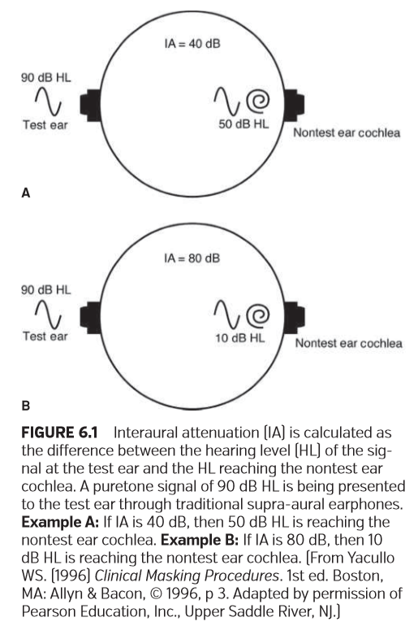

图6.1耳间衰减（IA）是指测试耳的听力级（HL）与到达非测试耳朵耳蜗的听力级（HL）之间的差值。一个90dBHL的纯音信号通过传统的压耳式耳机呈现给测试耳。示例A：如果IA为40dB，则到达非测试耳的耳蜗是50 dB HL。示例B：如果IA为80dB，则到达非测试耳的耳蜗是10 dB HL。

If IA is 80 dB, then only 10 dB HL is reaching the nontest ear. It should be apparent that a greater portion of the test signal can reach the nontest ear when IA is small. Depending on the hearing sensitivity in the nontest ear, cross hearing can occur.

如果IA为80dB，则只有10dB HL到达非测试耳。很明显，当IA较小时，测试信号的较大部分可以到达非测试耳朵。根据非测试耳朵的听力灵敏度，可能会发生交叉听力。

IA during earphone testing is dependent on three factors: Transducer type, frequency spectrum of the test signal, and individual subject. There are three major types of earphones currently used during audiologic testing: Supraaural, circumaural, and insert (American National Standards Institute/Acoustical Society of America [ANSI/ASA], 2010). Supra-aural earphones use a cushion that makes contact solely with the pinna. Circumaural earphones use a cushion that encircles or surrounds the pinna, making contact with the skin covering the cranial skull. Insert earphones are coupled to the ear by insertion into the ear canal.

耳机测试中的耳间衰减取决于三个因素：换能器类型、测试信号的频谱和个体受试者。目前在听力测试中使用的耳机主要有三种：压耳式耳机、耳罩式耳机和插入式耳机（美国国家标准学会/美国声学学会[ANSI/ASA]，2010年）。压耳式耳机使用仅与耳廓接触的垫子。耳罩式耳机使用一个环绕或包围耳廓的垫子，与颅骨的皮肤接触。插入式耳机通过插入耳道与耳朵相连。

Generally, IA increases as the contact area of the transducer with the skull decreases (Zwislocki, 1953). More speciﬁcally, IA is greater for supra-aural than circumaural earphones. Furthermore, IA is greatest for insert earphones (Killion et al., 1985; Sklare and Denenberg, 1987), partly because of their smaller contact area with the skull. (The reader is referred to Killion and Villchur, 1989; Zwislocki et al., 1988, for a review of advantages and disadvantages of earphones in audiometry.) Because supra-aural and insert earphones are most typically used during audiologic testing, they will be the focus of this discussion.

通常，IA随着换能器与颅骨接触面积的减少而增加（Zwislocki, 1953）。更具体地说，IA对于压耳式的影响大于耳罩式。此外，插入式耳机的IA最大（Killion et al.，1985;Sklare和Denenberg, 1987），部分原因是他们与头骨的接触面积较小。（读者可以参考Killion和Villchur, 1989;Zwislocki et al.，1988, 耳机在测听中的优缺点综述）由于压耳式和插入式耳机是最常用的听力测试，他们将是本次讨论的重点。

There are different approaches to measuring IA for airconducted sound (e.g., “masking” method, “compensation” method, method of “best beats”; the reader is referred to Zwislocki, 1953, for discussion). The most direct approach, however, involves measurement of transcranial thresholds (Berrett, 1973). Speciﬁcally, IA is measured by obtaining unmasked air-conduction (AC) thresholds in subjects with unilateral, profound sensory/neural hearing loss and then calculating the threshold difference between the normal and impaired ears:

测量气导中的IA有不同的方法（如“掩蔽法”、“补偿法”、“最佳节拍法”等；读者可以参考Zwislocki, 1953，进行讨论）。然而，最直接的方法是测量经颅阈值（Berrett, 1973）。具体来说，IA的测量是通过获得单侧、重度感音/神经性聋受试者未掩蔽的气导（AC）阈值，然后计算正常和受损耳朵之间的阈值差异：



For example, if unmasked air-conduction thresholds are obtained at 60 dB HL in the impaired ear and 0 dB HL in the normal ear, then IA is calculated as 60 dB:

例如，如果在受损的耳朵中获得60dB HL的未掩蔽空气传导阈值，在正常耳朵中获得0dB HL的气导阈值，则IA被计算为60dB：

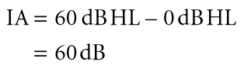

There is the assumption that air-and bone-conduction thresholds are equal (i.e., no air-bone gaps) in the ear with normal hearing.

有一种假设是，在听力正常人的耳中，气导阈值和骨导阈值是相等的（即，没有气骨间隙）。

Figure 6.2 illustrates the expected unmasked puretone air-conduction thresholds in an individual with normal hearing in the left ear and a profound sensory/neural hearing loss in the right ear. Unmasked bone-conduction thresholds, regardless of bone vibrator placement, are expected at HLs consistent with normal hearing in the left ear. If appropriate contralateral masking is not used during air-conduction testing, then a shadow curve will result in the right ear. Because cross hearing is primarily a bone-conduction mechanism, unmasked air-conduction thresholds in the right ear will “shadow” the bone-conduction thresholds in the left (i.e., better) ear by the amount of IA. For example, if IA for airconducted sound is equal to 60 dB at all frequencies, then unmasked air-conduction thresholds in the right ear theoretically will be measured 60 dB above the bone-conduction thresholds in the better ear. The shadow curve does not represent true hearing thresholds in the right ear. Rather, it reﬂects cross-hearing responses from the better (i.e., left) ear.

图6.2显示了左耳正常听力，右耳重度感音/神经性聋个体的预期未掩蔽的纯音气导阈值。无论骨骼振动器放置如何，未经掩盖的骨传导阈值在HLs出阈值预期与左耳的正常听力一致。如果在气导测试期间没有使用适当的对侧掩蔽，那么右耳将产生影子曲线。因为交叉听力主要发生在骨传导机制，所以右耳中未掩蔽的空气传导阈值会“掩盖”左侧（即，更好）耳朵中的骨传导阈值的IA量。例如，如果在所有频率下气导声音的IA等于60 dB，那么理论上右耳中未屏蔽的气导阈值将在好耳骨导阈值之上60 dB处测量。影子曲线不代表右耳的真实听力阈值。相反，它反映了来自更好（即左）耳交叉听力的反应。

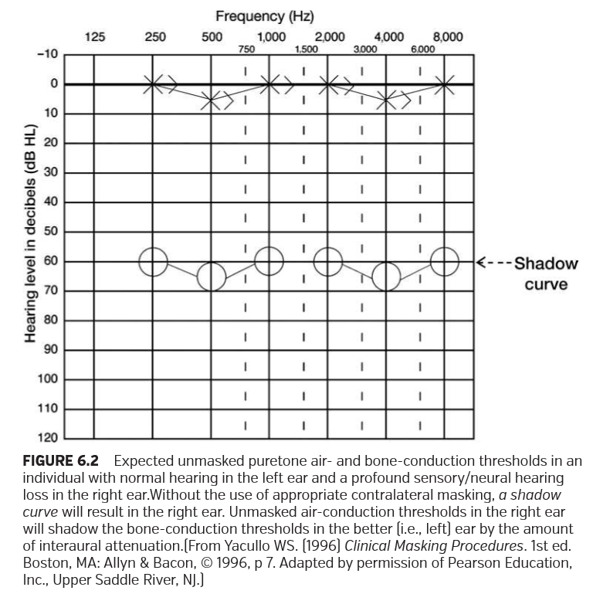

对于左耳听力正常且右耳感觉/神经性听力损失严重的个体，预期的无掩蔽空气和骨传导阈值。如果未使用适当的对侧掩蔽，右耳将出现影子曲线。右耳中未掩蔽的空气传导阈值将通过耳间衰减的量影响更好（即左）耳中的骨传导阈值。

When using supra-aural earphones, IA for puretone air-conducted signals varies considerably, particularly across subjects, ranging from about 40 to 85 dB (Berrett, 1973; Chaiklin, 1967; Coles and Priede, 1970; Killion et al., 1985; Sklare and Denenberg, 1987; Smith and Markides, 1981; Snyder, 1973). Your assumption about IA will inﬂuence the decision about the need for contralateral masking. The use of a smaller IA value assumes that there is smaller separation between ears. Consequently, contralateral masking will be required more often. When making a decision about the need for contralateral masking during clinical practice, a single value deﬁning the lower limit of IA is recommended (Studebaker, 1967a).

当使用压耳式耳机时，纯音气导信号的IA变化很大，特别是在受试者之间，大约40到85分贝（Berrett，1973; Chaiklin，1967; Coles和Priede，1970; Killion等，1985; Sklare和Denenberg，1987; Smith和Markides，1981; Snyder，1973）。你对IA的假设将决定是否需要对侧掩蔽。使用较小的IA值时假设耳朵之间的间隔较小。因此，需要更频繁地进行对侧掩蔽。在临床实践中决定是否需要对侧掩蔽时，建议使用单一值来确定IA的下限。

Based on currently available data, a conservative estimate of IA for supra-aural earphones is 40 dB at all frequencies.

根据现有数据，保守的估计，压耳式耳机的IA在所有频率下都是40dB。

Although this very conservative estimate will take into account the IA characteristics of all individuals, it will result in the unnecessary use of masking in some instances.

尽管这种非常保守的估计将考虑所有个体的IA特征，但在某些情况下会导致不必要地使用掩蔽。

Commonly used insert earphones are the Etymotic Research ER-3A (Killion, 1984) and the E-A-RTONE 3A (E-A-R Auditory Systems, 1997). The ER-3A and the E-ARTONE 3A insert earphones are considered functionally equivalent because they are built to identical speciﬁcations (Frank and Vavrek, 1992). Each earphone consists of a shoulder-mounted transducer, a plastic sound tube of speciﬁed length, a nipple adaptor, and a disposable foam eartip. A major advantage of the 3A insert earphone is increased IA for air-conducted sound, particularly in the lower frequencies (Hosford-Dunn et al., 1986; Killion et al., 1985; Sklare and Denenberg, 1987; Van Campen et al., 1990). This is clearly illustrated in the results of a study by Killion et al. (1985) (Figure 6.3).

常用的插入式耳机有Etymotic Research ER-3A（Killion，1984）和E-A-RTONE 3A（E-A-R Auditory Systems，1997）。ER-3A和E-ARTONE 3A插入式耳机在功能上被认为是相同的，因为它们是按照相同的规范制造的（Frank和Vavrek，1992）。每个耳机都包括一个放置于肩部的换能器，一个特定长度的塑料音管，一个乳头适配器和一次性泡沫耳塞。3A插入式耳机的主要优点是增加了气导声音的IA，特别是在较低频率下（Hosford-Dunn等，1986; Killion等，1985; Sklare和Denenberg，1987; Van Campen等，1990）。Killion等人的研究结果清楚地说明了这一点。

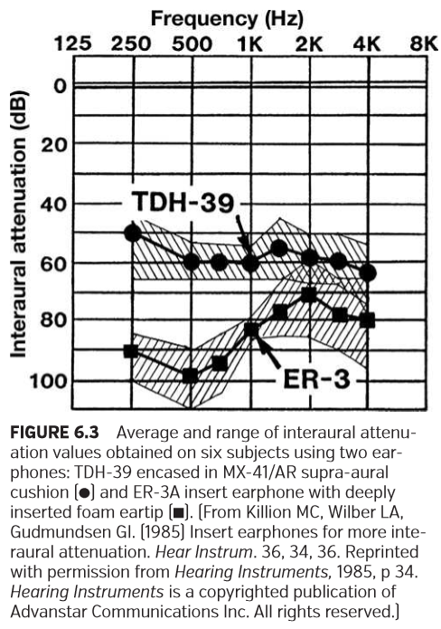

六个受试者使用两个耳机获得的耳间衰减值的平均值和范围：包含在MX-41/Ar上耳垫中的TDH-39和具有深插入泡沫耳塞的ER-3A插入式耳机

Increased IA with 3A insert earphones is the result of two factors: (1) Reduced contact area of the transducer with the skull and (2) reduction of the occlusion effect (OE). Zwislocki (1953) evaluated IA for three types of earphones: circumaural, supra-aural, and insert. Results suggested that IA for air-conducted sound increased as the contact area of the earphone with the skull decreased. When an acoustic signal is delivered through an earphone, the resultant sound pressure acts over a surface area of the skull determined by the earphone cushion. The surface area associated with a small eartip will result in a smaller applied force to the skull, resulting in reduced bone-conduction transmission.

采用3A插入式耳机增加IA 是两个因素的结果：（1）减少了换能器与颅骨的接触面积；（2）减少了堵耳效应（OE）。Zwislocki（1953）评估了三种类型的耳机的IA：耳罩式、压耳式和插入式。结果表明，气导声音的IA随着耳机与颅骨接触面积的减少而增加。当声学信号通过耳机传递时，由此产生的声压作用于耳机坐垫接触的颅骨区域。与小的耳塞接触的区域将导致对颅骨施加较小的力，从而使骨传导减少。

If increased IA is a primary goal when selecting an insert earphone, then the 3A is the transducer of choice. Evidence suggests that the 3A insert earphone provides signiﬁcantly greater IA, particularly in the lower frequencies, than the “button” transducer (Blackwell et al., 1991; HosfordDunn et al., 1986). Blackwell et al. (1991) compared the IA obtained with a standard supra-aural earphone (TDH-50P) and a button transducer ﬁtted with a standard immittance probe cuff. Although greater IA was observed with the button transducer, the difference between the insert and supraaural earphone did not exceed 10 dB at any frequency.

如果在选择插入式耳机时增加IA是主要目标，则3A是首选换能器。有证据表明，3A插入式耳机比“按钮”换能器提供了更大的IA，特别是在较低频率下（Blackwell等，1991; HosfordDunn等，1986）。布莱克威尔等人（1991）将标准耳罩式耳机（TDH-50P）获得的IA与配有标准导纳探头的按钮换能器获得的IA进行了比较。虽然按钮传感器观察到更大的IA，但插入式和压耳式耳机之间的差异在任何频率下都不超过10 dB。

There are only limited data available regarding IA of 3A insert earphones using deeply or intermediately inserted foam eartips. IA values vary across subjects and frequency, ranging from about 75 to 110 dB at frequencies of ≤1,000 Hz and about 50 to 95 dB at frequencies >1,000 Hz (Killion et al., 1985; Sklare and Denenberg, 1987; Van Campen et al., 1990). Based on Studebaker’s (1967a) recommendation, we will again use the smallest IA values reported when making a decision about the need for contralateral masking. To take advantage of the signiﬁcantly increased IA proved by the 3A insert in the lower frequencies, a single value of IA will not be employed across the frequency range.

对于使用深度或中等深度插入式泡沫耳塞的3A插入式耳机的IA而言，只有有限的数据可用。IA值因受试者和频率而异，在≤1000Hz的频率下为约75至110dB，在>1000Hz的频率下为约50至95dB（Killion等人，1985；Sklare和Denenberg，1987；Van Campen等人，1990）。根据Studebaker（1967a）的建议，决定需要对侧掩蔽时我们将使用最小的IA值。为了利用由3A插入式耳机在较低频率中证明的显著增加的IA，在整个频率范围内不会使用IA的单个值。

Based on currently available data, conservative estimates of IA for 3A insert earphones with deeply inserted foam eartips are 75 dB at ≤1,000 Hz and 50 dB at frequencies >1,000 Hz.

根据目前可获得的数据，对于深插入泡沫耳塞的3A插入式耳机，IA的保守估计值在≤1,000Hz时为75 dB，在频率> 1,000 Hz时为50 dB。

The IA values recommended clinically for 3A earphones assume that deeply inserted foam eartips are used. Maximum IA is achieved in the low frequencies when a deep eartip insertion is used (Killion et al., 1985). The recommended deep insertion depth is achieved when the outer edge of the eartip is 2 to 3 mm inside the entrance of the ear canal. Conversely, a shallow insertion is obtained when the outer edge of the eartip protrudes from the entrance of the ear canal (E-A-R Auditory Systems, 1997). An intermediate insertion is achieved when the outer edge of the eartip is ﬂush with the opening of the ear canal (Van Campen et al., 1990). There are limited data suggesting that IA is similar for either intermediate or deep insertion of the foam eartip. However, a shallow insertion appears to signiﬁcantly reduce IA (Killion et al., 1985; Sklare and Denenberg, 1987; Van Campen et al., 1990). Remember that a major factor contributing to superior IA of the 3A insert earphone is a signiﬁcantly reduced OE. There is evidence that the OE is negligible when using either deeply or intermediately inserted insert earphones. In fact, the advantage of a greatly reduced OE is lost when a shallow insertion is used (Berger and Kerivan, 1983). To achieve maximum IA with 3A insert earphones, deeply inserted eartips are strongly recommended.

临床为3A耳机推荐的IA值假定使用的是深插入的泡沫耳塞。当使用深插入耳塞时，在低频下可以获得最大的IA （Killion et al.， 1985）。当耳塞外缘在耳道口内2 - 3mm时，达到推荐的深插入深度。相反，当耳塞外缘从耳道入口突出时，就会形成浅插入（E-A-R听觉系统，1997）。当耳塞外缘与耳道开口齐平时，就可以实现中等插入（Van Campen et al.， 1990）。有限的数据表明IA对于泡沫耳塞的中等或深度插入是相似的。然而，浅插入似乎可以显著降低IA（Killion et al.， 1985;Sklare和Denenberg, 1987;Van Campen等，1990）。请记住，导致3A插入式耳机显著IA的主要因素是OE的显著降低。有证据表明，当使用深度或中等插入式耳机时，OE是可以忽略不计的。事实上，当使用浅层插入时，大大减少的OE的优势会丧失（Berger and Kerivan, 1983）。为了达到3A插入式耳机的最大IA，强烈推荐深度插入式耳塞。

More recently, E-A-R Auditory Systems (2000a, 2000b) introduced a next-generation insert earphone, the E-ARTONE 5A. The lengthy plastic sound tube that conducted sound from the body-level transducer of the 3A has been eliminated in the 5A model; rather, the foam eartip is coupled directly to an ear-level transducer. Very limited data obtained with only two subjects (unpublished research by Killion, 2000, as cited in E-A-R Auditory Systems, 2000b) suggest that the average IA for puretone stimuli ranging from 250 to 4,000 Hz is equivalent (within approximately 5 dB) to the average values reported for the 3A insert earphone (Killion et al., 1985).

最近，E-A-R 听觉系统（2000a，2000b）推出了新一代插入式耳机E-ARTONE 5A。在5A模型中，3A体位换能器传导声音的长塑料管已被淘汰，相反，泡沫耳塞直接耦合到耳电平换能器。只用两个受试者获得的有限数据（Killion，2000年未发表的研究，如EAR Auditory Systems，2000b中所述）表明，250至4,000 Hz范围内的纯音刺激的平均IA与3A插入式耳机报告的平均值相当（在约5 dB内）。

IA for speech is typically measured by obtaining speech recognition thresholds (SRTs) in individuals with unilateral, profound sensory/neural hearing loss. Speciﬁcally, the difference in threshold between the normal ear and impaired ear without contralateral masking is calculated:

对于单侧，重度感音/神经性聋的个体，通常通过获得言语识别阈值（SRT）来测量用于言语的IA。具体而言，计算正常耳朵和未加对侧掩蔽的受损耳朵之间的阈值差异：



Recall that SRT represents the lowest HL at which speech is recognized 50% of the time (ANSI/ASA, 2010; American Speech-Language-Hearing Association [ASHA], 1988). IA for spondaic words presented through supra-aural earphones varies across subjects and ranges from 48 to 76 dB (Martin and Blythe, 1977; Sklare and Denenberg, 1987; Snyder, 1973). Again, a single value deﬁning the lower limit of IA is recommended when making a decision about the need for contralateral masking (Studebaker, 1967a). A conservative estimate of IA for spondees, therefore, is 45 dB when using supra-aural earphones (Konkle and Berry, 1983). The majority of audiologists measure SRT using a 5-dB step size (Martin et al., 1998). Therefore, the IA value of 48 dB is typically rounded down to 45 dB.

回想一下，SRT代表50％时间内语音被识别的最低HL（ANSI / ASA，2010; American Speech-Language-Hearing Association [ASHA]，1988）。IA通过压耳式耳机呈现的扬扬格词因受试者而异，范围从48到76分贝（Martin和Blythe，1977; Sklare和Denenberg，1987; Snyder，1973）。同样，在决定是否需要对侧掩蔽时，建议使用单个值来定义IA的下限（Studebaker，1967a）。因此，当使用压耳式耳机时，对于扬扬格词的保守估计值为45 dB（Konkle和Berry，1983）。大多数听力师使用每次5-dB增减测量SRT（Martin等，1998）。 因此，48 dB的IA值通常向下舍入到45 dB。

There is considerable evidence that speech can be detected at a lower HL than that required to reach SRT. Speech detection threshold (SDT) is deﬁned as the lowest HL at which speech can be detected or “discerned” 50% of the time (ASHA, 1988). The SRT typically requires an average of about 8 to 9 dB greater HL than that required for the detection threshold (Beattie et al., 1978; Chaiklin, 1959; Thurlow et al., 1948). Given this relationship between the two speech thresholds, Yacullo (1996) has suggested that a more conservative value of IA may be appropriate when considering the need for contralateral masking during measurement of SDT.

有大量证据表明，可以在较低的HL检测到语音，而不是达到SRT所需。语音检测阈值（SDT）被定义为可以检测语音的最低HL或50%的“可识别”时间（Asha，1988年）。SRT通常需要比检测阈值所需的HL高8 - 9 dB左右（Beattie et al.， 1978;Chaiklin, 1959;瑟洛等人，1948）。考虑到这两个语音阈值之间的关系，Yacullo（1996）提出，在SDT测量期间考虑对侧掩蔽的需要时，IA采取保守值可能是合适的。

Consider the following hypothetical example. You are measuring speech thresholds in a patient with normal hearing in the right ear and a profound, sensory/neural hearing loss in the left ear. If the patient exhibits the minimum reported IA value for speech of 48 dB, then an SRT of 0 dB HL would be measured in the right ear and an unmasked SRT of 48 dB HL would be measured in the left ear. If an unmasked SDT is subsequently measured in the left ear, it is predicted that the threshold would occur at an HL of about 8 to 9 dB lower than the unmasked SRT. An unmasked SDT would be expected to occur at about 39 to 40 dB HL. Comparison of the unmasked SDT in the impaired ear with the SRT in the normal ear theoretically would result in measured IA of approximately 39 to 40 dB. When an unmasked SDT is measured and the response is compared to the SRT in the nontest ear, a more conservative estimate of IA for speech may be appropriate.

请考虑以下假设示例。您正在测量右耳听力正常，左耳重度感音/神经性听力损失的患者的言语阈值。如果患者报告的最小IA值为48db，那么右耳的SRT为0db HL，左耳未掩蔽的SRT为48db HL。如果随后在左耳测量未掩蔽的SDT，则可以预测阈值比未掩蔽的SRT将低约8至9 dB HL。预计未掩蔽的SDT预计发生在大约39到40 dB HL。从理论上讲，将受损耳的未掩蔽SDT与正常耳的SRT进行比较，可测得IA约为39至40 dB。当测量未掩蔽的SDT并且将反应与非测试耳朵中的SRT进行比较时，对于言语IA进行更保守的估计可能是合适的。

It should be noted that the actual IA for speech does not change during measurement of speech detection and recognition thresholds. Rather, a different response task when measuring different speech thresholds in each ear (i.e., SDT in one ear and SRT in the other) can affect the measured IA for speech. Comparison of SRTs between ears or SDTs between ears generally should result in the same measured IA. Smith and Markides (1981) measured IA for speech in 11 subjects with unilateral, profound hearing loss. IA was calculated as the difference between the SDT in the better ear and the unmasked SDT in the poorer ear. The range of IA values was 50 to 65 dB. It is interesting to note that the lowest IA value reported for speech using a detection task in each ear was 50 dB, a value comparable to the lowest minimum reported IA value (i.e., 48 dB) for spondaic words (e.g., Martin and Blythe, 1977; Snyder, 1973).

应当注意，在语音检测和识别阈值的测试期间，用于言语的实际IA不会改变。相反，当测量每只耳朵中的不同语音阈值（即，一只耳朵中的SDT和另一只耳朵中的SRT）时的不同响应可以影响所测量的语音IA。比较耳间的SRT或耳间的SDT通常应该导致相同的IA测量值。Smith和Markides（1981）在11名患有单侧、重度听力损失的受试者中测量了言语IA。IA计算为好耳中的SDT与差耳中未掩蔽的SDT之间的差异。IA值的范围为50至65 dB。有趣的是，在每只耳朵中使用检测报告的语音的最低IA值是50dB，这个值与扬扬格词的最低报告IA值（即48dB）相当。

There is also some evidence that it may be appropriate to use a more conservative estimate of IA when making a decision about the need for contralateral masking during assessment of suprathreshold speech recognition. Although IA for the speech signal remains constant during measurement of threshold or suprathreshold measures of speech recognition (i.e., the decibel difference between the level of the speech signal at the test ear and the level at the nontest ear cochlea), differences in the performance criterion for each measure must be taken into account when selecting an appropriate IA value for clinical use. SRT is deﬁned relative to a 50% response criterion. However, suprathreshold speech recognition performance can range from 0% to 100%.

也有证据表明，在评估阈上语音识别时，在做出对侧掩蔽的决定时，使用更保守的IA可能是合适的。尽管在语音识别的阈值或阈上测量的测量期间语音信号的IA保持恒定（即，测试耳朵处的语音信号的水平与非测试耳蜗的水平之间的分贝差异），在选择合适的IA值供临床使用时，必须考虑每种测量方法的性能标准的差异。SRT是根据50%响应标准定义的。然而，阈上语音识别表现可以从0%到100%不等。

Konkle and Berry (1983) provide an excellent rationale for the use of a more conservative estimate of IA when measuring suprathreshold speech recognition. They suggest that the fundamental difference in percent correct criterion requires the speciﬁcation of nontest ear cochlear sensitivity in a different way than that used for threshold measurement. If suprathreshold speech recognition materials are presented at an HL equal to the SRT, then a small percentage of the test items can be recognized. It should be noted that the percentage of test words that can be recognized at an HL equal to SRT is dependent on the type of speech stimuli, as well as on the talker and/or recorded version of a speech recognition test. Regardless of the type of speech stimulus (e.g., meaningful monosyllabic words, nonsense syllables, or sentences) and the speciﬁc version (i.e., talker/ recording) of a speech recognition test, 0% performance may not be established until an HL of about −10 dB relative to the SRT. Konkle and Berry (1983) recommend that the value of IA used for measurement of suprathreshold speech recognition should be estimated as 35 dB. That is, the IA value of 45 dB (rounded down from 48 dB) based on SRT measurement is adjusted by subtracting 10 dB. This adjustment in the estimate of IA reﬂects differences in percent correct criterion used for speech threshold and suprathreshold measurements.

Konkle和Berry（1983）为在测量阈上语音识别时使用更保守的IA估计提供了极好的理论基础。他们认为，正确率标准的基本差异要求以不同于阈值测量的方式来指定非测试耳蜗敏感度。如果阈上语音识别材料以与SRT相等的HL表示，那么可以识别出一小部分测试项目。应当注意，在HL等于SRT的测试中，能够被识别的单词的百分比取决于语言刺激的类型，以及说话者和/或语音识别测试的录制版本。不考虑语言刺激的类型（如有意义的单音节词、无意义的音节或句子）和语音识别测试的特定版本中（讲者/记录），只有当相对于SRT的HL值为- 10 dB左右时，才能确定0%的表现。Konkle和Berry（1983）建议用于阈上语音识别测量的IA值应该估计为35dB。即，基于SRT测量的45 dB（从48 dB向下舍入）的IA值通过减去10 dB进行调整。这种对IA的估计的调整反映了语音阈值和阈上测量中使用的准确率标准的差异。

The majority of audiologists use an IA value of 40 dB for all air-conduction measurements, both puretone and speech, when making a decision about the need for contralateral masking (Martin et al., 1998). The use of a single IA value of 40 dB for both threshold and suprathreshold speech audiometric measurements can be supported. Given the smallest reported IA value of 48 dB for spondaic words, a value of 40 dB is somewhat too conservative during measurement of SRT. However, it should prove adequate during measurement of SDT and suprathreshold speech recognition when a more conservative estimate of IA (by approximately 10 dB) may be appropriate.

在决定是否需要对侧掩蔽时，大多数听力学家使用40 dB的IA值进行所有气导测量，包括纯音和言语测试（Martin等，1998）。单个IA值在阈值和阈上语音听力测量中使用40dB的值是合适的。考虑到已报告的扬扬格声的最小IA值为48 dB，在测量SRT期间40 dB的值有些过于保守。然而，在测量SDT和超阈值语音识别时，当IA的更保守估计（大约10 db）可能是合适的时，它应该被证明是足够的。

Unfortunately, there are only very limited data available about IA for speech when using insert earphones. Sklare and Denenberg (1987) reported IA for speech (i.e., SRT using spondaic words) in seven adults with unilateral, profound sensory/neural hearing loss using ER-3A insert earphones. IA ranged from 68 to 84 dB. It should be noted that the smallest reported value of IA for spondaic words (i.e., 68 dB) is 20 dB greater when using 3A insert earphones with deeply inserted foam eartips (Sklare and Denenberg, 1987) than when using supra-aural earphones (i.e., 48 dB) (Martin and Blythe, 1977; Snyder, 1973). Therefore, a value of 60 dB represents a very conservative estimate of IA for speech when using 3A insert earphones. This value is derived by adding a correction factor of 20 dB to the conservative IA value used with supra-aural earphones (i.e., 40 dB) for all threshold and suprathreshold measures of speech.

不幸的是，当使用插入式耳机时，关于IA的言语可用的数据非常有限。Sklare和Denenberg（1987）报告了7名单侧的、严重的感觉/神经性听力损失的成年人使用ER-3A插入式耳机进行的言语IA（即，使用扬声词的SRT）。IA范围从68分贝到84分贝。应该注意到，当使用深度插入泡沫耳塞（SkLaar和Denenberg，1987）的3A插入式耳机时，IA的最大值（即，68分贝）比使用压耳式耳机（即48分贝）（马丁和Bythes，1977；斯奈德，1973）时大20 dB。因此，在使用3A插入式耳机时，60dB的值表示对语音IA的非常保守的估计。该值是通过将20分贝的校正因子添加到所有阈值和超阈值语音测量的与超听觉耳机（即40分贝）一起使用的保守IA值中得出的。

Based on currently available data, conservative estimates of IA for all threshold and suprathreshold measures of speech are 40 dB for supra-aural earphones and 60 dB for 3A insert earphones with deeply inserted foam eartips.

根据现有数据，对于所有阈值和阈上言语测量的IA保守估计为：压耳式耳机为40dB，深度插入泡沫耳塞的3A插入式耳机为60dB。

**Bone-Conduction Testing**

骨导测试

There are two possible locations for placement of a bone vibrator (typically, the Radioear B-71) during puretone threshold audiometry: The mastoid process of the temporal bone and the frontal bone (i.e., the forehead). Although there is some evidence that a forehead placement produces more reliable and valid thresholds than a mastoid placement (see Dirks, 1994, for further discussion), the majority (92%) of audiologists in the United States continue to place a bone-conduction transducer on the mastoid process (Martin et al., 1998).

在纯音阈值听力测量中，有两种可能的位置放置骨振动器（通常是放射性耳B-71）：颞骨乳突和额骨 （即额部）。虽然有一些证据表明，前额放置比乳突放置产生更可靠和有效的阈值（见Dirks, 1994，进一步讨论），但大多数（92%）的美国听力学家继续在乳突放置骨传导换能器。

IA is greatly reduced during bone-conduction audiometry. IA for bone-conducted sound when using a bone vibrator placed at the forehead is essentially 0 dB at all frequencies; IA when using a mastoid placement is approximately 0 dB at 250 Hz and increases to about 15 dB at 4,000 Hz (Studebaker, 1967a). Regardless of the placement of a bone vibrator (i.e., mastoid vs. forehead), it is generally agreed that IA for boneconducted sound at all frequencies is negligible and should be considered 0 dB (e.g., Dirks, 1994; Hood, 1960; Sanders and Rintelmann, 1964; Studebaker, 1967a). When a bone vibrator, regardless of its location, sets the bones of the skull into vibration, both cochleas can be potentially stimulated. Consequently, an unmasked bone-conduction threshold can reﬂect a response from either cochlea or perhaps both. Although a bone vibrator may be placed at the side of the test ear, it cannot be assumed that the observed response is in fact from that ear.

IA在骨传导测听时显著降低。当放置在前额处，在所有频率下，骨传导声音的IA基本上为0 dB；当骨振动器放置在乳突时，IA在250Hz时约为0 dB，在4000Hz时增加到大约15 dB（Studebaker，1967a）。不管骨振动器放置何处（即乳突与额头），人们普遍认为在所有频率下骨传导声音的IA可以忽略不计，应该被认为是0dB（例如，Dirks，1994；Hood，1960；Sanders和Rintelmann，1964；Studebaker，1967a）。无论骨振动器位置如何，颅骨振动时，两个耳蜗都可能受到刺激。因此，一个未被掩蔽的骨传导阈值可以反映来自其中一个耳蜗或者可能来自两者。虽然骨振动器可以放置在测试耳朵的一侧，但不能假定观察到的响应实际上来自该耳朵。

Consider the following example. You have placed a bone vibrator at the right mastoid process. A puretone signal of 50 dB HL is presented. If IA is considered to be 0 dB, then it should be assumed that a signal of 50 dB HL is potentially reaching both cochleas. It should be apparent that there is essentially no separation between the two cochleas during unmasked bone-conduction audiometry.

考虑以下示例。你在右乳突上放了一个骨振动器。给出了一个50dBHL的纯音信号。如果IA被认为是0 dB，那么应该假设50dB HL的信号有可能到达两个耳蜗。，显而易见，在未掩蔽的骨导测听中，两个耳蜗之间基本上没有区别。

Based on currently available data, a conservative estimate of IA for bone-conducted sound is 0 dB at all frequencies.

基于当前可用的数据，骨传导声音IA在所有频率下的保守估计是0dB。

### WHEN TO MASK

何时需加掩蔽

Contralateral masking is required whenever there is the possibility that the test signal can be perceived in the nontest ear. IA is one of the major factors that will be considered when evaluating the need for masking. The basic principles underlying the decision-making processes of when to mask during puretone and speech audiometry will now be addressed.

当测试信号有可能在非测试的耳朵中被察觉时，需要对侧掩蔽。IA是评估掩蔽需要时要考虑的主要因素之一。下面将讨论在纯音和言语测听过程中何时进行掩蔽这一决策的基本原则。

Puretone Audiometry: Air Conduction

纯音测听：气导

When making a decision about the need for masking during puretone air-conduction testing, three factors need to be considered: (1) IA, (2) unmasked air-conduction threshold in the test ear (i.e., HL at the test ear), and (3) bone-conduction hearing sensitivity (i.e., threshold) in the nontest ear. Recall that when cross hearing occurs, the nontest ear is stimulated primarily through the bone-conduction mechanism. When a decision is made about the need for contralateral masking, the unmasked air-conduction threshold in the test ear (ACTest Ear) is compared to the boneconduction threshold in the nontest ear (BCNontest Ear). If the difference between ears equals or exceeds IA, then air-conduction threshold in the test ear must be remeasured using contralateral masking. The rule for when to mask during puretone air-conduction testing can be stated as follows:

纯音气导测试期间是否需要掩蔽，需要考虑三个因素：（1）IA，（2）测试耳中未掩蔽的气导阈值（即测试耳朵处的HL），（3）非测试耳朵中的骨传导听觉灵敏度（即阈值）。回想一下，当交叉听力发生时，主要通过骨传导机制刺激非测试耳朵。当决定是否需要对侧掩蔽时，将测试耳朵中的未掩蔽的气导阈值（ACTest Ear）与非测试耳朵中的骨导阈值（BCNontest Ear）进行比较。如果耳朵之间的差异等于或超过IA，则必须使用对侧掩蔽重新测量测试耳中的气导阈值。在纯音气导测试期间何时掩蔽的规则可以表述如下：

Contralateral masking is required during puretone airconduction audiometry when the unmasked air-conduction threshold in the test ear equals or exceeds the apparent boneconduction threshold (i.e., the unmasked bone-conduction threshold) in the nontest ear by a conservative estimate of IA:



在纯音气导测试中，测试耳未掩蔽气导的阈值与非测试耳明显的骨导阈值的差值等于或大于IA时，需要对侧掩蔽：

This rule is consistent with the guidelines for manual puretone threshold audiometry recommended by ASHA (2005).

此规则与ASHA（2005）建议的手动纯音阈值听力测定指南一致。

Note that the term “apparent” bone-conduction threshold is considered when making a decision about the need for masking. Remember that an unmasked bone-conduction threshold does not convey ear-speciﬁc information. It is assumed that the bone-conduction response can originate from either or both ears. Therefore, the unmasked boneconduction response is considered the apparent or possible threshold for either ear.

请注意，术语“明显的”骨传导阈值是在是否需要掩蔽时考虑的。请记住，未掩蔽的骨导阈值不能表达特定耳朵的信息。假定骨传导响应可以来自任一耳或双耳。因此，未掩蔽的骨传导响应被认为是任何一只耳朵的明显或可能的阈值。

Consider the unmasked puretone audiogram* presented in Figure 6.4. Because IA for bone-conducted sound is considered 0 dB, unmasked bone-conduction thresholds are traditionally obtained at only one mastoid process. During air-conduction threshold testing, the potential for cross hearing is greatest when there is a substantial difference in hearing sensitivity between the two ears and when a stimulus is presented at higher HLs to the poorer ear. Consequently, there is greater potential for cross hearing when measuring puretone thresholds in the right ear.

仔细看图6.4中显示的未掩蔽的纯音听力图*。因为骨导的IA被认为是0dB，所以未掩蔽的骨传导阈值传统上仅在一侧乳突获得。在气导阈值测试期间，当两只耳朵之间的听觉灵敏度存在显著差异并且当刺激以较高的HL呈现给较差的耳朵时，交叉听力的可能性最大。 因此，在测量右耳中的纯音阈值时，交叉听力的可能性更大。

*The puretone audiogram and audiometric symbols used throughout this chapter are those recommended in ASHA’s (1990) most recent guidelines for audiometric symbols (see Chapter 3).

本章中使用的纯音听力图和听力测量符号是ASHA（1990）最新的听力测量符号指南中所推荐使用的。

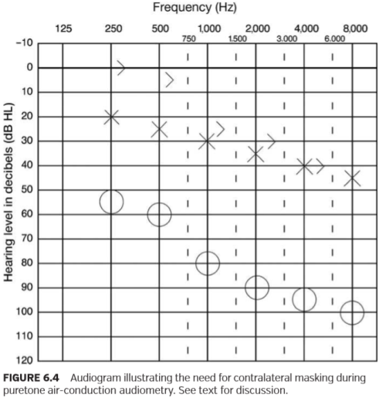

图6.4描述在纯音气导测听过程中需要对侧掩蔽的听力图。见正文讨论。

First consider the need for contralateral masking assuming that air-conduction thresholds were measured using supra-aural earphones. A conservative estimate of IA is 40 dB. We will use the following equation when making a decision about the need for contralateral masking:

首先考虑对侧掩蔽的必要性，假定气导阈值是用压耳式耳机测量的。IA保守估计是40dB。在决定是否需要对侧掩蔽时，我们将使用以下等式:

Because it is not possible to measure bone-conduction threshold at 8,000 Hz, it is necessary to predict an unmasked threshold given the ﬁndings at other test frequencies. In this particular example, unmasked bone-conduction threshold at 8,000 Hz will probably have a similar relationship with the air-conduction thresholds in the better (i.e., left) ear. Because there is no evidence of air-bone gaps at the adjacent high frequencies, we will assume that a similar relationship exists at 8,000 Hz. Therefore, our estimate of unmasked bone-conduction threshold is 45 dB HL.

由于在8000Hz下无法测量骨传导阈值，因此有必要根据其他测试频率下的阈值来预测未掩蔽的阈值。在这个特定的例子中，在8000Hz处未掩蔽的骨传导阈值可能与好（即，左）耳中的气导阈值相似。因为没有证据表明在相邻的高频处存在气-骨间隙，我们将假定在8000Hz处存在类似的关系。因此，我们对未掩盖骨传导阈值的估计为45dB HL。

It will be necessary to remeasure puretone thresholds at all test frequencies in the right ear using contralateral masking because the difference between ears equals or exceeds our estimate of IA.

有必要使用对侧掩蔽重新测量右耳所有测试频率的纯音阈值，因为两耳之间的差异等于或超过我们对IA的估计。

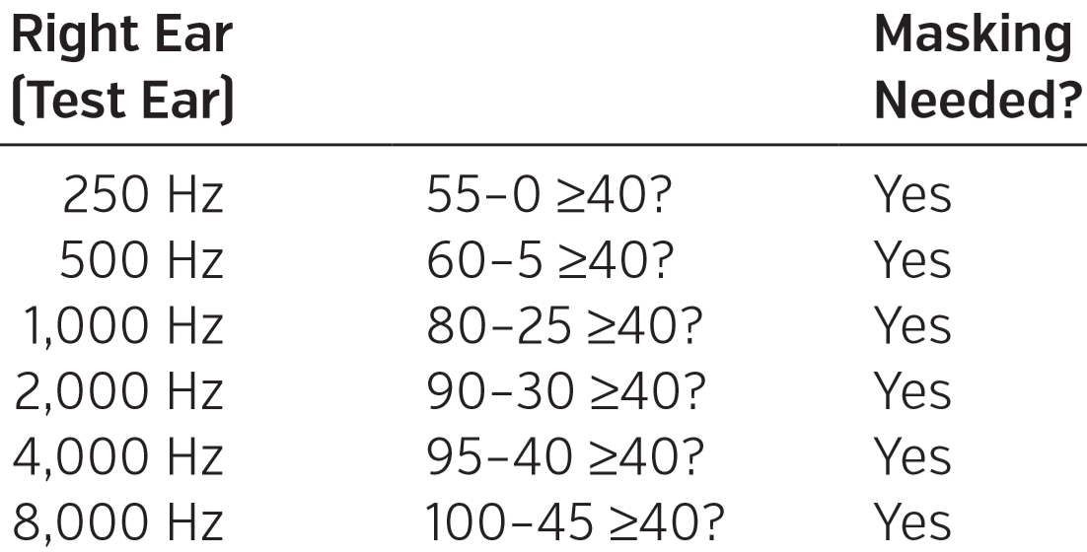

However, contralateral masking is not required when testing the left ear. The difference between ears does not equal or exceed the estimate of IA.

然而，在测试左耳时不需要对侧掩蔽。耳朵之间的差异不等于或不超过估计的IA值。

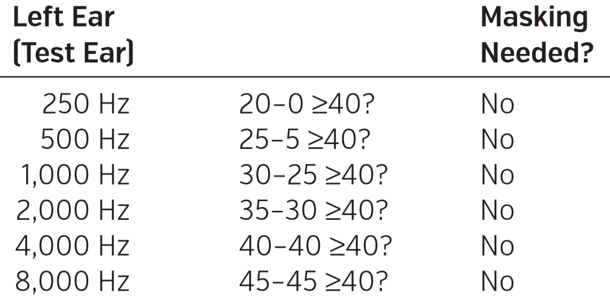

Many audiologists will obtain air-conduction thresholds prior to measurement of bone-conduction thresholds. A preliminary decision about the need for contralateral masking can be made by comparing the air-conduction thresholds of the two ears.

许多听力师将在测量骨导阈值前获得气导阈值。通过比较两耳的气导阈值，可以初步决定是否需要对侧掩蔽。

Contralateral masking is required during puretone airconduction audiometry when the unmasked air-conduction threshold in the test ear (ACTest Ear) equals or exceeds the airconduction threshold in the nontest ear (ACNontest Ear) by a conservative estimate of IA:



在纯音气导测听中，当测试耳中未掩蔽的气导阈值与非测试耳中的气导阈值的差值等于或大于保守估计的IA时，对侧掩蔽是必需的。

It is important to remember, however, that cross hearing for air-conducted sound occurs primarily through the mechanism of bone conduction. Consequently, it will be necessary to re-evaluate the need for contralateral masking during airconduction testing following the measurement of unmasked bone-conduction thresholds.

然而，需要铭记，气导声音的交叉听力主要是通过骨骼传导机制产生的。因此，在测量未掩蔽的骨导阈值之后，有必要在气导测试中重新评估是否需要对侧掩蔽。

Consider again the audiogram presented in Figure 6.4. Let us assume that we have not yet measured unmasked boneconduction thresholds. We can make a preliminary decision about the need for contralateral masking by considering the difference between air-conduction thresholds in the two ears. Based on the air-conduction responses only, it appears that contralateral masking is needed only when testing the right ear at octave frequencies from 1,000 through 8,000 Hz. Yet, once unmasked bone-conduction thresholds are measured, it becomes apparent that contralateral masking will also be required when testing the right ear at 250 and 500 Hz.

再次看图6.4中的听力图。假设我们尚未测量未掩蔽的骨导阈值。我们可以通过考虑双耳气导阈值之间的差异来初步决定是否需要对侧掩蔽。仅基于空气传导响应，似乎只有在以1,000到8,000 Hz的倍频音程测试右耳时才需要对侧掩蔽。然而，一旦开始测量未掩盖的骨传导阈值，显然在250和500Hz测试右耳时，还需要对侧掩蔽。

It is conventional to obtain air-conduction thresholds prior to bone-conduction thresholds. However, an alternative (and recommended) approach involves obtaining unmasked bone-conduction thresholds before obtaining unmasked air-conduction thresholds. Decisions about the need for masking during air-conduction testing then can be made using the important bone-conduction responses.

传统的做法是在骨导阈值之前获得空气传导阈值。然而，一种替代（和推荐的）方法是在获得未掩蔽的空气传导阈值之前获得未掩蔽的骨传导阈值。然后，可以利用重要的骨传导响应来决定在气导测试期间是否需要遮蔽。

3A insert earphones are often substituted for the supraaural conﬁguration during audiometric testing. We now will take a second look at the audiogram in Figure 6.4 and assume that air-conduction thresholds were obtained with 3A insert earphones. Recall that conservative estimates of IA for 3A insert earphones with deeply inserted foam eartips are 75 dB at ≤1,000 Hz and 50 dB at frequencies >1,000 Hz. Previously, we determined that contralateral masking was not required when testing the better (i.e., left) ear using supra-aural earphones. Given the greater IA offered by 3A insert earphones, it is easy to understand that contralateral masking again should not be required when testing the left ear. However, a different picture results when considering the need for contralateral masking when testing the right ear.

在听力测试期间，3A插入式耳机通常被用来替代压耳式耳机。我们现在将再次看一下图6.4中的听力图，并假设使用3A插入式耳机获得了气导阈值。回想一下，对于深度插入泡沫耳塞的3A插入式耳机，IA的保守估计在频率≤1,000Hz时为75 dB，在频率> 1,000 Hz时为50 dB。 以前，我们确定在使用压耳式耳机测试好（即左）耳时不需要对侧掩蔽。鉴于3A插入耳机提供的IA更大，很容易理解在测试左耳时不应再次要求对侧掩蔽。 然而，当在测试右耳时考虑到对侧掩蔽的需要时，会产生不同的结果。

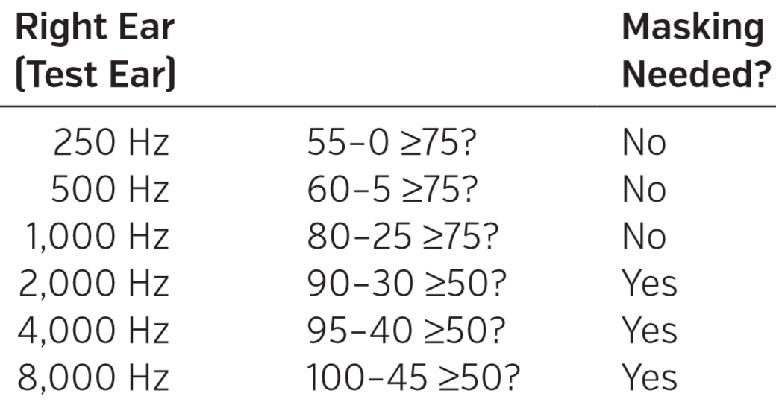

Because of the greater IA provided by 3A insert earphones in the lower frequencies, the need for contralateral masking is eliminated at 250, 500, and 1,000 Hz. It should be apparent that the process of evaluating the need for contralateral masking when using either supra-aural or insert earphones is the same. The only difference is the substitution of different values of IA in our equations.

由于3A插入式耳机在较低频率中提供较大的IA，因此在250、500和1000Hz时不需要对侧掩蔽。显然，当使用压耳式或插入式耳机时，评估是否需要对侧掩蔽的过程是相同的。唯一的区别在于我们等式中不同的IA值。

**Puretone Audiometry: Bone Conduction**

纯音测听：骨传导

Remember that a conservative estimate of IA for bone- conducted sound is 0 dB. Theoretically, masked bone-conduction measurements are always required if ear-speciﬁc information is needed. However, given the goal of boneconduction audiometry, contralateral masking is not always required. Generally, bone-conduction thresholds are primarily useful for determining gross site of lesion (i.e., conductive, sensory/neural, or mixed). The presence of air-bone gaps suggests a conductive component to a hearing loss.

请记住，骨传导声音的保守估计值为0 dB。从理论上讲，如果需要特定耳朵的信息，骨传导测量需要加掩蔽。然而，考虑到骨传导测听的目的，并不总是需要对侧掩蔽。通常，骨传导阈值主要用于确定病变的大体性质（即，传导性，感音/神经性或混合性）。气骨间隙的存在表明传导性聋。

The major factor to consider when making a decision about the need for contralateral masking during boneconduction audiometry is whether the unmasked boneconduction threshold (Unmasked BC) suggests the presence of a signiﬁcant conductive component in the test ear.

在骨传导测听过程中决定是否需要进行对侧掩蔽时，主要因素是未掩蔽的骨导阈值是否表明测试耳中存在传导性损失成分。

The use of contralateral masking is indicated whenever the results of unmasked bone-conduction audiometry suggest the presence of an air-bone gap in the test ear (Air-Bone GapTest Ear) of 15 dB or greater:



Where



对侧掩蔽提示，未掩蔽的骨传导测听结果表明在测试耳（测试耳的气骨间隙）中存在15dB或更大的气骨间隙时：

ASHA (2005) recommends that contralateral masking should be used whenever a potential air-bone gap of 10 dB or greater exists. When taking into account the variability inherent in bone-conduction measurements (Studebaker, 1967b), however, a criterion of 10 dB may be too stringent. There is a certain degree of variability between air- and bone-conduction threshold, even in individuals without conductive hearing loss. If we assume that there is a normal distribution of the relationship between air- and boneconduction thresholds in individuals without signiﬁcant air-bone gaps, then an air-bone difference of ±10 dB is not unexpected.

ASHA（2005）建议，当存在10dB或更大可能的气骨间隙时，应使用对侧掩蔽。然而，考虑到骨传导测量中固有的变异性（Studebaker，1967b），10dB的标准可能过于严格。气导阈值和骨导阈值之间存在一定程度的差异，即使在没有传导性听力损失的个体中也是如此。如果我们假定在没有显著气骨间隙的个体中气导和骨导阈值之间存在正常的分布关系，那么±10 dB的气骨差异并不出乎意料。

If unmasked bone-conduction thresholds suggest airbone gaps of 10 dB or less, then contralateral masking is not required. Although unmasked bone-conduction thresholds do not provide ear-speciﬁc information, we have accomplished our goal for bone-conduction testing. If unmasked bone-conduction thresholds suggest no evidence of signiﬁcant air-bone gaps, then we have ruled out the presence of a signiﬁcant conductive component. Consequently, our assumption is that the hearing loss is sensory/neural in nature.

如果未掩蔽的骨传导阈值提示气骨间隙小于或等于10dB，则不需要对侧掩蔽。虽然未掩蔽的骨传导阈值不能提供特定耳的信息，但我们已经完成了骨传导测试的目的。如果未掩蔽的骨导阈值表明没有明显的气-骨间隙，那么我们就排除了存在明显传导性损失的可能性。因此，我们的假设是听力损失本质上是感音/神经性的。

Figure 6.5 provides three examples of the need for contralateral masking during bone-conduction audiometry. Unmasked air- and bone-conduction thresholds are provided in each case.

图6.5提供了在骨传导听力测量中需要对侧掩蔽的三个例子。每一个例子都提供了未掩蔽的气导阈值和骨导阈值。

FIGURE 6.5 Audiograms illustrating the need for contralateral masking during bone-conduction audiometry. Example A: Masked bone-conduction thresholds are not required in either ear. Example B: Masked bone-conduction thresholds are required only in the right ear. Example C: Masked bone-conduction thresholds are potentially required in both ears. See text for further discussion.

图6.5描述在骨传导测听期间需要对侧掩蔽的听力图。例A：两只耳朵都不需要掩蔽的骨导阈值。例B：仅在右耳中需要掩蔽的骨导阈值。例C：双耳可能需要掩蔽的骨导阈值。 有关进一步讨论见正文。

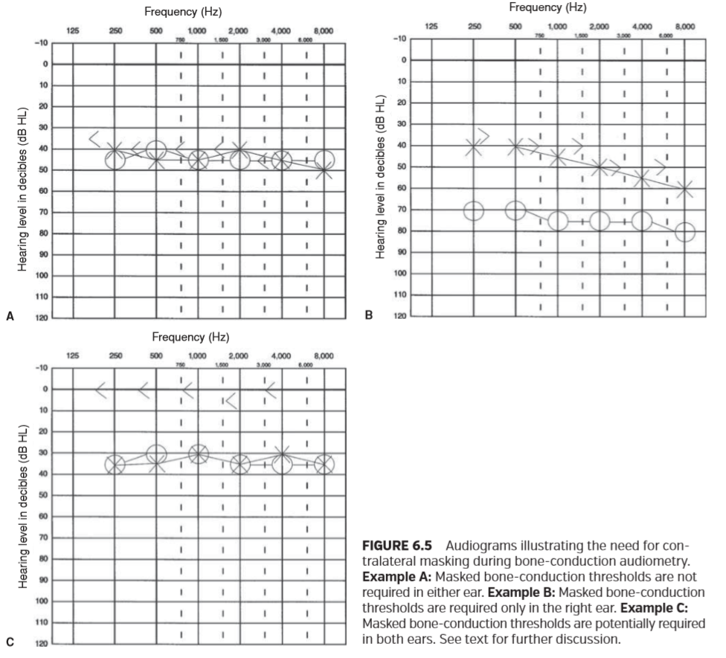

Example A. Contralateral masking is not required during bone-conduction testing in either ear. When we compare the unmasked bone-conduction thresholds to the air-conduction thresholds in each ear, there are no potential air-bone gaps of 15 dB or greater. For example, consider the thresholds at 2,000 Hz. Comparison of the unmasked boneconduction threshold to the air-conduction thresholds suggests a potential air-bone gap of 5 dB in the right ear and 0 dB in the left ear. Because the unmasked bone-conduction threshold does not suggest the presence of signiﬁcant air-bone gaps in either ear, our conclusion is that the hearing loss is sensory/neural bilaterally. Obtaining masked bone-conduction thresholds, although they would provide ear-speciﬁc information, would not provide additional diagnostic information.

例A。在任一耳朵的骨传导测试期间都不需要对侧掩蔽。当我们将未掩蔽的骨传导阈值与每只耳朵的气导阈值进行比较时，没有15 dB大小或更大的潜在的气-骨间隙值。例如，看一下2,000 Hz的阈值。将未掩盖的骨传导阈值与气导阈值进行比较，表明右耳的潜在气骨间隙为5 dB，左耳为0 dB。因为未掩蔽的骨导阈值并不表明两耳存在明显的气骨间隙，我们的结论是听力损失是双侧感音/神经性的。获得掩蔽骨传导阈值虽然可以提供特定耳的信息，但不会提供额外的诊断信息。

Example B. Comparison of unmasked bone-conduction thresholds to the air-conduction thresholds in the left ear does not suggest the presence of signiﬁcant air-bone gaps. Consequently, masked bone-conduction thresholds are not required in the left ear. Our conclusion is that the hearing loss is sensory/neural.

例B。未掩蔽的骨导阈值与左耳的气导阈值的比较并未表明存在明显的气骨间隙。因此，左耳骨传导阈值不需要掩蔽。我们的结论是听力损失是感音/神经性的。

However, masked bone-conduction thresholds will be required in the right ear. Comparison of unmasked bone-conduction thresholds to the air-conduction thresholds in the right ear suggests potential air-bone gaps ranging from 25 to 35 dB. The unmasked bone-conduction thresholds may reﬂect hearing in the better (i.e., left) ear. Bone-conduction thresholds in the right ear may be as good as the unmasked responses. They also may be as poor as the air-conduction thresholds in that ear. Because we do not have ear-speciﬁc information for bone-conduction thresholds, the loss in the right ear can be either mixed or sensory/neural. To make a deﬁnitive statement about the type of hearing loss, it will be necessary to obtain masked bone-conduction thresholds in the right ear.

但是，右耳骨导阈值需要屏蔽。将未掩蔽的骨导阈值与右耳的气导阈值进行比较表明潜在的气-骨间隙为25至35 dB。未掩蔽的骨导阈值可以反映好（即左）耳的听力。右耳的骨传导阈值可能与未掩蔽时的反应一样好。它们也可能与气导阈值一样差。因为我们没有特定耳骨导阈值的信息，所以右耳的损失可以是混合的或感音/神经的。为了对听力损失的类型做出明确的陈述，有必要在右耳骨传导阈值测试中采取对侧掩蔽的。

Example C. There is evidence that contralateral masking will be required when measuring bone-conduction thresholds in both ears. Comparison of unmasked bone-conduction thresholds to the air-conduction thresholds suggests potential air-bone gaps ranging from 30 to 35 dB in each ear. As in the previous example, bone-conduction thresholds in each ear may be as good as the unmasked responses. They may also be as poor as the air-conduction thresholds in that ear. To make a deﬁnitive statement about the type of hearing loss, it will be necessary to obtain masked boneconduction thresholds in both ears.

例C。有证据表明，当测量双耳的骨导阈值时，将需要对侧掩蔽。将未掩蔽的骨导阈值与气导阈值进行比较，表明每只耳朵的潜在气骨间隙为30至35 dB。如在先前的示例中，每个耳朵中的骨传导阈值可以与未掩蔽时一样好。它们也可能与气导阈值一样差。 为了对听力损失的类型做出明确的陈述，有必要在双耳骨传导阈值测试中采取对侧掩蔽。

**Speech Audiometry**

言语测听

Because speech audiometry is an air-conduction procedure, the rules for when to mask will be similar to those used during puretone air-conduction audiometry. There are three factors to consider when making a decision about the need for contralateral masking during speech audiometry: (1) IA, (2) presentation level of the speech signal (in dB HL) in the test ear, and (3) bone-conduction hearing sensitivity (i.e., threshold) in the nontest ear.

由于言语测听属于一个气导过程，所以何时掩蔽的规则将类似于纯音气导测听过程中使用的规则。在进行言语测听时决定是否需要对侧掩蔽，需要考虑三个因素：（1）IA，（2）测试耳中语音信号的呈现级别（dB HL），（3）非测试耳中的骨传导听力敏感度（即阈值）。

Contralateral masking is indicated during speech audiometry whenever the presentation level of the speech signal (in dB HL) in the test ear (Presentation LevelTest Ear) equals or exceeds the best puretone bone-conduction threshold in the nontest ear (Best BCNontest Ear) by a conservative estimate of IA:

言语测听对侧掩蔽提示，测试耳朵（Presentation LevelTest Ear）中语音信号的呈现级别（以dB HL为单位）与非测试耳朵（Best BCNontest Ear）中的最佳纯音骨传导阈值的差值大于或等于最小IA值。



Because speech is a broadband signal, it is necessary to consider bone-conduction hearing sensitivity at more than a single puretone frequency. Konkle and Berry (1983) and Sanders (1991) recommend the use of the bone-conduction puretone average of 500, 1,000, and 2,000 Hz or some other average that is predictive of the SRT. ASHA (1988) recommends that the puretone bone-conduction thresholds at 500, 1,000, 2,000, and 4,000 Hz should be considered. Martin and Blythe (1977) suggest that 250 Hz can be eliminated from any formula for determining the need for contralateral masking when measuring the SRT. Yet, the nontest ear bone-conduction threshold at 250 Hz may be an important consideration when measuring the SDT. Olsen and Matkin (1991) state that the SDT may be most closely related to the best threshold in the 250 to 4,000 Hz range when audiometric conﬁguration steeply rises or slopes. Therefore, following the recommendation of Coles and Priede (1975), the most conservative approach involves considering the best bone-conduction threshold in the 250- to 4,000-Hz frequency range.

由于语音是一种宽带信号，因此有必要考虑多个纯音频率下的骨导听觉灵敏度。Konkle和Berry(（1983）和Sanders（1991）推荐使用500、1000和2000 Hz的骨导纯音平均值或其他一些SRT的预测平均值。Asha（1988）建议应考虑500、1000、2000和4000赫兹的纯音骨传导阈值。Martin和Blythe（1977）建议，在测量SRT时，可以从确定对侧掩蔽需求的任何公式中消除250赫兹。然而，在测量SDT时，250赫兹时非测试耳骨导阈值可能是一个重要的考虑因素。Olsen和Matkin（1991）指出，当听阈急剧上升或倾斜时，SDT可能与250至4000赫兹范围内的最佳阈值密切相关。因此，根据Coles和Priede（1975）的建议，最保守的方法是考虑250-4000赫兹频率范围内的最佳骨传导阈值。

The examples presented in Figures 6.6 and 6.7 illustrate the need for contralateral masking during threshold and suprathreshold speech audiometry, respectively. First consider the audiogram presented in Figure 6.6. Audiometry was performed using supra-aural earphones. Puretone testing (using appropriate contralateral masking during both air- and bone-conduction audiometry) reveals a severe-to-profound, sensory/neural hearing loss of gradually sloping conﬁguration in the right ear. There is a very mild, sensory/neural hearing loss of relatively ﬂat conﬁguration in the left ear. Given the difference between ears observed during puretone audiometry, it is anticipated that contralateral masking may be needed during assessment of SRT in the poorer ear.

图6.6和6.7中的例子分别说明了在阈中和阈上言语测听中对侧掩蔽的需要。首先看图6.6所示的听力图。听力测定采用压耳式耳机。纯音测试（在气导和骨导测听中使用适当的对侧掩蔽）显示右耳听力曲线陡峭的从重度到极重度的感觉/神经性听力损失。左耳有一种曲线相对平坦非常轻微的感觉/神经性听力损失。考虑到在纯音测听中观察到的两耳之间的差异，在评估较差耳朵的SRT时可能需要对侧掩蔽。

There are different approaches that can be used when determining the need for contralateral masking during measurement of SRT. The most efﬁcient and recommended approach involves predicting the speech threshold using the puretone threshold data in the poorer ear and, on that basis, determining the need for contralateral masking. For example, SRT is measured at 20 dB HL in the left ear, a ﬁnding consistent with the puretone results. Given the relatively low HL at which the SRT was established in the better (i.e., left) ear, it is expected that contralateral masking will not be required when measuring the SRT. Speciﬁcally, the SRT of 20 dB HL in the left ear does not equal or exceed the best bone-conduction threshold of 55 dB HL in the nontest ear by a conservative estimate of IA (40 dB):

在测定SRT时，可以使用不同的方法确定对侧掩蔽的需要。最有效和推荐的方法包括在较差的耳朵中使用纯音阈值数据预测语音阈值，并在此基础上确定对侧掩蔽的需要。例如，在左耳20 dB HL处测量SRT，与纯音结果一致。鉴于在较好（即左）耳中建立SRT的HL相对较低，预计在测量SRT时不需要对侧掩蔽。具体而言，通过保守估计IA（40 dB），左耳中20 dB HL的SRT不等于或超过非测试耳中最佳骨导阈值55 dB HL：

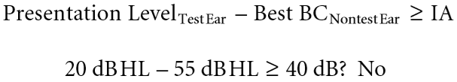

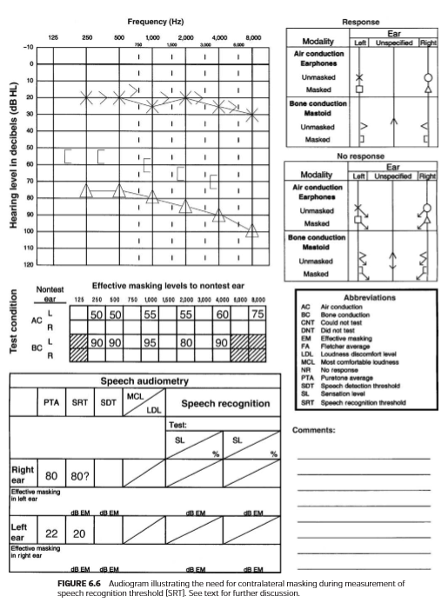

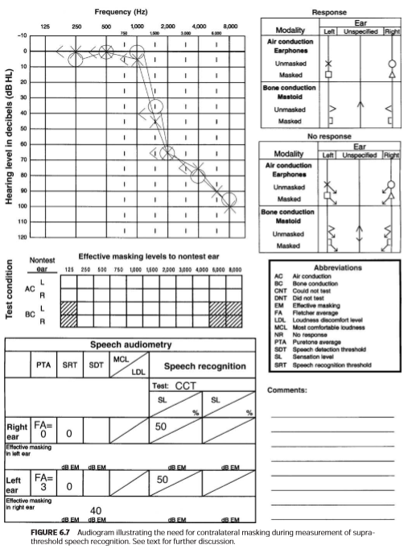

However, if we predict that an SRT will be measured at about 80 dB HL in the right ear (based on the puretone average), then contralateral masking will be required because the estimated speech threshold of 80 dB HL equals or exceeds the best bone-conduction threshold of 15 dB HL in the nontest ear by 40 dB, our estimate of IA for speech:

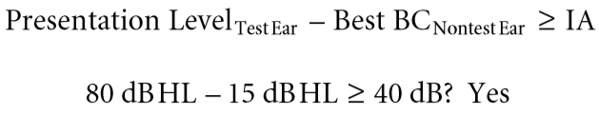

然而，如果我们预测右耳SRT的测量值约为80分贝HL（基于纯音平均值），则需要进行对侧掩蔽，因为在最佳骨传导阈值40分贝时，80 dB HL的估计语音阈值等于或超过非测试耳15dBHL的，言语的IA我们估计为：

Stated differently, the difference between the predicted presentation level in the test ear and the best bone-conduction threshold in the nontest ear equals or exceeds our estimate of IA. It is important to note, however, that a decision about the need for contralateral masking during measurement of speech threshold must always take into account not only the presentation level at the measured SRT, but also all suprathreshold levels used during threshold measurement. This will be discussed further in the section addressing selection of masking levels during speech audiometry.

换句话说，测试耳中的预计呈现水平与非测试耳中的最佳骨导阈值之间的差异等于或超过我们对IA的估计。然而，值得注意的是，关于在测量语音阈值期间需要对侧掩蔽的决定时，不仅要考虑被测SRT的呈现级别，还要考虑在测量阈值时使用的所有阈上水平。。这将在解决语音测听期间掩蔽级别的选择一节中进一步讨论。

During our earlier discussion of the need for contralateral masking during puretone air-conduction audiometry, it was indicated that a correct decision about the need for contralateral masking can be made sometimes by simply comparing the air-conduction thresholds of the two ears. Similarly, a decision about the need for contralateral masking during measurement of speech thresholds can be often made by comparing speech thresholds in the two ears.

在我们之前讨论纯音气导测听过程中对侧掩蔽的必要性时，我们指出有时可以通过简单地比较两只耳朵的气导阈值来做出关于对侧掩蔽需要的决定。同样，在测量语音阈值时，通常可以通过比较两耳的语音阈值来决定是否需要对侧掩蔽。

Contralateral masking is required during measurement of speech threshold when the speech threshold in the test ear (STTest Ear) equals or exceeds the speech threshold in the nontest ear (STNontest Ear) by a conservative estimate of IA:

当测试耳（STTest ear）中的语音阈值与非测试耳（STNontest ear）中的语音阈值相等或超过保守估计的IA时，在测量语音阈值时需要对侧掩蔽:

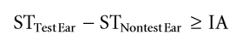

Consider again the audiogram presented in Figure 6.6. Recall that we predicted that SRT would be measured at about 80 dB HL in the right ear. In this particular example, comparison of the two speech thresholds (i.e., the measured SRT of 20 dB HL in the left ear and the predicted SRT of 80 dB HL in the right ear) would lead us to a correct decision about the need for contralateral masking when measuring SRT in the poorer ear without the need to consider bone-conduction hearing sensitivity in the nontest ear. The difference between the predicted SRT in the right ear (80 dB HL) and the measured SRT in the left ear (20 dB HL) equals or exceeds 40 dB, our estimate of IA for speech:

再次考虑图6.6所示的听力图。回想一下，我们预测SRT将在右耳测量到大约80dB HL。在这个特定的例子中，比较两个语音阈值（即，左耳中SRT测量到20dB HL和右耳中SRT预测的80dB HL）将引导我们在测量较差的耳朵中的SRT时正确地决定对侧掩蔽的需要，而不需要考虑非测试耳中的骨传导听力敏感度。右耳预测SRT（80 dB HL）与左耳测量SRT（20 dB HL）之差等于或超过40 dB，即我们对语音IA的估计：

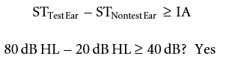

An alternative approach that can be used when making a decision about the need for contralateral masking during assessment of SRT involves measuring unmasked speech thresholds in both ears. Consider again the example presented in Figure 6.6. Assume that unmasked SRTs were measured at 65 and 20 dB HL in the right and left ears, respectively. Again there is an indication that contralateral masking will be required when measuring the SRT in the right ear. The presentation level of 65 dB HL (i.e., the unmasked SRT) in the test ear equals or exceeds the best bone-conduction threshold of 15 dB HL in the nontest ear by 40 dB, our estimate of IA for speech:

在评估SRT时，当决定是否需要对侧掩蔽时，可以使用的另一种方法测量双耳中的未掩蔽语音阈值。再次考虑图6.6中的示例。假设在右耳和左耳分别在65 dB HL和20 dB HL下测量了未掩蔽的SRT。再次有迹象表明，当测量右耳的SRT时，需要对侧掩蔽。测试耳中65 dB HL（即未掩蔽SRT）的呈现级别等于或超过非测试耳中15 dB HL的最佳骨导阈值40 dB，我们对语音IA的估计：

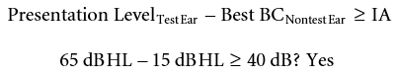

Similarly, the difference between the unmasked SRT in the right ear (65 dB HL) and the measured SRT in the left ear (20 dB HL) equals or exceeds our estimate of IA (40 dB). Although this approach can sometimes provide the audiologist with a more accurate estimate of the patient’s IA for speech (which may be useful when selecting appropriate masking levels), it often just increases the number of steps needed to establish the true SRT in the test ear.

同样，右耳未掩蔽SRT（65 dB HL）与左耳测量SRT（20 dB HL）之间的差值等于或超过我们估计的IA（40 dB）。虽然这种方法有时可以为听力专家提供更准确的患者语音IA估计（在选择适当的掩蔽级别时可能有用），但它通常只是增加了在测试耳中建立真正SRT所需的步骤数。

The audiogram presented in Figure 6.7 illustrates the need for contralateral masking during assessment of suprathreshold speech recognition. Puretone testing reveals normal hearing through 1,000 Hz, steeply sloping to a severe-to-profound sensory/neural hearing loss in the high frequencies bilaterally. SRTs were measured at 0 dB HL in both ears, a ﬁnding consistent with the puretone ﬁndings. Contralateral masking was not required during puretone and speech threshold audiometry. Suprathreshold speech recognition will be assessed using the California Consonant Test (CCT). This is a closed-set word recognition test that is sensitive to the speech recognition difﬁculties of individuals with high-frequency hearing loss (Owens and Schubert, 1977). If we use the recommended sensation level (SL) of 50 dB (Schwartz and Surr, 1979), then presentation level for both ears will be 50 dB HL (i.e., 50 dB relative to the SRT of 0 dB HL).

图6.7中所示的听力图说明了在评估阈上语音识别过程中对侧掩蔽的必要性。纯音测试显示通过1，000 Hz正常听力，双侧高频急剧倾斜至重度至极重度感觉/神经听力损失。双耳在0dBHL下测得SRT，测定结果与纯音测定结果一致。在纯音和言语阈值测听过程中不需要对侧掩蔽。阈值以上语音识别将使用加利福尼亚辅音测试（CCT）进行评估。这是一种封闭的单词识别测试，对高频听力损失个体的语音识别诊断非常敏感（OwensﬁSchubert，1977）。如果我们使用50 dB的推荐感觉水平（SL）（Schwartz和Surr，1979），那么两只耳朵的呈现水平将是50 dB HL（即相对于0dB HL的SRT为50 dB）。

Let us now consider the need for contralateral masking during assessment of suprathreshold speech recognition. We will consider the need for masking using two types of air-conduction transducers: Supra-aural and 3A insert earphones. The advantage of insert earphones will become apparent.

现在让我们考虑在评估阈上语音识别时对侧掩蔽的必要性。我们将考虑使用两种类型的气导换能器进行掩蔽的必要性：压耳式和3A插入式耳机。插入耳机的优点将变得明显。

Let us assume that supra-aural earphones are being used during speech audiometry. Contralateral masking will be required when assessing suprathreshold speech recognition in both ears because the difference between the presentation level of 50 dB HL in the test ear and the best puretone bone-conduction threshold of 0 dB HL in the nontest ear equals or exceeds 40 dB, our conservative estimate of IA for speech：

让我们假设在言语测听过程中正在使用压耳式耳机。当评估双耳的阈上语音识别时，将需要对侧掩蔽，因为测试耳中50 dB HL的呈现级别与非测试耳中最佳纯音骨导阈值0 dB HL之间的差值等于或超过40 dB，即我们对语音IA的保守估计：

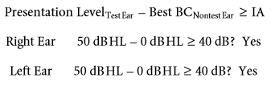

A different outcome results if we substitute 3A insert earphones for the supra-aural arrangement. Because of the greater IA offered by 3A insert earphones, contralateral masking will not be required when assessing suprathreshold speech recognition in either ear. Specifically, the difference between the presentation level of 50 dB HL in the test ear and the best puretone bone-conduction threshold of 0 dB HL in the nontest ear does not equal or exceed 60 dB, our conservative estimate of IA for speech:

如果我们用3A插入式耳机代替压耳式耳机，结果会有所不同。由于3A插入式耳机提供了更大的IA，在评估任一耳朵的阈上语音识别时将不需要对侧掩蔽。具体地说，测试耳中50 dB HL的呈现级别与非测试耳中最佳纯音骨导阈值0 dB HL之间的差值不等于或超过60 dB，即我们对语音IA的保守估计：

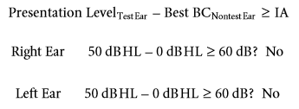

The example presented in Figure 6.7 illustrates two important concepts related to assessment of suprathreshold speech recognition. First, it should not be assumed that contralateral masking is never required when assessing individuals with symmetrical sensory/neural hearing loss. Second, the need for contralateral masking often can be eliminated by using an air-conduction transducer that provides greater IA (i.e., 3A insert earphone).

图6.7中的示例说明了与阈上语音识别的评估相关的两个重要概念。首先，在评估对称性感音/神经性听力损失的个体时，不应假定不需要对侧掩蔽。其次，通过使用提供更大IA的气导换能器（即3A插入式耳机），来消除对侧掩蔽的需要。

### MASKING CONCEPTS

掩蔽概念

Before proceeding to a discussion of clinical masking procedures, a brief review of basic masking concepts, including masking noise selection and calibration, will be presented. Generally, masking relates to how sensitivity for one sound is affected by the presence of another sound. ANSI/ASA (2010) deﬁnes masking as follows:

在继续讨论临床掩蔽程序之前，将简要回顾基本掩蔽概念，包括掩蔽噪声的选择和校准。通常，掩蔽涉及到一个声音的灵敏度如何受到另一个声音的存在的影响。ansi/asa（2010年）定义掩蔽如下：

The process by which the threshold of hearing for one sound is raised by the presence of another (masking) sound. The amount by which the threshold of hearing for one sound is raised by the presence of another (masking) sound, expressed in decibels (p 7).

一种声音的听觉阈值因另一种声音（掩蔽）的存在而提高。一种声音的听力阈值因另一种（掩蔽）声音的存在而提高的量，以分贝表示（P7）。

Consider the following example. Absolute threshold for a 1,000-Hz puretone stimulus is initially determined to be 40 dB HL. Another sound, white noise, is now presented simultaneously to the same ear. Absolute threshold for the 1,000-Hz signal is redetermined in the presence of the white noise and increases to 60 dB HL. Sensitivity to the puretone signal has been affected by the presence of the white noise. This increase in threshold of one sound in the presence of another is deﬁned as masking. Because the puretone threshold was raised by 20 dB (i.e., a threshold shift of 20 dB), the white noise has produced 20 dB of masking.

考虑以下示例。1000 Hz 纯音刺激的绝对阈值最初被确定为40dB HL。另一种声音，白噪声，现在同时呈现给同一个耳朵。在存在白噪声的情况下，重新确定1000 Hz信号的绝对阈值，并将其增加到60dB HL。白噪声的存在影响了对纯音信号的灵敏度。一种声音在另一种声音存在时阈值的增加被定义为掩蔽。由于纯音阈值提高了20dB（即阈值偏移20dB），因此白噪声产生了20dB的掩蔽。

There are two basic masking paradigms: ipsilateral and contralateral. In an ipsilateral masking paradigm, the test signal and the masker are presented to the same ear. In a contralateral masking paradigm, the test signal and masker are presented to opposite ears. Masking is used clinically whenever it is suspected that the nontest ear is participating in the evaluation of the test ear. Consequently, masking is always applied to the nontest or contralateral ear. Masking reduces sensitivity of the nontest ear to the test signal. The purpose of contralateral masking, therefore, is to raise the threshold of the nontest ear sufﬁciently so that its contribution to a response from the test ear is eliminated.

有两种基本的掩蔽范式：同侧掩蔽和对侧掩蔽。在同侧掩蔽范例中，测试信号和掩蔽呈现给同一只耳朵。在对侧掩蔽范例中，测试信号和掩蔽呈现给不同的耳朵。当怀疑非测试耳参与了测试耳的评估时，临床上都会使用掩蔽。因此，掩蔽总是应用于非测试耳或对侧耳。掩蔽降低了非测试耳朵对测试信号的敏感度。因此，对侧掩蔽的目的是充分提高非测试耳的阈值，以消除其对来自测试耳信号的响应。

**Masking Noise Selection**

屏蔽噪音的选择

Standard diagnostic audiometers provide three types of masking stimuli: narrowband noise, speech spectrum noise, and white noise. Our clinical goal is to select a masker that is efﬁcient (Hood, 1960). An efﬁcient masker is one that produces a given effective level of masking with the least overall sound pressure level.

标准诊断听力计提供三种类型的掩蔽刺激：窄带噪声、语音频谱噪声和白噪声。我们的临床目标是选择一种有效的掩蔽刺激（Hood，1960）。有效掩蔽刺激是一种以最小的总声压级产生给定有效掩蔽级别的掩蔽。

To better understand this concept of masker efﬁciency, let us review the classic masking experiment conducted by Fletcher (1940). White noise is a broadband stimulus that contains equal energy across a broad range of frequencies. Because of its broadband spectrum, it has the ability to mask puretone stimuli across a broad range of frequencies (Hawkins and Stevens, 1950). Fletcher addressed which frequency components of broadband noise contribute to the masking of a tone.

为了更好地理解掩蔽的概念，让我们回顾一下Fletcher（1940年）进行的经典掩蔽实验。白噪声是一种宽频带刺激，在广泛的频率范围内包含相等的能量。由于其宽带频谱，它有能力在广泛的频率范围内屏蔽纯音刺激（Hawkins and Stevens，1950）。Fletcher解决了宽带噪声的哪些频率成分有助于掩蔽音调。

Fletcher (1940) conducted what is known as a centered masking experiment. Initially, a very narrow band of noise was centered around a puretone signal. The bandwidth of the noise was progressively widened, and the masking effect on the puretone signal was determined. Fletcher observed that the masked puretone threshold increased as the bandwidth of the masking noise was increased. However, once the noise band reached and then exceeded a “critical bandwidth,” additional masking of the puretone signal did not occur.

Fletcher（1940）进行了所谓的中心掩蔽实验。最初，一个非常窄的噪声波段围绕着纯音信号。噪声的带宽逐渐加宽，并确定了对纯音信号的掩蔽效应。Fletcher观察到，掩蔽纯音阈值随着掩蔽噪声带宽的增加而增加。然而，一旦噪声频带达到然后超过“临界带宽”，就不会出现对纯音信号的额外掩蔽。

This concept of the critical band as ﬁrst described by Fletcher (1940) consists of two components:

弗莱彻（1940）首次提出的临界带概念包括两部分:

1. When masking a puretone with broadband noise, the only components of the noise that have a masking effect on the tone are those frequencies included within a narrow band centered around the frequency of the tone.

2. When a puretone is just audible in the presence of the noise, the total noise power present in the narrow band of frequencies is equal to the power of the tone.

1. 当用宽带噪声屏蔽纯音时，噪声中唯一对音调有屏蔽作用的成分是那些在以音调频率为中心的窄带内的频率。

2. 当纯音在存在噪声的情况下刚刚可听到时，窄带频率中存在的总噪声功率等于音调的功率。

The ﬁrst component of the critical band concept has clinical implications when selecting an appropriate masker during puretone audiometry. The second component has relevance when calibrating the effective masking (EM) level of the masking stimulus.

在纯音测听过程中选择合适的掩蔽刺激时，临界频带概念的第一各成分具有临床意义。当校准掩蔽刺激的有效掩蔽（EM）水平时，第二个分量具有相关性。

White noise is adequate as a masker for puretone stimuli. However, it contains noise components that do not contribute to the effectiveness of the masker. The additional noise components outside the tone’s critical band simply add to the overall level (and loudness) of the masking stimulus. Therefore, the most efﬁcient masker for puretone stimuli is a narrow band of noise with a bandwidth slightly greater than the critical band surrounding the tone. It provides the greatest masking effect with the least overall intensity. Sanders and Rintelmann (1964) conﬁrmed that narrowband noise was a far more efﬁcient masker for puretone stimuli than white noise. For a given sound pressure level (50, 70, and 90 dB SPL), narrowband noise centered at the frequency of the puretone signal (ranging from 250 to 4,000 Hz) consistently produced a greater masking effect (about 10 to 20 dB) than white noise.

白噪声足以作为纯音刺激的掩蔽物。但是，它包含的噪声成分并不有助于掩蔽刺激的有效性。音调临界频带外的额外噪声分量只是增加了掩蔽刺激的整体水平（和响度）。因此，对于纯音刺激，最有效的掩蔽刺激是一个窄带噪声，其带宽略大于环绕音调的临界频带。它以最小的总强度提供最大的掩蔽效果。Sanders和Rintelmann（1964年）证实窄带噪声对纯音刺激比白噪声更有效。对于给定的声压级（50、70和90 dB SPL），以PureTone信号的频率为中心的窄带噪声（范围为250至4，000 Hz）始终比白噪声产生更大的掩蔽效应（约10至20 dB）。

The masking noise typically used during puretone audiometry, therefore, is narrowband noise centered geometrically around the audiometric test frequency. ANSI/ ASA (2010) speciﬁes the band limits (i.e., the upper and lower cutoff frequencies) of narrowband masking noise. To minimize the perception of tonality that often is associated with very narrow bands of noise, the bands speciﬁed by ANSI/ASA are somewhat wider than the critical bands for EM. The goal is to avoid confusion of the masker with the signal.

因此，在纯音测听过程中通常使用的掩蔽噪声是以测试频率为几何中心的窄带噪声。ANSI/ ASA（2010）规定了窄带掩蔽噪声的频带限制（即频率上限和频率下限）。为了尽量减少与非常窄的噪声频带有关的音调感知，ANSI/ASA指定的频带要比EM的临界频带宽一些，目的是避免掩蔽刺激与信号混淆。

Speech spectrum noise (i.e., weighted random noise for the masking of speech) is typically used as a masker during speech audiometry. Speech is a broadband stimulus that requires a broadband masker. Although white noise is an adequate masker, it is not the most efﬁcient. Speech spectrum noise is white noise that has been ﬁltered to simulate the long-term average spectrum of speech. The average spectrum of speech contains the greatest energy in the low frequencies with spectrum level decreasing as a function of increasing frequency (Dunn and White, 1940). Speech spectrum noise has a more limited bandwidth than white noise. It is a more efﬁcient masker than white noise, producing a masking advantage of 8 dB (Konkle and Berry, 1983). ANSI/ASA (2010) speciﬁes that the spectrum of weighted random noise for the masking of speech should have a sound pressure spectrum level that is constant from 100 to 1,000 Hz, decreasing at a rate of 12 dB per octave from 1,000 to 6,000 Hz.

语音频谱噪声（即用于掩蔽语音的加权随机噪声）通常在语音测听过程中用作掩蔽刺激。语音是一种宽带刺激，需要一个宽带掩蔽刺激。虽然白噪声是一个足够的掩蔽刺激，它不是最有效的。语音频谱噪声是一种过滤后的白噪声，用来模拟语音的长时平均频谱。语音的平均频谱在低频中能量最大，频谱级别随频率的增加而降低（Dunn and White, 1940）。语音频谱噪声比白噪声具有更加有限的带宽。它是一种比白噪声更有效的掩蔽物，具有8分贝的掩码优势（Konkle and Berry, 1983）。ANSI/ASA（2010）规定用于语音掩蔽的加权随机噪声频谱应具有一个从100到1000hz不变的声压谱级，从1000到6000 Hz以每八度12 dB的速度递减。

**Calibration of Effective Masking Level**

有效掩蔽水平的校准

When a masking noise is presented to the nontest ear, we are interested in how much masking is produced. Consequently, masking noise is calibrated in EM level (dB EM).

当掩蔽噪声呈现给非测试耳朵时，我们感兴趣的是产生了多少掩蔽。因此，掩蔽噪声是在EM级（dB EM）校准。

ANSI/ASA (2010) deﬁnes EM level for puretones as “the sound pressure level of a band of noise whose geomet-ric center frequency coincides with that of a speciﬁc pure tone that masks the pure tone to 50% probability of detection” (p 7). (Reference EM levels, calculated by adding an appropriate correction value to the reference equivalent threshold sound pressure level [RETSPL] at each frequency, are provided in the current ANSI/ASA speciﬁcation for audiometers.) It is also indicated that, in individuals with normal hearing, “the amount of effective masking . . . is equal to the number of decibels that a given band of noise shifts a pure-tone threshold . . . when the band of noise and the pure tone are presented simultaneously to the same ear” (ANSI/ASA, 2010, p 7).

ANSI/ASA（2010）将纯音的EM级定义为“其几何中心频率与掩盖纯音至50%检测概率的特定纯音的中心频率一致的噪声带的声压级”（第7页）。（通过在每个频率的参考等效阈声压级[RETSPL ]上加上适当的校正值来计算的参考EM级，在当前的ANSI/ASA听力计规范中提供。）还表明，在听力正常的人中，“有效掩蔽的数量。…等于给定噪声带移动纯音阈值的分贝数。…当噪声带和纯音同时出现在同一只耳朵上时”

Stated differently, effective masking (in dB EM) refers to

换句话说，有效掩蔽（以dB EM为单位）是指

1. The HL (dB HL) to which puretone threshold is shifted by a given level of noise; and

2. The puretone threshold shift (in dB) relative to 0 dB HL provided by a given level of noise.

1. 在给定的噪声级下，纯音阈值移到的HL（dB HL）；和

2. 由给定噪声级提供的相对于0dB HL的纯音阈值偏移（单位为dB）。

Although contralateral masking is used clinically during hearing assessment, the following examples of ipsilateral masking will facilitate an understanding of the concept of EM level.

Example 1: A puretone air-conduction threshold is measured at 0 dB HL in the right ear. A narrowband noise geometrically centered at the test frequency is presented to the same ear at 50 dB EM. This EM level of 50 dB will shift puretone threshold to 50 dB HL.

Example 2: A puretone air-conduction threshold is measured at 30 dB HL in the right ear. A narrowband noise geometrically centered at the test frequency is presented to the same ear at 50 dB EM. This EM level of 50 dB will shift puretone threshold to 50 dB HL.

尽管在听力评估中临床上使用对侧掩蔽，但以下同侧掩蔽的例子将有助于理解EM级的概念。

例1：纯音气导阈值在右耳0dB HL下测量。以测试频率为几何中心的窄带噪声在50dB EM下呈现给同一耳朵。这个50 dB的EM级将纯音阈值偏移到50 dB HL。

例2：纯音气导阈值在右耳30dB HL下测量。以测试频率为几何中心的窄带噪声在50dB EM下呈现给同一耳朵。这个50 dB的EM级将纯音阈值移动到50 dB HL。

These examples illustrate two important points. First, a given level of EM will shift all unmasked puretone thresholds to the same dB HL. Of course, if unmasked puretone threshold is greater than a particular level of EM, then no threshold shift will occur. For example, a masker of 50 dB EM will not have a masking effect if the unmasked puretone threshold is 70 dB HL. Second, EM refers to the amount of threshold shift only relative to 0 dB HL.

这些例子说明了两个要点。首先，给定的EM级会将所有未掩蔽的纯音阈值偏移到相同的dB HL。当然，如果未掩蔽的纯音阈值大于特定水平的EM级，则不会发生阈值偏移。例如，如果未屏蔽的纯音阈值为70 dB HL，则50 dB EM的掩蔽声将不具有掩蔽效果。其次，EM级仅指相对于0dB HL的阈值偏移量。

Speech spectrum noise is also calibrated in EM level. Just as HL for speech (dB HL) is speciﬁed relative to the SRT, EM level is also referenced to the SRT. Speciﬁcally, EM for speech refers to the dB HL to which the SRT is shifted by a given level of noise. ANSI/ASA (2010) deﬁnes EM level for speech as the “sound pressure level of a speciﬁed masking noise that masks a speech signal to 50% probability of recognition” (p 8). (If the speech spectrum noise has spectral density characteristics as speciﬁed by ANSI/ASA and if the sound pressure level of the masker is equal to the RETSPL for speech, then the masker is calibrated in dB EM.) ANSI/ASA (2010) also states that in individuals with normal hearing, “the amount of effective masking . . . is equal to the number of decibels that a masking noise shifts a speech recognition threshold . . . when the masking noise and speech signal are presented simultaneously to the same ear” (p 8).

语音频谱噪声也在EM级进行了校准。就像语音HL （dB HL）是相对于SRT指定的一样，EM级别也引用到SRT。具体地说，语音EM指的是SRT被给定的噪声级偏移到的dB HL。ANSI / ASA（2010）定义了言语的EM级，“将语音信号掩蔽为50%识别概率的特定掩蔽噪声的声压级”（第8页）。如果语音频谱噪声具有ANSI/ASA规定的频谱密度特性，并且如果掩蔽声的声压级等于语音的RETSPL，则掩蔽器的校准单位为dB EM。ANSI / ASA（2010）也指出，在听力正常的人中，“有效的掩蔽量。。。等于掩蔽噪声改变语音识别阈值的分贝数…当掩蔽噪声和语音信号同时呈现给同一只耳朵时”（第8页）。

Consider the following example. SRT is measured at 0 dB HL. Speech spectrum noise is then presented to the same ear at 50 dB EM. This EM level of 50 dB will shift the SRT to 50 dB HL.

请看下面的示例。SRT在0dB HL下测量。然后将语音频谱噪声以50dB EM呈现给同一耳朵。这个50 dB的EM电平将使SRT移动到50 dB HL。

Calibration of masking noise in EM level greatly simpliﬁes clinical masking procedures. When masking noise is calibrated in dB EM, then the decibel value indicated on the masking level control will indicate the masking effect produced in the nontest ear. This clearly facilitates the selection of appropriate masking levels during clinical testing.

EM级掩蔽噪声的校准大大简化了临床掩蔽程序。当掩蔽噪声以dB EM进行校准时，掩蔽级控制上显示的分贝值将指示非测试耳中产生的掩蔽效果。这显然有助于在临床试验中选择适当的掩蔽水平。

### CLINICAL MASKING PROCEDURES

临床掩蔽步骤

All approaches to clinical masking address two basic questions. First, what is the minimum level of noise that is needed in the nontest ear to eliminate its response to the test signal? Stated differently, this is the minimum masking level that is needed to avoid undermasking (i.e., even with contralateral masking, the test signal continues to be perceived in the nontest ear). Second, what is the maximum level of noise that can be used in the nontest ear that will not change the true threshold or response in the test ear? Stated differently, this is the maximum masking level that can be used without overmasking (i.e., with contralateral masking, the true threshold or response in the test ear has been changed). Because of limited IA for air-conducted sound, the masking stimulus presented to the nontest ear can also cross over to the test ear and produce masking of the test signal (i.e., overmasking). Stated simply, the purpose of clinical masking is to make the test signal inaudible in the nontest ear without affecting the true response to the signal in the test ear. Therefore, the major goal of any clinical masking procedure is the avoidance of both undermasking and overmasking.

所有临床掩蔽的方法都解决了两个基本问题。首先，为了消除非测试耳朵对测试信号的响应，非测试耳朵需要的最低噪声水平是多少？换句话说，这是避免掩蔽不足所需的最低掩蔽级（即，即使有对侧掩蔽，测试信号仍然在非测试耳中被感知）。其次，在不会改变测试耳中真实阈值或测试耳中响应的可以使用的最大噪声级是多少？换句话说，这是可以在没有过度掩蔽的情况下使用的最大掩蔽水平（即，在对侧掩蔽下，测试耳中的真实阈值或响应已经改变）。由于气导声音的有限IA，呈现给非测试耳的掩蔽刺激也可以交叉到测试耳并产生测试信号的掩蔽（即，过度掩蔽）。简单地说，临床掩蔽的目的是使测试信号在非测试耳中听不见，而不影响测试耳对信号的真实响应。因此，任何临床掩蔽程序的主要目标都是避免掩蔽不足和过度掩蔽。

Studebaker (1979) has identiﬁed two major approaches to clinical masking: psychoacoustic and acoustic. Psychoacoustic procedures are “those based upon observed shifts in the measured threshold as a function of suprathreshold masker effective levels in the nontest ear” (Studebaker, 1979, p 82). These approaches are also identiﬁed as threshold shift or shadowing procedures. Acoustic procedures are “those based upon calculating the approximate acoustic levels of the test and masker signals in the two ears under any given set of conditions and on this basis deriving the required masking level” (Studebaker, 1979, p 82). These procedures are also referred to as calculation or formula methods. Psychoacoustic approaches are considered appropriate for threshold measurements, whereas acoustic methods are typically most efﬁcient for suprathreshold measurements.

Studebaker(（1979）已经确定了两种主要的临床掩蔽方法：心理声学和声学。心理声学疗法是“那些基于观察到的作为非测试耳中阈上掩蔽有效水平的函数的测量阈值偏移的程序”（Studebaker, 1979, p 82）。这些方法也被确定为阈值偏移或阴影过程。声学程序是“基于在任何给定条件下计算测试和掩蔽器信号在两耳中的近似声级，并在此基础上得出所需掩蔽级的程序”（Studebaker, 1979, p 82）。这些程序也称为计算或公式方法。心理声学方法被认为适用于阈值测量，而声学方法通常是阈上测量最有效的方法。

**Puretone Audiometry**

纯音测听

Formulas and equations have been presented for the calculation of minimum and maximum masking levels during puretone audiometry (Lidén et al., 1959; Martin, 1967, 1974; Studebaker, 1962, 1964). A brief discussion of these formulas will facilitate an understanding of the manner in which appropriate levels of masking are selected during puretone threshold testing.

计算纯音测听过程中最小和最大掩蔽水平的公式和方程已经被提出（Liden et al.， 1959;1967年马丁,1974;Studebaker、1962、1964）。对这些公式的简要讨论将有助于理解在纯音阈值测试中选择适当掩蔽级的方式。

**MINIMUM MASKING LEVEL**

最低掩蔽级别

Lidén et al. (1959) and Studebaker (1964) offered formulas for calculating minimum masking level during puretone air-conduction audiometry that include consideration of IA, HL of the test signal, and air-bone gaps in the nontest ear. Although this “formula” approach to calculating minimum masking level is necessary during administration of suprathreshold auditory tests (this approach will be discussed later in the section addressing masking in speech audiometry), it proves somewhat disadvantageous during threshold audiometry. First, it can be time consuming. Second, the clinician may not have all required information to accurately calculate minimum masking level at that point in time. (The reader is referred to Yacullo, 1996 for further discussion of the derivation of these equations and formulas.)

Liden et al.（1959）和Studebaker（1964）提供了计算纯音气导测听期间最小掩蔽级的公式，包括考虑IA、测试信号的HL和非测试耳的气骨间隙。虽然这种计算最小掩蔽级的“公式”方法在阈上听觉测试中是必要的（这种方法将在稍后的语音听力测试掩蔽寻址一节中讨论），但它在阈值听力测试中被证明有些不利。首先，这可能很费时。其次，临床医生可能不具备准确计算该时间点最小掩蔽级所需的所有信息。（读者可以参考Yacullo, 1996，以进一步讨论这些方程和公式的推导过程。）

The simpliﬁed method described by Martin (1967, 1974) is recommended for clinical use. Martin has suggested that formulas are unnecessary during threshold audiometry and has simpliﬁed the calculation of minimum masking level. Speciﬁcally, the “initial” masking level (in dB EM) during air-conduction threshold testing is simply equal to air-conduction threshold (in dB HL) of the nontest ear (i.e., ACNontest Ear). It should be noted that the initial masking level is calculated in the same manner regardless of the air- conduction transducer being used (i.e., supra-aural earphone or 3A insert earphone).

马丁（1967、1974）所描述的简化方法推荐用于临床。马丁建议在阈值测听时不必使用公式，并简化了最小掩蔽级的计算。具体来说，空气传导阈值测试期间的“初始”掩蔽级（单位：dB EM）仅等于非测试耳（即非测试耳）的气导阈值（单位：dB HL）。应注意的是，无论使用的是气导换能器（即，压耳式耳机或3A插入式耳机），初始掩蔽级都是以相同的方式计算的。

The audiometric data presented in Figure 6.8 will be used to facilitate an understanding of the calculation of masking levels during puretone threshold audiometry. Audiometry was performed using supra-aural earphones. Unmasked air- and bone-conduction thresholds at 500 Hz are provided; masked air- and bone-conduction thresholds are also included for later discussion. Unmasked puretone air-conduction testing suggests that contralateral masking will be required only when measuring air-conduction threshold in the left ear. Speciﬁcally, the unmasked airconduction threshold of 65 dB HL in the left ear equals or exceeds the threshold (both air and bone conduction) in the nontest ear by a conservative estimate of IA (i.e., 40 dB). According to Martin (1967, 1974), the initial masking level (in dB EM) is equal to 5 dB EM (i.e., ACNontest Ear).

图6.8所示的测听数据将用于帮助理解在纯音阈值测听期间掩蔽级的计算。使用压耳式耳机进行测听。提供500赫兹下的未掩蔽气导和骨导阈值；也包括掩蔽的气导和骨导阈值，以供以后讨论。未掩蔽的纯音气导测试表明，只有在测量左耳的气导阈值时，才需要对侧掩蔽。具体来说，左耳65分贝HL的未掩蔽气导阈值等于或超过非测试耳的阈值（气导和骨导），保守估计为IA（即40分贝）。根据martin所述（1967，1974），初始掩蔽级（单位为dB EM）等于5 dB EM（即ACNontest Ear）。

Martin (1967, 1974) explains the derivation of this simpliﬁed equation in the following way. A signal detected at threshold is assumed to have an SL of 0 dB, regardless of whether it is perceived in the test or nontest ear. Therefore, a cross-hearing response during puretone threshold testing theoretically represents a threshold response in the nontest ear. Given this assumption, the initial masking level required is one that will just mask a signal of 0 dB SL (i.e., threshold) in the nontest ear. Because of the manner in which masking stimuli are calibrated clinically (i.e., EM level, dB EM), a masker presented at a level (in dB EM) equal to the air-conduction threshold (in dB HL) in the nontest ear should just mask the threshold response in the nontest ear. Given the example presented in Figure 6.8, a masker level of 5 dB EM (which is equal to the air-conduction threshold in the right ear) should be sufﬁcient to just mask a threshold response to the test signal in the right ear. Martin also indicates that the simpliﬁed approach will lead to the selection of the same masker level as when using the more complex formulas for calculating minimum masking level.

马丁（1967，1974）用以下方式解释了这个简化方程的推导过程。假设在阈值处检测到的信号具有0db的SL，而不管它是在测试耳中被感知还是在非测试耳中被感知。因此，纯音阈值测试中的交叉听力反应理论上代表了非测试耳的阈值反应。在这种假设下，所需的初始掩蔽级是在非测试耳朵中掩蔽的0db SL（即阈值）信号。因为掩蔽刺激在临床上是经过校准的（即EM级，dB EM），在非测试耳中与气导阈值（dB HL）相等的水平（dB EM）上呈现的掩蔽声应该仅掩蔽非测试耳中的阈值响应。如图6.8所示，5分贝EM（相当于右耳的气导阈值）的掩蔽级应足以掩蔽右耳对测试信号的阈值响应。马丁还指出，简化的方法将导致选择与使用更复杂的公式计算最小掩蔽级相同的掩蔽级别。

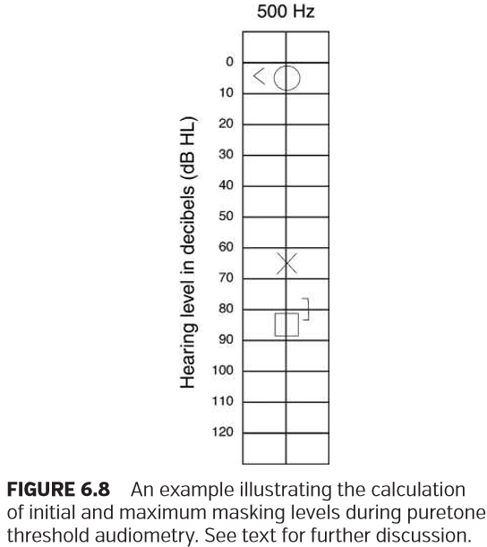

Martin (1974) recommends that approximately 10 dB should be added to the initial masking level to account for intersubject variability. Remember that dB EM refers to the HL (dB HL) to which threshold is shifted by a given level of noise. Calibration of EM is based on the averaged responses of a group of normal-hearing subjects. Therefore, a given EM level will not prove equally effective for all subjects. If masked thresholds are normally distributed around the average effective level and if the standard deviation of the distribution is about 5 dB, then Studebaker (1979) recommends that a safety factor of not less than 10 dB should be added to the calculated minimum masking level. Given this recommendation, Martin’s simpliﬁed equation for initial masking level (in dB EM) during air-conduction threshold audiometry can be stated as follows:

Martin（1974）建议在初始掩蔽级上增加大约10dB，以说明主体间的可变性。记住，dB EM是指通过给定的噪声水平将阈值偏移到的HL（DB HL）。EM的校准是基于一组正常听力受试者的平均反应。因此，给定的EM级不会证明对所有受试者都是同样有效的。如果掩蔽阈值在平均有效水平周围呈正态分布，并且分布的标准偏差约为5 dB，则Studebaker（1979）建议在计算的最小掩蔽级中添加不小于10 dB的安全系数。根据这一建议，气导阈值测听过程中初始掩蔽级（以dB EM为单位）的Martin‘s Simpliﬁed方程式可表述如下：



Considering again the example presented in Figure 6.8, the initial masking level is now calculated as 15 dB EM:

再次考虑图6.8中的示例，初始掩蔽级别现在计算为15 dB EM：

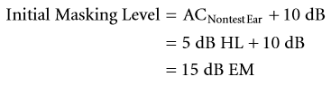

It is important to differentiate the terms minimum masking level and initial masking level during air-conduction threshold audiometry. Earlier in this discussion, a general deﬁnition of minimum masking level was provided. Minimum masking level was deﬁned as the minimum level of noise needed in the nontest ear to eliminate its response to the test signal. Related to puretone threshold audiometry, a more speciﬁc deﬁnition of minimum masking level can be offered: Minimum masking level is the minimum level of noise needed to eliminate the contribution of the nontest ear to establish the true or correct threshold in the test ear. Initial masking level is simply the ﬁrst level of noise introduced to the nontest ear. This initial level of masking is often not sufﬁcient to establish the threshold in the test ear; higher levels of masking are often required. This concept will be addressed again in our discussion of the recommended clinical masking procedure during puretone threshold audiometry.

在气导阈值测听中，区分最小掩蔽级和初始掩蔽级是非常重要的。在本讨论的早期，提供了最小掩蔽级的一般定义。最小掩蔽级被定义为非测试耳朵所需的最小噪声级，以消除其对测试信号的响应。与纯音阈值测听法相关，可提供最低掩蔽级的更详细定义：最小掩蔽级是消除非测试耳朵的参与以在测试耳朵中建立真实或正确阈值所需的最低噪声级别。初始掩蔽级别只是引入到非测试耳的噪声的第一级别。这种初始掩蔽级通常不足以确定测试耳朵的阈值；通常需要更高级别的掩蔽。这一概念将在我们讨论纯音阈值测听过程中推荐的临床掩蔽程序时再次讨论。

Lidén et al. (1959) and Studebaker (1964) also have offered formulas for minimum masking level during boneconduction testing that are derived from the same theoretical constructs used during air-conduction testing (see Yacullo, 1996 for further discussion). Again, the formula approach during bone-conduction threshold audiometry is not clinically practical. The use of Martin’s simpliﬁed approach is recommended. Speciﬁcally, initial masking level during bone-conduction audiometry is equal to the air- conduction threshold of the nontest ear. However, we will need to add the OE to the initial masking level to compensate for covering (i.e., occluding) the nontest ear with an earphone (Martin, 1967, 1974; Studebaker, 1964). Martin’s simpliﬁed equation for initial masking level (in dB EM) during bone-conduction threshold testing can be stated as follows:

Lidén等人。（1959）和Studebaker（1964）也提供了骨导测试期间最小掩蔽级的公式，这些公式来自于气导测试期间使用的相同理论构造（有关进一步的讨论，请参阅Yacullo，1996）。同样，骨导阈值测听过程中的公式方法在临床上并不实用。建议使用Martin的简化方法。特别是，骨导测听时的初始掩蔽级别等于非测试耳的气导阈值。然而，我们需要将OE添加到初始掩蔽级别，以补偿用耳机覆盖（即掩蔽）未测试的耳朵（Martin，1967，1974；Studebaker，1964）。在骨传导阈值测试期间，针对初始掩蔽级（以dB EM为单位）的Martin‘s Simpliﬁed方程可以表述如下：



Bone-conduction thresholds are always obtained with the test ear unoccluded or uncovered. However, when an earphone covers or occludes the nontest ear during masked bone-conduction audiometry, an OE can be created in the nontest ear. The nontest ear consequently can become more sensitive to bone-conducted sound for test frequencies below 2,000 Hz, particularly when using supra-aural earphones (Berger and Kerivan, 1983; Berrett, 1973; Dean and Martin, 2000; Dirks and Swindeman, 1967; Elpern and Naunton, 1963; Goldstein and Hayes, 1965; Hodgson and Tillman, 1966). During the application of contralateral masking, there is increased probability that the nontest ear will respond when obtaining a masked bone-conduction threshold in the test ear. Studebaker (1979) points out that the OE does not actually affect the hearing sensitivity of the occluded ear, but rather increases the sound pressure level of the signal reaching the cochlea. The reader is referred to Tonndorf (1968, 1972) for further discussion of the contribution of the external auditory meatus to bone-conduction thresholds.

骨导阈值总是在测试耳未封闭或未覆盖的情况下获得。然而，当耳机在掩蔽骨传导测听过程中覆盖或阻塞非测试耳时，可以在非测试耳中产生OE。因此，当测试频率低于2000赫兹时，非测试者的耳朵对骨传导的声音更加敏感，尤其是当使用压耳式耳机时（Berger和Kerivan, 1983;Berrett, 1973;迪恩和马丁，2000年;Dirks和swan, 1967;埃尔彭和农顿，1963年;戈尔茨坦和海斯，1965年;霍奇森和蒂尔曼，1966）。在对侧掩蔽的应用过程中，当测试耳获得掩蔽骨传导阈值时，非测试耳响应的概率增加。Studebaker（1979）指出OE实际上并不影响闭塞的耳朵的听力敏感度，而是增加了到达耳蜗的信号的声压级。读者可参考Tonndorf（1968, 1972）进一步讨论外耳道对骨导阈值的影响。

There is evidence suggesting that the OE is decreased signiﬁcantly when using deeply inserted insert earphones (Berger and Kerivan, 1983; Chaiklin, 1967; Dean and Martin, 2000). Berger and Kerivan (1983) and Dean and Martin (2000) studied the magnitude of the OE in normal- hearing subjects using E-A-R foam eartips and supraaural earphones as occluding devices. Their overall results are remarkably similar. First, the average OEs in the low frequencies are greatly reduced when occluding the ear using an E-A-R foam eartip with deep insertion. Second, the advantage of a greatly reduced OE for the E-A-R foam eartip is lost when a partial or shallow insertion is used. Third, partial or shallow insertion of an E-A-R foam eartip yields average OEs that are similar to those measured with supra-aural earphones. Different theories have been offered to explain the reduced OE for an occluding device that is deeply inserted into the ear canal. The reader is referred to Berger and Kerivan (1983), Tonndorf (1972), and Yacullo (1996) for further discussion.

有证据表明，当使用深插入式耳机时，OE明显降低（BergerﬁKerivan，1983；Chaiklin，1967；Dean和Martin，2000）。伯杰和KiiVaN（1983）和迪安和马丁（2000）研究了E-A-泡沫耳塞和耳膜作为阻塞装置的正常听力受试者的OE的大小。他们的总体结果非常相似。首先，使用E-A-R泡沫耳塞深插入时，低频中的平均OE大大降低。第二，当使用部分或浅插入时，E-A-R泡沫耳尖的OE大大降低的优点丢失。第三，部分或浅插入E-A-R泡沫耳尖产生的平均OO与使用压耳式耳机测量的OE相似。不同的理论已经被提供来解释被深深地插入耳道的阻塞装置降低的OE。读者可参考Berger和Kerivan（1983）、Tonndorf（1972）和Yacullo（1996）进行进一步讨论。

The clinician can use either individually determined (Dean and Martin, 2000; Martin et al., 1974) or ﬁxed OE values (i.e., based on average data reported in the literature) when calculating initial masking level. Based on the largest average OEs reported in the literature (Berger and Kerivan, 1983; Berrett, 1973; Dean and Martin, 2000; Dirks and Swindeman, 1967; Elpern and Naunton, 1963; Goldstein and Hayes, 1965; Hodgson and Tillman, 1966), the following values are recommended for clinical use.

当计算初始掩蔽级时，临床医生可以使用单独确定的（Dean和Martin，2000年；Martin等人，1974年）或固定的OE值（即基于文献中报告的平均数据）。基于文献中报道的最大平均OES（Berger和Kerivan，1983；Berrett，1973；Dean和Martin，2000；Dirks和Swindeman，1967；Elpern和Naunton，1963；Goldstein和Hayes，1965；Hodgson和Tillman，1966），建议临床使用以下值。

When using supra-aural earphones, the following ﬁxed OE values are recommended: 30 dB at 250 Hz, 20 dB at 500 Hz, and 10 dB at 1,000 Hz. When using 3A insert earphones with deeply inserted foam eartips, the following values are recommended: 10 dB at 250 and 500 Hz and 0 dB at frequencies of 1,000 Hz or higher.

使用压耳式耳机时，建议使用以下固定的OE值：250hz时为30dB, 500hz时为20dB 1000hz时为10dB。当使用深度插入的泡沫耳塞的3A插入式耳机时，建议以下值：在250 Hz和500 Hz下的10分贝，在1000 Hz或更高的频率下为0分贝。。

It should be noted that the OE is decreased or absent in ears with conductive hearing impairment (Martin et al., 1974; Studebaker, 1979). If the nontest ear exhibits a potential air-bone gap of 20 dB or more, then the OE should not be added to the initial masking level at that frequency.

应注意的是，患有传导性听力障碍的耳朵中，OE减少或缺失（Martin et al.，1974；Studebaker，1979）。如果非测试耳表现出20dB或更大的潜在气骨间隙，则不应将OE添加到该频率下的初始掩蔽级别。

Consider again the example presented in Figure 6.8. Assume that we have subsequently measured a masked airconduction threshold of 85 dB HL in the left ear. A masked bone-conduction threshold will also be required in the left ear. Comparison of the unmasked bone-conduction threshold of 5 dB HL with the masked air-conduction threshold of 85 dB HL in the left ear suggests a potentially signiﬁcant air-bone gap (i.e., ≥15 dB). Initial masking level is calculated in the same manner regardless of the air-conduction transducer used for the delivery of the masking stimulus. The only difference in calculation relates to applying a different correction factor for the OE when testing in the lower frequencies. Using the recommended ﬁxed OE values for supra-aural earphones, initial masking level during boneconduction testing at 500 Hz is calculated as follows:

再次考虑图6.8所示的示例。假设我们随后在左耳测量了85 dB HL的掩蔽气导阈值。左耳还需要一个掩蔽的骨导阈值。左耳非掩蔽骨导阈值5 dB HL与掩蔽的气导阈值85 dB HL进行比较，发现潜在的显著气骨间隙（即≥15 dB）。无论用于掩蔽刺激的气导换能器是什么，初始掩蔽电平的计算方法是相同的。计算上的唯一不同之处在于，在较低频率测试时，对OE采用不同的校正因子。使用压耳式耳机推荐的固定OE值，在500hz骨导测试期间时的初始掩蔽级如下：

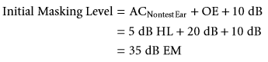

In this particular example, it is appropriate to account for the OE because there is no evidence of a signiﬁcant air-bone gap in the nontest (i.e., right) ear. The use of a supra-aural earphone for delivery of masking in the lower frequencies, however, will result in greater initial masking levels than when using a 3A insert because of a larger OE correction factor.

在这个特殊的例子中，考虑OE是合适的，因为在非测试耳中没有明显的气骨间隙的证据（例如，右）的耳朵。然而，由于较大的OE校正因子，使用压耳式耳机在较低频率下传递掩蔽将导致比使用3A插入式时更大的初始掩蔽级别。

MAXIMUM MASKING LEVEL

最大掩蔽级别

Maximum masking level refers to the maximum level of noise that can be used in the nontest ear that will not shift or change the true threshold in the test ear. Two factors inﬂuence maximum masking level during puretone audiometry: (1) The bone-conduction threshold of the test ear (BCTest Ear) and (2) IA of the air-conducted masking stimulus (Lidén et al., 1959). Maximum masking level (MMax), based on the original concept described by Lidén et al., can be summarized using the following equation:

最大掩蔽电平是指在不改变测试耳的真实阈值的情况下，可以在非测试耳中使用的最大噪声级别。在纯音测听过程中，有两个因素影响最大掩蔽水平：（1）测试耳的骨传导阈值（BCTest ear）和（2）气导掩蔽刺激的IA （Liden et al.，1959）。最大掩蔽级别（MMax）是基于Liden等人的原始概念，可以用下式来概括:

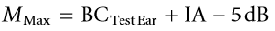

If BCTest Ear + IA is just sufﬁcient to produce overmasking, then clinically, we want to use a masking level that is somewhat less than the calculated value. Consequently, 5 dB is subtracted from the level that theoretically produces overmasking. Because we are concerned about an undesired masking effect in the test ear, bone-conduction sensitivity in that ear must be considered. As a result, overmasking is more of a potential problem when bone-conduction sensitivity is very good in the test ear. Overmasking, on the other hand, is generally not an issue when bone-conduction hearing sensitivity is poor. The poorer the bone-conduction hearing sensitivity is in the test ear, the greater the levels of masking that can be used without overmasking.

如果BCTest Ear + IA足以产生过掩蔽，那么在临床中，我们希望使用比计算值略低的掩蔽级别。因此，从理论上产生过掩蔽级别减去5分贝。由于我们关注的是测试耳中不希望出现的掩蔽效应，因此必须考虑该耳中的骨传导敏感性。因此，当测试耳的骨传导敏感性非常好时，过度掩蔽更是一个潜在的问题。另一方面，当骨传导听力敏感性较差时，过度掩蔽通常不是问题。在测试耳中，骨传导听力敏感性越差，可以在不过度掩蔽的情况下使用的掩蔽级别就越高。

The following two points are important to remember. First, the equation for maximum masking level is the same for both air- and bone-conduction audiometry. Masking noise is always delivered through an air-conduction transducer (e.g., insert or supra-aural earphone) regardless of the transducer used for measuring puretone threshold (i.e., air- or bone-conduction transducer). Second, maximum masking level is generally higher when using 3A insert earphones because of increased IA, particularly in the lower frequencies.

以下两点必须记住。首先，气导测听和传导测听的最大掩蔽级别方程式是相同的。无论用于测量PureTone阈值的换能器（即空气传导换能器或骨导换能器）如何，掩蔽噪声总是通过气导换能器（例如，插入式或压耳式耳机）传递。其次，当使用3A插入式耳机时，由于IA增加，特别是在较低频率下，最大掩蔽级别通常较高。

Consider again the example presented in Figure 6.8. We will now calculate the maximum masking level that can be used during both masked air- and bone-conduction audiometry:

再次考虑图6.8所示的示例。现在，我们将计算掩蔽下气导和骨导测听过程中可以使用的最大掩蔽级别：

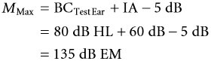

Rather than using the very conservative IA estimate of 40 dB when using supra-aural earphones, in this case, we will use the more accurate estimate of 60 dB. If the bone-conduction threshold in the right (i.e., nontest) ear is assumed to be 5 dB HL (i.e., the unmasked bone-conduction threshold) and the unmasked air-conduction threshold in the left ear is 65 dB HL, then there is evidence that IA is at least 60 dB. If 140 dB EM is just sufﬁcient to produce overmasking (i.e., BCTest Ear + IA), then 135 dB EM is the maximum level of noise that can be used in the nontest ear that will not shift or change the true threshold in the test ear. It should be noted that 135 dB EM is a level that signiﬁcantly exceeds the output limits for standard audiometers.

在这种情况下，我们将使用更准确的IA估计值60分贝，而不是使用非常保守的40分贝。如果假设右耳（即非测试）的骨导阈值为5dB HL（即未掩蔽的骨导阈值），而左耳的未掩蔽气导阈值为65dB HL，则有证据表明IA至少为60 dB。如果14dB EM刚好足够产生过度掩蔽（即， BCTest Ear + IA），则135 dB EM是可用于非测试耳且不会移动或改变测试耳中的真实阈值的最大噪声级别。应该注意的是，135dB EM是一个明显超过标准听力计输出限制的级别。

Generally, it is neither time efﬁcient nor necessary to calculate maximum masking level during puretone threshold audiometry, particularly when using psychoacoustic or threshold shift masking procedures (which will be described shortly). In addition, the estimated maximum masking level is typically very conservative and not an accurate indication of the true maximum. In the above example, we calculated a relatively accurate estimate by using a more accurate value of IA (rather than the conservative value) and the actual boneconduction threshold in the test ear (i.e., 80 dB HL). However, the true bone-conduction threshold (obtained with appropriate contralateral masking) in the test ear is typically not known when maximum masking level is estimated during both air- and bone-conduction threshold audiometry. Because only an unmasked bone-conduction threshold is available at the time that masking levels are determined, we are required to use the unmasked threshold as the estimate of bone-conduction hearing sensitivity in the test ear. Let us calculate again MMax using the unmasked bone-conduction response as the estimate of bone-conduction threshold:

一般来说，在纯音阈值测听过程中，计算最大掩蔽级别既没有时间效率也不必要，特别是在使用心理声学或阈移掩蔽程序（稍后将介绍）时。此外，估计的最大掩蔽级别通常是非常保守的，并不能准确地指示真实的最大值。在上面的例子中，我们通过使用更精确的IA值（而不是保守值）和测试耳中的实际骨导阈值（即80dB HL）来计算相对准确的估计值。然而，当在气导和骨导听阈测听期间估计最大掩蔽级别时，测试耳中的真实骨导阈值（通过适当的对侧掩蔽获得）通常是未知的。由于在确定掩蔽级别时只有一个未掩蔽的骨导阈值可用，因此我们需要使用未掩蔽的骨导阈值作为测试耳中骨导听力敏感性的估计。让我们使用未掩蔽的骨传导响应作为骨传导阈值的估计来再次计算MMax：

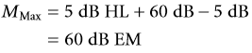

Clearly in this case, our calculation based on the unmasked bone-conduction threshold (i.e., 60 dB EM) is an underestimate of the actual maximum level (i.e., 135 dB EM).

显然，在这种情况下，我们基于未掩蔽骨导阈值（即60dB EM）的计算低估了实际最大级别（即135dB EM）。

Whenever an unmasked bone-conduction threshold is used during determination of maximum masking, the resultant value is typically smaller than the masking level that will actually result in overmasking. Although the actual calculation of maximum masking level during puretone threshold audiometry is often of limited use, consideration of the maximum level of noise that can be used in the nontest ear can alert the audiologist to the possibility of overmasking, particularly in cases of conductive hearing loss when bone-conduction hearing sensitivity is very good.

当在确定最大掩蔽期间使用未掩蔽的骨传导阈值时，产生的值通常小于实际将导致过度掩蔽的掩蔽级别。虽然纯音阈值测听过程中最大掩蔽级别的实际计算通常是有限的，但考虑用于非测试耳的最大噪声级别可以提醒听力专家过度掩蔽的可能性，特别是在骨导听力敏感度非常好的传导性听力损失的情况下。

**RECOMMENDED CLINICAL PROCEDURE**

推荐的临床步骤

The most popular method for measuring masked puretone thresholds was ﬁrst described by Hood in 1957 (Hood, 1960). The Hood method, also referred to as the plateau, threshold shift, or shadowing procedure, is a psychoacoustic technique that relies on observations about the relationship between masker level in the nontest ear and measured threshold in the test ear. Hood originally described a masking procedure that was applicable for measurement of masked bone-conduction thresholds. However, it proves equally effective for measurement of air-conduction thresholds as well.

测量掩蔽纯音阈值最流行的方法是Hood在1957年首次提出的（Hood, 1960）。Hood法，也被称为平台法、阈值偏移法或阴影法，是一种心理声学技术，它依赖于观察非测试耳中掩蔽声级别与测试耳中被测阈值之间关系。Hood最初描述了一种用于测量掩蔽骨传导阈值的掩蔽程序。然而，它在测量气导阈值方面同样有效。

The example presented in Figure 6.9 will help facilitate an understanding of the underlying concept of the threshold shift procedure. Unmasked puretone air-conduction thresholds, obtained using supra-aural earphones, were measured at 10 dB HL in the right ear and 60 dB HL in the left ear (Figure 6.9A). Contralateral masking will be required when testing the left ear because there is a difference between the test and nontest ears that equals or exceeds a conservative estimate of IA (i.e., 40 dB). An initial masking level of 20 dB EM (i.e., ACNontest Ear + 10 dB) is now presented to the right ear, and puretone threshold is re-established. Recall that the purpose of contralateral masking is to raise the threshold of the nontest ear sufﬁciently to eliminate its contribution when measuring a response in the test ear. Assuming that overmasking is not occurring, then contralateral masking should have an effect only on the responsiveness of the nontest ear.

图6.9中的示例将有助于理解阈值偏移过程的基本概念。使用压耳式耳机获得的未掩蔽纯音气导阈值，分别为右耳10db HL和左耳60db HL时测量（图6.9A）。测试左耳时需要对侧掩蔽，因为测试耳与非测试耳之间的差异等于或超过IA的保守估计值（即40 dB）。现在在右耳呈现20 dB EM（即acnontest ear+10 db）的初始掩蔽级别，并且重新建立纯音阈值。回想一下，对侧掩蔽的目的是提高非测试耳的阈值，以便在测量测试耳的响应时消除其影响。假设没有发生过度掩蔽，那么对侧掩蔽只会对非测试耳朵的反应性产生影响。

There are two possible outcomes when puretone threshold is re-established in the presence of contralateral masking: (1) No measured puretone threshold shift (e.g., puretone threshold remains constant at 60 dB HL; Figure 6.9B) or (2) a measured puretone threshold shift (e.g., puretone thre shold shifts from 60 to 70 dB HL; Figure 6.9C). If contralateral masking in the nontest ear does not produce a masking effect, then it is concluded that the unmasked puretone threshold represents a response from the test ear. Conversely, if contralateral masking in the nontest ear does produce a masking effect, then it is concluded that the unmasked puretone threshold represents a response from the nontest ear. The underlying concept of the Hood procedure is that the introduction of masking to the nontest ear will produce a masking effect (i.e., a threshold shift) only if the nontest ear is contributing to the observed response. Decisions about which ear is contributing to the measured threshold are based on whether a threshold shift occurs when masking is introduced to the nontest ear.

当在对侧掩蔽存在的情况下重新建立纯音阈值时，有两种可能的结果：（1）没有测量到的纯音阈值偏移（例如，纯音阈值在60db hl时保持恒定；图6.9b）或（2）测量到的纯音阈值偏移（例如，纯音阈值偏移从60分贝升到70分贝升；图6.9c）。如果非测试耳中的对侧掩蔽没有产生掩蔽效应，则可以得出结论，未掩蔽的纯音阈值表示来自测试耳的响应。相反，如果非测试耳中的对侧掩蔽确实产生掩蔽效应，则可以得出结论，未掩蔽的纯音阈值表示非测试耳的响应。hood过程的基本概念是，只有当非测试耳朵对观察到的反应有影响时，将掩蔽引入非测试耳才会产生掩蔽效应（即阈值偏移）。关于哪只耳朵对测量阈值起作用的决定是基于当向非测试耳引入掩蔽时是否发生阈值偏移。

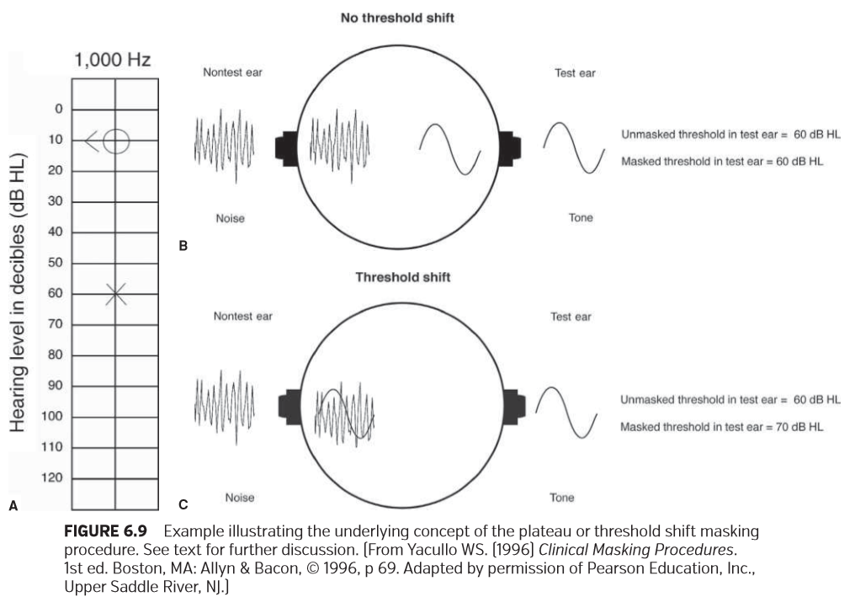

Hood (1960) outlined two essential steps of the plateau masking procedure: (1) Demonstration of the shadowing effect and (2) identiﬁcation of the changeover point. The hypothetical example presented in Figure 6.10 illustrates basic concepts of the plateau masking procedure. Puretone testing using supra-aural earphones reveals unmasked air-conduction thresholds of 0 dB HL in the right ear and 40 dB HL in the left ear (Figure 6.10A). Unmasked bone- conduction threshold is 0 dB HL. Because there is a 40-dB difference between ears, contralateral masking will be required when measuring air-conduction threshold in the left ear. (Masked air- and bone-conduction thresholds in the left ear are included for later discussion.)

Hood（1960）概述了平台掩蔽程序的两个基本步骤：（1）阴影效果的演示和（2）转换点的识别。图6.10中给出的假设示例说明了平台掩蔽程序的基本概念。使用压耳式耳机进行的纯音测试显示，右耳的未掩蔽气导阈值为0 dB HL，左耳为40 dB HL（图6.10a）。未掩蔽骨传导阈值为0 dB HL。由于两耳之间存在40分贝的差异，在测量左耳的空气传导阈值时需要对侧掩蔽。（包括左耳掩蔽的气导和骨导阈值，将在以后讨论。）

The masking function presented in Figure 6.10B shows the relationship between measured puretone threshold (in dB HL) in the test ear and EM level (in dB EM) in the nontest ear. Masking noise is introduced at an initial masking level of 10 dB EM (i.e., ACNontest Ear + 10 dB), and puretone threshold is re-established. Threshold shifts to 50 dB HL. When the masker level is raised sequentially to 20 and 30 dB EM, puretone threshold continues to shift by 10 dB. A shadowing effect has occurred because the masked puretone threshold “shadows” the threshold of the nontest or masked ear with each increment in EM level. Because a threshold shift occurs when masking level is raised, it is concluded that the masking noise and the tone are restricted to the nontest ear.

图6.10b所示的掩蔽函数显示了测试耳中测量的纯音阈值（单位：dB HL）与非测试耳中的EM级别（单位：dB EM）之间的关系。在初始掩蔽级别为10dB EM（即ACNontest ear+10dB）时引入掩蔽噪声，并重新建立纯音阈值。阈值偏移到50 dB HL。当掩蔽声级别依次提高到20和30 dB EM时，纯音阈值继续偏移10db。由于掩蔽的纯音阈值随着EM级别的每次增加而“遮蔽”了非测试或掩蔽的耳朵的阈值，因此出现了阴影效应。由于掩蔽级别升高时会出现阈值偏移，因此可以得出掩蔽噪声和音调仅限于非测试耳朵的结论。

When the masker is raised from 30 to 100 dB EM, puretone threshold no longer shifts and remains stable at 70 dB HL. A plateau has been reached. Because there is no additional masking effect (i.e., a threshold shift) when masker level is increased, it is concluded that the nontest ear is no longer contributing to the observed response. Puretone threshold of the test ear (i.e., 70 dB HL) has been reached. Hood (1960) refers to the initial point on the masking function where puretone threshold remains stable with increasing masking level as the “changeover point.” In this example, the changeover point of 30 dB EM also corresponds to minimum masking level, the minimum amount of noise required to establish the true threshold in the test ear. Masker levels that result in no threshold shift (i.e., the plateau) represent adequate masking (i.e., 30 through 100 dB EM). Masker levels less than 30 dB EM represent undermasking. That is, there is insufﬁcient masking to establish the true puretone threshold in the test ear.

当掩蔽声从30 dB EM提高到100 dB EM时，纯音阈值不再偏移，并稳定保持在70 dB HL。已经达到一个平台。因为当掩蔽级别增加时没有额外的掩蔽效应（即阈值偏移），所以得出结论，非测试耳朵不再参与观察到的响应。已达到测试耳的纯音阈值（即70dB HL）。Hood法（1960）是指掩蔽函数上的初始点，在这一点纯音阈值随着作为“转换点”的掩蔽级别的增加而保持稳定。在本例中，30 dB EM的转换点也对应于最小掩蔽级别，即在测试耳中建立真实阈值所需的最小噪声量。导致无阈值偏移（即平台）的掩蔽级别表示足够的掩蔽（即30至100 dB EM）。掩蔽级别低于30dB EM表示掩蔽不足。也就是说，存在不足的掩蔽以确定测试耳中真实的纯音阈值。

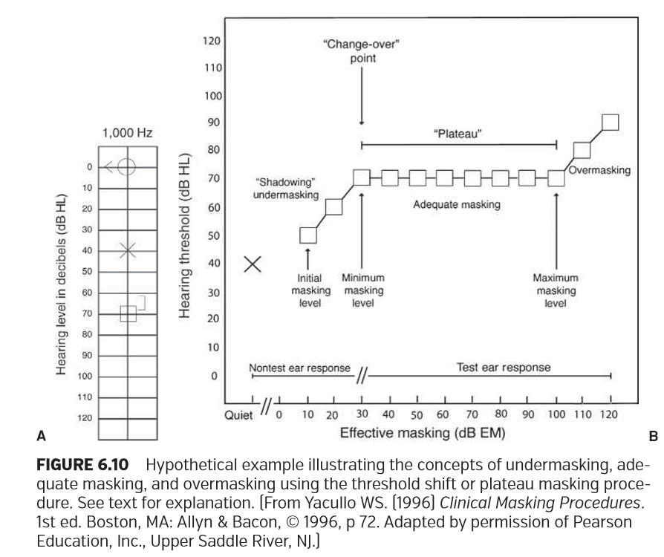

When the masker level exceeds 100 dB EM (i.e., 110 and 120 dB EM), however, a puretone threshold shift with each increment in masking level is again observed. Overmasking is now occurring. The masking noise has reached the test ear through cross hearing, and a masking effect (i.e., a threshold shift) is observed in the test ear. Assuming that a masked bone-conduction threshold is measured subsequently in the left ear at 65 dB HL, then an estimate of maximum masking level is 100 dB EM (BCTest Ear + IA − 5 dB: 65 dB HL + 40 dB − 5 dB). Whereas the plateau and overmasking portions of the masking function represent responses from the test ear, the undermasking or shadowing portion represents responses from the nontest ear. It should be apparent from the masking function in Figure 6.10 that the width of the masking plateau is deﬁned by the minimum and maximum masking levels.

然而，当掩蔽级别超过100dB EM（即110和120dB EM）时，再次观察到随着掩蔽级别的每一次增加，纯音阈值发生偏移。过度掩蔽正在发生。掩蔽噪声已经通过交叉听力到达测试耳，并且在测试耳中观察到掩蔽效应（即，阈值偏移）。假设随后在左耳测量掩蔽骨导阈值为65dB HL，则最大掩蔽级别的估计为100dB EM（BCTest Ear+IA−5 dB：65 dB HL+40 dB−5 dB）。而掩蔽作用的平台和过掩蔽部分表示来自测试耳朵的响应，而未掩蔽或阴影部分表示来自非测试耳朵的响应。从图6.10中可以明显看出掩蔽作用，掩蔽平台的宽度由最小和最大掩蔽级别表示。

The clinical goal of the plateau procedure is to establish the HL at which puretone threshold remains unchanged with increments in masking level. Two important variables that relate to the plateau procedure are (1) the magnitude of the masker increment and (2) the number of masker increments needed to establish a masking plateau. Although Hood (1960) originally recommended that masker level be changed in increments of 10 dB, others have suggested that the level should be a 5-dB step size (Martin, 1980; Silman and Silverman, 1991). Martin (1980) suggests that accuracy is increased somewhat by using a masker increment of 5 dB. It is somewhat arbitrary whether a 5- or 10-dB step size is used for increasing masker level. Either step size is acceptable. However, the smaller step size of 5 dB is strongly recommended whenever the masking plateau is narrow and there is increased risk of overmasking (i.e., cases of bilateral conductive hearing loss).

平台程序的临床目标是建立HL，在该HL处，随着掩蔽级别的增加纯音阈值保持不变，。与平台程序相关的两个重要变量是（1）掩蔽增量的程度和（2）建立掩蔽平台所需的掩蔽增量的数量。虽然Hood（1960）最初建议以10dB为增量改变掩蔽级别，但其他人建议该级别应该是每次5dB（Martin，1980；Silman和Silverman，1991）。Martin（1980）建议，通过使用5dB的掩码增量，精确度有所提高。使用5分贝或10分贝的步长来增加掩蔽级别多少有些武断。两种步长都可以接受。然而，强烈建议在掩蔽平台较窄且存在增加过度掩蔽风险 （即双侧传导性听力损失的情况）时，强烈建议使用5 dB的较小步长。

Hood (1960) did not specify the number of masker increments needed to establish a masking plateau. Clinically, it is neither time efﬁcient nor necessary to measure the entire masking plateau. It is generally agreed that a masking “plateau” has been established when masker level can be increased over a range of at least 15 to 20 dB without shifting puretone threshold (Kaplan et al., 1993; Martin, 1980; Sanders, 1991; Silman and Silverman, 1991).

Hood（1960）没有详细说明建立掩蔽平台所需的掩蔽声增量的数量。在临床上，测量整个掩蔽平台既没有时间效率，也没有必要。人们普遍认为，当掩蔽级别在至少15至20 dB的范围内增加时，纯音阈值没有发生偏移，就建立了掩蔽“平台”（Kaplan et al.， 1993;马丁,1980;桑德斯,1991;西尔曼和西尔弗曼，1991）。

The recommended clinical procedure (Yacullo, 1996, 2004), based on the major components of Hood’s shadowing technique, is summarized as follows:

基于Hood阴影理论技术的主要组成部分，推荐的临床程序（Yacullo, 1996, 2004）总结如下:

1. Masking noise is introduced to the nontest ear at the initial masking level. Puretone threshold is then re-established.

2. Level of the tone or noise is increased subsequently by 5 dB. If there is a response to the tone in the presence of the noise, the level of the noise is increased by 5 dB. If there is no response to the tone in the presence of the noise, the level of the tone is increased in 5-dB steps until a response is obtained.

3. A plateau has been reached when the level of the noise can be increased over a range of 15 to 20 dB without shifting the threshold of the tone. This corresponds to a response to the tone at the same HL when the masker is increased in three to four consecutive levels.

4. Masked puretone threshold corresponds to the HL of the tone at which a masking plateau has been established.

1.在初始掩蔽级别处将掩蔽噪声引入非测试耳朵。然后重新建立纯音阈值。

2.音调或噪声级别随后增加5dB。如果在有噪声情况下对音调做出响应，则噪声级别增加5 dB。如果在有噪声情况下没有对音调做出响应，则音调的级别以5-dB的步长增加，直到获得响应。

3.当噪声级别在15到20 dB的范围内增加时，阈值不发生偏移，则已经达到了平台期。这符合在相同HL处音调的响应，当掩蔽声增加三到四个连续级别时。

4.掩蔽纯音阈值对应于已建立掩蔽平台时的音调的HL。

If a 10-dB step size is used for increasing masking level, then the plateau corresponds to a range of 20 dB (i.e., a response to the tone at the same HL when the masker is increased in two consecutive levels).

如果使用10-dB步长来增加掩蔽级别，则平台对应于20 dB的范围（即，当掩蔽声在两个连续级别中增加时对相同HL处的音调的响应）。

The recommended procedure for establishing a masking plateau does not require that puretone threshold be formally established each time that the masking level is increased. This approach would signiﬁcantly increase the time required to establish a masking plateau. Rather, the tone is presented once at the same HL as the previous response. If no response occurs, the tone is increased in 5-dB steps until audibility is achieved. However, the HL of the tone may be increased inappropriately because of a decision-making process based on a single response. This may lead to imprecision when measuring the masked threshold. Therefore, it is recommended that masked puretone threshold be re-established using a standardized threshold procedure (e.g., ASHA, 2005) in the presence of the ﬁnal level of masking noise that resulted in a plateau. This sometimes leads to a 5-dB improvement in the masked puretone threshold. However, the decision to reestablish masked puretone threshold at the end of the plateau procedure will be inﬂuenced by time considerations.

建立掩蔽平台的推荐程序不要求每次增加掩蔽级别时都正式确定纯音阈值。这种方法将显着增加建立掩蔽平台所需的时间。相反，音调在与之前的响应相同的HL处呈现一次。如果没有发生响应，则音调以5-dB的步长递增，直到能听到为止。然而，由于基于单一响应的决策，音调的HL可能会不适当地增加。这可能会导致测量掩蔽阈值不精确。因此，建议在存在形成平台的掩蔽噪声最终级别下，使用标准化的阈值程序（例如，ASHA，2005年）来重新建立掩蔽的纯音阈值。这有时会导致掩蔽纯音阈值提高5 dB。然而，在平台期程序结束时重建掩蔽纯音阈值的决定将会被时间因素而影响。

Remember that the goal of the plateau procedure is to establish the HL at which puretone threshold remains unchanged with increments in masking level. Given this goal, there are three major outcomes that can result when measuring puretone threshold. These outcomes are illustrated in the three examples presented in Figure 6.11. In each example, the unmasked puretone thresholds at 2,000 Hz are the same. Unmasked puretone air-conduction thresholds, obtained using 3A insert earphones, were measured at 15 dB HL in the right ear and 75 dB HL in the left ear. Contralateral masking will be required when measuring air-conduction threshold in the left ear; an initial masking level of 25 dB EM is presented to the right ear, and puretone threshold is re-established

记住，平台程序的目标是建立HL，在该HL处，随着掩蔽级别的增加纯音阈值保持不变。考虑到这个目标，在测量纯音阈值时可以产生三个主要结果。图6.11所示的三个示例说明了这些结果。在每个示例中，2，000 Hz的未掩蔽纯音阈值都是相同的。使用3A插入式耳机获得的非掩蔽纯音气导阈值在右耳测量为15dB HL和左耳为75dB HL。测量左耳气导阈值时需要对侧掩蔽；向右耳呈现25dB EM的初始掩蔽级别，并重新建立纯音阈值。

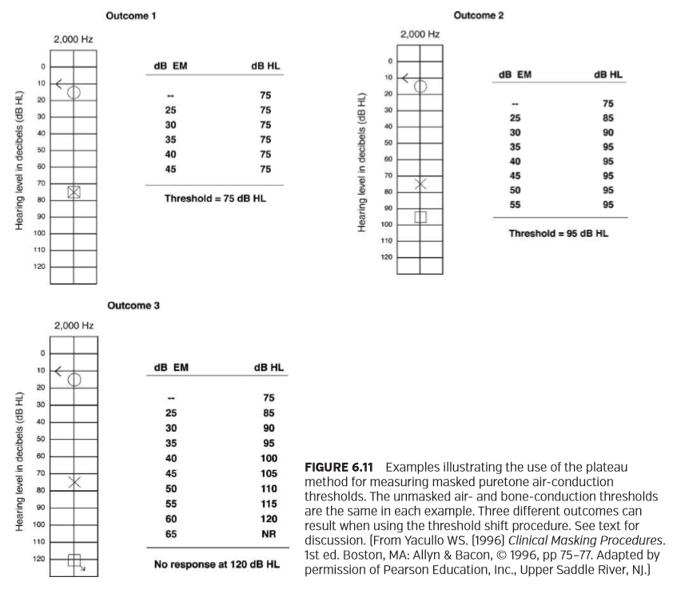

In the ﬁrst outcome, the unmasked puretone threshold of 75 dB HL remains unaffected with increasing masking level. The level of the noise was increased over a range of 20 dB without shifting the threshold of the tone. In this example, the initial masking level occurs at the masking plateau. Contralateral masking has conﬁrmed that the unmasked puretone threshold represents a response from the test ear.

在第一个结果中，随着掩蔽级别的增加，未掩蔽的纯音阈值75 dB HL仍然不受影响。在不改变音调阈值的情况下，噪音级别在20分贝的范围内增加。在本例中，初始掩蔽级别发生在掩蔽平台上。对侧掩蔽证实，未掩蔽的纯音阈值代表来自测试耳的响应。

In the second outcome, the initial masking level produces a puretone threshold shift. A masking plateau is reached, however, when masking level is increased from 35 to 55 dB EM (i.e., a masking range of 20 dB). Because masked puretone threshold remains stable at 95 dB HL with increasing masking level, puretone threshold is recorded as 95 dB HL. Contralateral masking has conﬁrmed that the unmasked puretone threshold represents a cross-hearing response from the nontest ear.

在第二个结果中，初始掩蔽级别产生纯音阈值偏移。然而，当掩蔽级别从35分贝EM增加到55分贝EM（即，掩蔽变化了20分贝）。由于掩蔽的纯音阈值随着掩蔽级别的增加在95 dB HL时保持稳定，纯音阈值被记录为95 dB HL。对侧掩蔽证实了未掩蔽的纯音阈值代表非测试耳的交叉听觉反应。

In the third outcome, the initial masking level again produces a puretone threshold shift. However, puretone threshold continues to shift to the output limits of the audiometer with increasing masking level. A plateau is not obtained. Therefore, it is concluded that there is no measurable hearing in the left ear. This conclusion is correct assuming that overmasking has not occurred.

在第三个结果中，初始掩蔽级别再次产生纯音阈值偏移。然而，随着掩蔽级别的增加，纯音阈值继续向听力计的输出极限移动。没有得到平台值。因此，我们的结论是左耳没有可测量的听力。假设没有发生过度掩蔽，这个结论是正确的。

Turner (2004a, 2004b) has described a masking method that can replace the plateau procedure in some masking situations. A disadvantage of the plateau method is that it can be time consuming. The “optimized” masking method described by Turner, which is based on the principles of the masking plateau, can reduce the number of masking levels required to reach the plateau and establish threshold. The method is optimized because it uses the maximum possible masking levels without overmasking. This is accomplished through the use of higher initial masking levels and maximum masker increments. However, there are some masking situations where the optimized approach is not appropriate. The reader is referred to the two articles by Turner (2004a, 2004b) for further discussion.

Turner （2004a, 2004b）描述了一种在某些掩蔽情况下可以替代平台步骤的掩蔽方法。平台法的一个缺点是，它可能是费时的。Turner所描述的“优化”掩蔽方法，是基于掩蔽平台的原理，可以减少达到平台所需的掩蔽级别的数量，并建立阈值。该方法是优化的，因为它使用最大允许的掩蔽级别且没有发生过度掩蔽。这是通过使用更高的初始掩蔽级别和最大掩蔽声增量来完成的。然而，在某些掩蔽情况下，优化方法并不合适。读者可以参考Turner （2004a, 2004b）的两篇文章进一步讨论。

**THE MASKING DILEMMA**

掩蔽的困境

There are clinical situations where minimum masking levels can result in overmasking. Studebaker (1979) states that a “masking dilemma” results when the width of the masking plateau is very narrow or nonexistent. Remember that the width of the masking plateau is deﬁned by minimum and maximum masking levels. Generally, a masking dilemma results whenever there is a signiﬁcant hearing loss in the nontest ear and a conductive hearing loss in the test ear. The presence of signiﬁcant hearing loss in the nontest ear requires higher initial masking levels; the presence of a conductive hearing loss in the test ear (i.e., normal boneconduction hearing sensitivity) decreases the maximum masking level. The consequence of a reduced or nonexistent masking plateau is the inability to establish correct masked thresholds in the test ear.

在一些临床情况下，最小的掩蔽级别可能导致过度掩蔽。Studebaker（1979）指出，当掩蔽平台的宽度非常窄或不存在时，就会导致“掩蔽困境”。请记住掩蔽平台的宽度由最小和最大掩蔽级别定义。一般情况下，当非测试耳出现明显听力损失和测试耳出现传导性听力损失时，就会出现掩蔽困境。非测试耳出现明显听力损失需要较高的初始掩蔽级别；在测试耳内存在传导性听力损失（即，正常的骨导听力灵敏度）降低了最大掩蔽级别。减少或不存在掩蔽平台的后果是无法在测试耳中建立正确的掩蔽阈值。

The classic example of a masking dilemma is demonstrated with a bilateral, mild-to-moderate conductive hearing loss. The possibility for overmasking exists when measuring masked air- and bone-conduction thresholds in both ears. Naunton (1960) states that, in some cases of bilateral conductive hearing loss, it is not possible to mask the nontest ear without simultaneously producing a masking effect in the test ear.

掩蔽困境的典型例子被证明是双侧的、轻度到中度的传导性听力损失。当测量双耳的通气和骨导阈值时，可能存在过度掩蔽。Naunton（1960）指出，在一些双侧传导性听力损失的情况下，如果不同时在测试耳中产生掩蔽效应，就不可能对非测试耳进行掩蔽。

One solution to the masking dilemma is the use of insert earphones (Coles and Priede, 1970; Hosford-Dunn et al., 1986; Studebaker, 1962, 1964). Recall that the use of 3A insert earphones signiﬁcantly increases IA for air- conducted sound, particularly in the lower frequencies (Killion et al., 1985; Sklare and Denenberg, 1987). There are two advantages of using insert earphones in cases of bilateral conductive hearing loss. First, the need for masking during measurement of air-conduction thresholds is often eliminated because of greater IA for air-conducted sound. Second, the use of insert earphones reduces the probability of overmasking in cases where contralateral masking is required. The use of an air-conduction transducer with increased IA increases the range between the minimum and maximum masking levels, thereby increasing the width of the masking plateau and the range of permissible masking levels (Studebaker, 1962).

掩盖困境的一个解决方案是使用插入式耳机（Coles和Priede, 1970;Hosford-Dunn等，1986;Studebaker、1962、1964）。还记得3A插入式耳机的使用显著增加了气导声音的IA，特别是在较低的频率（Killion et al.， 1985;Sklare和Denenberg, 1987）。在双侧传导性听力丧失的情况下，使用插入式耳机有两个优点。首先，在测量气导阈值时通常不需要掩蔽，因为气导声音的IA较大。其次，使用插入式耳机减少了在需要对侧掩蔽的情况下发生过度掩蔽的可能性。增大IA的气导换能器的使用增加了最小和最大掩蔽级别之间的范围，从而增加了掩蔽平台的宽度和允许掩蔽级别的范围（Studebaker, 1962）。

**CENTRAL MASKING**

中枢掩蔽

The introduction of contralateral masking can produce a small threshold shift in the test ear even when the masking level is insufﬁcient to produce overmasking. Wegel and Lane (1924) referred to this phenomenon as central masking. It has been hypothesized that threshold shifts in the presence of low levels of masking are mediated through central nervous system processes (Lidén et al., 1959). Central masking has been reported to inﬂuence thresholds measured during both puretone and speech audiometry (Dirks and Malmquist, 1964; Lidén et al., 1959; Martin, 1966; Martin and DiGiovanni, 1979; Martin et al., 1965; Studebaker, 1962). Although the threshold shift produced by central masking is generally considered to be approximately 5 dB (Konkle and Berry, 1983; Martin, 1966), variable results have been reported across subjects and studies. There is also some indication that central masking effects increase with increasing masking level (Dirks and Malmquist, 1964; Martin et al., 1965; Studebaker, 1962).

对侧掩蔽的引入，即使在掩蔽级别不足以产生过掩蔽时，也会在测试耳中产生一个小的阈值偏移。Wegel和Lane（1924）将这种现象称为中枢掩蔽。有一种假说认为，阈值的变化是通过中枢神经系统的处理来调节的（Liden et al.， 1959）。据报道，中枢掩蔽影响阈值测量在纯音和言语听力测量时（Dirks和Malmquist, 1964;利登等人，1959年;马丁,1966;马丁和迪乔瓦尼，1979年;Martin et al.， 1965;Studebaker, 1962）。虽然中心掩蔽产生的阈值偏移通常被认为是大约5 dB （Konkle and Berry, 1983;Martin, 1966），不同的研究对象和研究报告了不同的结果。也有一些迹象表明，中枢掩蔽效应随着掩蔽级别的增加而增加（Dirks和Malmquist, 1964;Martin et al.， 1965;Studebaker, 1962）。

There is currently no agreed upon procedure that accounts for central masking effects during threshold audiometry. However, it is generally not recommended that the effect of central masking be subtracted from masked thresholds. First, it is difﬁcult to determine an appropriate correction factor given the variability of the central masking effect across subjects. Second, the typical central masking effect size of about 5 dB is considered to be within good test-retest reliability during threshold measurements. It is important to remember that the use of contralateral masking can somewhat inﬂuence the measured masked thresholds and should be taken into account when interpreting audiometric test results. For example, a difference of 5 dB between unmasked and masked thresholds is generally not considered signiﬁcant. This difference may simply reﬂect (1) central masking effects and/or (2) normal variability related to test-retest reliability.

目前还没有一致的程序，以解释阈值听力测量时的中枢掩蔽效应。然而，通常不建议从掩蔽阈值中减去中枢掩蔽效应。首先，由于中枢掩蔽效应在受试者之间的可变性，很难确定合适的校正因子。其次，在阈值测量过程中，典型的中心掩蔽效应大小约为5 dB，被认为具有良好的复测变异性。重要的是，使用对侧掩蔽可以在一定程度上影响测量的掩蔽阈值，在解释听力测试结果时应该考虑到这一点。例如，未掩蔽阈值和掩蔽阈值之间5 dB的差异通常不被认为是显著的。这种差异可能仅仅反映了（1）中枢掩蔽效应和/或（2）与复测可靠性相关的正常变异性。

MASKED AUDIOGRAM INTERPRETATION

掩蔽听力图解释

Unmasked and masked puretone thresholds are typically recorded on the same audiogram. Therefore, audiogram interpretation will involve consideration of both masked and unmasked responses. ASHA (1990) has published guidelines for audiometric symbols and procedures for graphic representation of frequency-speciﬁc audiometric ﬁndings. These guidelines have been followed throughout this chapter.

未掩蔽和掩蔽的纯音阈值通常记录在相同的听力图上。因此，听力图的解释将涉及掩蔽和未掩蔽反应两方面的考虑。ASHA（1990）出版了听力符号指南和特定频率听力发现的图形表示步骤。本章始终遵循这些指导原则。

Figure 6.12 presents an audiogram in which contralateral masking was required when obtaining both air- and bone-conduction thresholds in the left ear. Air-conduction audiometry was performed using supra-aural earphones. Puretone testing reveals a mild conductive hearing loss of ﬂat conﬁguration in the right ear. Masked air- and bone- conduction responses indicate a severe-to-profound, sensory/ neural hearing loss of gradually sloping conﬁguration in the right ear.

图6.12显示了在获得左耳的气导阈值和骨导阈值时需要对侧掩蔽的听力图。采用压耳式耳机进行气导听力测量。纯音测试显示，右耳为轻度传导性听力损失的平坦曲线。掩蔽的空气导和骨导反应表明，右耳为曲线逐渐倾斜的重度到极重度的感音/神经听力丧失。

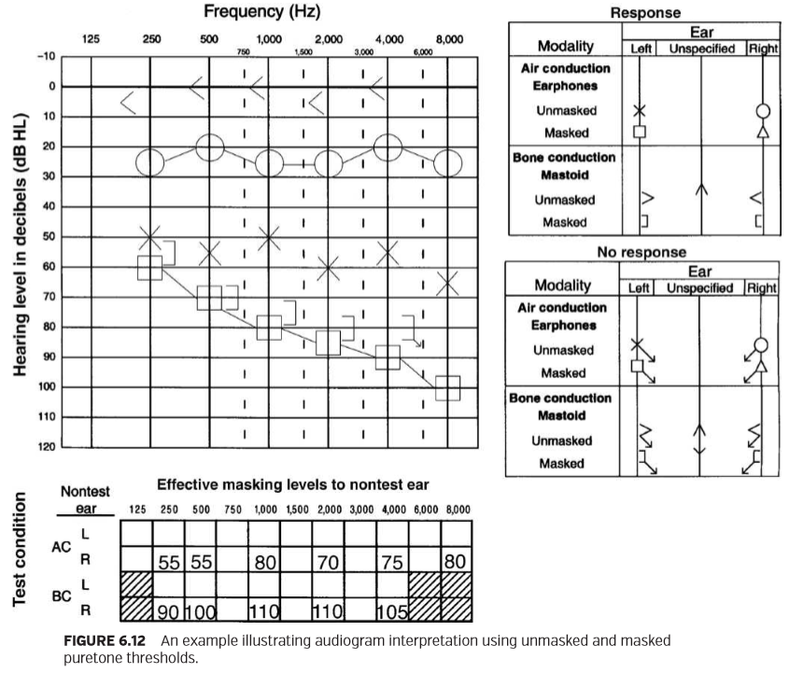

It should be noted that the unmasked air-conduction thresholds in the left ear are not considered when interpreting hearing status. Because a signiﬁcant threshold shift (i.e., >5 dB) occurred when contralateral masking was introduced to the nontest ear, the unmasked air-conduction responses in the left ear actually represent cross-hearing responses from the better (i.e., right) ear. In this case, the unmasked air-conduction thresholds should not be connected with lines. In cases where contralateral masking is required, it is acceptable to record only the masked thresholds (ASHA, 1990).

需要注意的是，在解释听力状况时，没有考虑到左耳未被掩蔽的气导阈值。因为一个显著的阈值偏移（即，>5 dB），当非测试耳采用对侧掩蔽时，左耳中未掩蔽的气导反应实际上代表较好（即,右）的耳朵的交叉听觉反应。在这种情况下，未掩蔽的气导阈值不应与线路连接。在需要对侧掩蔽的情况下，只记录掩蔽后的阈值是可以接受的（ASHA, 1990）。

Although the results of unmasked bone-conduction audiometry suggested that masked bone-conduction thresholds were required in both ears because of potential air-bone gaps, contralateral masking was required only when testing the left ear. Whenever there is an asymmetrical hearing loss, it is traditional to ﬁrst measure masked bone-conduction thresholds in the poorer ear. There is the assumption that the unmasked bone-conduction thresholds may more likely reﬂect hearing in the better ear. When masked bone-conduction thresholds were subsequently measured in the left ear, results suggested a sensory/neural hearing loss. Consequently, we can correctly assume that the unmasked responses are originating from the better (i.e., right) ear. Depending on the outcome when measuring masked bone-conduction thresholds in the poorer ear, it is not always necessary to also measure masked thresholds in the opposite ear. As the above example illustrates, earspeciﬁc information can be inferred from unmasked boneconduction responses in some cases.

虽然未掩蔽骨传导测听结果表明，由于潜在的气骨间隙，双耳均需要掩蔽的骨导阈值，但仅在测试左耳时才需要对侧掩蔽。每当出现不对称听力损失时，传统的做法是首先测量较差的耳朵的掩蔽骨传导阈值。有一种假设认为，未掩蔽的骨导阈值更可能反映出较好耳朵的听力。当随后在左耳测量掩蔽的骨导阈值时，结果显示感音/神经性听力损失。因此，我们可以正确地假定未掩蔽的响应来自好（即,右）耳。根据在差耳中测量掩蔽骨导阈值的结果，在对侧耳中测量掩蔽阈值并不总是有必要的。如上例所示，在某些情况下，可以从未掩蔽的骨导响应推断特定耳的信息。

It is traditional to record masking levels when obtaining masked air- and bone-conduction thresholds. Assuming that the clinician has used the recommended threshold shift (i.e., plateau) procedure, then a range of masking levels will be used when establishing threshold. ASHA (1990) recommends that the ﬁnal level of masking used to obtain masked threshold should be recorded for the nontest ear. A table for recording EM levels to the nontest ear is typically provided on an audiogram form. Consider again the audiogram presented in Figure 6.12. For example, a masked puretone air-conduction threshold was measured at 85 dB HL at 2,000 Hz in the left ear; this threshold was obtained with a ﬁnal masking level of 70 dB EM in the right ear.

传统的方法是在获得掩蔽气导和骨导阈值时记录掩蔽级别。假设临床医生已经使用了推荐的阈值偏移程序（即，平台），然后在确定阈值时使用一定范围的掩蔽级别。ASHA（1990）建议，用于获得掩蔽阈值的用于非测试耳朵最终掩蔽级别应该记录下来。用于记录非测试耳朵的EM级别的表格通常以听力图形式记录。再次考虑图6.12中显示的听力图。例如，在左耳2000赫兹、85 dB HL时测定了一个掩蔽的纯音气导阈值；这个阈值是在右耳最终掩蔽级别为70db EM时获得的。

**Speech Audiometry**

言语测听

The speech audiometry test battery is traditionally composed of two major components: (1) Measures of hearing sensitivity for speech (i.e., speech threshold) and (2) measures of suprathreshold speech recognition. Although the psychoacoustic or threshold shift procedure proves efﬁcient when measuring SDT, the acoustic masking procedure is the method of choice when assessing threshold and suprathreshold speech recognition.

言语测听的一系列测试传统上由两个主要部分组成：（1）对言语的听力灵敏度的测量（即，言语阈值），（2）阈上言语识别测量。虽然心理声学或阈值偏移法在测量SDT时被证明是有效的，但在评估阈值和阈上言语识别时，声掩蔽法是首选的方法。

**PSYCHOACOUSTIC MASKING PROCEDURES**

心理声学的掩蔽步骤

Recall that the psychoacoustic or threshold shift masking procedures rely on the observation of shifts in the measured threshold in the test ear as a function of masking levels in the nontest ear. The plateau procedure can be applied easily during measurement of speech thresholds (Konkle and Berry, 1983; Studebaker, 1979). A major advantage of the plateau procedure is that information about bone-conduction hearing sensitivity in each ear is not required when selecting appropriate masking levels. Although the plateau procedure can be applied during measurement of both masked recognition and detection thresholds, it proves most efﬁcient during measurement of SDT because of the nature of the response task (i.e., detection rather than recognition).

回想一下，心理声学或阈值偏移掩蔽程序依赖于对测试耳朵中测量的阈值的偏移的观察，作为非测试耳掩蔽级别的函数。平台程序可以很容易地应用于言语阈值的测量（Konkle和Berry，1983；Studebaker，1979）。平台法的一个主要优点是，在选择适当的掩蔽级别时，不需要关于每个耳朵中的骨导听力敏感度的信息。虽然平台法可以在掩蔽识别和检测阈值的测量期间应用，但由于响应任务的性质（即，检测而不是识别），它证明在测量SDT期间最有效。

ASHA’s most recent guidelines for determining threshold level for speech were published in 1988. Recommended procedures for measuring both detection and recognition thresholds are described. Given that determination of SDT involves a detection task that is similar to the one used in puretone threshold audiometry, ASHA recommends using a test procedure that follows published guidelines for measuring puretone threshold (e.g., ASHA, 2005). Therefore, the plateau masking procedure recommended earlier for use during puretone threshold audiometry can be used equally effectively when measuring masked SDT.

ASHA最近有关确定言语阈值水平的指导方针发表在1988年。介绍了测量检测和识别阈值的推荐程序。鉴于SDT的测定涉及的检测任务与差异阈值测听中使用的检测任务类似，ASHA建议使用一种遵循已发表的测量差异阈值指南的测试程序（例如，ASHA, 2005）。因此，早期推荐的用于纯音阈值听力测量的平台掩蔽程序可以同样有效地用于测量掩蔽SDT。

Consider the example presented in Figure 6.13. Audiometry was performed using 3A insert earphones. puretone testing reveals normal hearing in the right ear. There is a profound sensory/neural hearing loss of fragmentary conﬁguration in the left ear. (Contralateral masking was required during measurement of air- and bone-conduction thresholds in the left ear.) An SRT of 5 dB HL was measured in the right ear, a ﬁnding that supports the puretone results. When spondaic words were presented at suprathreshold levels in the left ear, the patient was not able to correctly recognize any words. Consequently, a decision was made to measure an SDT.

考虑图6.13中给出的示例。使用3A插入式耳机进行听力测量。纯音测试显示右耳听力正常。左耳有严重的曲线残缺的感音/神经听力损失。（在测量左耳的气导阈值和骨导阈值时，需要对侧掩蔽。）右耳的SRT为5db HL，这一发现支持纯音的结果。当扬扬格词呈现在左耳阈上水平时，患者不能正确识别任何单词。因此，决定测量SDT。

An unmasked SDT is measured at 75 dB HL in the left ear. Because the difference between the unmasked SDT in the test ear (i.e., 75 dB HL) and the SRT in the nontest ear (i.e., 5 dB HL) clearly exceeds our conservative estimate of IA for speech (i.e., 60 dB) when using 3A insert earphones, contralateral masking will be required.

未掩蔽的SDT在左耳测量为75 dB HL。因为在测试耳中未屏蔽的SDT之间的差异（即，75 dB HL）和非测试耳中的SRT（即，5db HL）。当使用3A插入式耳机时明显超过我们对语音IA的保守估计，需要对侧屏蔽。

Using the recommended plateau masking procedure, speech spectrum noise is introduced to the nontest ear at an initial masking level, that is, an EM level (in dB EM) equal to the speech threshold of the nontest ear (SRTNontest Ear) plus a 10-dB safety factor:

使用推荐的平台掩蔽程序，将语音频谱噪声引入到非测试耳的初始掩蔽水平，即EM水平（dB EM）等于非测试耳的言语阈值（SRTNontest ear）加上10 dB安全系数:



In this example, initial masking level is equal to 15 dB EM. SDT is then re-established in the nontest ear in the presence of the initial masking level. Depending on the patient’s response to the speech in the presence of the noise, the level of the speech or noise is increased by 5 dB until a masking plateau has been reached. Remember that it is acceptable to use a 10-dB masker increment when establishing a masking plateau. In this particular case, the risk of overmasking is essentially nonexistent because of the poor bone-conduction hearing sensitivity in the test ear (and the use of an airconduction transducer with increased IA for presenting the masking noise). Therefore, the use of a 10-dB masker increment can be easily justiﬁed. Masked SDT is subsequently measured at 90 dB HL (using 40 dB EM).

在本例中，初始掩蔽水平等于15dB EM。然后，在初始掩蔽水平存在的情况下，在非测试耳中重新确定SDT。根据患者在有噪声存在时对言语的反应，言语或噪声的级别将增加5分贝，直到达到掩蔽平台值。请记住，在达到掩蔽平台值过程中可以使用10-dB掩蔽增量。在特殊情况下，由于测试耳的骨导听力敏感性较差（以及使用可增加IA的气导换能器来表示掩蔽噪声），基本上不存在过度掩蔽的风险。因此，使用10-dB掩蔽增量可以很容易地得到验证。掩蔽的SDT随后测量到90 dB HL（使用40 dB EM）。

Although the plateau masking procedure can be used during assessment of masked SRT, it can prove very time consuming. Recall that only a single detection response to speech is required when measuring masked SDT before making a decision about increasing the level of the speech or masker. The use of the plateau procedure for measuring masked SRT, however, requires that threshold be re-established (i.e., 50% correct recognition of spondaic words) at each masking level until a plateau is reached. The acoustic method proves to be the method of choice when measuring masked SRT because of its greater time efﬁciency (Konkle and Berry, 1983; Studebaker, 1979) and will be discussed in the following section.

虽然平台掩蔽程序可以用于掩蔽SRT的评估，但它可能非常耗时。回想一下，决定增加语音或掩蔽的级别之前，在测量掩码SDT时，只需要对语音进行一次检测响应。然而，使用平台程序来测量掩蔽SRT，需要在每个掩蔽级别上重新确定阈值（即，对扬扬格词的正确识别率为50%），直到达到一个平台值。声学方法被证明是测量掩蔽SRT的首选方法，因为它具有更高的时间效率（Konkle and Berry, 1983;），并将在下一节中讨论。

ACOUSTIC MASKING PROCEDURES

声掩蔽程序

Recall that acoustic masking procedures are based on calculating the estimated acoustic levels of the test and masking stimuli in the two ears during a test condition and, on this basis, selecting an appropriate masking level. A major disadvantage of the acoustic or formula approach is that the application requires knowledge about air-bone gaps in both test and nontest ears (Konkle and Berry, 1983; Studebaker, 1979). Knowledge about air-bone gaps in the nontest ear is required to calculate minimum masking level. Information about bone-conduction hearing sensitivity in the test ear is required to calculate maximum masking level. Assuming that complete puretone threshold data are available before performing speech audiometry, however, formula approaches for calculating required masking levels prove very effective during measurement of both threshold and suprathreshold speech recognition.

回想一下，声学掩蔽程序是基于在测试条件期间计算测试和掩蔽刺激在两个耳朵中的估计声级，并在此基础上选择适当的掩蔽级别。声学或公式方法的一个主要缺点是，应用程序需要测试和非测试耳朵中的气骨间隙知识（Konkle和Berry，1983；Studebaker，1979）。计算最小掩蔽级别需要了解非测试耳的气骨间隙。计算最大掩蔽级别需要测试耳骨导听力敏感度的信息。假设在进行言语测听之前可以获得完整的纯音阈值数据，然而，在测量阈值和阈上言语识别时，计算所需掩蔽度的公式方法证明是非常有效的。

The underlying concepts of minimum and maximum masking levels for speech are similar to those offered earlier for puretone stimuli. Minimum masking level for speech (MMin), originally described by Lidén et al. (1959), can be deﬁned using the following equation:

言语的最小和最大掩蔽级别的基本概念与之前提供的纯音刺激相似。言语的最小掩蔽水平（MMin），最初由Liden等人（1959）描述，可使用以下方程式进行定义：

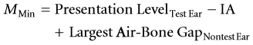

Presentation LevelTest Ear represents the HL (dB HL) of the speech signal at the test ear, IA is equal to IA for speech, and Largest Air-Bone GapNontest Ear represents the largest air-bone gap in the nontest ear in the 250- to 4,000-Hz frequency range. Presentation LevelTest Ear – IA, an estimate of the HL of the speech signal reaching the test ear, represents the minimum masking level required. The presence of air-bone gaps in the nontest (i.e., masked) ear, however, will reduce the effectiveness of the masker. Consequently, minimum masking level must be increased by the size of the air-bone gap.

Presentation LevelTest Ear表示测试耳处语音信号的HL （dB HL）， IA等于语音的IA，最大的气骨间隙表示250 ~ 4000 hz频段内非测试耳中最大的气骨间隙。Presentation LevelTest Ear – IA，是对到达测试耳朵的语音信号HL的估计，表示所需的最小掩蔽级别。然而，在非测试（即，掩蔽的）耳存在气骨间隙，将降低掩蔽的效果。因此，最小掩蔽级别必须随着气骨间隙的大小而增加。

Lidén et al. (1959) recommended that the average air-bone gap in the nontest ear, calculated using frequencies of 500, 1,000, and 2,000 Hz, be accounted for when determining the minimum masking level. Coles and Priede (1975) suggested a more conservative approach and recommended that the largest air-bone gap at any frequency in the range from 250 to 4,000 Hz be considered. Remember that speech is a broadband signal. Therefore, bone-conduction hearing sensitivity across a range of frequencies in the nontest ear must be considered. There is the assumption that the largest air-bone gap will have the greatest effect on masking level. Following the conservative recommendation of Coles and Priede (1975), it is recommended that the largest air-bone gap across the frequency range in the nontest ear be accounted for when determining minimum masking level.

Liden等人（1959）建议在确定最小掩蔽级别时，考虑非测试耳的平均气骨间隙（使用500、1000和2000赫兹的频率计算）。Coles和Priede（1975）提出了一种更为保守的方法，建议考虑250到4000赫兹范围内的任何频率下最大的气骨间隙。记住，言语是宽带信号。因此，必须考虑非测试耳骨导听觉灵敏度范围内的频率。假设最大的气骨间隙对掩蔽级别的影响最大。根据Coles和Priede（1975）的保守建议，在确定最小掩蔽级别时，建议在非测试耳的频率范围内考虑最大的气骨间隙。

Maximum masking level (MMax) for speech, originally described by Lidén et al. (1959), can be deﬁned using the following equation:

语音的最大掩蔽级别（MMax），最初由Liden等人（1959）描述，可使用以下方程式进行定义：



Best BCTest Ear represents the best bone-conduction threshold in the test ear in the frequency range from 250 to 4,000 Hz, and IA is equal to IA for speech. If Best BCTest Ear + IA represents a level that will just produce overmasking in the test ear, then a slightly lower masking level should be used clinically. Consequently, a value of 5 dB is subtracted from the calculated level.

Best BCTest Ear表示在250 ~ 4000 Hz的频率范围内测试耳骨传导的最佳阈值，IA等于言语的IA。如果Best BCTest Ear + IA代表的级别只会在测试耳中产生过度掩蔽，那么临床应该使用稍微低一点的掩蔽级别。因此，从计算的级别中减去5 dB的值。

Lidén et al. (1959) originally recommended that the average puretone bone-conduction threshold in the test ear, again calculated using frequencies of 500, 1,000, and 2,000 Hz, should be accounted for when estimating maximum masking level. However, a more conservative approach includes consideration of the best bone-conduction threshold in the test ear over a wider range of frequencies (i.e., 250 to 4,000 Hz). There is the assumption that the best bone-conduction threshold in the test ear is the most susceptible to the effects of overmasking.

Liden et al.（1959）最初建议，在估计最大掩蔽级别时，应考虑测试耳中骨传导阈值的平均阈值（再次使用500、1000和2000赫兹的频率计算）。然而，一种更为保守的方法包括在更大的频率范围内考虑测试耳的最佳骨传导阈值。（比如250至4,000赫兹）。有一种假设认为，在测试耳中，最佳骨导阈值是最容易受到过度掩蔽效应影响的。

The optimal masking level during speech audiometry is one that occurs above the minimum and below the maximum masking levels (Konkle and Berry, 1983; Lidén et al., 1959; Studebaker, 1979). Minimum and maximum masking levels represent, respectively, the lower and upper limits of the masking plateau. Studebaker (1979) states that a major goal of the acoustic or formula approach is to apply rules that will place the masking level at approximately the middle of the range of correct values (i.e., the middle of the masking plateau). This concept was originally discussed by Luscher and König in 1955 (cited by Studebaker, 1979).

语音听力测量的最佳掩蔽级别是发生在最小掩蔽级别之上和最大掩蔽级别之下的掩蔽级别（Konkle and Berry, 1983;利登等人，1959年;Studebaker, 1979）。最小和最大掩蔽级别分别表示掩蔽平台的上下限。Studebaker（1979）指出，声学或公式方法的主要目标是应用规则，使掩蔽级别大约位于正确值范围中间（即，位于掩蔽平台值中部）。这个概念最初是由Luscher和König在1955年讨论的（引用Studebaker, 1979）。

Studebaker (1962) ﬁrst described an equation for calculating midmasking level during puretone bone-conduction audiometry. The basic concepts underlying the midplateau procedure, however, can be easily applied during speech audiometry. Yacullo (1999) states that a simple approach to calculating the midmasking level (MMid) involves determining the arithmetic mean of the minimum and maximum masking levels:

Studebaker（1962）首先描述了在纯音骨导测听术中计算掩蔽级别的方程。然而，在平台中间值的基本概念，可以很容易地应用于言语听力测量。Yacullo（1999）指出，计算中掩蔽级别（MMid）的简单方法包括确定最小和最大掩蔽级别的算术平均值：



For example, if MMin is equal to 40 dB EM and MMax is equal to 80 dB EM, then MMid, the masking level that falls at midplateau, is 60 dB EM. When a masking level falls at the middle of the acceptable masking range (i.e., midmasking level), then the risk of undermasking and overmasking is minimized (Studebaker, 1962). It should be noted that midplateau actually represents a range of values surrounding the midmasking level. Consequently, there is some ﬂexibility in using a somewhat higher or lower masking level.

例如，如果MMin等于40 dB EM，MMAX等于80 dB EM，则MMid，即在MidPlatform下降的掩蔽级别是60 dB EM。当掩蔽级别落在可接受的掩蔽范围的中间时（即，中掩蔽级别），则掩蔽不足和过度掩蔽的风险被最小化（Studebaker，1962）。应该注意的是，平台中间值实际上代表围绕中间掩蔽级别的一系列值。因此，在使用略高或稍低的掩蔽级别时，存在一定灵活性。

Yacullo (1999) states that there are two major advantages of the midplateau masking procedure. First, IA is eliminated as a source of error when determining an appropriate masking level. Masking levels are often determined using very conservative estimates of IA. However, IA has equal yet opposite effects on minimum and maximum masking levels. Although the value of IA used for determining minimum and maximum masking levels will inﬂuence the width of the masking plateau, the midmasking level remains the same.

Yacullo（1999）指出，平台中间值掩蔽程序有两个主要优点。首先，在确定适当的掩蔽级别时，消除IA作为误差源。掩蔽级别通常使用非常保守的IA估计来确定。然而，IA在最小和最大掩蔽级别上具有相等但相反的影响。虽然用于确定最小和最大掩蔽级别的IA的值将影响使用掩蔽平台的宽度，但中间掩蔽级别是相同的。

Second, midmasking level can be determined for both threshold and suprathreshold speech measures by using the same formula approach (Konkle and Berry, 1983). The midplateau procedure avoids a potential problem during measurement of suprathreshold speech recognition that is related to calibration of EM level and percent correct response criterion. Recall that EM level for speech is speciﬁed relative to the SRT (i.e., 50% correct recognition of spondaic words) (ANSI/ASA, 2010). Suprathreshold speech recognition performance, however, can range from 0% to 100%. Konkle and Berry (1983) indicate that a major advantage of the midplateau procedure is that the middle of the masking plateau (i.e., the optimal masking level) is not inﬂuenced by different listener response criteria used during assessment of threshold and suprathreshold speech recognition. The reader is referred to Konkle and Berry (1983) and Studebaker (1979) for more detailed discussion.

其次，使用相同的公式方法可以确定阈值和阈上言语测量的中掩蔽级别（Konkle and Berry, 1983）。中平台程序避免了在测量超阈值语音识别时可能出现的问题，该问题与EM级别和响应准则正确率的校准有关。回想一下，针对语音的em级别是相对于srt指定的（即，50%正确识别扬扬格词）（ANSI/ASA, 2010）。然而，阈上语音识别率可以从0%到100%不等。Konkle和Berry(1983)指出，中平台程序的一个主要优势是，在评估阈值和阈上言语识别时，掩蔽平台的中间（即最佳掩蔽级别）不受不同听者反应标准的影响。读者可以参考Konkle and Berry（1983）和Studebaker（1979）进行更详细的讨论。

Studebaker (1979) has described a somewhat different acoustic masking procedure for use during speech audiometry that is consistent with the goal of selecting a masking level that occurs at midplateau. Speciﬁcally, the recommended masking level is equal to the presentation level of the speech signal in dB HL at the test ear, adjusted appropriately for air-bone gaps in the test and nontest ears. In cases where there are no air-bone gaps in either ear, the selected masking level is simply equal to the HL of the speech signal. To avoid the use of very high levels of contralateral masking that can sometimes result, Studebaker indicates that it is permissible to reduce the masking level by 20 to 25 dB below the presentation level of the speech signal. The reader is referred to Studebaker (1979) for a more comprehensive discussion.

Studebaker（1979）描述了一种用于言语听力测量的稍微不同的声学掩蔽程序，这与选择发生在中平台的掩蔽级别的目标一致。具体而言，建议的掩蔽级别等于测试耳处言语信号的呈现水平（单位：db hl），并根据测试耳和非测试耳的气骨间隙进行适当调整。在两耳都没有气骨间隙的情况下，所选择的掩蔽级别仅等于语音信号的HL。为了避免使用有时可能产生的非常高程度的对侧掩蔽，Studebaker指出，允许将掩蔽级别降低到言语信号呈现级别以下20到25分贝。读者可以参考Studebaker（1979）进行更全面的讨论。

According to the results of a survey of audiometric practices in the United States, many audiologists “base their masking level for word-recognition testing on the stimulus level presented to the test ear and subtract a set amount, such as 20 dB” (Martin et al., 1998, p 100). Although selection of a masking level that is equal to the presentation level at the test ear minus 20 dB may appear somewhat arbitrary, it can actually be supported by sound theoretical constructs.

根据对美国的一项听力测量实践调查结果，许多听力学家“根据呈现给测试耳朵的刺激级别来确定单词识别测试的掩蔽级别，并减去一定量，如20分贝”（Martin等人，1998年，第100页）。尽管选择的掩蔽级别等于测试耳朵的呈现级别减去20分贝可能看起来有点任意，但它实际上可以由声音理论结构来支持。

Yacullo (1996, 1999) has described a simpliﬁed approach, based on the underlying concepts of both the midplateau and Studebaker acoustic procedures, that can be used when selecting contralateral masking levels during speech audiometry. Although this approach was originally described for use during assessment of suprathreshold speech recognition (Yacullo, 1996), it also proves equally effective during measurement of SRT (Yacullo, 1999). Stated simply, EM level is equal to the presentation level of the speech signal in dB HL at the test ear minus 20 dB:

Yacullo(1996, 1999)描述了一种基于midplateau和Studebaker声学程序的基本概念的简化方法，可用于在言语听力测量选择对侧掩蔽级别时。虽然这种方法最初被描述用于阈上言语识别的评估（Yacullo, 1996），但它也证明在SRT测量中同样有效（Yacullo, 1999）。简而言之，EM级别等于测试耳时dB HL中语音信号的表示级别减去20 dB:



Given two prerequisite conditions (which will be discussed shortly), the selected masking level will fall approximately at midplateau. Unfortunately, inappropriate use of this simpliﬁed approach can result in undermasking or overmasking.

给定两个前提条件（稍后将讨论），定的掩蔽级别将在平台中部大致下降。不幸的是，不恰当地使用这种简单的方法可能会导致掩蔽不足或掩蔽过度。

Jerger and associates (Jerger and Jerger, 1971; Jerger et al., 1966) appear to be the ﬁrst to report the use of a masking procedure that involved presenting contralateral masking noise at a level 20 dB less than the presentation level of the speech signal at the test ear. Speciﬁcally, it was reported that “whenever the speech level to the test ear was sufﬁciently intense that the signal might conceivably cross over and be heard on the nontest ear, the latter was masked by white noise at a level 20 dB less than the speech presentation level on the test ear” (Jerger and Jerger, 1971, p 574). It should be noted, however, that Jerger and associates used white noise as a contralateral masker rather than the typically used speech spectrum noise. In addition, the white noise was not calibrated in EM level for speech.

杰格和同事（杰格和杰格，1971;Jerger et al.， 1966）似乎是第一个报道使用掩蔽程序的人，该程序涉及在比测试耳中语音信号的表示级别低20分贝的级别下呈现对侧掩蔽噪声。具体地说，据报道，“当测试耳朵的语音水平非常强，信号可能会交叉并在非测试耳朵上听到时，非测试耳朵被比测试耳朵上的语音表达水平低20分贝的白噪声屏蔽”（Jerger和Jerger, 1971,第574页）。然而，应该注意的是，jerger和其同事使用白噪声作为对侧掩蔽，而不是通常使用的言语频谱噪声。此外，言语的白噪声没有在EM级别进行校准。

More recently, Hannley (1986) and Gelfand (2009) have discussed brieﬂy the simpliﬁed approach to masking. Gelfand indicates, however, that using an EM level equal to the HL of the speech signal at the test ear minus 20 dB generally proves most effective in cases of sensory/neural hearing loss. In fact, the desired outcome may not occur when there are signiﬁcant air-bone gaps in the nontest ear (e.g., conductive hearing loss).

最近，Hannley（1986）和Gelfand（2009）简要讨论了掩蔽的简化方法。然而，Gelfand指出，在测试耳中使用相当于言语信号HL减去 20db的EM级别通常被证明对感音/神经性听力损失最有效。事实上，当非测试的耳朵有明显的气骨间隙时（例如，传导性听力损失），可能不会出现预期的结果。

Yacullo (1999) states that the simpliﬁed masking procedure when used appropriately can signiﬁcantly reduce the calculations required for the determination of optimal (i.e., midmasking) masking level. Speciﬁcally, the method proves effective given the following two conditions: (1) There are no signiﬁcant air-bone gaps (i.e., ≥15 dB) in either ear and (2) speech is presented at a moderate SL (i.e., 30 to 40 dB SL) relative to the measured or estimated SRT. If these two prerequisites are met, then the selected masking level should occur approximately at midplateau.

Yacullo（1999）指出，适当使用简化的掩蔽程序可显著减少确定最佳掩蔽级别（即中掩蔽）所需的计算。具体而言，该方法在以下两种情况下证明有效：（1）两耳中均无明显的气骨间隙（即≥15分贝）和（2）相对于测量或估计的SRT，语音呈现为中等SL（即30至40分贝SL）。如果满足这两个先决条件，则所选掩蔽级别应大约出现在平台中部。

Acoustic masking procedures are recommended when assessing threshold and suprathreshold speech recognition. The following two examples help illustrate the use of the midplateau masking procedure, as well as the simpliﬁed approach when applicable, for measurement of suprathreshold speech recognition and SRT.

在评估阈值和阈上言语识别时，推荐使用声学掩蔽程序。下面的两个例子说明了中平台掩蔽程序的使用，以及适用于阈上语音识别和SRT测量的简化方法。

The example presented in Figure 6.14 illustrates the use of the midplateau masking procedure during assessment of suprathreshold speech recognition. Puretone testing reveals a mild, sensory/neural hearing loss of ﬂat conﬁguration in the right ear. There is a moderate-to-severe, sensory/neural hearing loss of gradually sloping conﬁguration in the left ear. SRTs were measured at 35 dB HL in the right ear and 55 dB HL in the left ear, ﬁndings that support the puretone results. Suprathreshold speech recognition will be assessed at 40 dB SL using Central Institute for the Deaf (CID) W-22 monosyllabic word lists.

图6.14所示的例子说明了在评估阈上言语识别时使用中平台掩蔽程序。纯音测试显示右耳有轻度感音/神经性听力丧失。左耳有中度至重度的感音/神经性听力丧失。SRT在右耳35分贝HL和左耳55分贝HL处测量，支持PureTone结果。使用中央聋人研究所（cid）w-22单音节词表，在40分贝的sl下对超阈值语音识别进行评估。

图6.14所示的示例说明了在阈上语音识别评估过程中使用midplateau掩蔽过程。Puretone测试显示右耳曲线平坦的轻度感觉/神经性听力损失。左耳有曲线倾斜的中度至重度感觉/神经听力丧失。在右耳为35 dB HL和左耳为55 dB HL时测量到SRTs，结果支持纯音的结果。使用中央聋人协会（CID）的W-22单音节单词表，将在40分贝SL下对阈上言语识别进行评估。

Let us ﬁrst consider the situation where supra-aural earphones are being used during audiometry. Contralateral masking will be required only when measuring suprathreshold speech recognition in the left ear. Speciﬁcally, the presentation level of 95 dB HL (i.e., SRT of 55 dB HL + 40 dB SL) exceeds the best bone-conduction threshold of 30 dB HL in the nontest ear by a conservative estimate of IA for speech (i.e., 40 dB):

让我们首先考虑一下在听力测量中使用压耳式耳机的情况。只有在左耳测量阈上言语识别时才需要对侧掩蔽。具体地说，95分贝HL（即55分贝HL+40分贝SL的SRT）的呈现级别超过了非测试耳中30分贝HL的最佳骨传导阈值，这是通过对语音IA（即40分贝）的保守估计得出的：

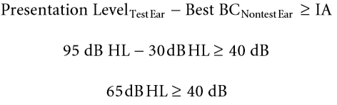

We will use the midplateau masking procedure to select an appropriate contralateral masking level. Remember that the midplateau masking procedure involves a three-step process: Calculation of (1) minimum masking level (MMin), (2) maximum masking level (MMax), and (3) midmasking level (MMid):

我们将使用中平台掩蔽程序来选择合适的对侧掩蔽水平。记住，中平台掩蔽程序包括三个步骤：计算（1）最小掩蔽级别（mmin），（2）最大掩蔽级别（mmax）和（3）中掩蔽级别（mmid）：

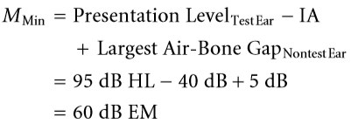

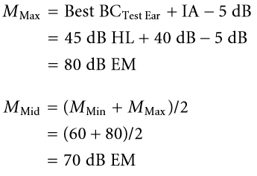

An EM level of 70 dB is appropriate for three reasons. First, it occurs at midplateau. Second, it occurs at least 10 dB above the calculated minimum. Remember that a safety factor of at least 10 dB or greater should be added to the calculated minimum value to account for intersubject variability with respect to masker effectiveness (Martin, 1974; Studebaker, 1979). Finally, it does not exceed the calculated maximum masking level.

EM级别为70 dB是合适的，原因有三。首先，它发生在平台中部。其次，它至少比计算的最小值高10 dB。请记住，应在计算的最小值上添加至少10分贝或更大的安全系数，以考虑受试者间对掩蔽声有效性的差异（Martin, 1974;Studebaker, 1979）。最后，它不超过计算掩蔽的最大级别。

It should be noted that the width of the masking plateau is typically underestimated when a conservative estimate of IA is used for determining the minimum and maximum masking levels. If IA is actually greater than the conservative estimate of 40 dB, then the width of the masking plateau will increase. For example, if this patient actually exhibits IA for speech of 55 dB (rather than the conservative estimate of 40 dB), then the minimum level will be decreased and the maximum level will be increased by the same amount (i.e., 15 dB). Although the width of the masking plateau increases, the midmasking level remains the same. As stated earlier, a major advantage of the midplateau method is that IA is eliminated as a source of error when selecting an appropriate masking level.

需要注意的是，当使用IA的保守估计值来确定最小和最大掩蔽级别时，掩蔽平台的宽度通常被低估。如果IA实际上大于保守估计的40dB，那么掩蔽平台的宽度将会增加。例如，如果该患者的语音实际上表现为55分贝的IA（而不是40分贝的保守估计），那么最小级别将降低，最大级别将增加相同的量（即15分贝）。尽管掩蔽平台的宽度增加，但中间掩蔽级别保持不变。如前所述，中平台方法的一个主要优点是，在选择适当的掩蔽级别时，消除IA作为误差源。

We now will take another look at the example presented in Figure 6.14 and substitute 3A insert earphones for the supra-aural arrangement. Contralateral masking will also be required when assessing suprathreshold speech recognition in the left ear. The presentation level of 95 dB HL (i.e., SRT of 55 dB HL + 40 dB SL) exceeds the best boneconduction threshold of 30 dB HL in the nontest ear by a conservative estimate of IA for speech (i.e., 60 dB). We will again use the midplateau masking procedure to select an appropriate level of contralateral masking. The calculations are the same for both supra-aural and 3A insert earphones with the exception that an IA value of 60 dB will be substituted in our equations for minimum and maximum masking levels. Masking levels for use with insert earphones are summarized below:

现在我们再看一看图6.14中的例子，用3A插入式耳机代替压耳式耳机。在评估左耳阈上言语识别时，还需要对侧掩蔽。在非测试耳中，95分贝HL（即55分贝hl+40分贝SL的SRT）的呈现级别超过了30分贝HL的最佳骨导阈值，这是通过对语音IA（即60分贝）的保守估计得到的。我们将再次使用中平台掩蔽程序来选择适当级别的对侧掩蔽。除了在我们的公式中用60分贝的IA值代替最小和最大掩蔽级别外，压耳式耳机和3A插入式耳机的计算都是一样的。与插入式耳机一起使用的掩蔽级别总结如下：

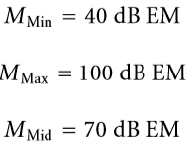

It should be apparent that an increase in IA has equal yet opposite effects on the minimum and maximum masking levels. Because IA is increased by 20 dB when using insert earphones, the width of the masking plateau is increased by 40 dB. The midmasking level, however, remains the same.

显然，IA的增加对最小和最大掩蔽级别具有相等但相反的影响。由于使用插入式耳机时IA增加了20dB，因此掩蔽平台的宽度增加了40dB。但是，中间掩蔽级别保持不变。

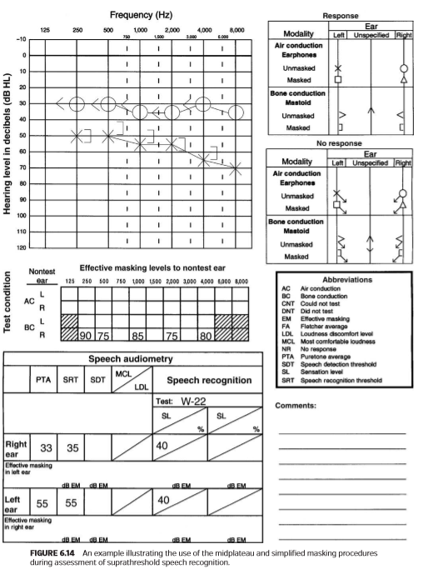

We now will take one ﬁnal look at the example presented in Figure 6.14 and consider the use of the simpliﬁed masking approach. Because the two prerequisite conditions are met, the simpliﬁed approach should result in the selection of an optimal masking level (i.e., midmasking level). Recall that EM level is simply calculated as the presentation level of the speech signal in dB HL at the test ear minus 20 dB. The same equation will be applicable when using any earphone (i.e., 3A and supra-aural):

现在，我们将对图6.14中的示例进行最后的分析，并考虑使用简化的掩蔽方法。由于满足了两个先决条件，简化的方法应选择最佳掩蔽级别（即中掩蔽级别）。回想一下，EM级别只是简单地计算为测试耳处语音信号的呈现级别（单位为dB HL减去20 db）。当使用任何耳机（即3A和压耳式）时，同样的公式也适用：

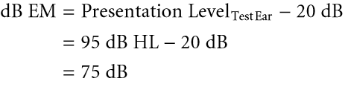

It should be noted that the masking level of 75 dB EM calculated using the simpliﬁed approach is in good agreement (i.e., ±5 dB) with the value (i.e., 70 dB EM) determined using the midplateau procedure. Yacullo (1999) indicates that there are two major advantages to using the simpliﬁed masking approach with 3A insert earphones, which are the result of a wider masking plateau. First, there is greater ﬂexibility in deviating somewhat from the calculated midmasking level while still remaining within an acceptable range of midplateau. It should be noted that the midplateau actually represents a small range of values surrounding the midmasking level. This range of acceptable values essentially increases when using 3A insert earphones. The use of the simpliﬁed masking approach can sometimes result in the selection of high masking levels, even though overmasking is not occurring. Consequently, the audiologist can justify subtracting a value of greater than 20 dB (e.g., 25 or 30 dB) from the presentation level at the test ear when using insert earphones. In the example presented in Figure 6.14, an EM level equal to the presentation level in the test ear minus 25 or 30 dB (e.g., 65 or 70 dB EM) would still result in an acceptable masking level that falls within the vicinity of midplateau, yet clearly exceeds the minimum level by a sizeable amount.

应注意的是，使用简化方法计算的75 dB em的掩蔽级别与使用中平台程序确定的值（即70 dB em）非常一致（即，±5 dB）。Yacullo（1999）指出，使用3A插入式耳机的简单掩蔽方法有两大优势，这是掩蔽平台更宽的结果。在仍然保持在可接受的中间平台范围内的情况下，在一定程度上偏离计算的中间掩蔽级别方面具有更大的灵活性。应该注意的是，中间平台实际上代表围绕中间掩蔽级别的一个小范围的值。当使用3A插入式耳机时，可接受值的范围基本上会增加。使用简单的掩蔽方法有时会导致选择高掩蔽级别，即使不会出现过度掩蔽。因此，当使用插入式耳机时，听力学家可以证明从测试耳朵的呈现级别减去大于20分贝（例如，25分贝或30分贝）的值是合理的。在图6.14所示的示例中，EM级别等于测试耳中的呈现级别减去25或30 dB（例如，65或70 dB EM）仍将产生可接受的掩蔽级别，该级别落在中高原附近，但明显比最低级别高出相当大的量。

Second, there is greater ﬂexibility in deviating slightly from the recommended prerequisite conditions (i.e., no air-bone gaps in either ear, use of moderate SLs) while still remaining within an acceptable range of midplateau and without signiﬁcantly increasing the potential for overmasking. Consequently, there is greater margin for error when selecting an appropriate level of masking.

其次，稍微偏离建议的先决条件（即，两只耳朵都没有气骨间隙，使用中等强度的SLs），同时仍保持在中平台的可接受范围内，不会显著增加过度掩蔽的可能性。因此，在选择适当的掩蔽级别时，有较大的误差余地。

The example presented in Figure 6.15 illustrates the application of the midplateau and simpliﬁed masking procedures during measurement of SRT. Audiometry was performed using 3A insert earphones. Puretone testing reveals normal hearing in the right ear. There is a severe sensory/ neural hearing loss of ﬂat conﬁguration in the left ear. Based on the puretone ﬁndings, it is predicted that SRTs will be measured at approximately 0 dB HL in the right ear and 70 dB HL in the left ear. Prior to measurement of speech thresholds, we can accurately predict whether contralateral masking will be required. Contralateral masking will be required only when measuring SRT in the left ear because the estimated speech threshold of 70 dB HL exceeds the best bone-conduction threshold of 0 dB HL in the nontest ear by a conservative estimate of IA for speech (i.e., 60 dB). An unmasked SRT is subsequently measured in the left ear at 0 dB HL, a ﬁnding consistent with the puretone results.

图6.15所示的示例说明了在测量SRT期间中平台和简化掩蔽程序的应用。使用3A插入式耳机进行测听。纯音测试显示右耳听力正常。左耳有严重的感音/神经性听力丧失。根据纯音的研究，预计SRT在右耳约为0分贝HL，左耳约为70分贝HL。在测量语音阈值之前，我们可以准确地预估是否需要对侧掩蔽。只有在测量左耳的SRT时才需要对侧掩蔽，因为70Db HL的估计言语阈值超过了非测试耳的最佳骨传导阈值0dB HL（即60dB）。随后在0分贝HL处测量了左耳的未掩蔽SRT，结果与纯音结果一致。

It has already been demonstrated that the simpliﬁed masking procedure proves very effective during assessment of suprathreshold speech recognition. However, it can also be applied effectively during measurement of SRT. When selecting an appropriate contralateral masking level when measuring SRT, it is important to consider not only the HL at which the speech threshold is ﬁnally established, but also the highest presentation levels used throughout the threshold procedure. Regardless of the SRT procedure used, spondaic words are presented typically at both suprathreshold and threshold levels.

实验表明，简化的掩蔽过程在阈上语音识别的评估中是非常有效的。然而，它也可以有效地应用于SRT的测量。在测量SRT时选择合适的对侧掩蔽水平时，不仅要考虑最终建立言语阈值的HL，还要考虑整个阈值过程中使用的最高呈现级别。无论使用何种SRT程序，扬扬格词通常都是在阈上和阈下两个级别上呈现的。

For example, ASHA (1988) recommends a descending threshold technique for measuring SRT that is based on the earlier work of others (Hirsh et al., 1952; Hudgins et al., 1947; Tillman and Olsen, 1973; Wilson et al., 1973). The initial phase involves familiarizing the patient with the spondaic words at a comfortable, suprathreshold HL. (Familiarization with test words is strongly recommended regardless of the SRT procedure.) The preliminary phase involves setting the HL to 30 to 40 dB above the estimated or predicted SRT before descending in 10-dB decrements until two words are missed. In fact, an HL of 30 to 40 dB above the predicted SRT typically results in a comfortable listening level for most patients during the familiarization phase. The test phase involves initially presenting test words at HLs approximately 10 dB higher than the calculated SRT. The calculation of threshold, based on a statistical precedent, takes into account the patient’s responses at higher HLs.

例如，ASHA（1988）在前人研究的基础上，推荐了一种下降阈值技术来测量SRT （Hirsh et al.， 1952;Hudgins等，1947;蒂尔曼和奥尔森，1973年;威尔逊等人，1973）。最初的阶段是让病人在一个舒适的阈上HL熟悉扬扬格词。（无论SRT程序如何，都强烈建议熟悉测试单词。）初始阶段包括将HL设置为比估计或预测的SRT高30到40 dB，然后以10-dB的递减下降，直到漏掉两个单词。事实上，HL值高于预测的SRT 30到40分贝通常会使大多数患者在熟悉阶段的听力水平达到舒适的水平。测试阶段包括最初在HLs处呈现测试词，比计算的SRT高出约10db。根据一个统计先例，阈值的计算考虑了患者在较高HLs时的反应。

Consider again the example presented in Figure 6.15. If the ASHA-recommended procedure is used to measure SRT, then the highest HLs employed (during the familiarization and preliminary phases) will be about 30 to 40 dB above the estimated SRT. In this example, we will use a moderate SL of 30 dB above the estimated SRT (i.e., 70 dB HL + 30 dB SL = 100 dB HL) during the familiarization and preliminary phases.

再次考虑图6.15中所示的示例。如果使用ASHA推荐的程序测量SRT，那么使用的最高HLs（在熟悉和初步阶段）将比估计的SRT高大约30到40 dB。在本例中，我们将在熟悉和初步阶段使用比估计SRT高30 dB的中等SL（即70 dB HL+30 dB SL=100 dB HL）。

The use of the simpliﬁed approach to selecting an appropriate level of contralateral masking should prove effective in this case because both prerequisite conditions have been met. First, there are no signiﬁcant air-bone gaps in either ear. Second, speech is presented at a moderate SL (i.e., 30 dB) when the highest HLs are used during the test procedure (i.e., familiarization and preliminary phases). Assuming that 100 dB HL is the highest presentation level used during our test procedure, then EM level in the nontest ear is calculated as follows:

在这种情况下，使用简化的方法选择适当级别的对侧掩蔽应该被证明是有效的，因为这两个先决条件都已满足。首先，两耳都没有明显的气骨间隙。其次，当在测试过程中使用最高的HLs（即熟悉和初步阶段）时，语音呈现为中等SL（即30分贝）。假设100db hl是测试过程中使用的最高呈现级别，则非测试耳中的EM级别计算如下：

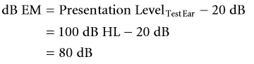

We can verify the appropriateness of the selected masking level by using the midplateau method:

我们可以使用中平台方法验证所选掩蔽级别的适当性:

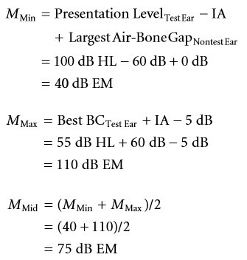

The masking level of 80 dB EM selected using the simpliﬁed approach is in good agreement (i.e., ±5 dB) with the value determined using the midplateau approach (i.e., 75 dB EM). Although spondees will be presented at lower HLs when measuring the SRT, it is not necessary to decrease the original level of masking. First, the selected masking level is appropriate for the highest HLs used during all phases of threshold determination. Second, the selected masking level does not exceed the maximum masking level (i.e., overmasking will not occur).

使用简化方法选择的80 dB EM的掩蔽级别与使用中平台方法确定的值（即75 dB EM）非常一致（即±5 dB）。虽然在测量SRT时，扬扬格词会出现在较低的HLs处，但不必降低原始的掩蔽级别。首先，所选择的掩蔽级别适合于阈值确定的所有阶段中使用的最高HLs。第二，所选掩蔽级别不超过最大掩蔽级别（即，不会出现过度掩蔽）。

It can be argued that the simpliﬁed approach (as well as the midplateau method) can result in the use of unnecessarily high masking levels during measurement of SRT. As was discussed earlier, the midplateau represents a range of masking levels. The audiologist can justify subtracting a value of greater than 20 dB (e.g., 25 or 30 dB) from the presentation level at the test ear, particularly when using insert earphones. In this example, a masking level of 70 or 75 dB EM (rather than the original level of 80 dB EM) still falls within an acceptable range of midplateau, while still occurring signiﬁcantly higher than the minimum.

可以说，简化的方法（以及中平台法）会导致在测量SRT时使用不必要的高掩蔽水平。如前所述，中平台代表一系列掩蔽级别。听力学家可以证明从测试耳朵的呈现级别中减去大于20分贝（例如25分贝或30分贝）的值是合理的，特别是当使用插入式耳机时。在本例中，70或75分贝EM（而不是原来的80分贝EM）的掩蔽级别仍在中平台的可接受范围内，同时仍显著高于最小值。

Yacullo (1999) states that the simpliﬁed masking approach during speech audiometry has wide applicability. First, it can be used with a large and diverse patient population, including those with normal hearing and sensory/ neural hearing loss. Second, it can be used equally effectively when using either supra-aural or insert earphones. Third, the procedure can be used in clinical situations where moderate SLs are used. For example, the majority of audiologists in the United States continue to administer suprathreshold word recognition tests at a speciﬁed SL referenced to the SRT (Martin and Morris, 1989; Martin et al., 1994, 1998), typically 30 or 40 dB (Martin and Morris, 1989; Martin et al., 1994). Finally, it can be applied effectively during both threshold and suprathreshold measures of speech recognition.

Yacullo（1999）指出，言语测听过程中的简化掩蔽方法具有广泛的适用性。首先，它可以用于大量不同的患者群体，包括听力正常和感音/神经性听力丧失的患者。其次，当使用压耳式耳机或插入式耳机时，它可以同样有效地使用。第三，该程序可用于临床情况下使用中度SLs。例如，美国的大多数听力学家继续在参考SRT的特定SL（Martin and Morris，1989；Martin et al.，1994，1998）进行阈上单词识别测试，通常为30或40分贝（Martin and Morris，1989；Martin et al.，1994）。最后，在阈值和超阈值两种语音识别方法中都能有效地应用。

Direct calculation of midmasking level is strongly recommended in cases where there is potential risk of overmasking. Yacullo (1999) states that any factor that increases minimum masking level or decreases maximum masking level will reduce the width of the masking plateau and increase the probability of overmasking. For example, the presence of signiﬁcant air-bone gaps in the nontest ear and/or the use of higher SLs (i.e., ≥50 dB) will increase minimum masking level. The presence of signiﬁcant air-bone gaps in the test ear will decrease maximum masking level. In cases where the masking plateau is either very narrow or nonexistent (e.g., unilateral or bilateral conductive hearing loss), knowledge about minimum and maximum masking levels will allow the clinician to make well-informed decisions about appropriate contralateral masking levels.

如果存在过度掩蔽的潜在风险，强烈建议直接计算中掩蔽级别。Yacullo（1999）指出，任何增加最小掩蔽级别或降低最大掩蔽级别的因素都会减小掩蔽平台的宽度，并增加过度掩蔽的可能性。例如，在非测试耳朵中存在显著的气骨间隙和/或使用更高的SLs（即≥50分贝）将增加最小掩蔽级别。在测试耳中存在显著的气骨间隙将降低最大掩蔽级别。在掩蔽平台非常狭窄或不存在的情况下（例如，单侧或双侧传导性听力损失），关于最小和最大掩蔽水平的知识将允许临床医生对适当的对侧掩蔽级别作出明智的决定。

### FOOD FOR THOUGHT

引人深思的事

1. Discuss how IA inﬂuences decisions about the need for contralateral masking during puretone and speech audiometry.

2. Discuss how the OE inﬂuences measured IA for airconduction transducers (i.e., supra-aural and 3A insert earphones with deeply inserted foam eartips). How does the OE inﬂuence contralateral masking levels during bone-conduction audiometry?

3. The plateau masking procedure originally was described by Hood as a method for contralateral masking during puretone threshold audiometry. Discuss how the underlying principles of the masking plateau are applied to procedures for contralateral masking during speech audiometry.

1. 讨论在纯音和言语测听过程中，IA如何影响对侧掩蔽的需要。

2. 讨论OE对空气传导换能器测量IA的影响（压耳式和深插入泡沫耳塞3A插入耳机）。在骨传导听力测量中，OE如何影响对侧掩蔽级别？

3. 高原掩蔽程序最初被胡德描述为在纯音阈测听期间对侧掩蔽的一种方法。讨论掩蔽平台的基本原理如何应用于言语测听过程中的对侧掩蔽。

# Chapter 7 Case History

第七章 病史

### INTRODUCTION

简介

Audiologists must critically and judiciously gather and examine all information related to sound perception, tinnitus, hearing, hearing loss, listening (in quiet and noise), dizziness, balance problems, and birth history (for newborns and infants). The audiologist creates and interprets anatomic and physiologic information within the context of a case history, to render an appropriate diagnosis. Audiologists are charged with the responsibility of diagnosing and “nonmedically” treating hearing loss. Traditional wisdom reveals two key ingredients to a correct differential diagnosis: An excellent case history and a thorough physical examination. Given these two key ingredients, the differential diagnosis “emerges” to the trained professional as the only clear answer (i.e., a single differential diagnosis) or potentially a series of equally plausible diagnoses emerge, indicating multiple remaining questions and avenues to be explored and resolved. Indeed, case history gathering is an important skill which facilitates the correct differential diagnosis if the clinician obtains relevant and focused information. Obtaining and using the case history requires skill, patience, practice, and knowledge.

听力师必须认真、明智地收集和检查与听觉、耳鸣、听力、听力损失、倾听（安静和噪音）、头晕、平衡问题和出生史（新生儿和婴儿）有关的所有信息。听力师在病史背景下创建和解释解剖学和生理学信息，以提供适当的诊断。听力师负责诊断和“非医学”治疗听力损失。传统的智慧揭示了正确鉴别诊断的两个关键要素：详尽的病史询问和细致的体格检查。考虑到这两个关键因素，对受过培训的专业人员来说，鉴别诊断作为唯一明确的答案“呈现”给训练有素的专业人员（即单个鉴别诊断），或者可能出现一系列同样可信的诊断，这表明还有许多问题和途径有待探索。解决了。事实上，病史收集是一项重要的技能，如果临床医生获得相关的和重点的信息，有助于正确的鉴别诊断。获取和使用病史需要技巧、耐心、实践和知识。

In general, if you’re not looking for something, you won’t ﬁnd it. However, simply looking for something doesn’t mean you will ﬁnd it. For example, if you’re looking for zebras in a cow pasture, you probably won’t ﬁnd them. Of course this doesn’t mean zebras don’t exist. However, it may indicate zebras generally don’t hang out in cow pastures. To ﬁnd the correct solution to a given problem, we must pose the right question, formulate reasonable options and alternatives, and ultimately, choose the most probable alternative.

一般来说，如果你不找东西，你就找不到。然而，仅仅寻找一些东西并不意味着你会找到它。例如，如果你在奶牛场寻找斑马，你可能找不到它们。当然，这并不意味着斑马不存在。然而，这可能意味着斑马一般不会在奶牛牧场上出没。为了找给定问题的正确解决方案，我们必须提出正确的问题，制定合理的方案和备选方案，最终选择最可能的方案。

When gathering and assembling case histories, healthcare professionals must narrow the focus and ﬁlter the information available quickly and efﬁciently while pulling together what is most important. The case history questions should be reasonable, and result driven, allowing for an evidence-based outcome.

在收集和汇总病史时，医疗专业人员必须缩小关注范围，快速有效地过滤可用信息，同时将最重要的内容集中起来。病史提问应该是合理的，由结果驱动的，并要考虑基于证据的结果。

Across healthcare disciplines (including audiology), the method of choice for obtaining the case history is the “medical model.” The medical model efﬁciently directs the professional to the “chief complaint” (CC) and helps organize information into a rational hierarchy with the most important or likely concerns at the forefront.

在医疗保健学科（包括听力学）中，获取病史的选择方法是“医疗模型”。医学模型有效地将专业人员了解“主诉”（CC），并帮助将信息组织成一个合理的层次结构，其中最重要的或可能的关注点放在最前面。

Researchers have designed decision trees and analysis weightings and other complex models which are powerful and accurate and, theoretically, will assist in ﬁnding the correct diagnosis. However, when the audiologist is working with the patient, assembling the case history is essentially a person-to-person event. Frankly, having good people skills and adjusting our approach (i.e., course corrections) to the client we are addressing, matter a great deal.

研究人员已经设计了决策树和分析权重以及其他复杂的模型，这些模型功能强大且准确，从理论上讲，将有助于做出正确的诊断。然而，当听力师与患者一起工作时，收集病历本质上是一个人对人的事件。坦率地说，拥有良好的人际交往技巧和调整我们对客户的方法（即课程修正）非常重要。

### CASE HISTORY TOOLS

病史工具

There are three primary tools used to create a case history: Interviews, questionnaires, and the subjective, objective, assessment, and plan (SOAP) format. These three tools are often used in tandem, but can certainly be used as preferred by the professional.

用于创建病史的主要工具有三种：访谈、问卷以及主观、客观、评估和计划（SOAP）格式。这三种工具通常是串联使用的，但肯定可以作为专业人士的首选。

The audiologist, as a licensed or regulated healthcare professional, has a legal obligation to the patient’s health and well-being. The audiologist must be aware of the warning signs of dangerous and treatable medical and surgical conditions and should refer to the appropriate professional when “red ﬂags” are noticed. Red ﬂags include a sudden hearing loss, ear pain, draining or bleeding ears, unilateral symptoms of hearing loss or tinnitus, conductive hearing loss, dizziness, and other referral criteria. Assembling the case history provides an opportunity to identify red ﬂags while considering a multitude of diagnostic and treatment alternatives.

听力师，作为一名执业或受监管的医疗专业人士，对患者的健康和福祉负有法律义务。听力学家必须意识到危险和可治疗的医疗和外科条件的警告信号，当注意到“危险信号”时，应参考适当的专业人士。危险信号包括突发性听力丧失、耳痛、耳漏或出血、单侧听力丧失或耳鸣症状、传导性听力丧失、头晕等转诊标准。在考虑多种诊断和治疗方案的同时，收集病史提供了一个识别危险信号的机会。

**Interview Techniques**

交谈技巧

Of course, there is no “one correct way” to interview patients. Flexibility is the key, as professionals, patients, work settings, and the particulars of each situation vary. Nonetheless, it is always a good idea to proceed in an orderly and professional manner. Interviews should be patient centered, friendly, and private, in accordance with applicable laws, rules, and regulations.

当然，没有“一种正确的方式”来与患者交谈。灵活性是关键，因为专业人员、患者、工作环境以及每种情况的细节都各不相同。尽管如此，以有序和专业的方式进行总是一个好主意。交谈应以患者为中心，友好、私人的，并遵守适用的法律、法规和规章。

While gathering the case history, ascertaining an “index of suspicion” regarding the CC is an important part of the interview. If the index of suspicion for the item highest on our list is low, we generally need to look for more probable alternatives. If the index of suspicion is high, we ask further questions to conﬁrm or refute our suspicions.

在收集病史的同时，确定与CC有关的“怀疑指数”是访谈的一个重要部分。如果我们清单上最高项目的怀疑指数较低，我们通常需要寻找更可能的替代品。如果怀疑指数很高，我们会提出进一步的问题来证实或反驳我们的怀疑。

For example, a patient presenting with a ﬂuctuating low-frequency sensory/neural hearing loss (SNHL) and tinnitus in the same ear, with aural fullness and occasional vertigo, has a low index of suspicion for otosclerosis, but has a reasonably high index of suspicion for Ménière’s disease. The high index of suspicion for Ménière’s disease would lead us to ask probing questions to note whether the presenting symptomatology is in agreement with a Ménière’s diagnosis or would lead us in another direction, such as an acoustic neuroma.

例如，同一只耳朵出现波动的低频感音/神经听力损失（SNHL）和耳鸣，并伴有耳胀和时眩晕，怀疑耳硬化的指数较低，但怀疑梅尼埃病的指数较高。对梅尼埃病的高怀疑指数将导致我们提出探究性的问题，以注意目前的症状是否符合梅尼埃病的诊断，或者会将我们引向另一个方向，如听神经瘤。

The competent professional understands the probabilities of certain things occurring and the related signs and symptoms of each. Although Ménière’s disease is a relatively rare disorder, occurring in less than 1% of the general population, it is a common diagnosis for patients with the symptoms described earlier. Of course, we do not make a medical diagnosis of a disease. However, if the data come together with what we know about the patient the audiologist might include “Consistent with Ménière’s disease,” in the report.

有能力的专业人员了解某些事情发生的可能性，以及每个事件的相关迹象和症状。虽然梅尼埃病是一种相对罕见的疾病，发生在不到1%的普通人群中，但它是早期症状患者的常见诊断。当然，我们不会对疾病进行医学诊断。然而，如果这些数据与我们对患者的了解相结合，听力师可能会在报告中提到“与梅尼埃病一致”。

Three scenarios follow to illustrate the interview technique.

接下来的三个场景说明了交谈技巧。

**SCENARIO ONE**

场景一

Review any/all assembled paperwork (chart, lab notes, test results, history, etc.) before meeting the patient for the initial consultation. Shake hands and greet the patient, their spouse, signiﬁcant other, family, and so on, and always introduce yourself. This is an amazingly simple protocol, but it is often overlooked, and when it is overlooked, it sets an unprofessional tone for the rest of the encounter. I usually say, “Good morning. My name is Dr. Beck, I’m an audiologist. Please come in Mr. Smith.”

在与患者会面进行初步会诊之前，审查所有已汇编的文件（图表、实验室笔记、测试结果、历史记录等）。握手并问候患者本人、他们的配偶、其他重要的人、家人等，并自我介绍。这是一个非常简单的礼节，但它经常被忽视，当它被忽视时，它为接下来的遭遇定了一个不专业的基调。我通常说，“早上好。我叫贝克医生，我是个听力师。请进，史密斯先生。”

After exchanging greetings and after sitting down in the ofﬁce, inquire as to why the patient scheduled today’s visit. “Thanks for coming in today Mr. Smith. What brings you to the ofﬁce?”

在相互问候和在办公室坐下来之后，询问病人为什么安排今天的访问。“谢谢你今天能来，史密斯先生。什么风把你吹到办公室来了?”

Mr. Smith: “I would like a comprehensive audiometric evaluation to conﬁrm my bilateral sensory/neural noise-induced hearing loss that my otolaryngologist diagnosed last week. I am very interested in acquiring two digital hearing aids, and by the way, I am wealthy and do not have insurance. I pay cash, and money is no object. I want to hear everything as best I can.”

史密斯:“我想做一个全面的听力评估，以确认我的双侧噪声引起的感音/神经性听力损失，这是我的耳鼻喉科医生上周诊断的。我对购买两只数字助听器非常感兴趣，顺便说一下，我很富有，没有保险。我付现金，钱不成问题。我想听到尽可能多的声音。”

Because this patient has already been seen and diagnosed by the ear, nose, and throat (ENT) specialist, the index of suspicion for some other disease process or a medical/ surgical issue is extremely low.

由于该患者已经由耳鼻喉科专家进行了检查和诊断，因此对其他疾病或医疗/外科问题的怀疑指数极低。

**SCENARIO TWO**

场景二

Mr. Smith: “Well doc, you know how it is. My wife always complains I have the TV up too loud and it drives her outta the room. I like to be able to hear the darn thing so I keep it a little loud. The same thing happens with the car radio when we’re driving to the store. When she sets the volume, I just hear noise and can’t tell anything about what they’re saying. When I was a boy, I could hear a pin drop from 40 paces.”

史密斯先生：“好吧，医生，你知道是怎么回事。我妻子总是抱怨我把电视声音开得太大，使她离开房间。我喜欢能听清楚声音，所以我把声音开得有点大。当我们开车去商店的时候，汽车收音机也会发生同样的事情。当她调好音量时，我只听到噪音，听不清他们在说什么。当我还是个孩子的时候，我能听到40步外的一根针掉下来的声音。”

“I understand. How long have you been playing the TV and radio louder than your wife likes it?”

“我明白。你把电视和收音机声音放得比你妻子喜欢的还要大有多长时间了？“

“Let’s see, I started working at the steel fabrication factory 14 years ago, and my son was born 8 years ago . . . . so yeah, it’s been at least 8 or 10 years. When I let her set the volume, I can hear the voices, but I really can’t understand what they’re saying. That drives me nuts. I told her and I’m telling you too, I ain’t gonna wear no hearing aids.”

“让我想想，14年前我在钢铁制造厂工作，8年前我儿子出生了。…是的，至少8到10年了。当我让她调音量时，我能听到声音，但我真的听不懂他们在说什么。这让我发疯。我告诉过她，我也告诉过你，我真不想戴助听器啊。”

Given the information presented in this scenario, one can make several, reasonable, assumptions. We could assume that Mr. Smith has a noise-induced SNHL, likely impacting 4,000 Hz, and because he cannot hear the consonant sounds (high frequencies), he cannot clearly understand the words spoken to him. We might also assume that Mr. Smith is not going to wear hearing aids and that there is little we can do to assist. However, there are other options and protocols to employ:

根据此场景中提供的信息，可以做出几个合理的假设。我们可以假设史密斯先生有噪音诱发的SNHL，可能影响4000赫兹，因为他听不到辅音（高频），所以他不能清楚地理解对他说的话。我们也可能认为史密斯先生不会戴助听器，我们也无能为力。不过，还有其他选择和协议可以采用：

“Mr. Smith, have you had a hearing test before?”

“史密斯先生，以前做过听力测试吗？”

“Not since the Army, back some 20 years ago.”

“自从20年前参军以来就没有了。”

“Do both ears seem about the same, or is one ear better than the other?”

“两只耳朵看起来差不多吗?还是一只耳朵比另一只好？”

“The left ear is terrible—can’t hear thunder with that one.”

“左耳很重——用那只左耳听不到雷声。”

“I see. Do you have any ear pain?”

“我明白了。你耳朵疼吗？”

“None at all. My ears feel ﬁne.”

“没有，我耳朵感觉很好。”

“Okay then. May I take a look?”

“好吧。我可以看一下吗？”

“Sure, help yourself.”

“当然可以，请便”

At this point, the audiologist has a rather low index of suspicion for a tumor, such as an acoustic neuroma, because they occur in about 0.00001% of the population, but a higher index of suspicion for more likely possibilities, including a unilateral sudden sensory/neural loss that went undiagnosed (or maybe Mr. Smith works with his left ear toward a loud machine while wearing hearing protection only in the right ear, or perhaps he experienced head trauma on the left or an explosion near his left side during boot camp; there are lots of possibilities). The examination of the pinna, concha, ear canal, and tympanic membranes is normal. The audiologist says, “Okay, your ears look ﬁne,” and the interview continues to determine which diagnosis has the highest index of suspicion.

此时，听力学家对肿瘤有一个相当低的怀疑指数，如听神经瘤，因为它们发生在约0.00001%的人口，但包括未确诊单耳突然感音/神经性损失在内的可能性应给予更高的怀疑指数，（或者史密斯先生工作时左耳对着一台轰隆的机器，右耳佩戴听力保护装置，或者也许他在新兵训练营中经历了头部左侧的创伤或者是左侧附近的爆炸，有很多可能性）。耳廓、耳甲腔、耳道、鼓膜检查正常。听力学家说:“好吧，你的耳朵看起来很好。”交谈继续确定哪种诊断具有最高的怀疑指数。

“Mr. Smith, let me make sure I understand . . . the right ear is the better ear and the left ear has been bad for a long time. Have you ever had the left ear checked?”

“史密斯先生，让我确认一下我明白了……右耳比较好，左耳已经坏了很长时间坏了。你的左耳检查过吗?”

“Yes. I had the doctor look at it a year or two ago when it went bad. He put me on antibiotics and that was the end of it. It didn’t get better though, so I left it alone.

“是的。一两年前，当它变坏时，我让医生检查过。他给我注射了抗生素，就这样结束了。但情况并没有好转，所以我就不管了。

“Okay. What about drainage, anything coming out of your ears?”

“好吧。那流水吗，你耳朵里有东西流出来吗?”

“No sir.”

“没有”

“Any dizziness or spinning sensations?”

“有头晕或眩晕的感觉吗？”

“Not any more. Well, maybe a little. When my left ear was going bad, I had some dizziness, but the doctor looked at it and put me on antibiotics, and the dizziness got better after a while.”

“不再有了。嗯，也许有点。当我的左耳不好的时候，我有点头晕，但是医生看了看，给我开了抗生素，头晕过一会儿就好了。”

“So the dizziness started and the left ear went bad all about a year or two ago?”

“那么大约一两年前就开始头晕了，左耳也变坏了？”

“That’s right.”

“是的”

“Okay, very good. Are you on any medications?”

“好的，非常好。你在吃药吗？”

“Just a cholesterol pill and a baby aspirin, that’s about it.”

“只要一片胆固醇药片和一片小剂量阿司匹林，就这样。”

“Okay, and one last thing I’d like to ask you before we do the hearing test—do you have any ringing or buzzing noises in your ears?”

“好的，在我们做听力测试之前，我想问你最后一件事——你耳朵里有嗡嗡声吗?”

“Yeah, the darn left ear can’t hear anything, but it sure makes a racket. Kinda like a “shhhhh” noise going on in there. Keeps me up at night sometimes.”

“是啊，那该死的左耳什么也听不见，但它的确发出了刺耳的声音。有点像在里面发出“嘘”的声音。有时让我夜不能寐。”

The audiologist does a comprehensive audiometric evaluation and determines the following audiometric proﬁle:

听力师进行全面的听力评估，并确定以下听力特征：

Right ear: Normal peripheral hearing. Tympanogram normal (type A), ipsilateral reﬂexes within normal limits (WNL). Word recognition score (WRS) = 96%. Speech reception threshold (SRT) = 15 dB HL.

右耳：周围听力正常。鼓室图正常（A型），同侧反射在正常范围内（Wnl）。单词识别分数（WRS）=96%。语音接收阈值（SRT）=15 dB hl。

Left ear: Flat 85 dB sensory/neural (SN) loss. Tympanogram normal (type A), ipsilateral reﬂexes absent @105 dB stimulus level. WRS = 8%, SRT = SAT (speech awareness threshold used because speech understanding was extremely poor) = 80 dB HL.

左耳:感觉/神经(SN)丧失85分贝。鼓室图正常（A型），同侧反射无105db刺激水平。WRS = 8%， SRT = SAT（由于语音理解非常差而使用的语音意识阈值）= 80 dB HL。

The index of suspicion for a left retrocochlear disorder is very high at this point. The case history supports this possibility, and the test results indicate a possible retrocochlear diagnosis for the left ear.

目前，对左后耳蜗疾病的怀疑指数很高。病史支持这一可能性，测试结果表明左耳可能有耳蜗后疾病诊断。

The audiologist refers the patient to an otolaryngologist (preferably an otologist or neurotologist) based on the high index of suspicion for a retrocochlear hearing loss. The otologist meets with and interviews the patient and refers the patient for a magnetic resonance imaging (MRI) study with contrast (gadolinium). A 3-cm vestibular schwannoma (acoustic neuroma) is diagnosed. Mr. Smith is scheduled for surgery 3 weeks later, and the tumor is removed via the translabyrinthine approach.

根据对蜗后听力损失的高度怀疑指数，听力学家将患者推荐给耳鼻喉科医生（最好是耳科医生或神经科医生）。耳科医生与患者会面并交谈，让患者进行磁共振成像（MRI）对比研究（钆）。一个3厘米大小的前庭神经鞘瘤（听神经瘤）被诊断。史密斯先生被安排在3周后进行手术，通过经路椎弓根入路肿瘤被切除。

**SCENARIO THREE**

场景三

Mr. Smith: “Let’s see, I started working at this really noisy factory 14 years ago, and my son was born 8 years ago . . . so yeah, it’s been at least 8 or 10 years. When my wife sets the TV, it sounds like everyone is mumbling; I can hear the voices, but I really can’t understand what they’re saying. That drives me nuts. I told her and I’m telling you too, I ain’t gonna wear no hearing aids.”

史密斯先生：“让我想想，14年前我就在这个噪音很大的工厂工作，8年前我儿子就出生了。…是的，至少有8到10年了。当我妻子打开电视时，听起来每个人都在咕哝；我能听到声音，但我真的听不懂他们在说什么。这让我发疯。我告诉过她，我也告诉过你，我真不想戴助听器啊。”

Given the information presented above, one can make several assumptions. We could assume Mr. Smith has a noise-induced SNHL, impacting frequencies around 4,000 Hz, and because of the reduced amplitude and distortion affecting mostly the high-frequency consonant sounds, he cannot clearly hear the words spoken to him. We can also be comfortable in thinking that Mr. Smith is not going to wear hearing aids, which reduces what we can do to assist him. However, there are other options and protocols to explore.

鉴于上述信息，我们可以做出几个假设。我们可以假设史密斯先生有噪声引起的SNHL，影响频率在4000赫兹左右，由于振幅和失真的降低，主要影响高频辅音，他不能清楚地听到对他说的话。我们也可以放心地认为史密斯先生不会戴助听器，我们可以帮助他的事情会减少。但是，还有其他选项和协议需要探讨。

“Mr. Smith, have you had a hearing test before?”

“史密斯先生，你以前做过听力测试吗？“

“Not since the Army, back some 20 years ago.”

“自从20年前参军以来就没有了。”

“Do both ears seem about the same, or is one ear better than the other?”

“两只耳朵看起来差不多吗?还是一只耳朵比另一只好?”

“They’re just about the same”

“差不多一样。”

“I see. Any ear pain?”

“明白了，耳朵痛吗？”

“None at all. My ears feel ﬁne.”

“没有，我的耳朵很好。”

“That’s good. May I take a look?”

“很好。我可以看看吗？”

“Sure doc, knock yourself out.”

“当然可以，医生，请自便。”

The pinna, concha, ear canal, and tympanic membranes are normal in appearance. The audiologist says, “Your ears look ﬁne,” and the interview continues.

耳廓、耳甲腔、耳道和鼓膜外观正常。听力师说，“你的耳朵看起来很好”，交谈继续进行。

“Okay, what about drainage? Is there anything coming out of your ears?”

“好的，那流水吗？你耳朵里有什么东西出来吗？“

“No sir.”

“没有”

“Any dizziness or spinning sensations”

“有头晕或者旋转感吗？”

“Nope.”

“没有”

“Very good. Are you taking any medications?”

“很好。服用什么药吗？“

“Just a cholesterol pill and a baby aspirin, that’s about it.”

“只有一片胆固醇药片和一片小剂量阿司匹林，就差不多了。”

“The last question I’d like to ask you before we do the hearing test is do you have any ringing or buzzing noises in your ears?”

“在我们做听力测试之前，我想问你的最后一个问题是，你的耳朵嗡嗡响吗?”

“Yeah . . . maybe a little when it’s really quiet, nothing that really bothers me though.”

“是的……也许在非常安静的时候会有一点，不过没有真正困扰我。”

The audiologist does a comprehensive audiometric evaluation and determines the following audiometric proﬁle:

听力学家进行全面的听力评估，并确定以下听力特征:

Right ear: Moderate high-frequency sensory/neural hearing loss. Tympanogram normal (type A), ipsilateral reﬂexes are within normal limits (WNL). WRS = 96%. SRT = 45 dB HL.

右耳：中度高频感音/神经性听力损失。鼓室图正常（A型），同侧反射在正常范围内（Wnl）。WRS=96%。SRT=45分贝HL。

Left ear: Moderate high-frequency sensory/neural hearing loss. Tympanogram normal (type A), ipsilateral reﬂexes are WNL. WRS = 92%. SRT = 45 dB HL.

左耳：中度高频感觉/神经性听力损失。鼓室图正常（A型），同侧反射为Wnl。WRS=92%。SRT=45分贝HL。

“Mr. Smith, I’d like to review the results of today’s tests with you. Would you like to have your wife join us while I review the results?”

“先生。史密斯，我想和你一起看一下今天的检查结果。你愿意让你的妻子和我们一起看检查结果吗?”

“Sure, that would be great. She’s in the waiting room.”

“当然，那太好了。她在候诊室。”

“Hi Mrs. Smith, please join us while I review the results of today’s examination. This way, the two of you will have the chance to learn about the results, and I can address your questions.”

“嗨，史密斯太太，请和我们一起看今天的检查结果。这样，你们两个就有机会了解结果，我可以回答你们的问题。”

In this third scenario, the index of suspicion for a noiseinduced hearing loss is high, and there are no red ﬂags and no indications of a medical or surgical problem. In essence, the same patient, in three different scenarios, has three separate sets of circumstances, each of which are typically revealed through an interview-based case history, which is more or less driven by the index of suspicion.

在第三种情况下，噪声性听力损失的怀疑指数很高，没有危险信号，也没有内科或外科问题的迹象。本质上，在三种不同的情况下，同一个患者有三组不同的情况，每一组情况通常都是通过基于交谈的病史来揭示的，而病史或多或少由怀疑指数驱动。

Questionnaires

调查表

Another very useful and efﬁcient case history tool is the health questionnaire. A well-designed questionnaire is highly focused, simple, takes just a few minutes to ﬁll out, and quickly directs the professional to the area(s) of greatest concern. Questionnaires regarding hearing health care can be presented to patients verbally or written. Written questionnaires are available in electronic and paper-based formats.

另一个非常有用和有效的病史工具是健康问卷。一份精心设计的调查问卷集中度高、简单，只需几分钟就可以完成，并迅速将专业人士引向最关注的领域。关于听力保健的调查问卷可以口头或书面形式提交给患者。书面问卷有电子和纸质两种形式。

However, it is my personal preference to not have patients ﬁll in downloadable, lengthy questionnaires at home. It is terriﬁcally advantageous for the audiologist to spend the time working through a well-designed questionnaire with the patient, to establish rapport and trust and to allow the patient to tell their story. We learn much more about the patient and their situation when we put in the time to ask questions and listen to the patient and then write chart notes reﬂecting that conversation. Time spent asking questions and listening to and then questioning and clarifying their response is time well spent.

然而，我个人倾向于不让病人在家填写下载的冗长问卷。对听力师来说，花时间与患者一起完成一份精心设计的问卷调查，建立融洽的关系和信任，并让患者讲述他们的故事，是非常有利的。当我们花时间问问题，倾听病人的声音，然后写下反映对话的图表笔记时，我们就能更多地了解病人和他们的情况。花时间提问，倾听，然后提问并澄清他们的回答是值得的。

VERBAL PRESENTATIONS

口头陈述

Remember, if you are giving a patient a verbal presentation of a hearing questionnaire, there is already a reasonable index of suspicion for hearing loss. Therefore, sit about 3 ft away from the patient in a well-lit room, face the patient, be sure there is no background noise or visual distractions, and maintain the patient’s full attention.

记住，如果你给患者口头陈述听力问卷，已经有了合理的听力损失怀疑指数。因此，在光线充足的房间里，坐在离患者3英尺远的地方，面对患者，确保没有背景噪音或视觉干扰，并保持患者的全神贯注。

PENCIL AND PAPER PRESENTATIONS

笔及纸张报告

Keep in mind that, because the majority of patients seen by audiologists are over 55 years of age, large font, dark print, and maximal contrast between the printed words and the background page are preferred and appreciated. Black print on a white background will be the easiest to read. Another important consideration is to use and/or design questionnaires that are easily assessed and tabulated, so the professional can scan the page to ﬁnd the “positive” results, which will need to be considered.

请记住，因为大多数听力师所见的患者年龄在55岁以上，所以首选大字体、深色打印以及打印文字与背景页之间的最大对比度。白色背景上的黑色字体最容易阅读。另一个重要的考虑是使用和/或设计易于评估和制表的问卷，以便专业人员能够浏览页面找到“阳性”结果，这将需要考虑。

In 2005, the Centers for Medicare and Medicaid Services (CMS) added a new beneﬁt under Medicare Part B that will likely increase the quantity of pencil and paper– based hearing and balance screenings offered to patients. This beneﬁt is “bundled” within the “Welcome to Medicare” examination. The examination has seven screening sections for physicians, nurses, or nurse practitioners to employ when addressing new patients. Importantly, the Medicare rules state that the screening tests must be in the form of questions or questionnaires and that the selected screening tests must be recognized by a national medical professional organization.

2005年，医疗保险和医疗补助服务中心（CMS）在医疗保险B部分增加了一项新的福利，这可能会增加为病人提供的以笔和纸质听力和平衡筛查的数量。这项福利“捆绑”在“欢迎加入医疗保险”检查中。该考试有七个筛选部分，供医生、护士或执业护士在治疗新病人时使用。重要的是，医疗保险规则规定，筛查测试必须以问题或问卷的形式进行，所选择的筛查测试必须得到全国医疗专业组织的认可。

In addition to a wealth of other tests, the American Academy of Audiology (AAA) and the American SpeechLanguage-Hearing Association (ASHA) have recommended that the following questionnaire be used for this purpose: Hearing Handicap Inventory for the Elderly—Screening Version (HHIE-S; Ventry and Weinstein, 1982). There is likely to be greater popularity for screening tests. Therefore, audiologists should be familiar with the above-noted questionnaires and their format, scoring, and importance.

除了大量的其他测试，美国听力学会（AAA）和美国言语语言听力协会（ASHA）建议使用以下的问卷调查：听力障碍的老年人筛查版本（hhy - s;Ventry和Weinstein, 1982）。筛查测试可能会更受欢迎。因此，听力师应熟悉上述问卷及其格式、评分和重要性。

**Subjective, Objective, Assessment, and Plan**

主观、客观、评估和计划

Another way to gather useful case history information quickly is to use the standard subjective, objective, assessment, and plan (SOAP) format. The SOAP format is essentially a “medical model” case history–gathering tool. There are many variations on the SOAP format used by clinics, medical schools, and, often, military healthcare facilities.

另一种快速收集有用病史信息的方法是使用标准的主观、客观、评估和计划（SOAP）格式。SOAP格式本质上是一个“医疗模型”病历史收集工具。诊所、医学院和军事医疗设施使用的SOAP格式有很多不同。

Critics believe the SOAP format is impersonal and does not recognize the patient as a whole person. In addition, the SOAP format tends to treat the person as if he or she was the disease/disorder/problem, and it calls for the use of jargon and related abbreviations. Although jargon is commonly used in health professions, it can vary from location to location, and it may be nearly impossible for many welleducated colleagues to interpret. In the following examples, abbreviations will be used along with their explanations, which will immediately follow in parenthesis.

批评者认为SOAP格式是非个人的，不能将患者视为一个完整的人。此外，SOAP格式倾向于将患者视为疾病/紊乱/问题，并要求使用术语和相关缩写。尽管专业术语在卫生行业中很常见，但它在不同的地点也会有所不同，而且对于许多受过良好教育的同事来说，这几乎是不可能解释的。在下面的例子中，将使用缩写和它们的解释，这些解释将立即跟随在圆括号中。

**SUBJECTIVE**

主观的

The subjective section provides a brief subjective history, often focusing on the CC as well as other clinical observations. The patient’s medical and audiology history would be placed in this section. Other entries in this section would be notes the patient/relative/friends offer regarding pain or discomfort and related miscellaneous symptoms. An example follows:

主观性部分提供一个简短的主观性病史，通常集中在CC和其他临床观察。病人的医疗和听力病史将放在此部分。本节的其他条目包括患者/亲属/朋友提供的关于疼痛或不适及相关杂项症状的说明。下面是一个示例:

Puretones:

65 dB HL SNHL (sensory/neural hearing loss) AD (right)

AS (left) WNL (within normal limits)

SRT (speech reception threshold):

70 dB HL AD, 15 dB HL AS

SAT (speech awareness threshold):

60 dB HL AD

15 dB HL AS

WRS (word recognition score):

24% AD at SAT plus 35 dB with contralateral masking

100% AS

OAEs (otoacoustic emissions):

AD ABS (absent)

AS WNL

Tympanograms:

WNL AU (within normal limits, both ears)

纯音：

65 dBHL SNHL（感觉/神经性听力损失）AD（右）

AS（左）WNL（正常范围内）

SRT（语音接收阈值）：

70分贝HL AD，15分贝HL AS

SAT（语音感知阈值）：

60分贝HL AD

15分贝HL组件

WRS（单词识别分数）：

SAT时24%的AD加上35 dB的对侧掩蔽

100%作为

OAES（耳声发射）：

Ad Abs（不存在）

作为WNL

鼓室图：

wnl au（正常范围内，双耳）

**ASSESSMENT**

评估

The assessment section is where the physician or audiologist would make a statement about the probable “working” diagnosis, or the ﬁnal diagnosis, and prognosis. For example,

评估部分是医生或听力师对可能的“有效”诊断或最终诊断和预后做出说明的地方。例如，

Pt presents with probable AD SNHL (right sensory/neural hearing loss), possibly from untreated sudden SNHL, possibly retrocochlear?

患者可能出现AD SNHL（右侧感觉/神经性听力丧失），可能来自未经治疗的突发性SNHL，可能来自耳蜗后？

PLAN

计划

The plan is the “plan” as of this moment, moving forward. The physician may write the recommended prescriptions or may order blood tests, lab work, or radiology tests, as needed. The audiologist might write

这个计划就是目前为止的“计划”，继续前进。根据需要，医生可以写推荐的处方，也可以要求进行血液测试、实验室工作或放射检查。听力专家可能会写

Refer pt to ENT for AD asymmetric, SNHL to R/O (rule out) retrocochlear origin or other medical/surgical concerns. Assuming medical/surgical is R/O, proceed with hearing aid evaluation AD.

将患者转诊至耳鼻喉科，以了解AD不对称、SNHL至R/O（排除）后耳蜗起源或其他医疗/外科问题。假设医疗/外科手术为R/O，则继续进行助听器评估AD。

Although the SOAP format is a quick and an efﬁcient way to gather the history and related information, it may ignore more global problems, while attending primarily to the CC.

虽然SOAP格式是一种快速有效地收集历史和相关信息的方法，但它可能会忽略更多的全局性问题，而主要关注CC。

### SUMMARY

总结

Gathering an efﬁcient and thorough case history requires understanding, patience, and knowledge of hearing, hearing loss, and related disorders. Although there are options regarding the preferred method with which to gather a case history, there is no alternative to accuracy.

收集一个有效和详尽的病史需要理解、耐心和对听力、听力损失和相关疾病的了解。尽管有关于收集病史的首选方法的选项，但除了准确性之外没有其他选择。

Whichever protocol(s) is (are) chosen, the clinician has the responsibility of assembling the information in a meaningful and relevant way to maximally address the needs, concerns, and well-being of the patient.

无论选择哪种方案，临床医师都有责任以有意义和相关的方式收集信息，最大限度地满足患者的需求、担忧和健康。

### FOOD FOR THOUGHT

引人深思的事

1. As we move forward, of course the electronic medical record (EMR) will play a more prominent role in medicine, audiology and will increasingly impact the case history. Although the EMR will eventually be standardized and comprehensive (at least we can hope!). Do you believe a better “Case History” will come about using a one-on-one dialog, rather than a checklist approach?

1. 随着我们的进步，电子病历（EMR）将在医学、听力学等领域发挥越来越重要的作用，并将对病史产生越来越大的影响。虽然EMR最终会标准化和全面化（至少我们可以希望!）你认为使用一对一的对话而不是检查清单的方法会带来更好的“病史”吗?

2. Do you feel that the human side (i.e., information, emotions and the relationship between the professional and the patient) will greatly impact the type of case history we use?

2. 你觉得人性的一面（如信息、情绪以及专业人士和病人之间的关系）会对我们使用的病史类型产生很大影响吗?

3. Although the standardized EMR will (eventually) enable the gathering and analysis of comprehensive and objective data, do you feel that this will reduce the value of dialog between the patient and the professional? That is, how important is the patient’s story more-or-less in their own words for the professional?

3.虽然标准化的EMR将（最终）使收集和分析全面和客观的数据成为可能，但您是否认为这将减少患者和专业人员之间对话的价值？也就是说，用专业人士的话来说，病人的故事或多或少有多重要？

# Chapter8 Diagnostic audiology

第八章 诊断听力学

### INTRODUCTION

简介

Diagnostic audiology is the use of audiologic tests to determine the location of a problem in the auditory system and, in many cases, further insights about the disorder. Diagnostic audiology can be likened to crime shows you may watch on television. Each test serves as a clue that points toward a diagnosis of the patient’s hearing disorder. However, if individual tests (or clues) are examined without taking other evidence into consideration, a wrong conclusion might be made. For audiologists to make correct diagnoses, an audiologic test battery is used. A test battery is a series or combination of tests used to assess the auditory system. For most of the examples in this chapter, we will limit discussion of diagnostic audiology to tests that are commonly performed in an audiologic clinic, including puretone air-conduction and bone-conduction testing, speech testing, tympanometry, acoustic reﬂex thresholds (ARTs, also called middle-ear muscle reﬂexes [MEMRs]), and otoacoustic emissions (OAEs). These tests are discussed more fully in other chapters in this textbook and we refer you to these chapters for speciﬁc test procedures and norms (see Table 8.1); however, it is important to understand how to utilize these tests synergistically to arrive at an accurate diagnosis for each patient. Audiometric tests are used in conjunction with one another to help reinforce or, alternatively, rule out the diagnosis of a particular type of hearing loss or the site of lesion. The test battery is useful for determining some, but not all, auditory disorders.

诊断听力学是使用听力学测试来确定听觉系统中问题所在的位置，在许多情况下，进一步了解疾病。诊断听力学可以比作你可能在电视上看到的犯罪节目。每一项测试都是一条线索，指向对患者听力障碍的诊断。然而，如果在不考虑其他证据的情况下对个别测试（或线索）进行检查，可能会得出错误的结论。为使听力学家作出正确的诊断，使用了听力学测试组块。测试组块是一系列或组合的测试，用于评估听觉系统。对于这一章里大多数的例子，我们将把诊断听力学的讨论局限于听力学临床中常见的测试，包括纯音空气传导和骨传导测试、言语测试、鼓室测量、听觉反射阈值（ARTS，也称为中间值），耳肌反射（MEMS）和耳声发射（OAES）。这些测试在本教材的其他章节中进行了更全面的讨论，我们将向您介绍这些章节，以了解具体的测试程序和规范（见表8.1）；然而，重要的是要了解如何协同利用这些测试，以达到对每个病人的准确诊断。听力测试与其他测试一起使用，以帮助加强或排除对特定类型听力损失或病变部位的诊断。测试组块有助于对于确定部分但不是全部的听觉障碍。

Following a brief introduction to the cross-check principles employed by audiologists, this chapter will utilize a case study format. Finally, we will address the limitations of the test battery and discuss situations when referrals for other testing are indicated.

在简要介绍听力学家采用的交叉检验原则之后，本章将使用案例研究格式。最后，我们将讨论测试组块的局限性，并讨论被推荐的其他测试情况。

### CROSS-CHECKING TEST RESULTS

交叉检验测试结果

The major reason that an audiologist uses a diagnostic battery is to be able to check the results of individual tests with each other. The idea that “the results of a single test are cross-checked by an independent test measure” is referred to as the cross-check principle (Jerger and Hayes, 1976, p. 614). Since the cross-check principle was ﬁrst proposed, many manuscripts have revisited the concept as new diagnostic tests have been developed and different test batteries have been proposed to diagnose speciﬁc disorders. The goal of comparing the results of two or more tests is to increase the rate of correct identiﬁcation of disorders (hit rate) and to decrease the rate of diagnosing a disorder when no disorder exists (false alarm rate) (Turner, 2003).

听力学家使用诊断组块的主要原因是能够相互检查单个测试的结果。“单次测试的结果通过独立的测试措施进行交叉检验”的观点被称为交叉检验原则（Jerger和Hayes，1976年，第614页）。自从交叉检验原则被首次提出以来，随着新的诊断测试的开发和不同的测试组块被提出来诊断特定的疾病，许多手稿重新审视了这一概念。比较两个或两个以上测试结果的目的是提高疾病的正确识别率（命中率），并在不存在疾病的情况下降低疾病的诊断率（误报率）（Turner，2003年）。

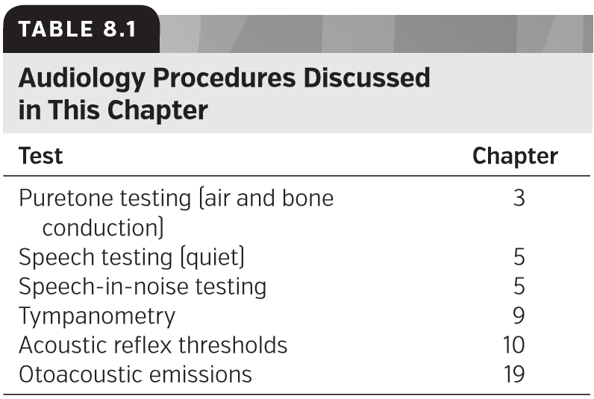

**Cross-checks for Puretone Air Conduction**

纯音空气传导的交叉检查

If you only obtained puretone air-conduction thresholds then you would not be able to accurately diagnose the type of hearing loss. Air-conduction audiometry is normally cross checked with bone-conduction audiometry or tympanometry to rule out a conductive component of the hearing loss. If a difference greater than 10 dB exists between the airconduction and bone-conduction thresholds at the same frequency, a conductive component is indicated. Similarly, air-conduction thresholds for an ear may be within normal limits; however, if a tympanogram for that ear falls outside of the norms for middle-ear pressure and compliance (e.g., Jerger Type B or Type C), a conductive component may be present. ARTs can reveal more information about the type of loss based on the pattern of responses obtained, thus serving as an additional cross-check for puretone air conduction.

如果您只获得纯音空气传导阈值，那么您将无法准确诊断听力损失的类型。空气传导测听术通常与骨传导测听术或鼓室测听术交叉检查，以排除听力损失的传导成分。如果在相同频率下，空气传导阈值和骨传导阈值之间存在大于10分贝的差异，则表明存在传导性因素。同样，耳朵的空气传导阈值可能在正常范围内；但是，如果该耳朵的鼓室图不符合中耳压力和顺应性规范（例如，Jerger B型或C型），则可能存在传导性因素。ARTS可以根据所获得的响应模式显示更多关于损失类型的信息，从而作为纯音空气传导的额外交叉检查。

**Cross-checks for Puretone Audiometry**

纯音测听交叉检查

When puretone audiometry (air- and bone-conduction testing) suggests a signiﬁcant air–bone gap, tympanometry and ARTs can be used to reinforce the diagnosis of the conductive element and to contribute to a speciﬁc diagnosis. OAEs also can be used as a cross-check of puretone audiometry. OAEs are used to assess the health of the outer hair cells of the cochlea, but their measurement may be affected by disorders in the conductive pathway. An audiologist might use OAEs as a cross-check to aid in potentially ruling out a nonorganic hearing loss, to verify outer hair cell function and the degree of cochlear hearing loss, and to further assist with the diagnosis of conductive components, auditory neuropathy spectrum disorder (ANSD), and other retrocochlear disorders. In addition, ARTs have been used to cross check puretone audiometry (Jerger et al., 1974), although other objective tests, such as tone-burst–stimulated auditory brainstem response (ABR), are considered to be better procedures for estimating hearing thresholds. Acoustic reﬂexes can be used to help identify the presence of hearing loss in young children as well as in adults with language and/or cognitive issues that may reduce the validity and reliability of behavioral measures (Hall, 2010). Acoustic reﬂexes can also be used to determine site of lesion within the auditory pathway, speciﬁcally in differentiating between cochlear and retrocochlear pathologies.

当纯音听力测试（空气和骨传导测试）显示有明显的气骨间隙时，鼓室测量和ARTS可用于加强对传导元件的诊断，并有助于特定诊断。OAE也可以用作纯音测听的交叉检查。OAE用于评估耳蜗外毛细胞的健康状况，但其测量可能会受到传导通路紊乱的影响。听力学家可以使用OAE作为交叉检查，以帮助排除潜在的非器质性听力损失，验证外毛细胞功能和耳蜗听力损失程度，并进一步帮助诊断传导成分、听神经病频谱障碍（ANSD），以及其他耳蜗后疾病。此外，ARTS还被用于交叉检查纯音听力测试（Jerger等人，1974年），尽管其他客观测试，如短纯音刺激听觉脑干反应（ABR）被认为是评估听力阈值的更好方法。声音反射可用于帮助识别幼儿和成人中存在的听力损失，语言和/或认知问题可能会降低行为测量的有效性和可靠性（Hall，2010年）。听觉反射也可以用来确定听觉通路中的损伤部位，特别是在区分耳蜗和耳蜗后病理学方面。

**Cross-check for Puretone Average**

纯音平均值的交叉检查

A puretone average (PTA) is usually calculated as the average of the air-conduction thresholds at 500, 1,000, and 2,000 Hz for each ear. Normally, the PTA should agree with the speech recognition threshold (SRT), meaning that the PTA and SRT should be within 10 dB of one another in the same ear. One instance in which the audiometric thresholds may cause the PTA to be greater than the SRT by 10 dB is when the audiogram conﬁguration is sharply sloping or sharply rising. In such instances, it is preferable to use a two-frequency PTA by averaging the two lowest (e.g., best) thresholds at 500, 1,000, and 2,000 Hz. The two-frequency PTA should then be in agreement with the SRT. Another instance in which the PTA and SRT may disagree is if a person is malingering or intentionally exaggerating a hearing loss. Outside of these special circumstances, we would expect SRTs and PTAs to be highly correlated (except when language or foreign language is a major factor). This allows us to use the SRT to validate the PTA (American Speech-Language-Hearing Association, 1988).

纯音平均值（PTA）通常计算为每只耳朵500、1000和2000赫兹的空气传导阈值的平均值。正常情况下，PTA应与语音识别阈值（SRT）一致，这意味着PTA和SRT应在同一耳朵中彼此之间的10分贝范围内。当听力图表现急剧倾斜或急剧上升时，听力阈值可能导致PTA大于SRT 10 dB。在这种情况下，最好通过在500、1000和2000 Hz下平均两个最低（例如，最佳）阈值来使用双频PTA。两个频率的PTA应与SRT一致。另一个PTA和SRT可能不同意的情况是，如果一个人在恶意或故意夸大听力损失。除这些特殊情况外，我们希望SRT和PTA高度相关（除非语言或外语是主要因素）。这允许我们使用SRT来验证PTA（美国语言听力协会，1988年）。

**Considerations for Assessing Speech Understanding**

评估言语理解的注意事项

One additional step that audiologists may take to address a patient’s complaint of not being able to understand speech in noisy environments is to administer a speech-in-noise test in addition to the word recognition testing in quiet. Although this is technically not a cross-check, the addition of a speech-in-noise test, especially with sentence stimuli, will provide a more realistic test environment to evaluate a common patient complaint. The puretone audiogram does not necessarily correlate with the amount of difﬁculty a listener will have in noise (Killion and Niquette, 2000). In addition, when word recognition testing is performed in quiet at a single speech presentation level, no guarantee exists that the test is measuring the patient’s maximum speech understanding (Wiley et al., 1995).

听力师在处理病人在嘈杂环境下听不懂说话的主诉时，可能采取的另一个步骤是，除了在安静的环境下进行单词识别测试外，还要进行语音噪声测试。虽然这在技术上不是一个交叉检查，但是添加一个语音噪声测试，特别是有句子刺激的，将提供一个更现实的测试环境来评估一个常见的病人诉求。纯音听力图并不一定与听者在噪音中的困难程度相关（Killion and Niquette, 2000）。此外，当单词识别测试在单一的语音表达水平上安静地进行时，并不能保证该测试能够测量患者最大的语音理解能力(Wiley et al.，1995)。

**Cross-check Considerations for Pediatric Testing**

儿科测试的交叉检查考虑因素

For children, it is imperative that the audiologist utilize the cross-check principle. The behavioral responses obtained via behavioral observation audiometry (BOA) or visual reinforcement audiometry (VRA) are considered to be accurate reﬂections of a child’s true thresholds when these tests are conducted carefully (Madell and Flexer, 2008). However, because children often do not respond as consistently or as quickly as adults, it is possible that a child’s behavioral responses may still be elevated compared to actual thresholds. As a result, the audiologist may judge the child’s responses as unreliable (Baldwin et al., 2010). Regardless of the judged reliability of such measures, audiologists should use objective tests such as OAEs and tympanometry as cross-checks for pediatric behavioral responses (Baldwin et al., 2010; Littman et al., 1998; Madell and Flexer, 2008). In addition, OAEs and acoustic reﬂexes have been shown to be good cross-checks for ABR in young children (Berlin et al., 2010; Stach et al., 1993). The Joint Committee on Infant Hearing Position Statement (JCIH; American Academy of Pediatrics, 2007) also recommends that electrophysiological measures be employed as a cross-check for behavioral response audiometry for children younger than 6 months chronological age. The statement further stresses the importance of obtaining behavioral thresholds as soon as possible using the most age-appropriate method “to cross check and augment physiologic ﬁndings” (American Academy of Pediatrics, 2007, p. 910).

对于儿童来说，听力学家必须利用交叉检查原则。通过行为观察测听（BOA）或视觉强化测听法（VRA）获得的行为反应被认为是这些测试仔细进行时儿童真实阈值的准确反映（Madell和Flexer, 2008）。然而，由于儿童的反应往往不像成年人那样一致或快速，因此，与实际阈值相比，儿童的行为反应仍有可能升高。因此，听力学家可能会判断孩子的反应是不可靠的（Baldwin et al.， 2010）。不管这些测量方法的判断可靠性如何，听力学家都应该使用客观测试，如OAEs和鼓室测压法，作为儿童行为反应的交叉检查（Baldwin et al.， 2010;Littman等，1998;Madell和Flexer, 2008）。此外，OAEs和声学反射已被证明是幼儿ABR的良好的交叉检查（柏林等，2010;Stach等，1993）。婴儿听力联合委员会立场声明（JCIH;美国儿科学会，2007年）也建议使用电生理测量作为6个月以下儿童行为反应测听的交叉检查。声明还强调了使用最适合年龄的方法“交叉检查和增强生理机能”尽快获得行为阈值的重要性（美国儿科学会，2007年，第910页）。

**Electrophysiological Tests as Cross-checks**

作为交叉检查的电生理测试

Although beyond the scope of this chapter, it should be noted that certain electrophysiological tests can be used to cross check behavioral measures, as well as to cross check each other and to help conﬁrm diagnoses of certain disorders (Bachmann and Hall, 1998; Berlin et al., 2010; Gravel, 2002; Hall and Bondurant, 2009; Stapells, 2011). For example, Berlin et al. (2010) discussed the use of cross-checking test results to diagnose ANSD: “ . . . the presence of a [cochlear microphonic] or reversing waves at the beginning of the trace does NOT make a diagnosis of ANSD . . . without the cross-check of middle-ear muscle reﬂexes (MEMR), OAEs, and an ABR latency-intensity function” (p. 32). For further information about these tests, the reader is referred to the chapters that discuss electrophysiological tests in the text. Table 8.2 summarizes many of the cross-check tests that are used in audiology.

尽管超出了本章的范围，但应注意的是，某些电生理测试可用于交叉检查行为测量，相互交叉检查，并有助于确定某些疾病的诊断（Bachmann和Hall，1998年；Berlin等人，2010年；Gravel，2002年；Hall和Bondurant，2009年；Stapells，2011年）。例如，Berlin等人（2010）讨论了交叉检查测试结果在诊断ANSD中的应用：“…在跟踪开始处有[耳蜗微音]或反向波不能诊断为ANSD。…没有中耳肌肉反射（MEMR）、OAES和ABR潜伏期强度功能的交叉检查（第32页）。关于这些测试的更多信息，读者可以参考本文中讨论电生理测试的章节。表8.2总结了听力学中使用的许多交叉检查测试。

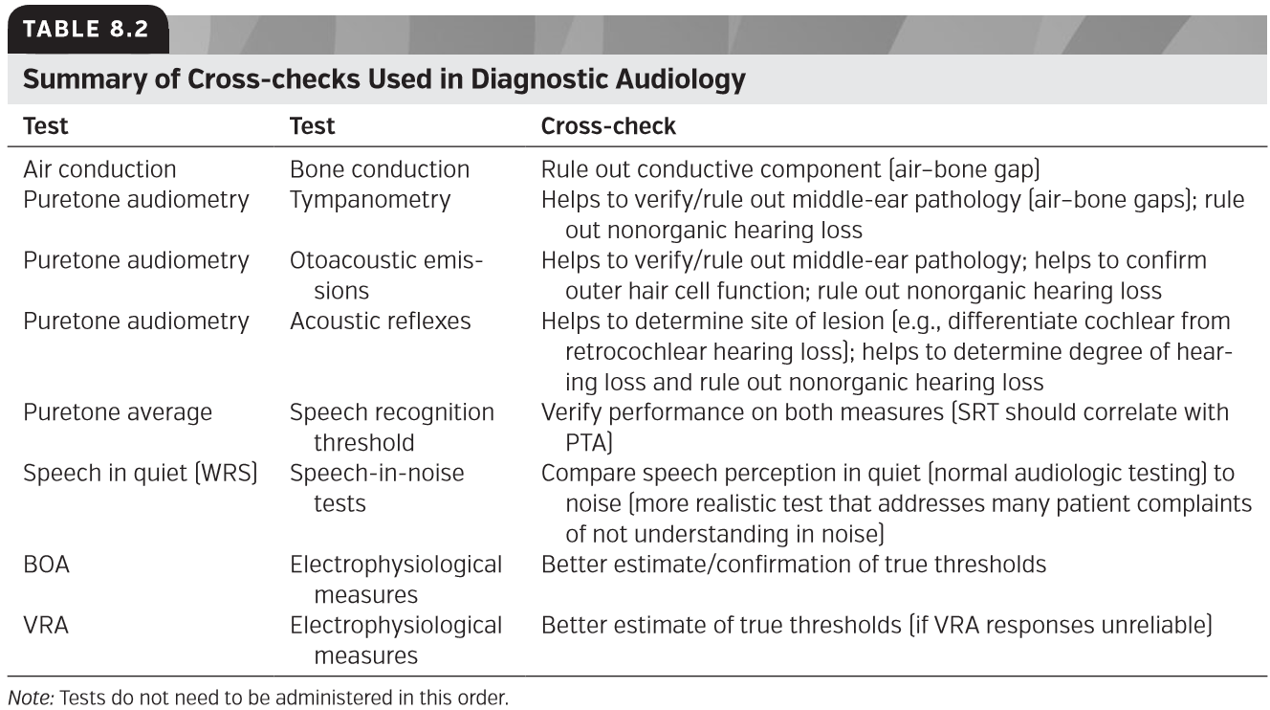

**Order of Tests Administered**

测试执行顺序

Although we acknowledge that there is considerable variability in test protocols across clinics, we recommend that testing begin with the objective tests unless contraindicated. At least two major advantages can be found for testing objective measures ﬁrst. The ﬁrst advantage is that the audiologist will have a good idea of the type and degree of hearing loss before beginning the subjective tests. The second advantage is the reduced risk for misdiagnosis of disorders such as ANSD and vestibular schwannoma, as well as failure to detect a patient who is malingering. One caveat needs to be discussed with conducting objective tests ﬁrst. With rising costs of health care we need to be cautious that we are doing tests that are necessary. It is possible that, if the patient’s hearing is completely normal (with no listening complaints) or the patient is profoundly deaf (with previous documentation to support the initial diagnosis), tests such as OAEs and acoustic reﬂexes will be unlikely to add further information about the patient (but we would

recommend that everyone have tympanometry for the reasons previously discussed). We think that a nonorganic component is more likely to be present during subjective testing and may not be discovered until cross-checked with objective tests. For these reasons, we recommend objective testing ﬁrst. A suggested testing order is shown in Figure 8.1. Nevertheless, it should be noted that some audiologists advocate giving puretone and speech tests ﬁrst when the patient may be more alert and can actively respond to these tests and then relax during the objective tests.

尽管我们承认，不同诊所的测试方案存在相当大的差异，但我们建议测试从客观测试开始，除非有禁忌。首先测试目标度量至少有两个主要优点。第一个优点是，在开始主观测试之前，听力学家会对听力损失的类型和程度有很好的了解。第二个优点是减少了误诊ANSD和前庭神经鞘瘤等疾病的风险，以及未能发现病人装病。需要与进行客观测试讨论一个注意事项。随着医疗保健费用的不断上涨，我们需要谨慎地进行必要的测试。如果患者听力完全正常（无听力方面的主诉，或者患者严重失聪（以前的文档支持初步诊断），诸如OAES和声学反射等测试将不可能增加关于患者的进一步信息。（但我们会的基于前面讨论过的原因，建议每个人都做鼓室检查）。我们认为，非有机成分在主观测试中更可能存在，只有与客观测试交叉检查才能发现。出于这些原因，我们首先建议进行客观测试。建议的测试顺序如图8.1所示。然而，应该注意的是，一些听力学家提倡在患者可能更加警觉的时候，首先进行纯音和语音测试，并且能够积极应对这些测试，然后在客观测试中放松。

**Beyond the Test Battery**

测试组块以外

Although the use of a test battery is important, it is also vital for the audiologist to remember the case history and the patient complaints. In some ways, one may consider this patient-reported information to be a cross-check of the test battery itself. The case studies presented below demonstrate examples of diagnostic audiology in action.

尽管使用测试组块很重要，但对于听力师来说，记住病史和患者投诉也是至关重要的。在某些方面，人们可能认为这个患者报告的信息是对测试组块本身的交叉检查。下面的案例研究证明了诊断听力学的应用实例。

### CASE STUDIES

案例研究

The importance of objective testing in conjunction with subjective tests can be seen through the use of case examples. The following cases are a range of examples that highlight the use and beneﬁt of incorporating the cross-check principle into your clinical practice. The cases will be presented with a brief history and test results. A discussion of potential difﬁculties and challenges in interpreting the audiologic data is incorporated within each case. Although there is an ideal order to the test sequence as noted above, the order of tests often varies because of tester preference, patient complaint, age of patient, and so on. Therefore, the test order in the cases below varies to better represent what may be actually done in a clinical setting or what a student clinician may see from his/her supervisors. For the sake of simplicity, all of the cases represent testing with standard audiologic procedures on adults. As you read through each case, we encourage you to make a decision tree based on the order of tests presented in the case and then think about how you might decide to change the test order. It is important to review your clinical decision making periodically to ensure that your practice is evidence based.

客观测试和主观测试的重要性可以通过使用实例来看出。以下案例是一系列例子，突出了交叉检查原则在临床实践中的应用和益处。这些案例将提供简要的病史和测试结果。在每个案例中都包含了对解释听力数据的潜在差异和挑战的讨论。尽管如上所述，测试顺序是理想的，但由于测试人员的偏好、患者投诉、患者年龄等原因，测试顺序通常会有所不同。因此，以下案例中的测试顺序会有所不同，以更好地表示在临床环境中实际执行的操作，或学生临床医师从其导师那里看到的操作。为了简单起见，所有的病例都是用标准的听力学程序对成人进行测试。在您阅读每个案例时，我们鼓励您根据案例中提供的测试顺序制作决策树，然后考虑如何决定更改测试顺序。定期回顾你的临床决策很重要，以确保你的实践是基于证据的。

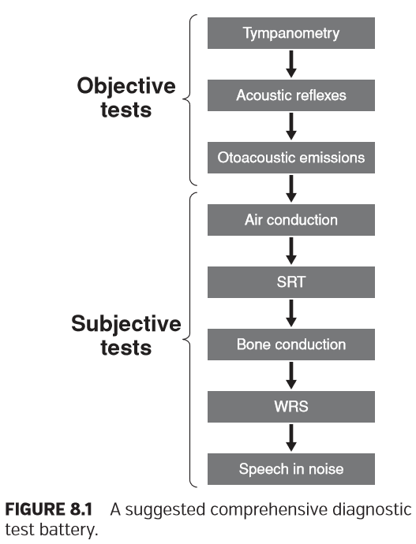

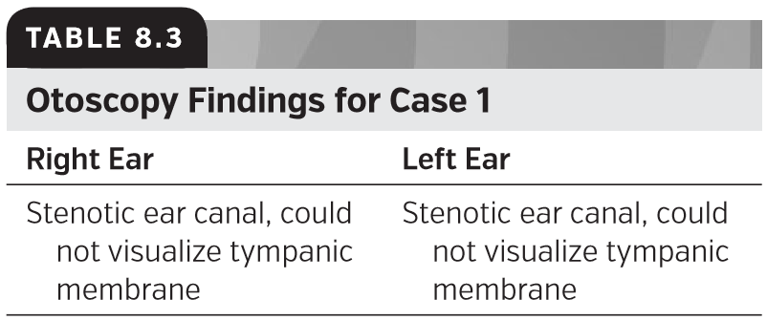

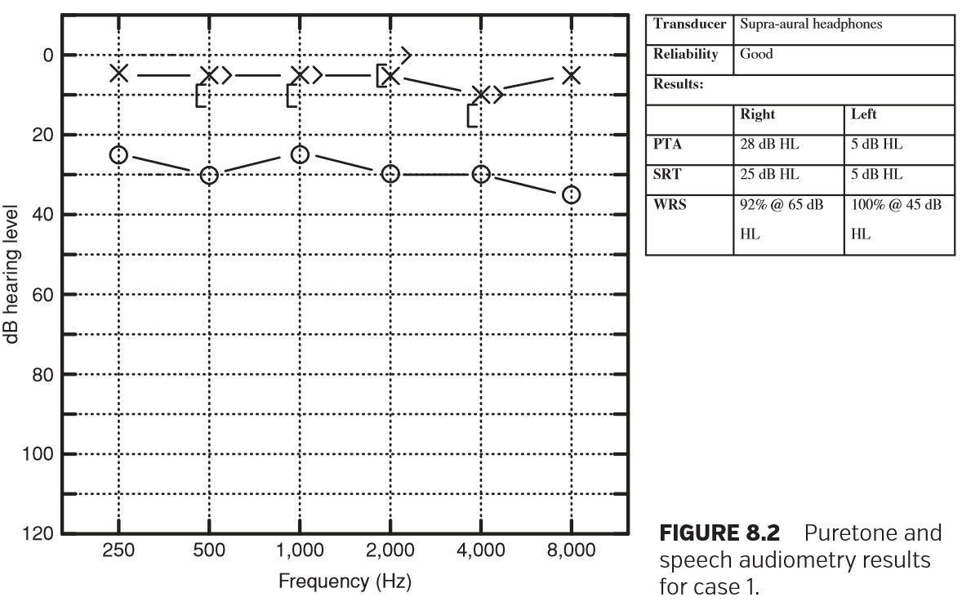

**Case 1**

案例1

**CASE HISTORY**

病史

Mr. Ang Kim, age 36, is being seen today after he failed the hearing screening at his company’s health fair. His medical history is generally unremarkable, though he reports that he is just getting over a sinus infection and recently underwent surgery for a slipped disc in his back. You have backto-back patients today and because there is nothing remarkable in his history you decide to do a quick audiogram and send him on his way. Results from otoscopy, puretone, and speech audiometry are shown in Table 8.3 and Figure 8.2.

现年36岁的金先生因未能通过公司体检中的听力筛查。他的病史一般都不起眼，尽管他说自己刚从鼻窦感染中恢复过来，最近因腰椎间盘突出而做了手术。你今天一个接一个的病人，因为他的病史没有什么特别的，你决定做一个快速的听力检查，然后送他回去。耳镜检查、纯音和言语测听结果如表8.3和图8.2所示。

With subjective information alone this audiogram could indicate many things. For example, you may inaccurately diagnose Mr. Kim with a collapsed ear canal, an impacted cerumen plug, or a perforated tympanic membrane without additional tests to cross check your ﬁndings. Despite your busy schedule, you decide you need more information to make an accurate diagnosis, so you perform objective testing to cross check your subjective results. The results from immittance testing and OAE testing are shown in Tables 8.4–8.6.

仅凭主观信息，这张听力图就能说明许多问题。例如，如果没有额外的测试来交叉检查你的发现，你可能会用耳道塌陷、耵聍堵塞或鼓膜穿孔来错误地诊断金正恩。尽管你的日程很忙，你还是决定需要更多的信息来做出准确的诊断，所以你会进行客观的测试来交叉检查你的主观结果。导容抗测试和OAE测试结果如表8.4-8.6所示。

With this information, you have several different tests to conﬁrm your ﬁnding of a conductive hearing loss. The Type B tympanogram in the right ear reveals normal ear canal volume but no mobility. The normal ear canal volume suggests that the TM is not perforated and there is no cerumen plug. The pattern of the ARTs is consistent with a right conductive pathology. TEOAEs in the right ear are absent which is expected with a conductive pathology.

有了这些信息，你就有了几个不同的测试来验证你的传导性听力损失的发现。右耳B型鼓室图显示耳道容量正常，但无活动能力。正常耳道容积提示鼓膜未穿孔，也没有耵聍。ARTs的模式与正确的传导病理学是一致的。右耳未见TEOAEs，这是一种传导性病变。

The combination of the subjective and objective test results correctly leads you to suspect otitis media with effusion and would require a referral for Mr. Kim to a physician. In this case, you are able to make an appropriate referral based on the information you obtained from a test battery incorporating both objective and subjective measures.

主观和客观测试结果的结合正确地导致您怀疑分泌性中耳炎，需要将金先生转诊给医生。在这种情况下，您可以根据从包含客观和主观测量的测试组块中获得的信息进行适当的转诊。

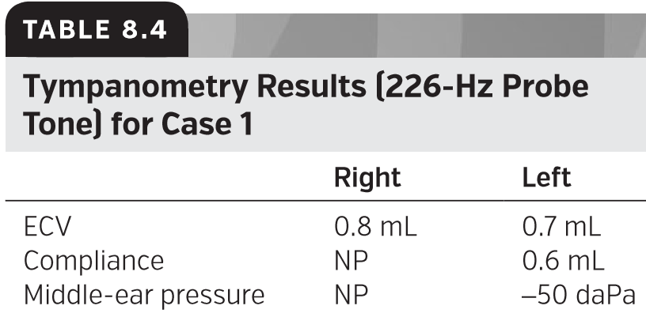

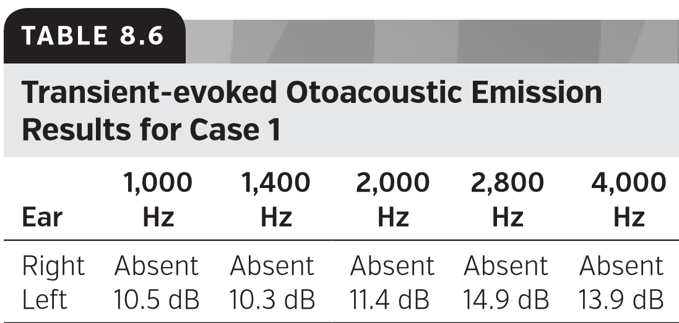

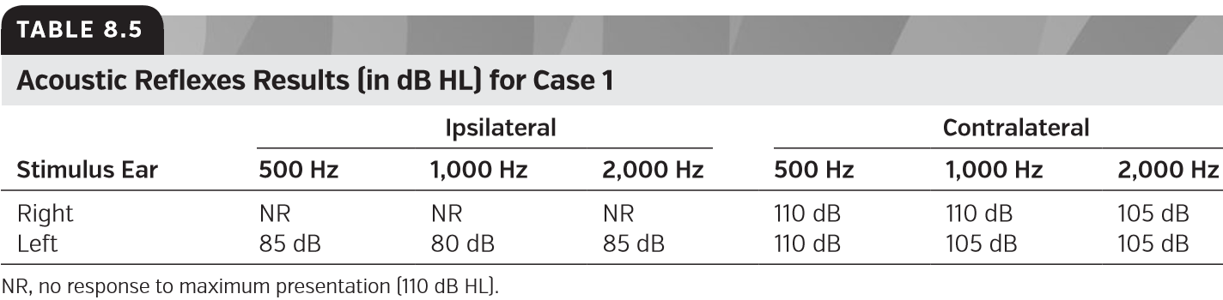

**Case 2**

案例2

**CASE HISTORY**

病史

Mrs. Edith Jones, age 77, is being seen today for a hearing test. She does not perceive a listening difﬁculty but her husband was recently ﬁt with hearing aids and insisted she have her hearing checked too. Her medical history is remarkable for high blood pressure and type 2 diabetes which are both controlled by medication.

现年77岁的伊迪丝·琼斯夫人今天正在接受听力测试。她没有感觉到听力障碍，但她的丈夫最近配戴了助听器，并坚持让她也检查一下听力。她的病史因高血压和2型糖尿病而引人注目，这两种疾病都是由药物控制的。

You conduct a basic audiometric evaluation on Mrs. Jones. Results for otoscopy are displayed in Table 8.7 and puretone and speech audiometry results are shown in Figure 8.3.

你对琼斯夫人做一个基本的听力评估。耳镜检查结果见表8.7，纯音和言语测听结果见图8.3。

If you decide not to proceed with further tests to cross check your results, you might diagnose this patient with normal hearing in the right ear and a mild conductive hearing loss in the left ear. You might then refer Mrs. Jones to an Ear Nose and Throat physician who would order more tests.

如果你决定不进行进一步的测试来交叉检查你的结果，你可能会诊断这个病人右耳听力正常，左耳轻度传导性听力丧失。然后你可以把琼斯太太介绍给耳鼻喉科的医生，他会安排更多的检查。

Instead, you decide to proceed and include additional tests in your battery that would provide a cross-check. We will review those results next (see Tables 8.8–8.10).

相反，您决定继续进行，并在您的组块中包含额外的测试，以提供交叉检查。接下来我们将回顾这些结果（见表8.8-8.10）。

These results suggest that Mrs. Jones has normal hearing that contradicts your puretone ﬁndings. Normal results on tympanometry, ARTs, and TEOAEs are not consistent with a mild conductive hearing loss. With this information you review the patient’s case history and puretone ﬁndings again and realize that the apparent conductive hearing loss in the right ear is likely the result of a collapsing ear canal. It is not uncommon for the pressure of the supra-aural headphones to cause the canal to collapse, particularly in older patients for whom the cartilage supporting the ear canal is soft. To conﬁrm this ﬁnding you decide to retest Mrs. Jones with insert earphones. When you repeat your audiogram using the insert earphones, you measure Mrs. Jones’s rightear air-conduction thresholds at 5 or 10 dB HL for all frequencies tested. You are able to report to Mrs. Jones that her hearing appears to be normal!

这些结果表明琼斯夫人的听力正常，这与你的纯音听阈发现相矛盾。鼓室压力测量，ARTs和TEOAEs的正常结果和轻度传导性听力损失不一致。利用这些信息，您可以回顾患者的病史和纯音情况，并再次认识到，明显的传导性听力损失，在右耳可能是由于耳道坍塌。压耳式耳机的压力导致耳道塌陷的情况并不少见，尤其是对那些支持耳道的软骨较软的老年患者。为了证实这一发现，你决定用插入式耳机重新测试琼斯夫人的听力。当你用插入式耳机重复你的听力记录时，你测量琼斯夫人在所有频率，空气传导阈值均在5或10dBHL。你可以向琼斯太太报告她的听力似乎很正常！

Both cases 1 and 2 highlight the importance of using objective test results in conjunction with subjective test results to avoid misdiagnosis. Both audiograms revealed similar test results but very different actual diagnoses, which were only conﬁrmed with the use of objective testing.

案例1和案例2都强调了将客观测试结果与主观测试结果结合使用以避免误诊的重要性。两种声像图的检测结果相似，但实际诊断有很大差异，只能通过客观检测加以证实。

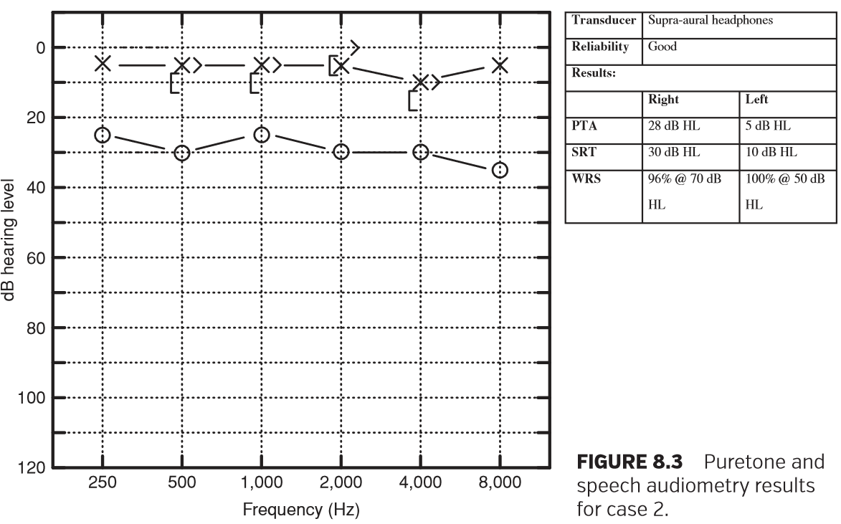

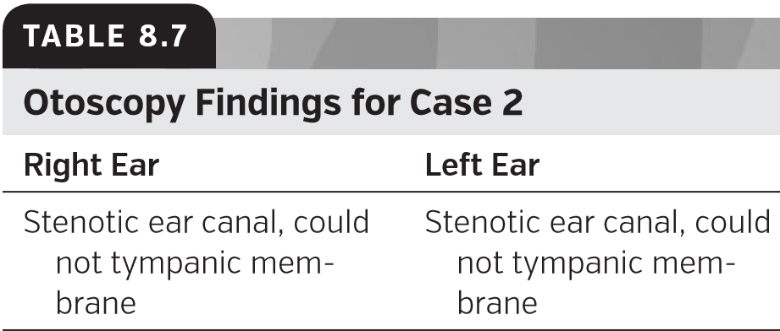

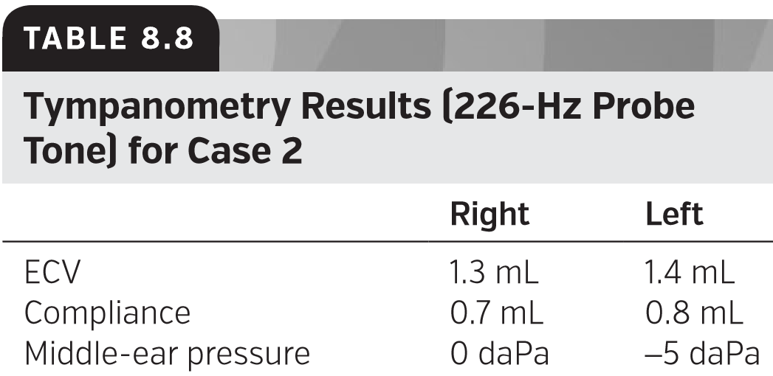

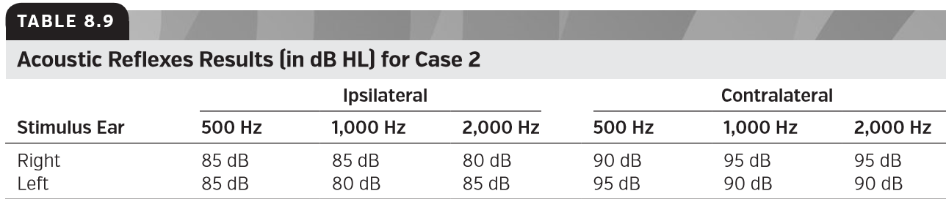

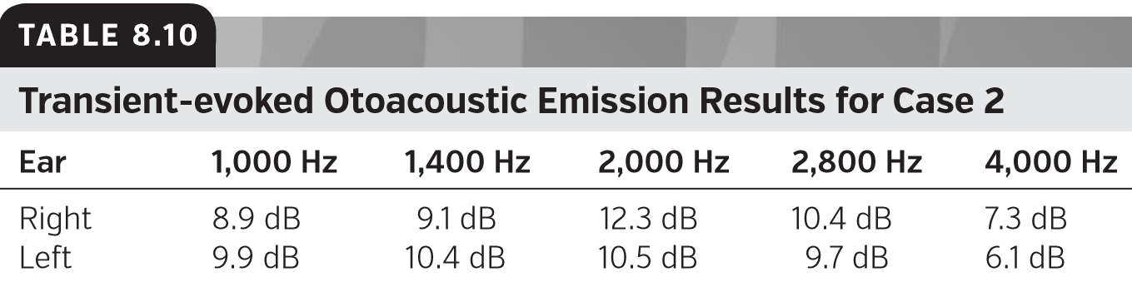

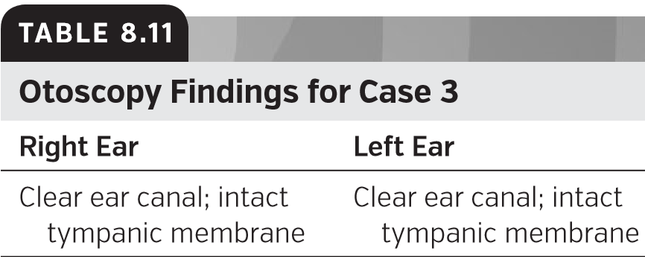

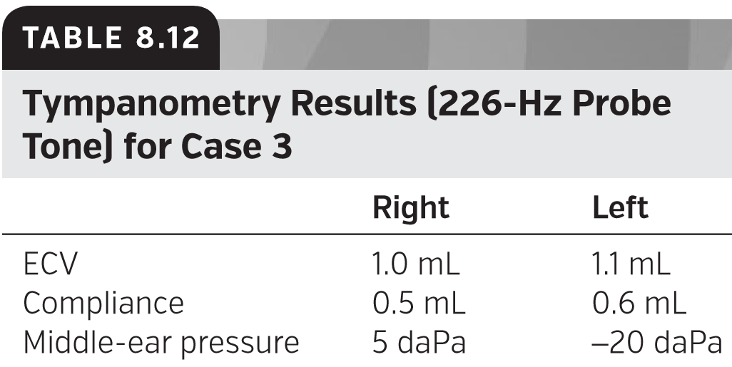

**Case 3**

案例3

You receive the following case, accompanied by a patient-signed medical information release, via fax. A recently graduated audiologist at a practice across town just finished testing Mr. Smith and would like a second opinion.

您将通过传真收到以下病例，并附上患者签署的相关就诊信息。一个刚刚毕业的听力师在镇上的一个诊所里刚刚完成了对史密斯先生的测试，他想听听你的的意见。

**CASE HISTORY**

病史

Mr. Aaron Smith, 49, reports that he can no longer hear out of his left ear. He works in construction and reports that a transformer overloaded at his work site yesterday, resulting in a loud explosion which he believes caused his hearing loss. Mr. Smith reported that his hearing was normal prior to the explosion. He denies any aural fullness, tinnitus, or dizziness. His medical history is unremarkable and he denies any other injuries as a result of the explosion. Results of the audiologic testing are shown in Tables 8.11–8.13 and Figure 8.4.

49岁的亚伦·史密斯说，他的左耳已经听不见了。他在建筑工地工作，他说，昨天他的工地上有一个变压器超载，导致了一场巨大的爆炸，他认为这导致了他的听力损失。史密斯先生报告说，爆炸前他的听力正常。他否认有任何耳胀、耳鸣或头晕。他的病史并不引人注目，他否认还有其他爆炸造成的伤害。听力学检查结果见表8.11-8.13和图8.4。

You call the audiologist right away and review your concerns with her. Both the air-conduction and bone- conduction thresholds for the left ear need to be masked. Cross-hearing should have occurred before those thresholds were obtained. Furthermore, you would not expect to obtain no response for bone-conduction testing with the bone oscillator on the left side when the hearing in the right ear is evidently normal. You also note that the PTA and the SRT are not in agreement for the left ear. ARTs are better than you would expect them to be (given the puretone thresholds for the left ear). A patient with hearing thresholds at 90 dB HL would be expected to have ARTs in the range of 95 to 125 dB HL at 500 Hz and 100 to 125 dB HL at 1,000 and 2,000 Hz (Gelfand et al., 1990). Lastly, the WRS was only obtained at 20 dB SL in the left ear, yet Mr. Smith’s WRS is 76%, which is better than expected. According to Dubno et al. (1995), a patient with a PTA of 90 dB HL would have an expected WRS of less than 24%. You suggest to the other audiologist that obtaining TEOAEs would further assist in this diagnosis. The audiologist performs TEOAEs (see Table 8.14) to conﬁrm the suspected diagnosis and faxes the results to you.

你马上打电话给听力学家，和她讨论你的担忧。左耳的空气传导阈值和骨传导阈值都需要掩蔽。交叉听证应该发生在这些阈值之前。此外，在右耳听力明显正常的情况下，用左侧的骨振子进行骨传导测试时，你不会期望没有反应的。您还注意到，左耳的PTA和SRT不一致。ARTs比你想象的要好（考虑到左耳的纯音阈值）。听力阈值为90 dB HL的患者，在500 Hz时的ARTs值为95至125 dB HL，在1000和2000 Hz时的ARTs值为100至125 dB HL （Gelfand et al.，1990）。最后，左耳的WRS仅为20 dB SL，Smith先生的WRS为76%，好于预期。根据Dubno等人（1995）的研究，PTA为90 dB HL的患者预期WRS小于24%。您向其他听力师建议，做TEOAEs检查将进一步有助于诊断。听力师执行TEOAEs（见表8.14）来确认疑似诊断并将结果传真给您。

Based on the pattern of test results, your suspected diagnosis is nonorganic hearing loss. Let us review the facts. First, the patient’s left ear thresholds are elevated above where cross-hearing should have occurred. Second, the objective test results (tympanometry, ARTs, and OAEs) reveal no conductive component and suggest that outer hair cells are functioning normally. However, the puretone and speech audiometry results suggest a severeto-profound unilateral hearing loss in the left ear, which is inconsistent with the objective results. Several crosschecks identiﬁed inconsistencies (e.g., ARTs and puretones; PTA–SRT agreement; puretone thresholds and OAEs). At this point, you could suggest that the audiologist reinstruct the patient and then retest the left ear, masking appropriately. If the thresholds for the left ear are still elevated, a Stenger test could be performed to conﬁrm the accuracy of the left puretone thresholds. If the Stenger test result is positive (i.e., the patient does not respond to the stimulus), this would be additional evidence that the apparent hearing loss is nonorganic. This case highlights the importance of a high-quality diagnostic battery (including masking where appropriate) and use of cross-checks to conﬁrm our test results.根据测试结果，您的疑似诊断是非器质性听力损失。让我们回顾一下事实。首先，患者的左耳阈值高于应该发生交叉听力的地方。第二，客观的测试结果（鼓室测量、ARTs和OAEs）显示没有传导性损失因素，表明外毛细胞功能正常。然而，纯音和言语测听结果显示左耳有严重的单侧听力损失，与客观结果不符。几个交叉检查发现了不一致性（例如，ARTS和纯音；PTA–SRT协议；纯音阈值和OAEs）。此时，你可以建议听力师重新指导病人，然后重新测试左耳，适当掩蔽。如果左耳的阈值仍在升高，则可以进行一次斯登格氏试验【斯登格氏试验（检伪装的单侧耳聋）】，以确认左耳纯音阈值的准确性。如果斯登格氏试验结果为阳性（即患者对刺激没有反应），这将是严重的听力损失是非器质性的。本例强调了高质量诊断组块（包括适当的掩蔽）和使用交叉检查确认测试结果的重要性。

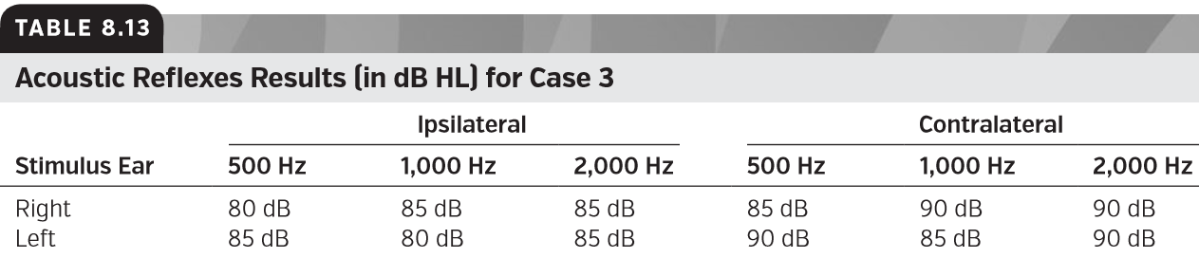

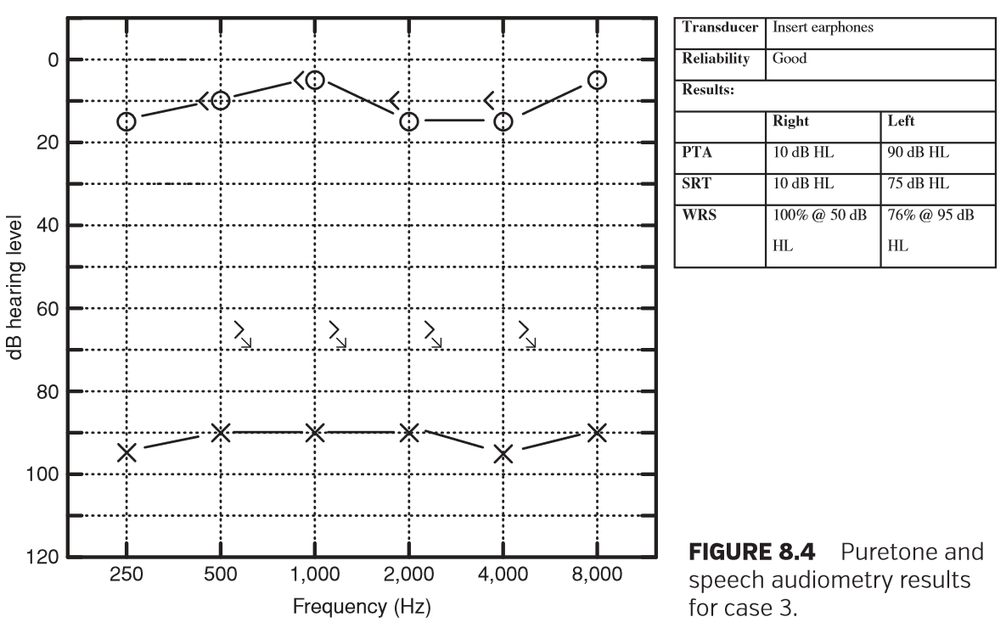

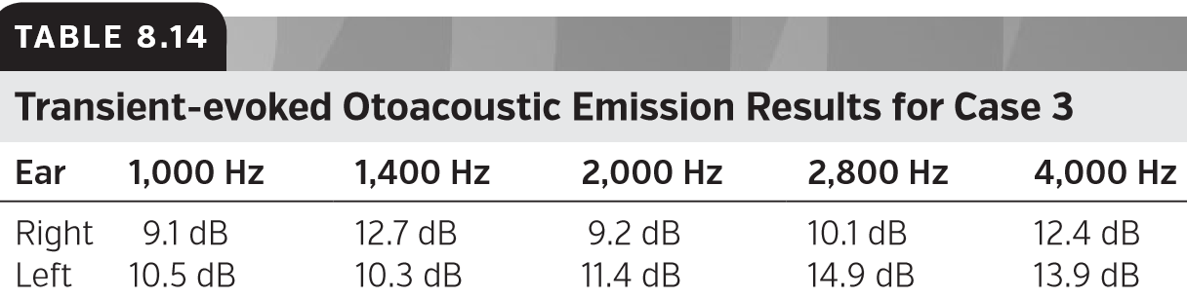

**Case 4**

案例4

**CASE HISTORY**

病史

Ms. Ashley Jackson, age 27, has had hearing problems all of her life. She has been told by her audiologist that she has only a mild sensory/neural hearing loss. Her doctor always tells her that her hearing is really very good. She tried hearing aids a few years ago but she says that they did not help at all. Unfortunately, Ms. Jackson cannot hold a job because of her hearing difﬁculties. Her bosses always cite miscommunication problems as the reason for her dismissal. Ms. Jackson is here today to see if her hearing has changed. Tables 8.15 and 8.16 show otoscopy and tympanometry results. Figure 8.5 shows puretone and speech audiometry results.

27岁的阿什利·杰克逊生活中存在听力问题。她的听力师告诉她，她只有轻微的感音/神经性听力损失。她的医生总是说她的听力很好。几年前，她尝试过助听器，但她说它们一点用也没有。不幸的是，由于听力障碍，杰克逊女士无法保住工作。她的老板总是以沟通不畅为理由解雇她。杰克逊女士今天来看看她的听力是否有变化。表8.15和8.16显示了耳镜检查和鼓室测量结果。图8.5显示了纯音和言语测听结果。

Ms. Jackson’s puretone results appear to be consistent with the previous hearing tests in her medical record. There are some red ﬂags that warrant additional testing, though. First, her reports of listening difﬁculties and communication problems in her case history suggest that she may have more than a mild sensory/neural hearing loss. Additionally, her word recognition scores are poorer than expected given her puretone thresholds. You would expect a patient with PTAs in this range to have WRS of 68% or better (Dubno et al., 1995). The next tests that should be performed are ARTs and OAEs. Tables 8.17 and 8.18 show the results of those tests.

杰克逊的纯音测试结果似乎与她之前的病历记录一致。不过，也有一些需要进行额外测试的危险信号。首先，她的病例记录中的听力障碍和沟通问题表明她可能不仅仅是轻微的感音/神经性听力损失。此外，考虑到她的纯音阈值，她的单词识别分数低于预期。您会期望此范围内的PTA患者的WRs为68%或更高（Dubno等人，1995年）。接下来应该进行的测试是ARTs和OAE。表8.17和8.18显示了这些试验的结果。

Now that you have completed your testing, you cross check your test results. First, the patient’s ARTs are not consistent with her puretone thresholds. With a mild sensory/ neural hearing loss you would expect acoustic reﬂexes to be present (Gelfand et al., 1990). The patient’s TEOAEs are present and robust which would not be expected based on Ms. Jackson’s puretone thresholds. These ﬁndings in conjunction with the poor WRS indicate a need for additional testing such as an ABR. You suspect that the patient has ANSD. Results of the ABR and a medical evaluation may help to conﬁrm or rule out your suspected diagnosis. Without the addition of both ARTs and OAEs to the test battery, Ms. Jackson’s disorder might have been missed again. The recommendations for patients with ANSD or other retrocochlear pathologies are often very different from the recommendations for those who have a peripheral hearing loss. Misidentiﬁcation of the site of lesion for a hearing loss like Ms. Jackson’s might result in delayed or inappropriate rehabilitation recommendations. Unfortunately, ANSD can be missed easily in clinical practice if the audiologist does not perform a thorough test battery (Smart and Kelly, 2008).

既然您已经完成了测试，那么就要交叉检查测试结果。首先，患者的ARTs与纯音阈值不一致。如果有轻微的感音/神经性听力损失，你会期望出现听觉反应（Gelfand等人，1990年）。根据杰克逊女士的纯音阈值，患者的TOAEs是存在的，并且是强大的，这是不可预期的。这些结果与较差的WR一起表明需要进行额外的测试，如ABR。你怀疑病人患有ANSD。ABR和医学评估的结果可能有助于确认或排除您的疑似诊断。如果不做ARTS和OAE，杰克逊的疾病可能会再次漏诊。对患有ANSD或其他耳蜗后病变的患者的建议通常与对外周听力损失患者的建议非常不同。对于像杰克逊女士这样的听力损失，误认损伤部位可能导致延迟或不当的康复建议。不幸的是，如果听力学家不进行全面的测试，那么ANSD在临床实践中很容易被忽略。（Smart和Kelly，2008年）。

**Case 5**

案例5

**CASE HISTORY**

病史

Mr. Don Warner, age 58, is being seen today with his primary complaint being a constant ringing in his right ear. He notes that the ringing has been present off and on for over 3 years but it has become more bothersome recently. When asked about his hearing he admits that he has difﬁculty understanding what others are saying in noisy places. He denies aural fullness and dizziness. He plays tennis regularly and generally is in great health. Results from your testing are shown in Tables 8.19–8.22 and Figure 8.6.

现年58岁的唐华纳今日来就诊，他的主诉是右耳一直在嗡嗡作响。他注意到响声已经断断续续地响了3年多，但最近变得更严重了。当被问到他的听力情况时，他承认他很难理解别人在嘈杂的地方说什么。他否认耳胀和头晕。他经常打网球，身体健康。测试结果如表8.19-8.22和图8.6所示。

The order of test administration is important. Because you performed immittance testing and TEOAEs ﬁrst, you knew that the patient’s tympanic membrane is mobile, that the ART pattern is abnormal in the right ear, and that the outer hair cells of the right ear do not appear to be functioning normally. You were able to obtain this information before the patient provided any information through subjective testing. The patient’s asymmetry in high-frequency audiometric thresholds and poor WRS in the right ear combined with the objective results suggest a retrocochlear pathology and warrant an ENT referral for additional testing. The patient’s report of unilateral tinnitus, the abnormal ART pattern, the asymmetry in puretone thresholds, and the apparent rollover in the patient’s right-ear word recognition are all suggestive of retrocochlear dysfunction. Taken in isolation, each might be sufﬁcient for you to make a referral for a medical evaluation. However, having consistent results from several tests allows you to be more conﬁdent in your recommendation and provide the ENT with as much information as possible.

测试执行的顺序很重要。因为你首先进行了导抗测试和TEOAEs，你知道病人的鼓膜是活动的，右耳的ART模式是不正常的，右耳的外毛细胞似乎不能正常工作。在获得患者主观测试所提供的信息之前，您可以获得这些信息。患者高频听力阈值不对称，右耳WRS差，结合客观结果，提示耳蜗后病变，并保证耳鼻喉科转诊进行额外检测。患者的单侧耳鸣报告、异常ART模式、纯音阈值不对称以及患者右耳单词识别的明显翻转均提示耳蜗后功能障碍。在孤立的情况下，每一个都可能有助于你转诊进行医疗评估。但是，几项测试获得一致的结果，您可以更加确信自己的转诊建议，并向ENT提供尽可能多的信息。

Case 6

案例6

CASE HISTORY

病史

Mr. José Gonzalez, age 24, was seen today for an audiologic evaluation. He was just hired as a clerk for a federal judge and therefore has to undergo a rigorous physical examination, including a hearing test. Mr. Gonzalez denies any hearing difﬁculties, tinnitus, dizziness, or aural fullness. He reports that he is in great health and is currently training for a marathon.

现年24岁的何塞·冈萨雷斯先生今天进行了听力检查。他刚刚被联邦法官聘为书记员，因此必须接受严格的身体检查，包括听力测试。冈萨雷斯先生否认任何听力障碍、耳鸣，头晕或耳胀。他说，他的身体很好，目前正在为马拉松训练。

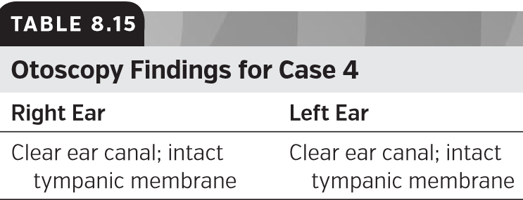

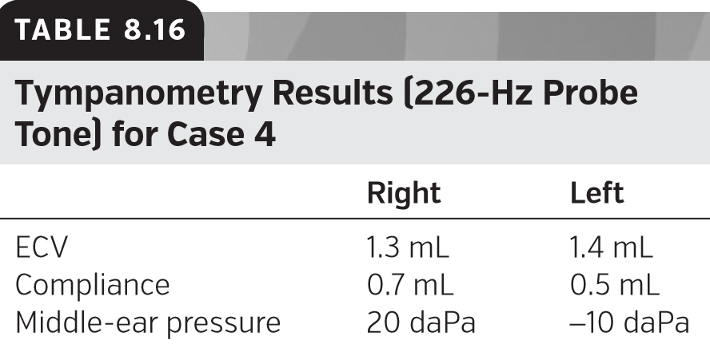

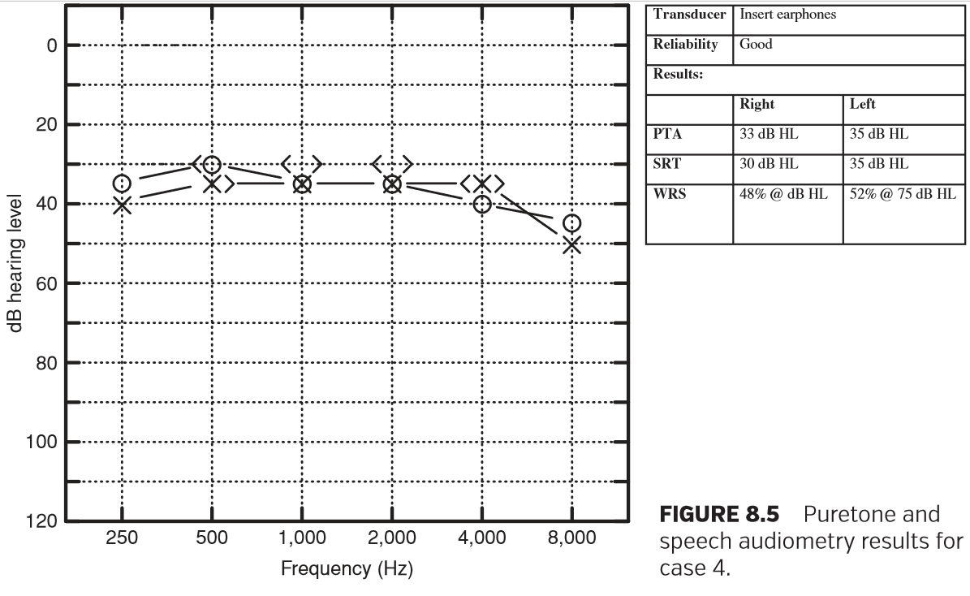

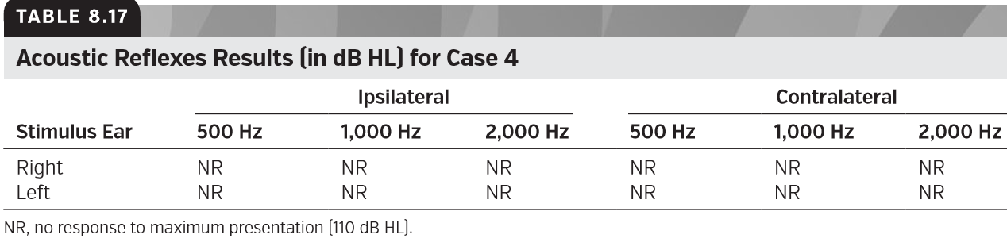

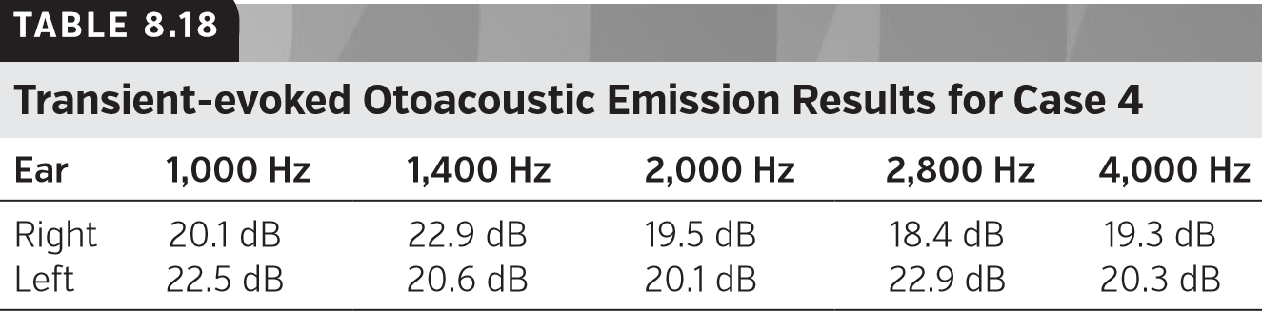

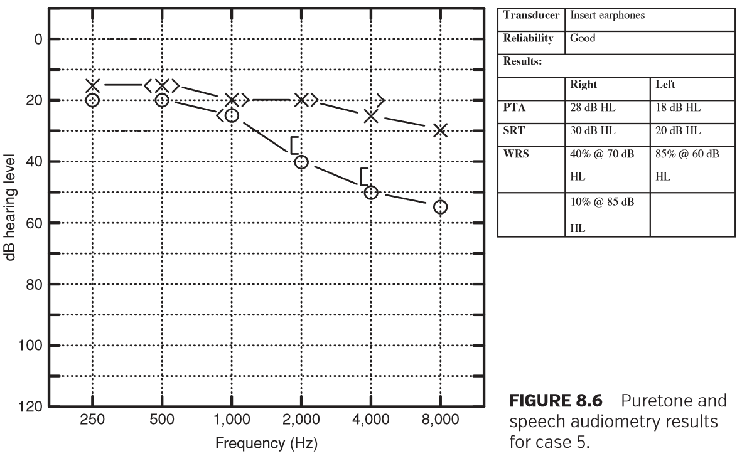

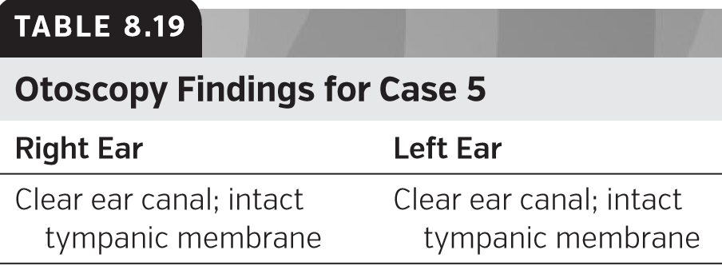

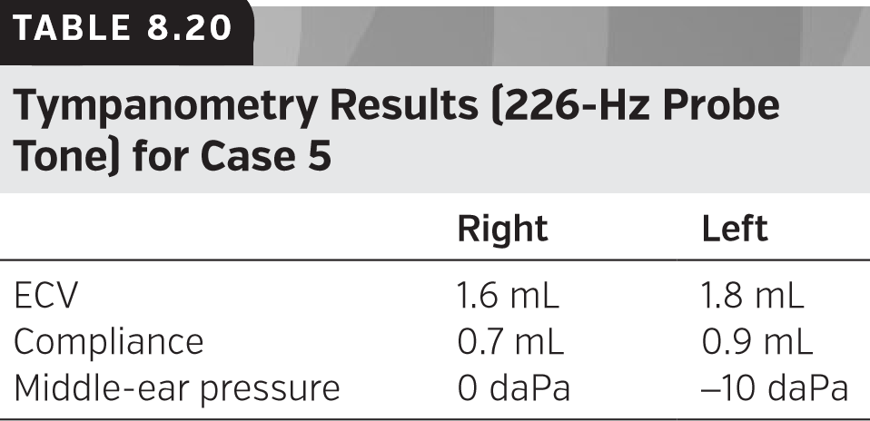

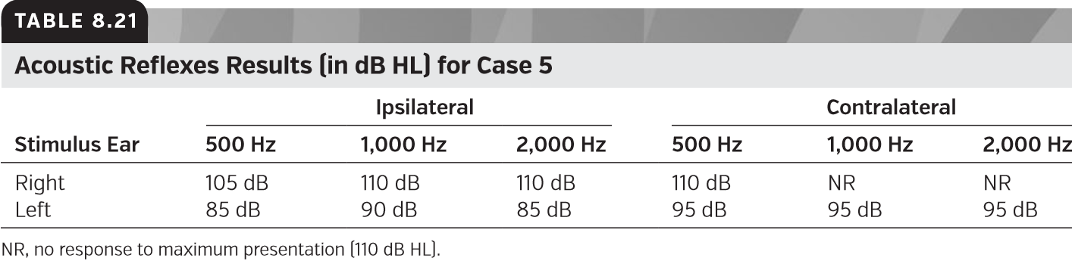

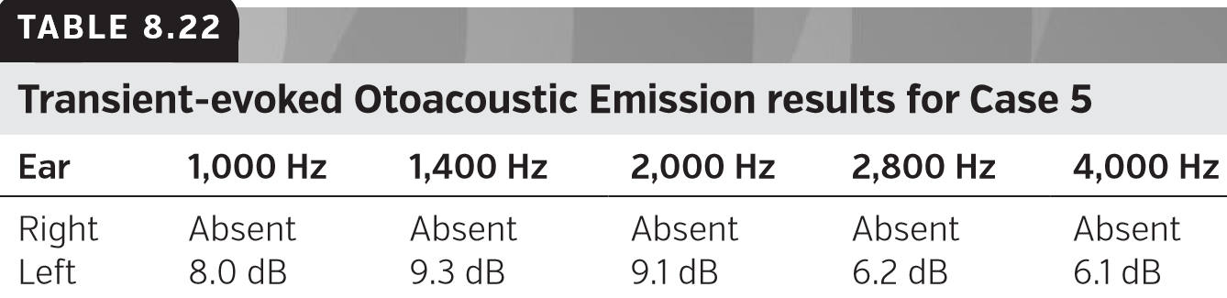

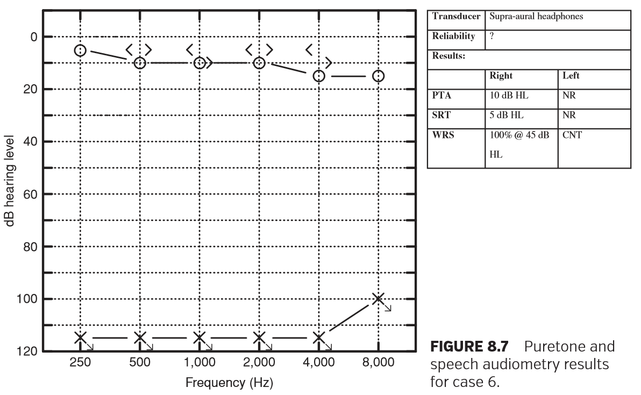

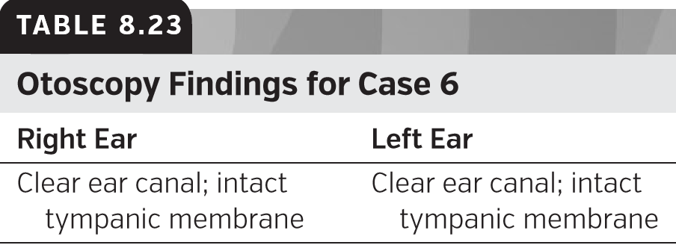

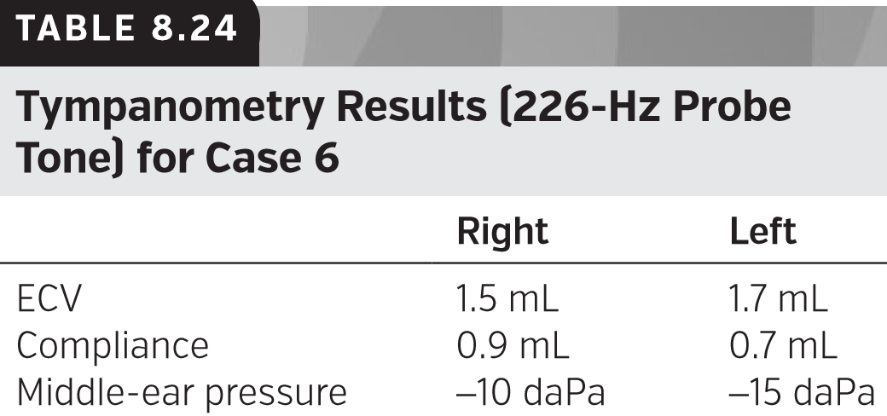

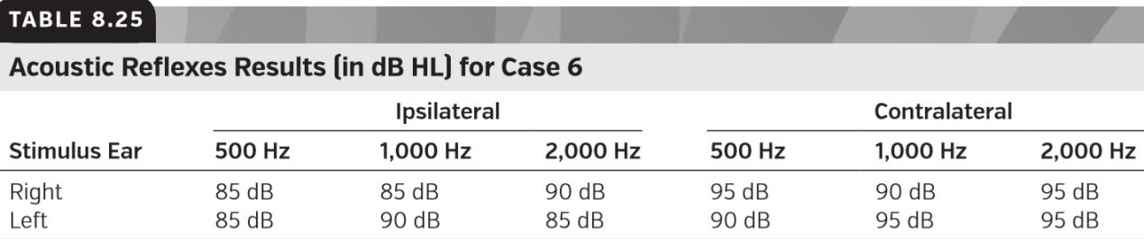

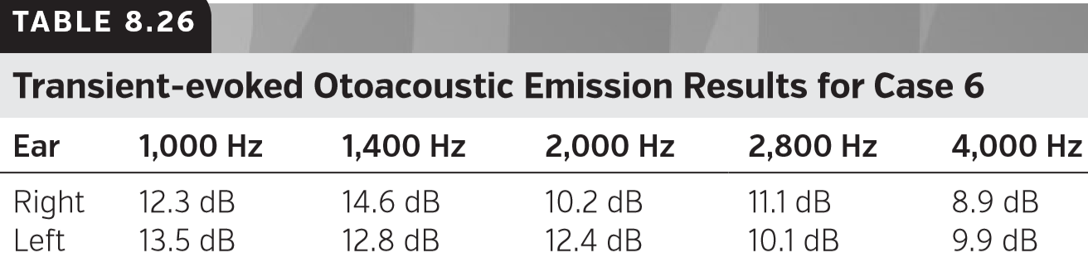

Based on the testing you have completed thus far you would expect this patient has normal hearing. His case history and all objective tests suggest hearing within normal limits. You proceed with your puretone and speech testing.

根据目前已完成的测试，您预计该患者听力正常。他的病史和所有客观测试表明听力在正常范围内。你继续进行纯音和语音测试。

Results from your testing are shown in Tables 8.23–8.26 and Figure 8.7.

测试结果如表8.23-8.26和图8.7所示。

The puretone and speech audiometry results are surprising because they conﬂict with the results from the objective tests. Speciﬁcally, ARTs and TEOAEs within normal limits are not consistent with a measured profound hearing loss in the left ear. Your ﬁrst thought is nonorganic hearing loss. You decide to reinstruct Mr. Gonzalez and retest the left ear air-conduction thresholds. This time you tell Mr. Gonzalez that you are going to play some more beeps in his left ear and all he has to do is press the button when he hears the tone. He nods and appears to understand the instructions. You begin retesting at 1,000 Hz and Mr. Gonzalez does not respond at the maximum limits of the audiometer. As you enter the booth to reinstruct again, Mr. Gonzalez informs you that he never heard a beep and has been waiting for you to present the tone. In fact, he notes that he has not heard anything from the left earphone. You check the headphone jack connections and ﬁnd that the left headphone jack is unplugged. After you plug in the jack and retest Mr. Gonzalez’s left ear, you obtain thresholds within normal limits. It is important to note that the patient history and the objective test results were not consistent with the subjective test results. Although having a well-constructed test battery is important, you also want to be ﬂexible with your test order and be vigilant to notice inconsistencies between test results as you go. This ﬂexibility would allow you to notice the unplugged headphone jack sooner and save time and frustration for you and Mr. Gonzalez.

纯音和语音测听结果令人惊讶，因为它们与客观测试的结果相冲突。具体来说，在正常范围内的ARTs和TEOAEs与左耳的重度听力损失是不一致的。你首先想到的是非器质性听力损失。你决定重新指导冈萨雷斯先生，重新测试左耳的空气传导阈值。这一次，你告诉冈萨雷斯先生，你要在他的左耳里再放一些哔哔声，他只要听到哔哔声就按下按钮。他点点头，似乎听懂了指令。你在1000赫兹开始重新测试，冈萨雷斯先生在听力计的最大分贝没有反应。当你再次进入测听室进行指导时，冈萨雷斯先生告诉你，他从来没有听到过哔的一声，他一直在等着你说出那个声音。事实上，他注意到他没有听到任何从左耳机发出的声音。检查耳机插孔连接，发现左侧耳机插孔未插拔。在插入插孔并重新测试冈萨雷斯的左耳后，就可以获得正常范围内的阈值。需要注意的是，患者的病史和客观测试结果与主观测试结果不一致。尽管拥有一个构造良好的测试组块很重要，但是您也希望灵活地执行您的测试顺序，并且在您进行测试时要注意到测试结果之间的不一致性。这种灵活性可以让你更快地注意到耳机插孔没有插电，为你和冈萨雷斯节省时间和挫败感。

### LIMITATIONS OF THE AUDIOLOGIC TEST BATTERY

听力测试组块的局限性

The combination of well-validated test measures, precise patient instruction, careful scoring, and application of the cross-check principle should result in accurate diagnostic and rehabilitative decisions for most patients. It is important to remember, however, that real-world patients usually do not present as textbook cases. The case studies contained in this chapter and the diagnostic criteria published in the audiologic test literature should be treated as guidelines rather than absolute rules. High-quality diagnosis depends on both the construction of a high-quality test battery and skill in interpreting ambiguous or seemingly contradictory test results. A good rule for daily practice is this: When test results seem in disagreement, ﬁrst check the tester (rule out the clinician’s own mistakes); then, check the equipment (rule out malfunction or equipment performing out of calibration); and ﬁnally, check the patient (rule out patient error or pseudohypacusis).

经过充分验证的测试措施、精确的患者指导、仔细的评分和交叉检查原则的应用相结合，应能为大多数患者做出准确的诊断和康复决策。然而，重要的是要记住，现实世界的患者通常不会以教科书的形式出现。本章中包含的案例研究和听力测试文献中公布的诊断标准应该被视为指南而不是绝对规则。高质量的诊断既取决于高质量测试组块的构建，也取决于对含糊或看似矛盾的测试结果的解释能力。日常实践的一个很好的规则是：当测试结果似乎不一致时，首先检查测试仪（排除临床医生自己的错误）；然后，检查设备（排除故障或设备执行未校准）；最后检查患者（排除患者错误或假性催眠）。

### MAKING REFERRALS

转诊

No audiologist is an island. A team approach to the treatment of hearing and balance disorders, particularly in pediatric patients, is often indicated. Appropriate treatment of a patient seen for audiologic evaluation may require consultation with specialists including (but not limited to) allergists, endocrinologists, neurologists, occupational therapists, ophthalmologists, psychiatrists, rheumatologists, and speech-language pathologists. Referral of pediatric patients with hearing loss to an ophthalmologist is particularly important; approximately 50% of children born with severe-to-profound hearing loss also have abnormalities of vision (American Academy of Pediatrics, 2007).

没有听力学家是孤岛。一种治疗听力和平衡障碍的团队方法，特别是在儿童患者中。对听力学评估的患者进行适当的治疗可能需要咨询专家，包括（但不限于）过敏科医生、内分泌科医生、神经科医生、职业治疗师、眼科医生、精神病学家、风湿病学家和言语病理学家。将听力受损的儿童患者转诊给眼科医生尤为重要；大约50%的先天性重度极重度听力丧失的儿童也有视力异常（美国儿科学会，2007）。

Referral for Medical Otolaryngologic Evaluation

转诊进行耳鼻喉科医学评估

The most common referral made by audiologists is to a medical doctor. Sending a patient to an otolaryngologist, primary care physician, or pediatrician is indicated if the audiologic evaluation reveals evidence of an underlying medical condition. Symptoms may include ear pain, bleeding or drainage from the ear (otorrhea), tympanometric abnormality without known etiology, or physical abnormality observed during otoscopy. Patients who report frequent ear infections, ﬂuctuating or sudden hearing loss, or balance disturbance should also be seen by a medical professional (see Table 8.27). Newly identiﬁed hearing loss is also reason for referral. Although some audiologists undertake cerumen management in their own practice, many others prefer to refer to an otolaryngologist or the patient’s primary care physician for removal of impacted wax. Children who exhibit a previously undiagnosed hearing loss or who exhibit delays in speech or language development should be seen by a pediatric otolaryngologist or developmental pediatrician prior to any audiologic management.

听力学家最常见的转诊是看医生。如果听力学评估显示有潜在疾病的证据，则应将患者送往耳鼻喉科医生、初级保健医生或儿科医生。症状可能包括耳痛、耳朵出血或引流（耳漏）、鼓室检查异常（病因不明）或耳镜检查时观察到的身体异常。报告反复耳部感染、心律不齐或突然失聪或平衡紊乱的患者也应由医疗专业人员进行检查（见表8.27）。新发现的听力损失也是转诊的原因。尽管一些听力学家在他们自己的实践中进行了耵聍处理，但许多其他人更愿意咨询耳鼻喉科医生或患者的初级护理医师，以去除受影响的耵聍。在进行听力学治疗前，儿童耳鼻喉科医生或发育儿科医生应先对先前未确诊的听力损失或言语或语言发育迟缓的儿童进行检查。

With respect to the audiologic test battery, disagreement among objective and subjective test measures which cannot be resolved as tester, equipment, or patient error is indicative of need for medical referral. Abnormally poor speech scores relative to the audiogram, asymmetric hearing loss, and reports of aural fullness and/or tinnitus are other signs of possible serious ear disease which should be evaluated by a physician.

关于听力测试组块，客观和主观测试措施之间的分歧不能作为测试者、设备或病人错误来解决，这表明需要进行医疗转诊。与听力图相关的异常差的语言评分、不对称听力损失、耳胀和/或耳鸣报告是其他可能的严重耳疾的迹象，应由医生进行评估。

**Referral for Auditory Processing Evaluation**

听力处理评估转诊

Disagreement between objective and subjective hearing tests may be reason to refer a patient for an evaluation of auditory processing. Patients with apparently normal peripheral auditory function may still have difﬁculty processing complex signals such as speech. These individuals often report that they can hear well, but have difﬁculty understanding what others are saying, particularly in the presence of noise. Tests of speech perception in noise such as the Bamford– Kowal–Bench Speech-in-Noise Test (BKB-SIN; Etymo -tic Research, 2005), Quick Speech-in-Noise Test (QuickSIN; Etymo -tic Research, 2001), and Hearing in Noise Test (HINT; Nilsson et al., 1994) may help to conﬁrm this difﬁculty. If performance on speech-in-noise tests is poor, particularly if the audiogram is normal or suggests good hearing sensitivity, auditory testing should be performed. Parental concerns about a child’s ability to process speech in noisy or reverberant places may also indicate need for APD evaluation. Auditory processing evaluation and rehabilitation are described in Chapters 27 to 30 of this textbook.

客观和主观听力测试的不一致可能是推荐患者进行听力处理评估的原因。外周听觉功能明显正常的患者可能仍然难以处理复杂的信号，如语音。这些人经常说他们能很好地听到，但是对别人说的话，尤其是在有噪音的情况下，理解能力很差。噪声中的言语知觉测试，如班福德-科瓦尔-斯台噪声中的言语知觉测试(BKB-SIN;词源学研究，2005)，快速语音噪声测试(QuickSIN;词源学研究，2001)，噪声测试中的听力(提示;尼尔森等人，1994)可能有助于证实这一差异。如果在噪音测试中表现不佳，特别是在听力记录正常或显示听力敏感性良好时，应进行听力测试。父母对孩子在嘈杂或混乱环境中处理语言能力的担忧也可能表明需要进行APD评估。听觉处理评估和康复在这本教科书的第27至30章描述。

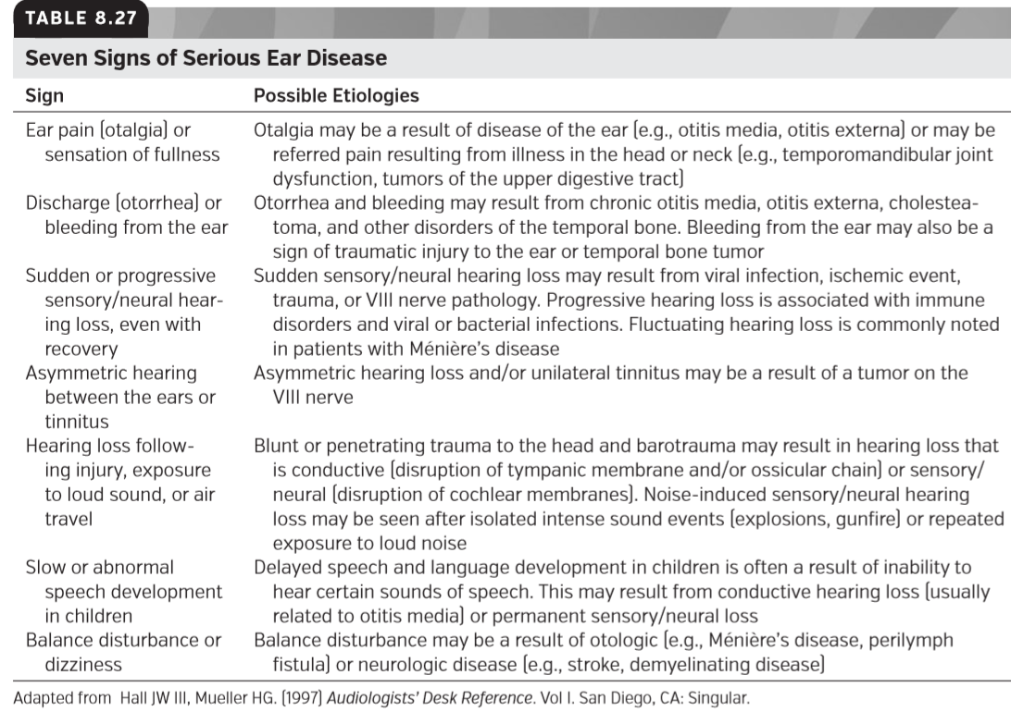

**Referral for Vestibular Evaluation**

前庭评估转诊

Formal vestibular evaluation may be indicated by patient history or results of a doctor’s physical evaluation. The symptoms of vestibular dysfunction are often obvious to the patient, but he or she may not realize that they are a relevant part of the audiologic case history. Therefore, it is important for any audiologist’s case history form to include questions speciﬁcally asking about vertigo or balance problems to elicit this information. Reports of dizziness (particularly recent dizziness), vertigo, or feelings of spinning suggest need for evaluation by a vestibular specialist and/or otolaryngologist. Reports of imbalance (as opposed to vertigo) are also reason for medical evaluation, but may require treatment by a physical therapist rather than an audiologist. Other speciﬁc indicators for vestibular testing include history of exposure to ototoxins (particularly vestibulotoxins, such as aminoglycoside antibiotics), bacterial meningitis, or perilymph ﬁstula. Patients with genetic conditions such as Pendred syndrome, Usher syndrome, and CHARGE syndrome are also candidates for vestibular referral. Pediatric patients presenting with inner ear dysplasia of unknown origin or delays in motor or balance skills should also be referred. Vestibular evaluation (Chapter 21) and rehabilitation (Chapter 22) are discussed in detail later in this textbook.

正式的前庭评估可以通过患者病史或医生的体格检查结果来表示。前庭功能障碍的症状对患者来说往往是显而易见的，但他或她可能没有意识到它们是听力学病史的一个相关部分。因此，对于任何听力学家的病例记录表来说，重要的是包含这些问题，尤其是专门询问有关眩晕或平衡问题的问题来引出这些信息是很重要的。头晕（特别是最近的头晕）、眩晕或旋转感觉的报告提示需要前庭专家和/或耳鼻喉科医生进行评估。不平衡的报告（与眩晕相反）也是医学评估的原因，但可能需要由物理治疗师而不是听力学家治疗。前庭检查的其他特殊指标包括耳毒素（特别是前庭毒素，如氨基糖苷类抗生素）、细菌性脑膜炎或外淋巴管炎的接触史。遗传性疾病患者如Pendred综合征、Usher综合征和Charge综合征的患者也可作为前庭转诊的候选者。儿童原因不明的内耳发育不良或运动或平衡技能延迟也应转诊。前庭评估（第21章）和康复（第22章）将在本教材后面详细讨论。

**Referral for Genetic Evaluation**

遗传评估转诊

Roughly 0.1% to 0.3% of children are born with some hearing loss, and about half of these cases appear to be related to some genetic cause. Of these genetic cases, about 30% are syndromic, meaning that they can be related to sets of clinically recognizable features or symptoms known to cooccur. The remaining 70% of genetic hearing loss cases are characterized by hearing loss in isolation and are referred to as nonsyndromic. Approximately 50% of cases of autosomal recessive nonsyndromic hearing loss are due to mutation in gap junction beta-2 (GJB2), the gene that encodes the gap junction protein connexin 26 (CX26) (Kelsell et al., 1997). Hearing loss resulting from connexin 26 mutation is typically present from birth and can range in severity from moderate to profound. More than 90 mutations of GJB2 have been identiﬁed.

大约0.1%到0.3%的儿童天生有听力损失，其中大约一半的病例似乎与某些遗传原因有关。在这些遗传病例中，大约30%是综合征，这意味着它们可能与一系列临床上可识别的特征或已知的症状有关。其余70%的遗传性听力损失病例以孤立性听力损失为特征，称为非综合征性听力损失。大约50%的常染色体隐性非综合性听力损失是由于缝隙连接β-2（gjb2）突变造成的，缝隙连接β-2是编码缝隙连接蛋白26（cx26）的基因（Kelsell等人，1997年）。由连接蛋白26突变引起的听力损失通常在出生就存在，其严重程度从中度到重度不等。已鉴定出90多个GJB2突变。

Testing for GJB2 mutation is an emergent ﬁeld in early hearing loss identiﬁcation. Quick and low-cost screening methods have been developed and are available through many medical centers and genetic testing service providers. It should be noted that many patients and parents may be hesitant to undergo formal genetic testing because of fears that their health insurance costs may increase if a genetic predisposition to disease is found. For these patients, a consultation with a genetic counselor may be preferable to a referral to a medical geneticist.

检测gjb2突变是早期听力损失鉴定的一个新兴领域。快速和低成本的筛选方法已经开发出来，并可通过许多医疗中心和基因检测服务提供商获得。应该注意的是，许多患者和家长可能会犹豫是否接受正式的基因测试，因为他们担心如果发现遗传易感性，他们的医疗保险费用可能会增加。对于这些患者，咨询遗传顾问可能比转诊给医学遗传学家更好。

### SUMMARY

总结

A well-constructed and consistently administered test battery provides the foundation for high-quality audiologic diagnosis and care. The case studies contained within this chapter are intended to underscore the importance of the diagnostic battery in terms of test selection, test order, and use of cross-checks. When test discrepancies cannot be resolved or a patient presents with complaints or symptoms outside of the audiologist’s scope of practice, a referral to an appropriate specialist is indicated. Consultation with other specialists can also help the audiologist form a more complete picture of a patient’s hearing health, increasing the likelihood of success in audiologic or vestibular rehabilitation.

一个构造良好且持续使用的测试组块为高质量的听力诊断和护理提供了基础。本章包含的案例研究旨在强调诊断组块在测试选择、测试顺序和交叉检查使用方面的重要性。如果测试差异无法解决，或者患者出现了超出听力师实践范围的主诉或症状，则需要转诊到合适的专科医生。咨询其他专家也可以帮助听力专家对患者的听力健康进行更全面的了解，增加听力或前庭康复成功的可能性。

### FOOD FOR THOUGHT

引人深思的事

1. For each of the cases presented in this chapter, what are some ways that the test order may have affected your thought process regarding the potential diagnoses?

1. 对于本章中提出的每个案例，测试顺序可能通过哪些方式影响您对潜在诊断的思考过程？

2. How might you modify the order that you administer tests in your test battery, or change particular tests, based on individual patient factors such as age or cognitive ability?

2. 您如何根据患者的个人因素，如年龄或认知能力，修改您在测试单元中执行测试的顺序，或更改特定的测试?

3. Imagine that you notice a colleague in your clinic administering tests in an order that you think is unhelpful or omitting tests that would help to differentiate between possible diagnoses. What might you say or do to suggest a different test battery or test sequence? What evidence might you use to support your suggestion?

3. 想象一下，你注意到一位同事在你的诊所里按照你认为没有帮助的顺序进行测试，或者省略了有助于区分可能诊断的测试。你会说什么或做什么来建议一个不同的测试组块或测试序列？你会用什么证据来支持你的建议？